THE ELITES JET



312/1 GEOGRAPHY Paper 1
PRE-MOCK - 2025.
MARKING GUIDE.
SECTION A: (25 MARKS)
- (a) Define ecosystem (2 marks)
- Consists of living and non-living organisms occupying and interrelating in an area.
(b) Describe the planet mercury. (3 marks)
- Smallest planet
- Nearest to the sun
- Takes 88 days to complete a revolution
- Has no moon
- Has small hills
- (a) How is the atmosphere heated? (1 mark)
- Terrestrial radiation
(b) Describe how a minimum thermometer works. (4 marks)
- When temperature falls alcohol contracts and its meniscus pulls the metal index backwards along the tube.
- This continues until the lowest temperature of the day is reached.
- When the temperature rises alcohol expands leaving behind the metal index
- The lowest temperature of the day is read and recorded.
- (a) What is a locolith? (2 marks)
- A mushroom like/done shaped mass of igneous rocks with flat floor/ base.
(b)Name any three examples of lava plateaus found in Kenya. (3 marks)
- Yatta
- Laikipia
- Uasin Gishu
- NorthWest Kenya

- (a) Differentiate soil creep from talus screep. (2 marks)
- Soil creep is slow but steady movement of soil and other fine particles down the slope while talus screep is slow and steady movement of angular rock particles.
(b) Give any three natural causes of soil creep. (3 marks)
- Alternate heating and cooling
- Alternate wetting and drying
- Freezing of soil water
- Rainwater lubricates soil particles.
- Describe how Lake Teleki was formed. (5 marks)
- Pre-existing depression occurred on the mountain side/Mt.Kenya.
- It was occupied by ice
- Erosion by abrasion occurred on the floor
- Ice plucked the back walls of the depression steepening it.
- The depression was widened and deepened
- Melt water collected in it forming Lake.Teleki.

SECTION B: (75 MARKS)
Answer question 6 (Compulsory) and any other 2 questions in this section.

- Use the map of Tambach sheet 90/3 to answer question 6.
- (i) Convert the map linear scale to statement. (2 marks)
2cm rep 1km
2 2

1cm rep ½ km
(ii) Measure the distance of approximate alignment around Lake.Kamnarok. give your answer in meters. (2 marks)

4800 4900 5000m
(iii) Calculate the area of Kaptagat Forest. (2 marks)
Full square – 0
Half squares $\frac{8}{2}$= 4mk²
- (i) Give three indicators which shows that the part of Tambach receive high rainfall. (3 marks)
- Kaptagat forest/forests
- Many permanent rivers
- Plantation
(ii) Describe characteristics of the long profile of River.Kerio. (6 marks)
- It is a permanent river
- It meanders
- It has tributaries
- It has interlocking spurs
- Flows through a seasonal swamp
- Forms dendrite drainage pattern
- Originate from the Southern part of Tambach
- Flows Northwards.
- A straight road is to be built from Tambach town to Muchukwo. State four problems that would be experiences during the construction. (4 marks)
- Elegeyo escarpment would be expensive to flatten
- Seasonal swamps will not be expensive to drain off
- River Kerio would require a bridge which is expensive to build
- Some settlements will be relocated which is very expensive

- Citing evidence explain three factors which have led to growth of Kapchemutwa forest plantation. (6 marks)
- High rainfall evidenced by many permanent rivers which provide moisture for continuous growth.
- High altitude evidenced by contours ranging from 2200m-2380m which provide cool conditions.
- Gentle slopes evidenced by widely spaced contours which provide deep well drained soils
- Market evidenced by many settlements/ saw mill which consumes.

- (a) i) Identify any three parts of the earth structure which has solid rocks. (3 marks)
- Sial/outer crust/continental
- Sima/oceanic/inner crust
- Upper mantle
- Inner core
ii) Name two ways how to determine the age of the rocks. (2 marks)
- Carbon dating
- Relative dating
- Absolute dating
iii) Name two regions in Kenya which are dominated by granitic rocks. (2 marks)
- Nyanza
- Western
(b) Describe how the following types of rocks are formed.
- Mechanically formed sedimentary rocks. (5 marks)
- Rock particles from pre-existing rocks are transported by wind or water
- They are deposited in the lowland forming thick layers.
- The upper layers compress the lower layers
- A hard solid material is formed
- These are mechanically formed sedimentary rocks.
- Chemically formed sedimentary rocks. (5 marks)
- Minerals are dissolved in rocks
- Solution is transported to large sea/lake
- Chemical reaction occurs between the solution and sea water.
- Sediments are formed and deposited on the floor of the geosyncline forming thick layers
- The upper layers compress the lower layers
- A hard solid material is formed
- This is a chemically formed sedimentary rock.
(c) With the aid of well labelled diagrams describe how intermountain basin is formed. (8 marks)
- Crustal rocks are composed of soft rock at the edges and hard rocks at the centre.
- They are subjected to compressional forces
- The soft rocks folded forming mountains
- Hard rocks remain unaffected forming plateaus
- Cracks develop on the plateaus
- They subside forming hollows called intermountain basins.
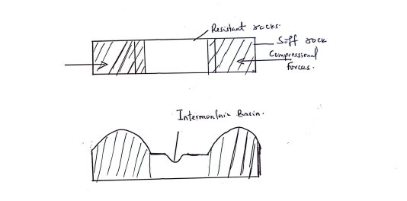
- (a) (i) Name any two types of climate experienced in the Western part of Kenya. (2 marks)
- Modified equatorial climate of the Lake Victoria region
- Tropical Northern climate/modified equatorial climate of Western border.
(ii) Explain how the following factors influence climate.
    - Latitude (4 marks)
- Areas around the equator experience higher temperature since the sun travels a shorter distance to reach them.
- Areas around the equator experience higher rainfall amounts because of high rates of evaporation.
- Areas around the equator experience lower atmospheric pressure because of high temperature.

    - Aspect (4 marks)
- The slopes facing the North are hidden from sunlight making them cooler/ south facing slopes are warmer.
- Windward slopes of mountains receive high rainfall/leeward slopes receive low rainfall/cold/are dry.
(b) Describe characteristics of equilateral climate. (6 marks)
- High temperature.
- Small range of annual temperature
- The area receives high rainfall
- The rainfall is in double maxima
- Temperature is high
- Rainfall is received throughout the year/no dry month
- Air pressure is low
- Rainfall is mainly convectional
- High humidity
- Cloud cover is thick
- N.E and S.E winds converge here
(c) You are planning to carry out a fieldwork in vegetation within your local environment.
(i) Apart from identifying different type of plants, state three other activities you would carry out during field study. (3 marks)
- Collect sample of plants
- Measure distances
- Estimate heights of plants
- Record/take notes
- Take photographs
- Count plants
- Sketch the area
(ii) How would you identify different types of trees. (3 marks)
  - Observe the appearance/leaf size/colour of leaves/flowers/shape of leaves
  - Smell flowers
  - Estimate heights
  - Feel the barks
  - Observe tree stems
(iii) State two ways in which the information collected during the field study would be useful to local community. (3 marks)
- Plan agricultural activities.
- Conservation of land/wildlife/soil/water
- Rationalize land use
- For future references
- To determine economic uses of plants.

- (a) (i) Define a coast. (2 marks)
- A narrow strip of land that border the sea or an ocean.
(ii) Explain how the following factors influence wave
    - Nature of materials carried by the wave. (4 marks)
- Hard materials carried by the wave
- Heavy materials erode faster and move
    - Orientation of the coast. (4 marks)
- Regular coasts are eroded least.
- Irregular coast will be eroded more
(b) Describe how a wavecut platform is formed. (7 marks)
- The base of a cliff is attacked by abrasion.
- A notch develops.
- Erosion enlarges the notch into a cave
- The roof of the cave eventually collapses forming a cliff
- When this process occurs repeatedly the cliff retreats
- Cliff retreat eventually leads to formation of a fairly smooth rock surface extending to the sea.
- This is a wave cut platform.
(c) With aid of a well labelled diagram, describe how a barrier reef is formed. (8 marks)
- Coral polyps starts building reef at the edge of the land seawards
- With time it encloses a shallow lagoon forming fringing reef
- The main land begins to sink and the sea level rises
- Coral continues to grow maintaining it depth.
- Eventually a wide coral platform enclosing a deep lagoon
- This is a barrier reef.
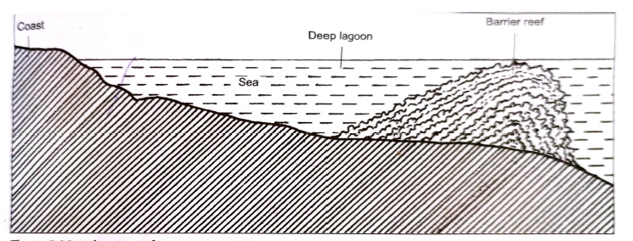
- (a) (i) What is a Karst Scenery? (2 marks)
- A rugged landscape made of limestone/ dolomite/chalk.
(ii) Explain three factors which are necessary for formation of Karst Scenery.(6 marks)
- Thick limestone rock to be dissolved by weak carbonic acid.
- Hard well jointed rock to facilitate infiltration
- Deep water table to facilitate formation of features
- Hot humid climate to facilitate chemical reaction.
(b) Describe how the following features are formed;
- Underground caves. (6 marks)
- Rain water mixes with CO2 forming weak carbonic acid
- It reacts with limestone rock forming calcium bicarbonate
- More water infiltrates and accumulate above the impervous rocks.
- Water enlarges the bedding planes forming underground streams
- The stream deepens and widens its valley as it flows downstream
- This lowers the water table
- When the stream flows out, it leaves behind hollows called caves

- Sinkhole (5 marks)
- Rainwater absorbs CO2 forming weak carbonic acid
- It percolates through a joint
- The joint is eroded by solution
- The joint is enlarged leading to formation of a vertical hole.
- This is a sink hole.
(c) Explain the significance of Karst landscape. (6 marks)
- Features such as uralas attract tourists
- Limestone is a raw material for manufacture of cement
- Limestone rocks are used for construction
- Terraross soil is suitable for agriculture
- Hotspring may deposit minerals.

