FORM FOUR MOCK 2025
Kenya Certificate of Secondary Education (K.C.S.E.)

Agriculture Paper 1 Marking scheme
SECTION A (30 MARKS)

Name four biotic factors that influence agriculture negatively. (2marks)
-Pests
-Parasites
-Predators
-Pathogens

State four activities that may be undertaken in organic farming. (2marks)
-Use of organic manure
-Timely planting
-Practicing crop rotation.
-Mulching
-Use of medicinal plant products to control diseases and parasites eg hot pepper solution.
-Livestock being reared by feeding them on natural feedstuffs without artificial additives.
-Physical/cultural pest, weed, parasite and disease control.

Give four reasons for early preparation of a seedbed in crop production. (2marks)
-To kill weeds
-To incorporate manure and other organic matter into the soil.
-To destroy different stages of crop pests such as eggs larvae, pupae or adults by burying them, exposing them to the heat of the sun and predators and starving them.
-To aerate the soil.
-To encourage the penetration of roots in the soil.
-To make subsequent operations possible eg planting, fertilizer application, rolling and ridging.
-To encourage water infiltration into the soil.

Give two reasons why crops do not do well in waterlogged soils. (1mark)
-There is poor soil aeration.
-Affects soil microbial activities.

Name four farming practices that may lead to soil erosion. (2marks)
-Overstocking

-Deforestation
-Planting of annual crops on steep slopes
-Clean weeding
-Indiscriminate burning of vegetation before cultivation
-Ploughing up and down the slope

Give four causes of poor drainage on farmland. (2marks)
-Too much rainfall on low lying areas.
-High amounts of clay particles in the soil.
-Presence of impermeable rock near the soil surface.
-Formation of hard pans in the soil.
-High water table.

State four advantages of a mixed grass legume pasture over a pure grass pasture. (2marks)
-It is more palatable than pure grass.
-A farmer has security against total loss in case of pest and disease attack or bad weather.
-Yields are higher per unit area of land than in pure grass pasture.
-It is more nutritious/has a higher nutritive value than pure grass pasture.
-It makes maximum use of soil nutrients because of different nutrient requirement.
-It has better weed control effect.
-It reduces soil erosion because of good soil cover.
-It increases soil fertility because of nitrogen fixation.
-There is economy in use of fertilizers in mixed pastures.
-There is better growth in a mixture of late and early maturing species.

Give a solution for each of the following properties of nitrogenous fertilizer when applying to crops.

  - Easily leached to lower horizons.
-They should be applied to an already established crop.

Are highly volatile.
-They should be applied to moist soils.

Are hygroscopic.
(1 𝑚𝑎𝑟𝑘)
2

(1 𝑚𝑎𝑟𝑘)
2

1

-They should be stored under dry conditions.
( 𝑚𝑎𝑟𝑘)
2

Give two ways in which records help farmers to obtain loans from money lending agencies.

(1mark)
-They establish a farmer’s credit worthiness by indicating the cash flow of the existing enterprise and hence the financial ability of the farmer to service the loan.
-From the proposed budget, records justify the need for the loans.
-They establish whether the loan applied for is relevant to the intended purpose of farming.

State four benefits of land consolidation. (2marks)
-Proper supervision of land
-Economic use of time and saving of transportation costs.
-Easy provision of agricultural advice by extension officers.
-Ensures sound farm planning and adoption of crop rotation programs.
-Facilitates soil conservation and land improvement.
-Promotes construction of permanent structures eg buildings and fences.
-Registered land gives the farmer legal ownership and the title deed which can be used to obtain loans.
-Weed, pest and disease control is enhanced.
-Facilitates mechanization especially because of large holdings.

State four ways in which humus is beneficial to a growing crop. (2marks)
- It increases the water holding capacity of the soil. It also increases the infiltration rate due to its colloidal nature.
-It improves soil fertility by releasing a wide range of nutrients into the soil.
-It provides food and shelter for soil micro-organisms responsible for the decomposition of organic matter.
-It improves soil structure. Humus binds soil particles together thus improving soil structure.as a result of this drainage and aeration of soil improves.
-It buffers soil ph ie moderates soil ph by avoiding rapid chemical changes due to the addition of acidic fertilizers and liming materials.
-It reduces the toxicity of plant poisons that may have built up in the soil as a result of continuous use of pesticides and fungicides.
Humus gives soil its dark colour which absorbs heat helping to moderate soil temperature.

State four disadvantages of chemical pest control. (2marks)

-Expensive.
-Most are not environmental friendly since they are toxic to man and livestock
-They require care and skill when handling and applying them.
-Most are non-selective and therefore they kill useful insects such as pollinators and pest predators.
-Pests establish resistance to pesticides if they are used continuously against them. E.g. DDT.

Define the term ‘’integrated pest management’’
-This is a combination of chemical physical, biological and pest control methods.
(1 𝑚𝑎𝑟𝑘)
2

State four factors considered when selecting planting material for forage crops. (2marks)
-Adaptable to the local ecological conditions.
-Fast growth
-High herbage yield/high leaf:stem ratio
-High germination percentage/viable
-High nutritive value
-Pure/true to type
-Certified seed
-Healthy/free from pests and diseases.

State four disadvantages of broadcasting seeds during planting. (2marks)
-It uses more seed than row planting.
-Seeds are spread unevenly leading to crowding of plants in some places.
-Lack of uniformity in seed placement causes lack of uniformity in establishment.
-There is uneven germination due to uneven depth of seed placement.
-Mechanization is hard eg weeding.

Name two sources of underground water. (1mark)
-Springs
-Wells
-Boreholes

State four factors that would determine the number of secondary cultivations to be carried out on a seedbed before planting. (2marks)
-Size of planting materials.
-Slope of the land.
-The moisture content of the soil.
-Condition of the soil after primary cultivation.
-The type of weeds to be controlled
-Soil texture

State two characteristics of a good vegetable seedling. (1mark)
-Healthy/free from diseases and pests.
-Free from physical deformities.

-High yielding.
-Correct stage of growth/height 10-15cm, 4-6 true leaves, 4-6 weeks old.

SECTION B (20 MARKS)
- A member of the young farmers’ club was advised to apply a complete compound fertilizer 30-20-10 in a tomato plot measuring 10m by 5m at the rate of 300kg per hectare.
  - Give the percentage of nitrogen (N) and phosphorus pentoxide (𝑃₂𝑂₅) in the fertilizer.
(2marks)
Nitrogen (N) -30%
Phosphorus pentoxide (𝑃₂𝑂₅)- 20%
  - Calculate the amount of fertilizer the member would require for the plot. (3marks)
Area of land 10x5=50msq; 1ha = 10000msq
If 300kg =10000msq;
? =50msq
300x50 10000
=1.5kg;

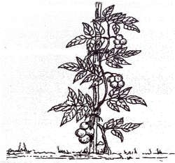
The diagram below illustrates a field management practice in tomatoes. Study it and answer the questions that follow.

  - Identify the field practice. (1 mark)
-Staking.

Name two materials used in the practice illustrated above. (2 marks)
-Stick/peg
-String

State three reasons for carrying out the practice above. (3 marks)

-Promotes the production of clean fruits.
-Facilitates spraying and harvesting of the crop.
-Prevents infestation by soil borne pests.
-Controls incidences of disease outbreaks eg blight.

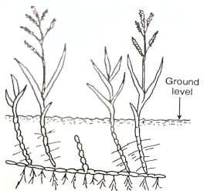
Below is a photograph of a weed. Study it carefully and answer the questions that follow.

  - Identify the weed above. (1mark)
-Couch grass (Digitaria scalarum)

Why is the weed above difficult to control? (1mark)
-Has underground stems/rhizomes which are difficult to control.

Give two ways in which the weed above can be controlled in a field of maize. (2marks)
-Use of herbicides.
-Good cultivation of seed bed.

Classify the weed basing on its morphology. (1mark)
-Narrow leaved.

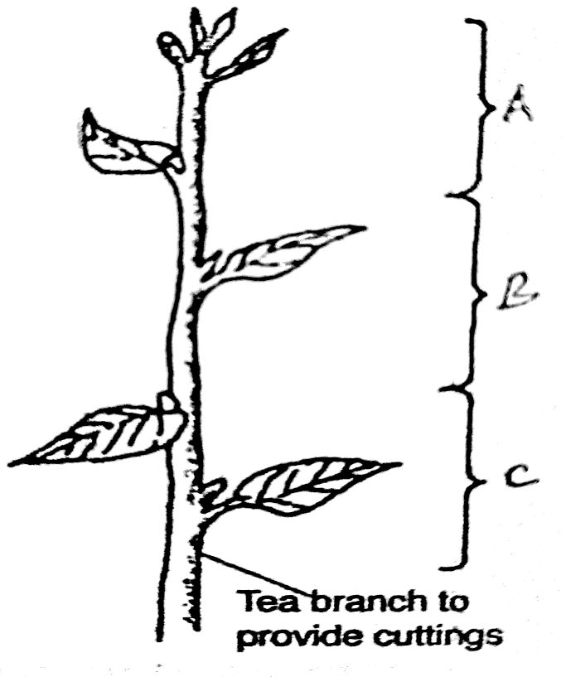
The diagram below is of a tea cutting. Study it and answer the questions that follow.

  - Which part of the branch is most appropriate for raising a new seedling. (1mark)
-Part B

Give a reason for your answer in (a) above. (1mark)
-The top part tends to rot when planted and the bottom part takes long to root.

Give a reason why farmers are advised to raise tea cuttings in polythene sleeves. (1 mark)
-The rooting system is not disturbed during transplanting.
-Seedlings can be stored further if transplanting is delayed after the seedlings have been collected from the nursery.
-Sleeved seedlings grow very fast and take a shorter time in the nursery.

State two factors that affect the rooting of the cutting above. (2 marks)
-Temperature
-Relative humidity
-Light intensity
-Oxygen supply
-Chemical treatment
-Leaf area.

SECTION C (40 MARKS)

a) Describe the production of tomatoes under the following sub-headings.
- Varieties (2 marks)
-Fresh market eg Money maker, hundred fold, beef eater, hot set, Ailsa Craig, super Marmande, ponderosa and Marglobe.
-Processing varieties eg Primabel, Sn Merzano, Cal J, Seinz, Kenya beauty, Rutgers and 10x hybrid. (Accept any two varieties given)

Nursery establishment (4 marks)
-The nursery should be sited on a gently sloping ground.
-It should be prepared to a fine tilth. Seed boxes may also be used as nursery beds.
-Drills are made across the bed 10-15cm apart using a finger or a stick.
-Seeds are dropped singly in the drills and covered lightly. More than 1cm soil cover will lower the germination %.
- Water, mulch and shade the nursery appropriately.

Transplanting (4 marks)
-Seedlings are ready for transplanting when they are about 10cm high,4-6wks old or have 4-5 true leaves
-The nursery should be watered before lifting the seedlings.
-Healthy and vigorously growing seedlings are lifted using a garden trowel.
-Apply phosphatic fertilizers/manures in the planting holes and mix with the soil.
-One seedling is planted per hole and soil firmed around the seedling.
-Plant at the same depth as was in the nursery.
-Transplanting should be done on a cool day or late in the evening.
-Seedlings are mulched and watered regularly.
-Provide temporary shade
-Transplant at the onset of rains.

Discuss the effects of wind in Agriculture. (6 marks)
-Increases the rate of evaporation of moisture from the soil.
-Causes lodging in cereals and damage to crops.
-Blowing away and bringing rain bearing clouds.
-Acts as an agent of seed dispersal.
-High winds leads to higher rates of evapotranspiration resulting into water stress in plants.
-Increases the spread of pests and diseases.
-Wind facilitates pollination in some plants.
-Areas with high humidity tend to be hotter but when wind blows away atmospheric water, a cooling effect occurs.
-Destroy farm structures.

State four reasons for mulching. (4 marks)
-Prevents water evaporation thus maintaining moisture in the soil for crop use.
-Acts as an insulator thus modifies or regulates the soil temperature.
-Controls soil erosion by reducing the speed of running water intercepting the rain drops and increasing the rate of infiltration.
-Controls weeds by suppressing their growth.
-Organic materials improve soil fertility by releasing nutrients after decomposition.
-Decomposition of organic matter results into humus that improves soil structure and water holding capacity.

a) Describe four types of soil erosion. (9 marks)
-Splash/rain drop erosion-Continuous falling of raindrops on loose soil surface detaches and disperses soil creating a hole which will enlarge to form a gulley.
-Sheet erosion-This the uniform removal of soil in thin layers caused by surface flow of water and wind which detaches and transports sheets of top soil over a wide area.
-Rill erosion-This is the removal of soil by water from small but well defined channels (rills) or streamlets where there is a concentration of flowing water down the slope.
-Gully erosion-This is an advanced stage of rill erosion.

Outline the precautions taken when harvesting cotton. (4 marks)
-Picking should be done immediately the bolls open/split to prevent staining by dust.
-Picking should be done when the lint is dry to prevent fibres from sticking together.
-Hands should be clean to avoid staining of the lint.
-Do not mix cotton with foreign matter eg leaves and small twigs.
-Use separate containers for separate cotton grades to ensure quality.
-Avoid using sisal bags for collecting the bolls because their fibres may mix with the seed cotton thus creating problems during ginning.

Describe seven factors considered when selecting bean seeds for planting. (7 marks)
-Select varieties adapted to the ecological conditions of the area.
-Select dry mature seeds.
-Select sound seeds that are free from physical damage and wrinkles/ Size and shape of the material.
-Select pure and health seeds.
-Disease resistance capability of the seeds should be good.
-Qualities of the plant such as its yield capacity should be high.
-Germination percentage of the seeds should be high.
-Use certified seeds/ obtain seeds from a reputable source.

a) State and explain four environmental factors affecting the effectiveness of
herbicides (8 marks)
-Wind-May blow away spray wash to unintended plants while decreasing chemical concentration on the intended plants.
-Rain-If rain falls immediately after herbicide application the chemical is diluted to non-toxic levels. Where only shallow rooted plants were intended to be killed, rain water may cause the herbicides to leach and reach roots of deep rooted plants thus killing them.
-Soil-Some soils are capable of absorbing and retaining more herbicides than others.
-Light-Increase in light intensity increases the rate of light absorption and photosynthesis by plants hence increasing absorption and translocation of herbicides.
Some herbicides are decomposed by high light intensity hence become less effective.
-Temperature-Increases translocation hence absorption of more herbicides and therefore death of the plant.

Describe five factors that determine the quality of farm yard manure. (5 marks)
-The type of animals’ used-Non ruminants eg pigs and poultry absorb less nutrients from their feed and therefore give dung which has a higher level of nutrients.
-Type of food eaten-Feedstuffs that are highly nutritious result in manure with a higher level of nutrients.
-Type of litter used-Leguminous materials used decompose faster and provide more nutrients.

-Method of storage-Preferably in a place with a leak free roof and a concrete floor to prevent loss of nutrients through leaching and vaporization.
-Age of FYM-Well rotted manure is rich in nutrients and it is easy to handle and mix with the soil.

State seven disadvantages of communal land tenure system. (7 marks)
-No individual has the responsibility of taking care of land or developing it.
-Farmers have no incentive to manage and develop the land well nor do they risk investing in permanent development projects because the land can be taken away from them anytime.
-Overstocking and overgrazing are common due to uncontrolled number of livestock leading to low yields.
-Poor breeding programs due to random mating and uncontrolled breeding.
-Pest and disease control is very difficult due to mixing of animals.
-Leads to soil erosion and land denudation.
-It is virtually impossible for a farmer to get loans from money lending agencies.

Page |

