SISO SUBCOUNTY
TRIAL 1 EXAMINATION
Kenya Certificate of Secondary Education (KCSE)

NAME…………………………………………………………………….……… ADM NO…………………………….
SIGN………………………………….. DATE………………………………..
MATHEMATICS PAPER 2
121/2
2HOURS 30 MINUTES
MARCH/APRIL 2025
Instructions to candidates
- Write your name and index number in the spaces provided above
- This paper consists of two sections. Section 1 and section II
- Answer ALL question in section I and only five question from section II
- Show all the steps in your calculations, giving your answers at each stage in the spaces below each question.
- Marks may be given for correct working even if the answer is wrong.
- Non-programmable silent electronic calculators and KNEC mathematics tables may be used

For examiners’ use only
SECTION I
1 | 2 | 3 | 4 | 5 | 6 | 7 | 8 | 9 | 10 | 11 | 12 | 13 | 14 | 15 | 16 | Total

SECTION II
17 | 18 | 19 | 20 | 21 | 22 | 23 | 24 | Total |  |  | Grand total

SECTION I ( 50 marks )
- The dimensions of a rectangle are 3.5 cm by 2 cm. Calculate the relative error in its area, leaving the answer as a simplified fraction. (3mks)

- Find the value of y
$2+\log_{2}{3 }+\log_{2}{y}=\log_{2}{5}+1$ (4mks)

- A bicycle can be bought for sh. 3 500 cash or by paying 10 monthly instalments of sh. 480 each. Determine the rate of interest charged per annum to 1 decimal place. (3mks)

- Simplify by rationalizing the denominator $\frac{2}{\sqrt{6}+\sqrt{3}}-\frac{5}{\sqrt{6} -\sqrt{3}}$ (3mks)

- A tea blender buys two grades of tea at sh. 60 and sh. 80 per packet. He mixed in the ratio 2:3. Find the selling price of the mixture so that he makes a profit of 25% (4mks)

- Find the value of x for $0°≤x≤360°$ if $sinx=\frac{\sqrt{3}}{2}$ (3mks)

- The equation of a circle is given by $x^{2}+8x+y^{2}-2y-8=0$ . Determine the radius and centre of the circle. (3mks)

- Make t the subject of the formula $y=\sqrt{\frac{t - x }{t - 1}}$ (3mks)

- A two-digit number is such that the product of its digits is 12. When the digits are reversed, the number formed exceeds the original by 9. Find the original number. (4mks)

- a). Expand ${\left(1-x\right)}^{9}$ up to the term in $x^{3}$. (1mk)

- use the expansion to estimate ${\left(0.98\right)}^{9}$ correct to 3 decimal places. (2mks)

- Find the distance between the points $3j+k$ and $2i+j+k$ . Give your answer as a simplified surd. (3mks)

- Calculate the standard deviation of the following data to 2 d.p
- , 2, 3, 4, 5, 6, 7, 8, 1 (4mks)

- In the figure, chords AB and CD intersect externally at point O. Find the value of x. (3mks)
4cm
X cm
5cm
9cm
O
B
D
C
A

- a). Draw the graph of y against x for the values below (3mks)
X | 1 | 3 | 6 | 10 | 15
Y | 4 | 7 | 11 | 17 | 20

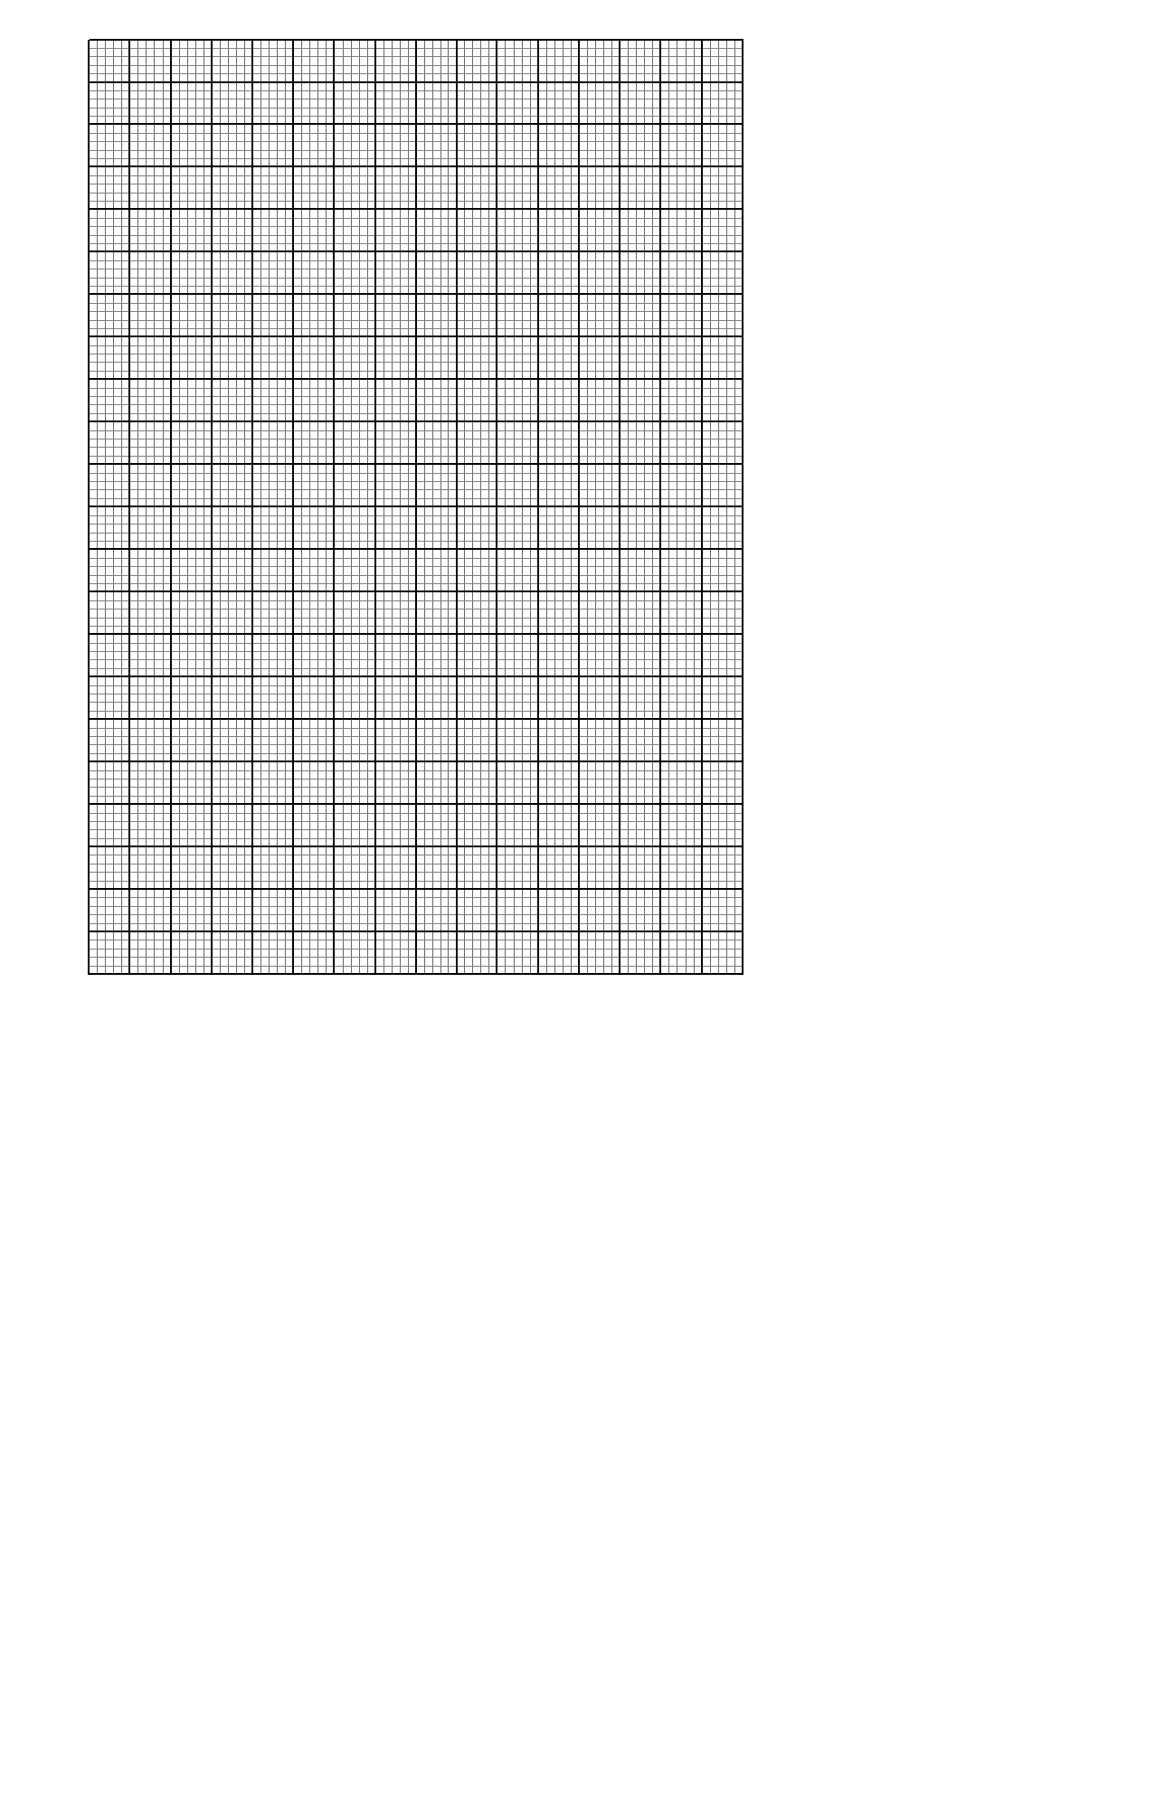

b). find the gradient of the line draw in a) above (1mk)

- If A’ (1,4) is the image of A (1,-2) under an enlargement scale factor $-\frac{1}{2}$ . calculate the centre of enlargement. (3mks)

- Solve the inequality $2x+3>5x-3>-8$ and represent the solution on a number line $.$ (3mks)

SECTION II (50 marks)
Answer any five questions in this section in the spaces provided.

- The probability that David goes to town is $\frac{1}{5}$. If he goes to town, the probability that he will read a newspaper is $\frac{3}{4}$. If he does not go to town, the probability that he will read a newspaper is $\frac{1}{3}$.

- Draw a tree diagram to represent the above information. (2mks)

- Find the probability that;

- David will go to town and read a newspaper. (2mks)

- David will not go to town yet he will read a newspaper. (2mks)

- David will read a newspaper. (2mks)

- David will not read a newspaper. (2mks)

18. In the figure below OJKL is a parallelogram in which OJ = 3p and OL = 2r

L K

2r

O 3p J
a) If A is a point on LK such that LA = ½ AK and point B divide the line JK externally in the ratio 3:1, express OB and AJ in terms of p and r. (2mks)

b) Line OB interests AJ at X such that OX = mOB and AX = nAJ.
i) Express OX in terms of p, r and m. (1mk)

ii) Express OX in terms of p, r and n (1mk)

iii) Determine the value of m and n. (4mks)

- Determine the ratio in which point x divides line AJ. (2mks)

19. The following table shows the distribution of marks obtained by 50 students in a test.

Marks | 45 - 49 | 50 -54 | 55 -59 | 60 - 64 | 65 -69 | 70 -74 | 75 - 79
No. of students | 3 | 9 | 13 | 15 | 5 | 4 | 1

(a). Draw a cumulative frequency curve on the grid below. (4mks)
(b). From the graph determine;

- Median mark (1mk)

- Quartile deviation (3mks)

- If the pass mark was 52, determine the percentage of students who passed the exam.
(2mk
20. The vertices of a rectangle ABCD are: A(0.2). B(0,4), C(4,4) and D(4,2).The vertices of its image under a transformation T are; A'(0,2). B'(0.4). C'(8,4) and D'(8,2).
(a) (i) On the grid provided, draw the rectangle ABCD and its image A'B'C'D' underT. (2mks)

(ii)Describe fully the transformation T. (2mks)

(iii) Determine the matrix of transformation. (3mks)

b) On the same grid as in (a), draw the image of rectangle ABCD under a shear with line x=-2 invariant and A(0,2) is mapped onto A”(0,0). (3mks)

21. In the figure below (not drawn to scale). AB = 9 CM, AC =7 CM, AD = 8 CM, CD =2.5 CM and <CAB = 50$°$

D

2.5 CM
C
8CM
7CM

$50°$
B
A
9 CM

Calculate to 2 d.p;

a) The length BC (3mks)

b) The size of <ABC (2mks)

- The size of <CAD (3mks)

- The area of triangle ACD (2mks)

22. The first term of an Arithmetic Progression (A.P.) with six terms is p and its common difference is c. Another A.P. with five terms has also its first term as p and a common difference of d. the last terms of the two Arithmetic Progressions are equal.
a) Express d in terms of c. (3mks)

b) Given that the 4th term of the second A.P. exceeds the 4th term of the first one by 1 ½ , find the value of c and d. (3mks)

c) Calculate the value of p if the sum of the terms of the first A.P. is 10 more than the terms of the second A.P. (4mks)

.

23. The income tax rates of a certain year were as shown in the table below:

Monthly taxable income in Kenya shillings(Ksh) | Tax rate percentage(%) in each shilling
0 to 9680 | 10
9681 to 18800 | 15
18801 to 27920 | 20
27921 to 37040 | 25
37041 and above | 30
In that year, Shaka's monthly earnings were as follows:

Basic salary Ksh 28 600
House allowance Ksh 15000
Medical allowance Ksh 3 200
Transport allowance Ksh 540

Shaka was entitled to a monthly tax relief of Ksh 1056.

(a) Calculate the tax charged on Shaka's monthly earnings. (6mks)

(b) Apart from income tax, the following monthly deductions were made; a Health Insurance fund of Ksh 500, Education Insurance of Ksh 1 200 and 2% of his basic salary for widow and children pension scheme. Calculate Shaka's monthly net income from his employment. (4mks)

24. Three quantities X, Y and Z are such that X varies directly as the square root of Y and inversely as the fourth root of Z. When X=64, Y=16, Z=625

(a) Determine the equation connecting X, Y and Z. (4mks)

(b)Find the value of Z when Y=36 and X=160. (2mks)

(c) Find the percentage change in X when Y is increased by 44%. (4mks)

