CaSPA ELDORET DIOCESE
NAME…………………………………………..……CLASS:…………ADM………

CANDIDATE’S SIGN………….……
232/3
PHYSICS
PAPER 3
(PRACTICAL)
JULY/AUGUST, 2024
TIME: 2½ HOURS

END OF TERM TWO 2023 EXAMINATION

Kenya Certificate of Secondary Education
PAPER 3
(PRACTICAL)
TIME: 2½ HOURS

INSTRUCTIONS TO CANDIDATES:
1. Write your name and index number in spaces provided above.
2. Sign and write the date of examination in spaces provided above.
3. Answer all the questions in spaces provided in the question paper.
4. You are supposed to spend the first 15 minutes of 2½ hours allowed for
this paper reading the whole paper carefully before commencing the work.
5. Marks are given for clear record of the observations actually made, their
suitability, accuracy and the use made of them.
6. Candidates are advised to record their observations as soon as they are made.
7. Non-programmable silent electronic calculators Mathematical table may be used.

FOR EXAMINER’S USE ONLY
Question 1
Section | A | B
Maximum score
Candidate’s score

Question 2
Section | A | B
Maximum score
Candidate’s score

Question 1
Part A
You are provided with the following:
- Two new dry cells.
- A cell holder.
- A wire mounted on a metre rule labeled G.
- A nichrome wire labeled R.
- A voltmeter (0-3V).
- An ammeter (0-1A).
- A switch.
- 7 connecting wires with a crocodile clip at one end.
- Glass rod
PART A
Proceed as follows:
- Wind the wire labeled R on the glass rod as shown in figure 2 below.
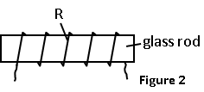

- Starting with the switch open connect the circuit as shown in figure 3 below.

R
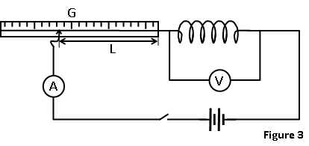

- Close the switch S and place the crocodile clip in contact with the resistance wire such that the length L = 0.0 m. Record the corresponding voltmeter and ammeter reading in table 2.

(d) Repeat step (c) above for other values of L and complete table 2. (4mks)

Table 1
L (m) | 0.0 | 0.2 | 0.4 | 0.6 | 0.8
I (A)
P.d (V)

- Plot a graph of I against p.d (x-axis) on the grid provided below.(5mks)


(f) From the graph, determine
(i) The slope S of the graph. (3mks)

PART B
Now rearrange and Proceed as follows;
- using the micrometer screw gauge determine the diameter D of the wire PQ

D = ………………………..m (1mk)

Determine the cross sectional area A of the wire given that,
$A=\frac{πD^{2}}{4}$ (2mks)

- set up the circuit as shown below
Q
A
V
l
Resistance wire
P

- With the switch open record the reading of the voltmeter E.

E ………………………………………… volts (1mk)
With the jockey at Q i.e L= 100cm, record the voltmeter reading (V) and the ammeter reading (I)
V = …………….volts (1/2 mk)

I = …………….. Amperes (1/2 mk)

- Determine R, given that, $R=\frac{V}{I}$ (1 mk)

- From Vr = (E – V) R, determine the value of r. (2mks)

Question 2
Part A
You are provided with the following apparatus
  - One test tube
  - One 10ml measuring cylinder
  - A piece of string
  - A ½ metre rule and electronic beam balance.
  - One retort stand
  - One boss and a clamp
  - A plasticine

- Proceed with the experiment as follows
- Record the mass ‘m’ of the test tube indicated on the side by a sticker label

M=…………………………………………………………g (1mark)

- Clamp the boiling tube vertically with its base resting on a flat surface. Pour 2cm³ of water from the measuring cylinder into the boiling tube.

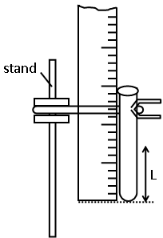

Record the length ‘L’ of the water column in the test tube in the table below. Repeat with values of V=2cm³ and V=4cm³ (2marks)

Volume V (cm³) | Length L (cm)
2 | L₁=
4 | L₂₌

(iii)Measure the length L_{o}, of the test tube

L_{O}=……………………………………………………………………cm (1mark)

- Wind the cotton thread round the test tube. The turns should touch one another but must not overlap. Count the number of turns and record.

n=………………………………………………………………………... turns (1mark)

(v)Unwind the cotton thread of n turns and measure its length

L_{T} =………………………………………………………………………….cm (1mark)

(vi) Calculate the quantity V of the glass material of which the test tube is made using the formula
$\frac{V}{LO}$ $=\frac{0.08{L_{T}}^{2}}{n}$ (3marks)

(C)Roll the plasticine to form a spherical ball that can freely enter the test- tube measure its mass and record.
M_{o}=…………………………………………………g

M_{o}=…………………………………………………Kg (1mark)

(d) Empty the test tube and put$\frac{1}{ 2}$ of water from the measuring cylinder into the test tube. Measure and record the length , L_{3.}

L₃₌………………………………………………………… cm (1marks)

(e) Carefully slide the ball into the test tube and record the new length, L₄

L₄=…………………………………………………………………….cm (1mks)

(g) Determine the density, of the plasticine ball given that
(3marks).
$ρ=\frac{Mo}{L4-L3}$

PART B
You are provided with:
. a metre rule
. a 100g mass
. a piece of celtape.
. a wedge.
Determine
- Arrange the apparatus as shown. With the pivot at the 30 cm mark, Let the metre rule balance horizontally as shown below.
d1
d2
c.o.g
W
100g

d₁ =..................................................................................... (mk)

d₂ =.................................................................................... (1 mk)
Use your measurements to determine the weight, W of the metre rule. (2mks)

- The spring constant K using the 100g mass
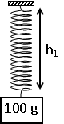
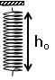

h_{o}=……………………cm(length of the spring) ( ½ mk)

h=..........................cm (length of the spring holding 100g mass )( ½ mk)

Hence determine the spring constant K(2mks)
Given that (where m is the mass in grams) -END-

