NAME……………………………………………CLASS:………………ADMNO………

232/2 CANDIDATE’S SIGN………….……
FORM 4 PHYSICS
PAPER 2 (THEORY)

JULY/AUGUST 2024
TIME: 2 HOURS

Kenya Certificate of Secondary Education
FORM 4 PHYSICS
PAPER 2
(THEORY)
TIME: 2 HOURS

INSTRUCTIONS TO THE CANDIDATE:
(a) Write your name and index number in the spaces provided above.
(b) Sign and write the date of examination in the spaces provided above.
(c) This paper consists of two Sections A and B.
(d) Answer all the questions in sections A and B in the spaces provided.
(e) All working must be clearly shown in the spaces provided.
(f) Mathematical tables and electronic calculators may be used.

FOR EXAMINER’S USE ONLY:
Section | Question | Maximum  Score | Candidate’s  Score
A | 1 – 11 | 25
 | 12 | 12
 | 13 | 12
B | 14 | 9
 | 15 | 11
 | 16 | 11
Total Score |  | 80

SECTION A: (25 MARKS)
- Figure 1 below shows a ray of light incident on a plane mirror
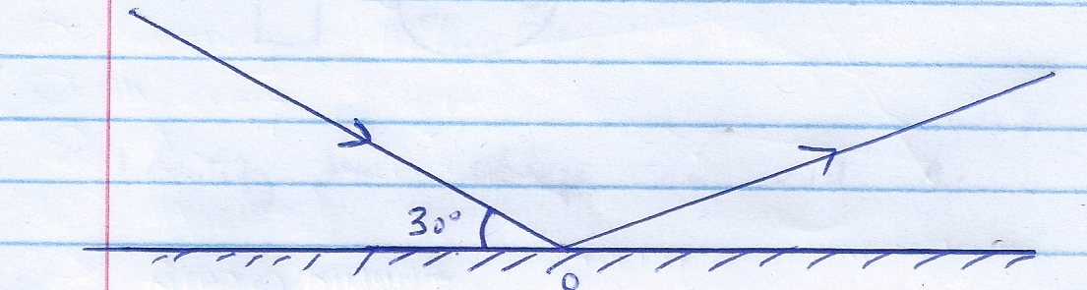

The mirror is then rotated 10⁰ clockwise about point o, with the path of incident ray remaining unchanged, what is the new angle of reflection. (2mks)
............................................................................................................................................................................................................................................................................................................................................................................................................................................................................................................................................................................................

- A house has two 100 w bulbs, three 60w bulbs and one 30w bulb. Determine the cost of having all bulbs switched on for 10 hours, given that the cost of electricity is Ksh. 0.95 per kilowatt hour. (3mks)
....................................................................................................................................................................................................................................................................................................................................................................................................................................................................................................................................................................................................................................................................................................................................................................
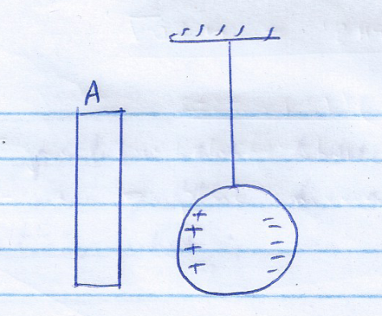
- Figure 2 shows a charged rod which is close to a metal sphere.

Identify the charge on rod A. (1mk)
..............................................................................................................................................................................................................................................................................................

- Figure 3 shows part of electromagnetic spectrum.
Gamma rays | P | Ultra-violet | Q | Infra red

(a) Identify radiation p (1mk)
..............................................................................................................................................................................................................................................................................................

(b) State two applications of radiation Q. (2mks)
............................................................................................................................................................................................................................................................................................................................................................................................................................................................................................................................................................................................

(c) Compare the frequency of P to that of Q (1mk)
..............................................................................................................................................................................................................................................................................................

- The half life of a certain radioactive element is 15 hours, if at time, t =0 the mass of the element is 640 g, what mass is left after 5 days? (3mks)
........................................................................................................................................................................................................................................................................................................

- A pendulum bob takes 0.5 seconds to move from its mean position to a maximum displacement position. What is the periodic time of the pendulum? (2mks)
............................................................................................................................................................................................................................................................................................................................................................................................................................................................................................................................................................................................
- Distinguish between real and virtual images. (1mk)
........................................................................................................................................................................................................................................................................................................

- Explain using domain theory of magnetism how hammering demagnetizes a magnet. (2mks)
...............................................................................................................................................................................................................................................................................................................................................................................................................................................................................................................................................................................................................
- A transformer connected to 240V a.c supply is used to supply power to three identical bulbs each rated 24W, 12V in a lighting circuit.
Calculate:
(a) The turns ratio (2mks)
............................................................................................................................................................................................................................................................................................................................................................................................................................................................................................................................................................................................
(b) The efficiency of the transformer, if the current from the power supply is 0.75A. (2mks)
............................................................................................................................................................................................................................................................................................................................................................................................................................................................................................................................................................................................
- What is meant by “doping” as used in the process of making semiconductors (1mk)
..........................................................................................................................................................................................................................................................................................................................................................................................................................................................
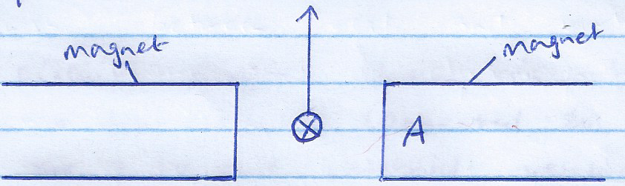
- Figure 4 shows a conductor carrying current in a magnetic field.

(a) If the conductor experiences a force in the direction shown, identify pole A of the magnet. (1mk)
(b) State one way of increasing the force experienced by the conductor (1mk)
........................................................................................................................................................................................................................................................................................................
SECTION B:
- (a) What is meant by the term electrical resistance? (1mk)
........................................................................................................................................................................................................................................................................................................
(b) State two factors that affect electrical resistance of a metallic conductor. (2mks)
.........................................................................................................................................................................................................................................................................................................................................................................................................................................................................................................................................................................................................................................................................................................................................................................................................................................................................................................................................................................................................................................
(c) The circuit diagram shown in figure 5 shows three resistors connected to a cell of emf 12 v .
12V
1Ω
2 Ω
4Ω
A B

Calculate
(i) The effective resistance in the circuit. (3mks)
..........................................................................................................................................................................................................................................................................................................................................................................................................................................................................................................................................................................................................................................................................................................................................................................................................................................................................................
(ii) The current flowing in the circuit. (2mks)
..........................................................................................................................................................................................................................................................................................................................................................................................................................................................................................................................................................................................................................................................................................................................................................................................................................................................................................
(iii) The potential difference (p.d) across points A and B (2mks)
..........................................................................................................................................................................................................................................................................................................................................................................................................................................................................................................................................................................................................................................................................................................................................................................................................................................................................................

(iv) Current through the 4Ω resistor. (2mks)
..............................................................................................................................................................................................................................................................................................
- (a) Distinguish between photoelectric effect and thermionic emission. (1mk)
............................................................................................................................................................................................................................................................................................................................................................................................................................................................
(b) State one property of x-ray which is:
(i) Similar to that of cathode rays (1mk)
.............................................................................................................................................................................................................................................................................................................................................................................................................................................

(ii) Different to that of cathode rays. (1mk)
.............................................................................................................................................................................................................................................................................................................................................................................................................................................

(c) The graph below shows the variation of stopping potential with frequency of radiation on a certain metal surface.
0
2
4
6
8
10
2
4
3
1
f x 10¹⁴ Hz
V_{S} (v)

From the graph, determine:
(i) The threshold frequency (1mk)

(ii) Planck’s constant, h given that the equation of the graph is hf=hf₀+ev_{s} where f is the frequency of radiation, f₀ is the threshold frequency, (4mks)
.............................................................................................................................................................................................................................................................................................................................................................................................................................................
.............................................................................................................................................................................................................................................................................................................................................................................................................................................
.............................................................................................................................................................................................................................................................................................................................................................................................................................................

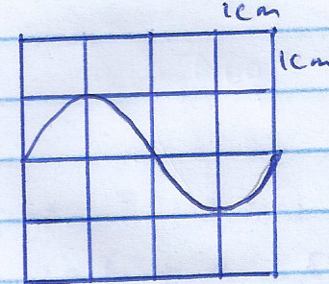
(d) Figure 6 shows the pattern produced by an A.C voltage on a cathode ray oscilloscope (CRO) screen.

Given that time base setting is 50ms/cm and y- gain calibration is 5 v/cm, determine;
(i) Peak – to – peak voltage of the y- input (1mk)
............................................................................................................................................................................................................................................................................................................................................................................................................................................
(ii) Frequency of the a.c signal (3mks)
............................................................................................................................................................................................................................................................................................................................................................................................................................................
............................................................................................................................................................................................................................................................................................................................................................................................................................................
- (a) Classify the following waves either as longitudinal or transverse waves; sound waves, light waves, water waves.
(i) Longitudinal waves (1mk)
............................................................................................................................................................................................................................................................................................................................................................................................................................................
(ii) Transverse waves. (2mks)
............................................................................................................................................................................................................................................................................................................................................................................................................................................
(b) Figure 7 shows waves formed on a slinky spring.
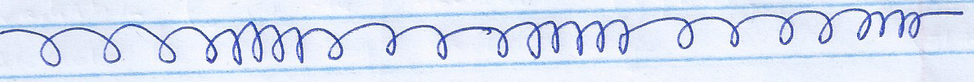

Indicate in the diagram, the distance equal to one wavelength, () (1mk)

(c) A certain radio station broadcasts at a frequency of 100MHz. Determine the wavelength of the waves if the speed of the waves is 3.0 x10⁸m/s. (3mks)
............................................................................................................................................................................................................................................................................................................................................................................................................................................
............................................................................................................................................................................................................................................................................................................................................................................................................................................

(d) Figure 8 shows straight waves in deep water approaching a shallow region
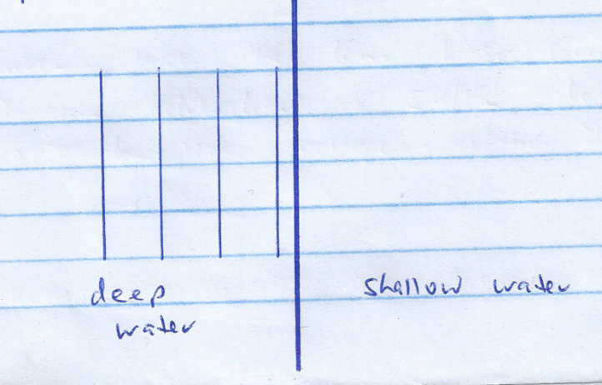

(d) Sketch the appearance of the waves in the shallow region. (2mks)

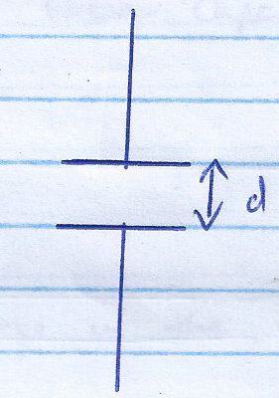
- (a) Figure 9 shows a parallel plate capacitor.

State two ways of increasing the capacitance of the capacitor. (2mks)
................................................................................................................................................................................................................................................................................................................................................................................................................................................................................................................................................................................................................(b) You are provided with three capacitors each of capacitance 2. Draw a diagram to show how you would connect all the three capacitors to give a combined capacitance of 3. (Show your working) (2mks)
........................................................................................................................................................................................................................................................................................................................................................................................................................................................................................................................................................................................................................................................................................................................................................................................................................................................................................................................
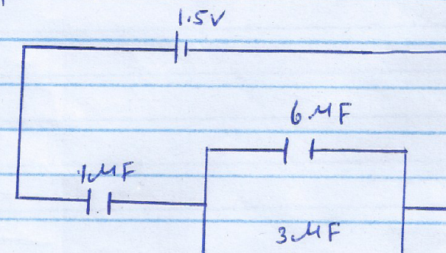
(c) Figure 10 shows three capacitors connected to a cell of emf 1.5v.

Calculate
(i) The effective capacitance. (3mks)
................................................................................................................................................................................................................................................................................................................................................................................................................................................................................................................................................................................................................
(ii) The total charge in the circuit. (2mks)
................................................................................................................................................................................................................................................................................................................................................................................................................................................................................................................................................................................................................
(iii) The charge across the 6 capacitor (2mks)
................................................................................................................................................................................................................................................................................................................................................................................................................................................................................................................................................................................................................
- (a) What is meant by the term refraction of light. (1mk)
................................................................................................................................................................................................................................................................................................................................................................................................................................................................................................................................................................................................................
(b) Figure 11 shows a ray of light travelling from glass to air.
Air
Glass
Ray
i

Given that the refractive index of glass is 1.5, determine angle, i. (3mks)
................................................................................................................................................................................................................................................................................................................................................................................................................................................................................................................................................................................................................................................................................................................................................................................................................................................................................................................................................................................................................................................................................................................................................................................................................................
(c) The figure below shows a ray of white light incident on a glass prism.
^{Violet}
Red
White light

What difference will be observed if monochromatic light is used instead of white light? (1mk)
................................................................................................................................................................................................................................................................................................................................................................................................................................................................................................................................................................................................................
(d) A convex lens produces a real image of an object which is half the size of the object, the distance between the object and the image is 60 cm. Calculate:
(i) The object distance (4mks)
................................................................................................................................................................................................................................................................................................................................................................................................................................................................................................................................................................................................................................................................................................................................................................................................................................................................................................................................................................................................................................................................................................................................................................................................................................
(ii) The focal length of the lens. (2mks)

-END

