CaSPA ELDORET DIOCESE

Name: Adm No: class: …………

Signature: Date:

232/1
Physics Paper 1
July/August 2024
Time: 2 Hours

Instructions to candidates:
- Write your name and index number in the spaces provided above.
- Sign and write the date of the examination in the spaces provided.
- Non – programmable silent electronic calculators may be used.
- This paper consists of 9 printed pages.
- Candidates should check the question paper to ascertain that all pages are printed as indicated and that no questions are missing.
- Candidates should answer the questions in English.

For Examiners Use Only

Question | Maximum Score | Candidate’s Score
SECTION A | 25
SECTION B
Q 12 | 10
13 | 12
14 | 12
15 | 10
16 | 11
TOTAL | 80

SECTION A – 25 MARKS
- The micrometer screw gauge represented by the figure 1 below has a zero error of 0.003cm.
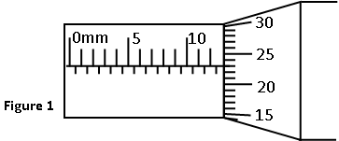

State the actual reading. (2marks)

- A stone was whirled round a horizontal circular path as shown in figure 2 below.

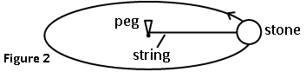

Name and indicate the forces acting on this stone. (2marks)

- Apart from length of conductor, state any other two factors affecting thermal conductivity in solids. (2marks)
……………………………………………………………………………………………………………………………………………………………………………………………………………………………………………………………………………………………………………………………………………………………………………………………………………………………………………………

- The figure 3 below shows 3 identical springs. If the mass of 1.2kg causes an extension of 4.5cm for the system. Determine the spring constant for one spring. (3marks)
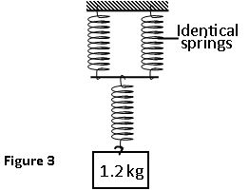

- The water level in a burette is 40.6cm³. 50 drops of water each of volume 0.15cm³ was added to the water in the burette. What is the final burette reading? (3marks)

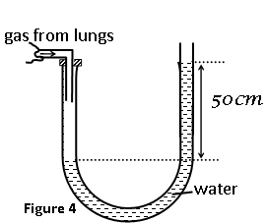
- The figure 4 below shows a U – tube manometer used to determine the lung pressure.

Determine the lung pressure given that atmospheric pressure is 1.03 × 10⁵ N/m² and density of water is 1000kg/m³. (3marks)

- Smoke particles are seen to move faster when the temperature inside the smoke cell is increased. Explain. (1mark)
………………………………………………………………………………………………………………………………………………………………………………………………………………………………………………………………………………………………………………………………………
- A farmer was advised to increase the stability of his milking jerry can. State two ways in which he will achieve that. (2marks)
………………………………………………………………………………………………………………………………………………………………………………………………………………………………………………………………………………………………………………………………………
- Explain why a car feels lighter as it travels at a higher velocity. (2marks)
………………………………………………………………………………………………………………………………………………………………………………………………………………………………………………………………………………………………………………………………………
- A bag of sugar is found to have the same weight on planet earth as an identical bag of dry saw dust on planet Jupiter. Explain why the masses of the two bags must be different. (1mark)
………………………………………………………………………………………………………………………………………………………………………………………………………………………………………………………………………………………………………………………………………
- a. Distinguish between elastic and inelastic collision. (1mark)
………………………………………………………………………………………………………………………………………………………………………………………………………………………………………………………………………………………………………………………………………
b. A 50g mass elastic ball moving on a horizontal surface at a velocity v collides with stationary wooden block of mass 500g. The ball bounces along the same path at a velocity of 1.5m/s while the block moves forward at a speed of 0.5m/s. Determine velocity v of the ball before collision. (3marks)

SECTION B (55 MKS)
- a) Define the term specific latent heat of vapourisation. (1mk)
………………………………………………………………………………………………………………………………………………………………………………………………………………………………………………………………………………………………………………………………………
b) In an experiment to determine specific latent heat of vapourisation, L_{v} of water, 100g of dry steam at 100⁰C is mixed with 2kg of water at 20⁰C in a well lagged calorimeter of mass 500g. After all the steam has condensed, the final steady temperature of the mixture is found to be 48.8⁰C. (Specific heat capacity of water and copper is 4200Jkg⁻¹k⁻¹ and 400Jkg⁻¹k⁻¹ respectively) Determine:
- Heat lost by steam at 100⁰C in condensing to water at 100⁰C. (Leave your answer in terms of L_{v}). (2marks)

- Heat lost by condensed water at 100⁰C on cooling to the final temperature. (2marks)

- Heat gained by water at 20⁰C and calorimeter. (2marks)

- Specific latent heat vapourisation of water, L_{v}. (3marks)

- a) Distinguish between distance and displacement. (1mark)
………………………………………………………………………………………………………………………………………………………………………………………………………………………………………………………………………………………………………………………………………
b) The tape in figure 5 below was produced by a ticker time with a frequency of 50H_{z}.
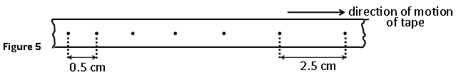

- Describe the motion of the velocity of the body. (1mark)
……………………………………………………………………………………………………………………………………………………………………………………………………
- Time between two successive dots. (1mark)

- Initial velocity of the body. (2marks)

- Final velocity of the body. (2marks)

- Acceleration of the body. (2marks)

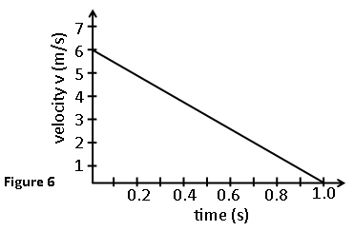
c) The figure 6 below shows the velocity – time graph of a ball bouncing vertically upwards from the ground

Determine the maximum height the ball reaches. (3marks)

- a) A body of mass 50kg was pulled up an inclined plane of length 20m with a stead speed.
The height of the vertical wall is 5m as shown in figure 7 below.
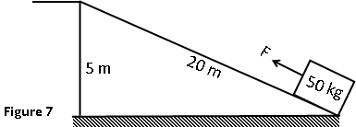

Given that the efficiency of the system is 80%. Calculate:
- The velocity ratio, V.R of the system. (2marks)

- The mechanical advantage of the inclined plane. (2marks)

- The force F applied on the body. (2marks)

- The work input of the system was found to be higher than the work output. Give a reason for this. (1mark)
………………………………………………………………………………………………………………………………………………………………………………………………………………………………………………………………………………………………………
b) The figure 8 below shows a hydraulic press supporting a load of F.
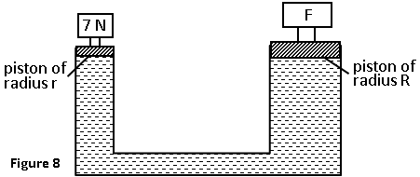

- Show that V.R = R² (3marks)
r²

- Determine the value of F if the M.A of the system is 100. (2marks)

- a) State the law of floatation. (1mark)
………………………………………………………………………………………………………………………………………………………………………………………………………………………………………………………………………………………………………………………………………
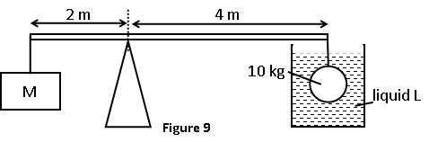
b) The figure 9 below shows a weightless plank with two masses suspended on it and balanced on a knife edge. A body of mass 10kg and density 4g/cm³ is fully submerged in a liquid of density 0.8g/cm³.

If the plank is at equilibrium, determine,
- The volume of the liquid displaced. (2marks)

- Upthrust due to the liquid. (3marks)

- Mass M of the object placed 2m from the support. (4marks)

- a) State what is meant by an ideal gas. (1mark)
………………………………………………………………………………………………………………………………………………………………………………………………………………………………………………………………………………………………………………………………………
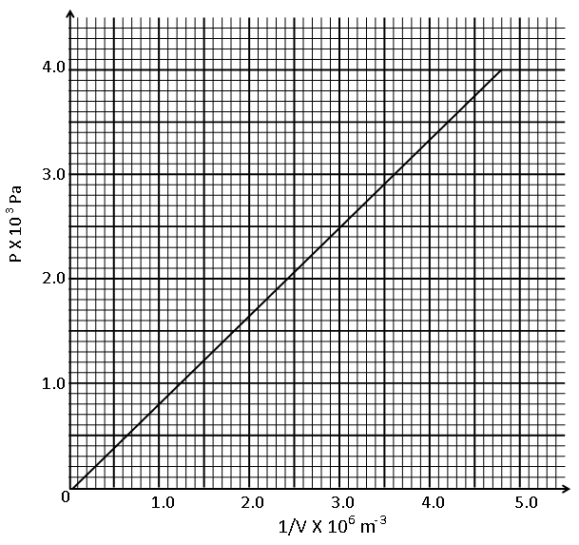
b) The pressure acting on a gas in a container was changed steadily while the temperature of the gas was maintained constant. The value of volume V of the gas was measured for various values of pressure. The graph in figure 10 below shows the relation between the pressure P and the reciprocal of volume, $\frac{1}{V}$

- Suggest the gas law that is being investigated in (b) above. (1mark)
…………………………………………………………………………………………………………………………………………………………………………………………………………

- Other than temperature, state any other quantity that is kept constant. (1mark)
………………………………………………………………………………………………………………………………………………………………………………………………………………………………………………………………………………………………………………
- Given that the relation between the pressure P and the volume V of the gas is given by PV = K where K is a constant. Using the graph, determine the value of K. (4marks)

c) Figure 11 below shows a set up used to verify a certain gas law.
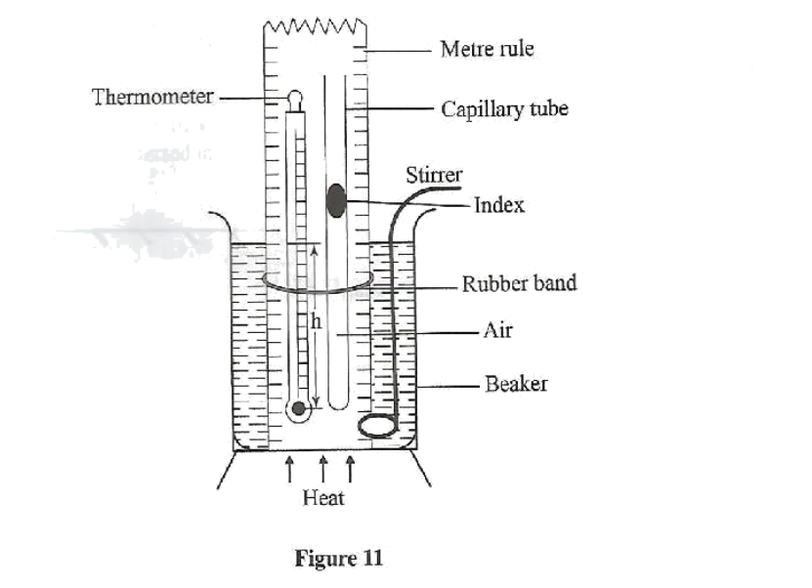
From the set up above describe an experiment to verify Charles’ law. (4marks)

END

