MURANG’A HIGH SCHOOL TRIAL EXAMINATION

231/ 2 - PHYSICS Paper -2
Time 2 hours

Name …………………………………………….……… Index Number…………………………..
Candidate’s Signature ………………….…...……….. Date ……………………………………
INSTRUCTIONS TO CANDIDATES
- Write your name, admission number and class in the spaces provided above.
- Sign and write the date of examination in the spaces provided above.
- This paper consists of TWO sections: A and B.
- Answer ALL the questions in sections A and B in the spaces provided.
- ALL working MUST be clearly shown.
- Non-programmable silent electronic calculators and KNEC mathematical tables may be used.
- Candidates should check the question paper to ascertain that all the pages are printed as indicated and that no questions are missing.
FOR EXAMINER’S USE ONLY:
Section | Question | Maximum  Score | Candidate’s  Score
A | 1 – 13 | 25
 | 14 | 07
 | 15 | 12
B | 16 | 12
 | 17 | 13
 | 18 | 11
Total Score |  | 80

Turn over
SECTION A (25 MARKS)
- Figure A and B are two conductors on insulating stands. Both A and B were initially uncharged. Conductor A is given the positive charge shown

x
Y
X
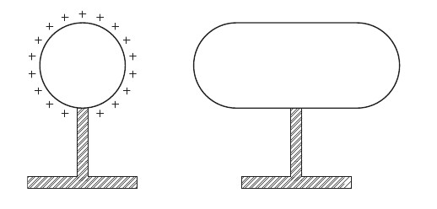
B
A

- Mark the signs of the charges induced at end X and at end Y of conductor B.
(1 mark)

- Explain how these charges are induced in No.1 (i) above (1 mark)
………………………………………………………………………………………………………………………………………………………………………………………………
- A student from Queens Of Peace Nembu lined up some permanent magnets with soft iron nails in between as shown in the diagram below

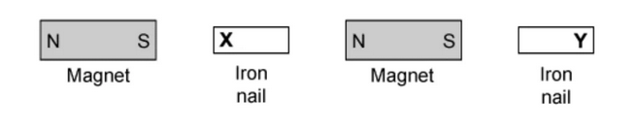

What would be the polarities of the poles marked X and Y (2 Marks)
X ………………………………
Y ………………………………
4. Figure 3 below shows a conductor in a uniform magnetic field carrying current in the direction shown.
Indicate on the diagram the direction of motion of the conductor. ( 1 mark) …………………………………………………………………………………………………………………………………………………………………………………………………………………………………………………………………………………………………….
- A person claps his hands at approximately 0.5s intervals in front of a wall 90m away. He notices that each echo produced by the wall coincides with the next clap. Calculate the approximate speed of sound (3mks)
………………………………………………………………………………………………………………………………………………………………………………………………………………………………………………………………………………………………
- A bulb is rated 100W, 240V. At what rate would it dissipate energy if it is connected to a 220V supply? (3 marks)
………………………………………………………………………………………………………………………………………………………………………………………………………………………………………………………………………………………………
- Determine the frequency of the wave shown below. (2 marks)
0.5
1.0
1.5
2.0
Time(s)
Displacement (m)

………………………………………………………………………………………………………………………………………………………………………………………………………………………………………………………………………………………………
- Why is a convex mirror better than plane mirror when used as a driving mirror? (1 mark)
………………………………………………………………………………………………………………………………………………………………………………………………………………………………………………………………………………………………
- Figure 6 below shows a cell of emf of 12V drives a current of 2A through R when the switch S₁ is open.
Calculate the internal resistance of the cells. (3 marks)
………………………………………………………………………………………………………………………………………………………………………………………………………………………………………………………………………………………………

- A negatively charged rod is brought rear the cap of a leaf electroscope. The cap is then earthed momentarily by touching with the finger. Finally the rod is withdrawn. State and explain the observation made. (2 marks)
………………………………………………………………………………………………………………………………………………………………………………………………………………………………………………………………………………………………
- The diagram shows a patient having her eyes tested. A chart with letters on it is placed behind her and she sees the chart reflected in a plane mirror.

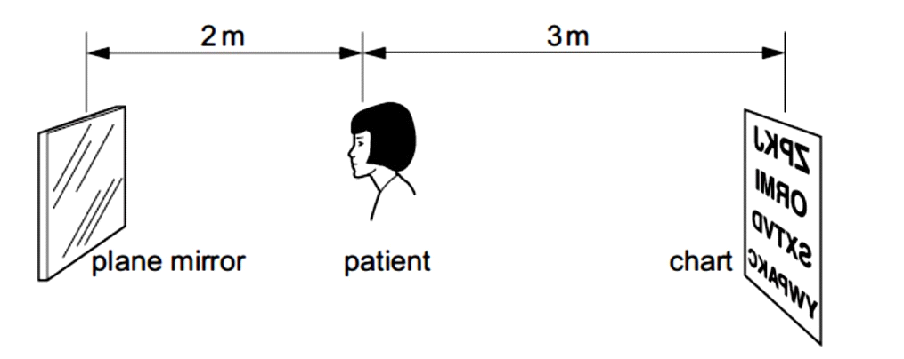

Determine how far away from the patient, the image of the chart is seen. (2 marks)

- Figure shows a motor connected to a magnetic switch called a relay operated by an ordinary switch S₁. Use the information in the figure to answer questions that follows:
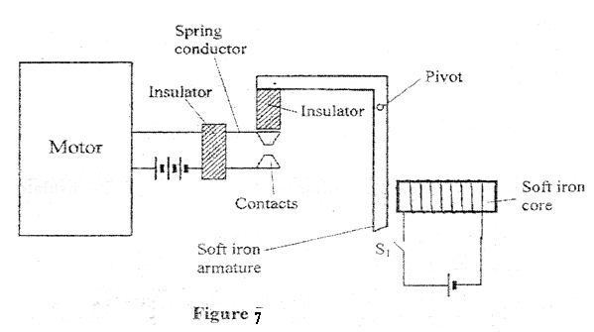

- Explain how the relay switches on the motor when S₁ is closed (2 marks)
……………………………………………………………………………………………………………………………………………………………………………………………………………………………………………………………………………………………………………………..

- State with a reason the effect on the motor if the iron core is replaced with a steel core and switch S₁ is put on and then off. (2 marks)
………………………………………………………………………………………………………………………………………………………………………………………………………………………………………………………………………………………………………………………
- A metal iron has work function of 6.8 x 10⁻¹⁹J. Calculate the minimum frequency of light that can cause photoelectric emission. (Take h = 6.63 x 10⁻³⁴ J (2 Marks)
…………………………………………………………………………………………………………………………………………………………………………………………………………………………………………………………………………………………………….
SECTION B (55 MARKS)
Answer all questions in this Section
- (a) Students From Keroka High school wanted to determine the focal length of a lens . They collected the following apparatus
- Mounted lens,
- Screen
- metre rule
- Candle

- Draw the apparatus set upo and describe how the set up may be used to determine the focal length f, of the lens. (5 marks)

- State why the set up would not work if the lens were replaced with a diverging lens.
(1 mark)
………………………………………………………………………………………………………………………………………………………………………………………………………………………………………………………………………………………………

- The figure below shows how an image is formed by a converging lens.

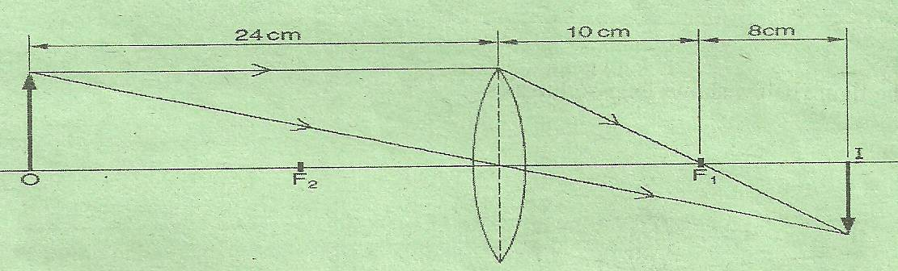

(i) State the value of the focal length of the lens. (1 mark)
…………………………………………………………………………………………………………………………………………………………………………………………………………………………………………………………………………………………………….
- Determine the magnification of the image produced. (2 marks)
………………………………………………………………………………………………………………………………………………………………………………………………………………………………………………………………………………

(b) The figure shows a glass lens in air and its two focal points F₁ and F₂.
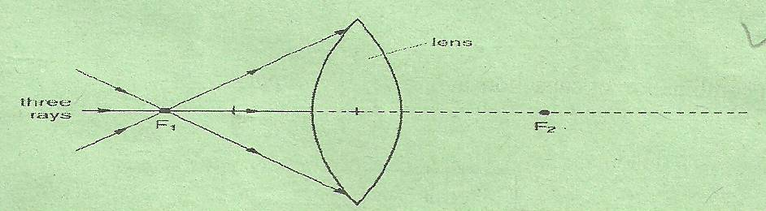
Three rays of light pass through F₁ to the lens.

- On the figure above show the path followed by the three rays through the lens and into the air. (1mark)
………………………………………………………………………………………………………………………………………………………………………………………………………………………………………………………………………………
(ii) State one possible causes of myopia . (1 mark)
…………………………………………………………………………………………………………………………………………………………………………………………………………………………………………………………………………………………………….
- State the type of lens that is used to correct myopia. (1 mark)

…………………………………………………………………………………………..
- Show the charge distribution on the hollow conductor shown below if it is positively charged. (1mk)

Insulator

b. State 2 factors affecting capacitance of a parallel plate capacitor. (2mks)
……………………………………………………………………………………………………………………………………………………………………………………………………………………………………………………………………………………………………………………………………………………………………………………………………………………

c) The diagram below shows a circuit containing three capacitors.
C₂
C₁
X Y
C₃

- Write an expression for effective capacitance between X and Y. (2mks)
…………………………………………………………………………………………………………………………………………………………………………………………………………………………………………………………………………………………………………………………………………
i i) If c₁=6µF, c₂=4.5µF and c₃=5 µF, calculate the charge stored when point XY is connected in series with a battery of 6V (3mks)
…………………………………………………………………………………………………………………………………………………………………………………………………………………………………………………………………………………………………………………………………………………………………………………………………………
d) The graph below shows the relationship between the voltage drop across a certain capacitor and the charge stored in the capacitor.

2
4
6
8
0
5
10
15
20
Charge (C)
Potential difference (V)
From the graph calculate the capacitance of the capacitor. (3mks)
……………………………………………………………………………………………………………………………………………………………………………………………………………………………………………………………………………………………………….

- a) State the conditions to be satisfied for total internal reflection to occur (2mks)
………………………………………………………………………………………………………………………………………………………………………………………………………………………………………………………………………………………………………………………………………………………………………………………………………………………………………………………………………………………………………………………………………………………………………………………………………………
- A ray of light travelling in the air enters a rectangular glass block at an angle of 30º face AB.
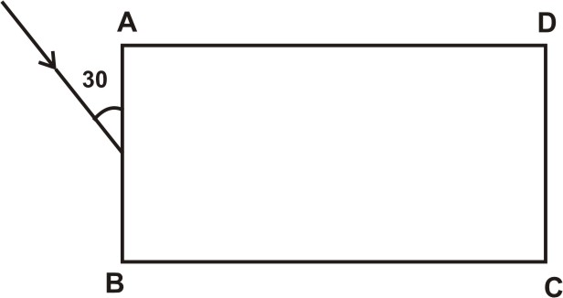

If the refractive index of the glass is 1.5, find;
- The angle of refraction in the glass block (3mks)

- The critical angle of the glass block (3mks)

- In the same diagram, complete the diagram to show the path of light through and out of the glass bloc (2mks)

- (a) State Ohm’s law. (l mk)
…………………………………………………………………………………………………………………………………………………………………………………………………………………………………………………………………………………………………….
(b) A wire was connected to a battery and it was found that the energy converted to heat 30J when20C of charge flowed through the wire in 5 seconds. Calculate.
  - the p.d between the ends of the wire (2mks)
………………………………………………………………………………………………………………………………………………………………………………………………………………………………………………………………………………………

(ii) the current flowing through the wire. (2mks)
…………………………………………………………………………………………………………………………………………………………………………………………………………………………………………………………………………………………………….
(iii) the resistance of the wire. (2mks)
…………………………………………………………………………………………………………………………………………………………………………………………………………………………………………………………………………………………………….
(iv) the average power development in the wire. (2mks)
…………………………………………………………………………………………………………………………………………………………………………………………………………………………………………………………………………………………………….

(c) The graph below shows results obtained in an experiment to determine the e.m.f.(E) and the internal resistance, r, of a cell.

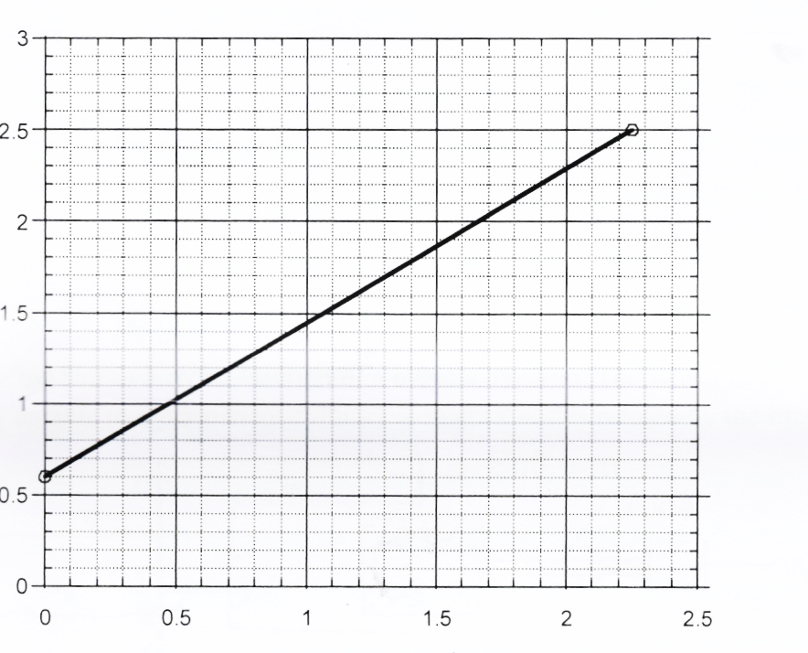

¹/_{V} (V⁻¹)

¹/_{R} (Ω⁻¹)

E
V
r
R
Given that the equation of the graph is = + I

Use the graph to determine the values of:- (2 marks) (i) E
  - r
- The figure below shows a cathode ray tube
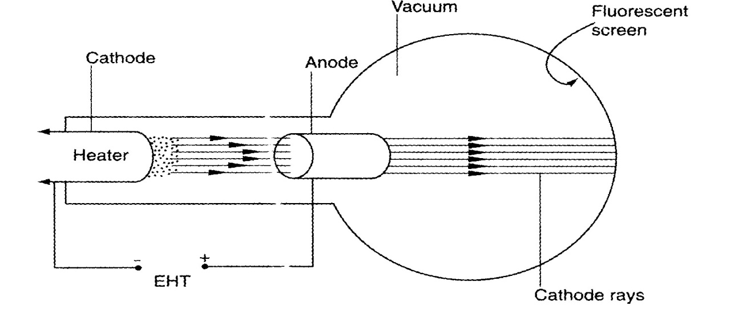

a) State the function of the
i) Heater (1mark)
........................................................................................................................................................................................................................................................................................................................
ii) Extra High Tension (E.H.T.) (1 mark) .......................................................................................................................................................................................................................................................................................................................
b) State how the intensity of the fluorescence on the screen can be increased. (1 mark)
......................................................................................................................................................................................................................................................................................................................... ..........................................................................................................................................................
c) State the effect of having air in the tube instead of a vacuum (1 mark)
.......................................................................................................................................................................................................................................................................................................................
d) State one properties of cathode rays (1 mark)
........................................................................................................................................................................................................................................................................................................................
e) Distinguish cathode rays and X-rays (1 mark)
................................................................................................................................................................................................................................................................................................................................................................................................................................................................................................................................................................................................................................................
f) Give one advantages of using a C.R.O instead of a voltmeter in measuring voltages
(1 mark)
.......................................................................................................................................................................................................................................................................................................................
g) The figure below shows an a.c. voltage. If the Y-gain control reads 10V/cm and the time base reads 5 milliseconds/cm
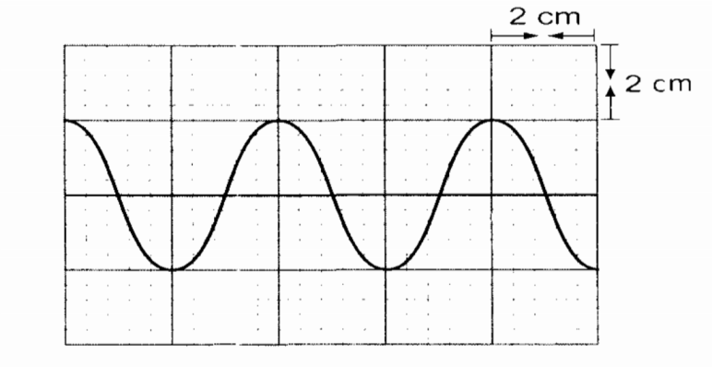
Calculate:
i) The frequency of the alternating voltage (2 marks)
.......................................................................................................................................................................................................................................................................................................................
ii) Peak to peak voltage of the alternating (2 marks)
........................................................................................................................................................................................................................................................................................................................

THIS IS THE LAST PAGE PRINTED

