NAME: ………………………………………..…CLASS:….…ADM NO:…………
SIGNATURE:……………………………INDEX NO:……………………………

232/1
PHYSICS
PAPER 1
MARKING SCHEME


KISII SCHOOL MOCK EXAM 2024
Instructions to candidates

- This paper consists of two sections A and B.
- Answer all the questions in the two sections in the spaces provided after each question
- All working must be clearly shown.
- Electronic calculators, mathematical tables may be used.
- All numerical answers should be expressed in the decimal notations.

SECTION | QUESTION | MAX MARKS | CANDIDATE’S SCORE
I | 1 – 10 | 25
II | 11 | 13
 | 12 | 10
 | 13 | 08
 | 14 | 12
 | 15 | 12
TOTAL |  | 80

This paper contains 12 printed pages.
Ensure that you have all the pages, all of them printed.

SECTION A (25 MARKS)

Attempt all the questions in the spaces provided.

1.State the name of the instrument used to take the following readings;
(i) 0.035m (1mk)
Metre rule
(ii) 0.00245m (1mk)
Micrometer screw gauge
2.A vernier caliper which had an error of 0.02cm was used to measure the diameter of a spherical marble. If the actual diameter was 3.67cm, draw a vernier caliper scale showing its reading (2mks) 3.67+0.02= 3.69cm

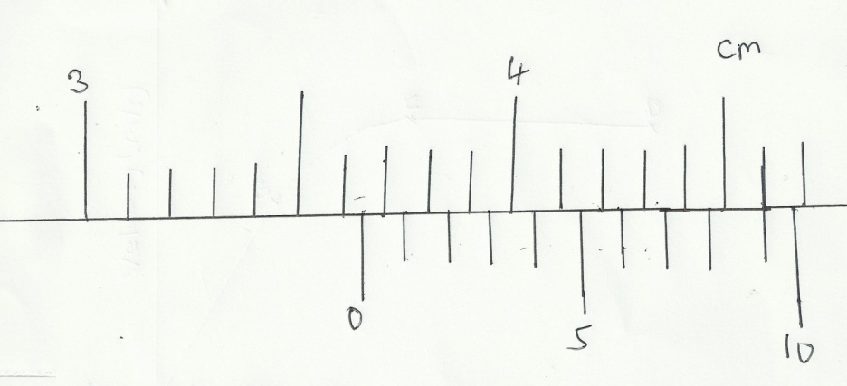
3. Fifty drops of oil have a volume of 1.0cm³.If a drop of oil forms an oil patch of diameter 20cm,determine the size of the oil molecule.(2mks)

50 drops 1.0cm³ V=Ah
1 drop ? 0.02=3.142$×10×10×h$
$\frac{1}{50}×1=0.02cm$³ $\frac{0.02}{314.2}$=6.365$×10$⁻⁵m
4. (a)State newton’s third law of motion. (1mk)
For every action,there is an equal and opposite reaction.
(b)A man whose mass is 70kg stands on a weighing machine.When the lift ascends with an acceleration of 2.45m/s²,w hat is the reading on the scale.( 2mks)
Reading$;=m\left( g+a\right)$
$70\left(10+2.45\right)$
$70×12.45=871.5N$
5.The figure below shows a sketch graph of velocity time graph for a body falling through a liquid. Explain the motion of the body between;
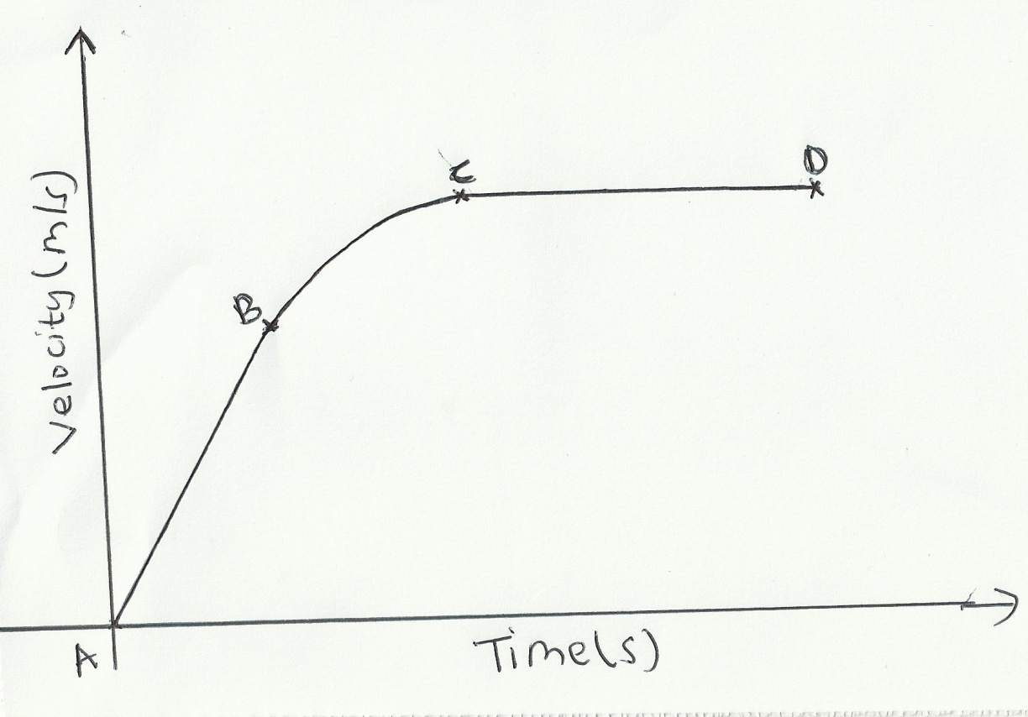
(a) A and B (1mk)
Constant acceleration (velocity is increasing uniformly) ($W>F+U$)
(b)B and C (1mk)
Decreasing acceleration ($W<F+U$)
(c) C and D (1mk)

Zero acceleration(constant velocity) ($W=F+U$)
The body has attained a terminal velocity.

6.In a faulty mercury-in-glass thermometer was found that the mercury level stands at 3 cm mark in the tube at 0⁰ C and 18 cm when in steam above boiling water at normal atmospheric pressure. Calculate the temperature when the mercury stands at 12 cm mark. (2mks)
100⁰C 18cm $\frac{18-12}{100-x}=\frac{18-3}{100-0}$ $600=1500-15x$

X 12cm $15x=900$
$\frac{6}{100-x}=\frac{15}{100}$ $x=60$⁰C
0⁰C 3cm

7.A balloon filled with argon gas of volume 200 cm³ at the earth’s surface where the temperature is 20⁰C, and the pressure 760mm of mercury. If it is allowed to ascend to a height where the temperature is 0⁰C and the pressure 100mm of mercury, calculate the volume of the balloon.(2mks)
V₁=200 cm³ $\frac{P_{1V_{1}}}{T_{1}}$=$\frac{P_{2V_{2}}}{T_{2}}$ V₂= $\frac{760×200×273}{293×100}$
T₁=20⁰C =293K
P₁=760mmHg
T₂=273K$\frac{760×200}{293}$=$\frac{100××V_{2}}{273}$ V₂=1416.25cm³
P₂=100mmHg

8.(a)The spiral springs shows in the figure below are identical. Each spring has a spring constant K = 300N/m .Each rod weighs 0.1N and each spring weighs 0.2N.

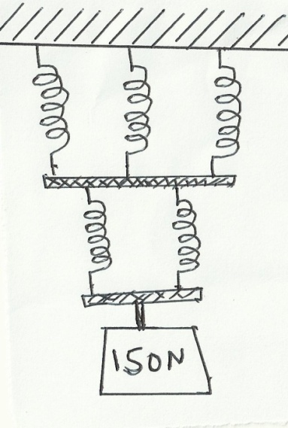
e₂
e₁

Determine the total extension caused by the 150N weight. (2mks)

e₁ =$\frac{75.05}{300}=0.2502m$
e₂ =$\frac{50.2}{300}=0.1673m$
e_{T}=$0.2502+0.1673=0.4175m=41.75cm$
(b) Apart from length of the spring and nature of material, state one other factor affecting the spring constant.(1mk)
The diameter of the spring, number of turns per unit length,thickness of the wire used to make the spring

9.State two conditions necessary for a body to be in equilibrium . (2mks)
- Sum of clockwise moments must be equal to sum of anticlockwise moments
- Sum of upward forces must be equal to sum of downward forces

10.(a) How does the position of the centre of gravity affect the stability of a body?(1mk)

The higher the centre of gravity,the lower the stability and the lower the centre of gravity, the more stable the body is.

(b)The figure below shows a uniform rod AE which is 40cm long. It has a mass of 2kg and pivoted at D. If 2N is acting at point E, and 30N force is passed through a frictionless pulley
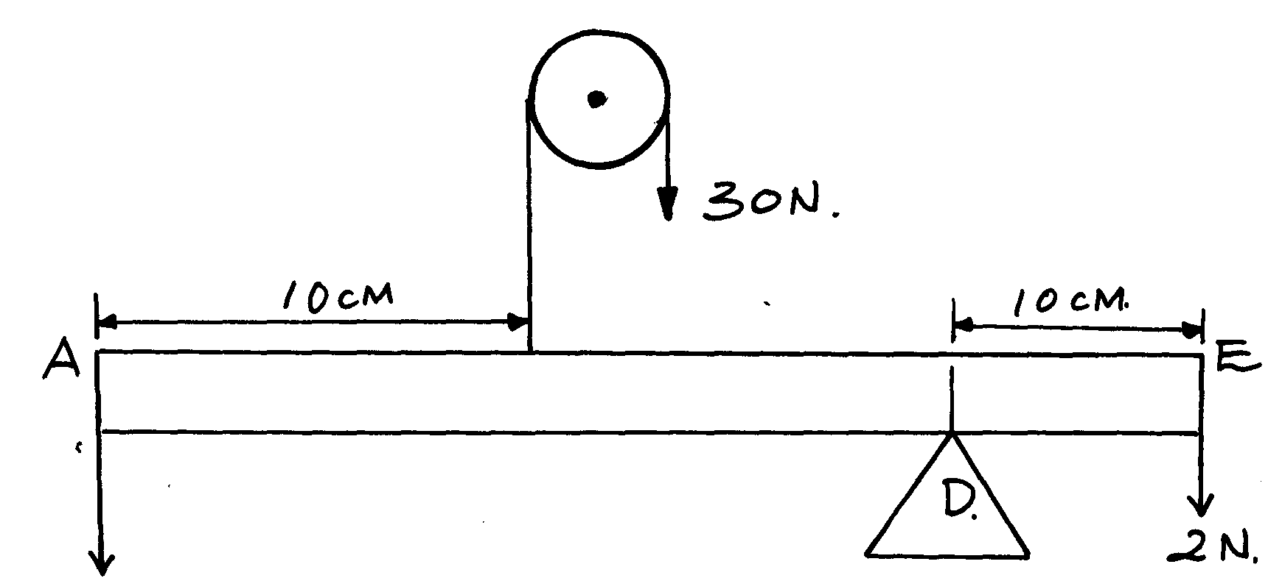

X

Find the force X acting at end A (3mks) actm = ctm
1
x(0.3) + 2.0 x 0.1 = (30 x 0.2) + 2 x 0.1
0.3x = 6.2 – 2.0
1
x = 14N
1

SECTION B (55 MARKS)
Attempt all the questions in this section.
11.(a)Sketch a block and tackle pulley system with three movable pulleys in the lower block and two fixed pulleys in the upper block. (2mks)
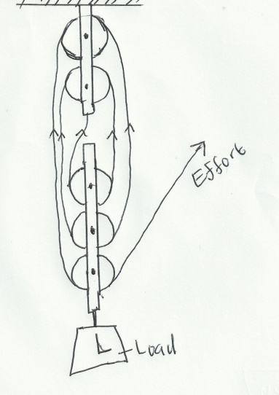
Find:
(b) (i)Velocity ratio (V.R.) (1mk)
V.R =Number of the ropes supporting the load = 6
1
(ii)An effort of 450 N is used to raise a load of 2400N.Determine:
- Mechanical advantage (M.A) (2mks)
1
$M.A=\frac{L}{E}=\frac{2400}{450}=5.333$
1
- Efficiency of the pulley system. (2mks)
$$\frac{M.A}{V.R}×100\%=$$
1
$\frac{5.333}{6}×100\%=88.88\%$
1
(iii)If all the wasted energy is used to raise the lower block and the frictional force between the pulleys and moving parts is 3.6N; determine the weight of the lower block. (3mks)
Wasted effort=$\frac{11.12}{100}×450=50.04N$
1
Frictional Force +wasted effort = Weight of lower block
1
1
3.6+50.04 =53.64 N
(c)If the load moved through a distance of 50cm, determine the useful work done by the effort. (2mks)
1
Load $×Load distance=2400×0.5=1200 J$
1

(d) James applied a force of 400N in pushing a stationery wall. If he took one hour to push the wall, calculate the power developed. (1mk)
$Power=\frac{work done}{time}=\frac{400×0}{3600}=0 J$
1
12(a)The figure below shows dots which were made by a ticker timer-tape attached to a trolley. The trolley was moving in the direction shown.
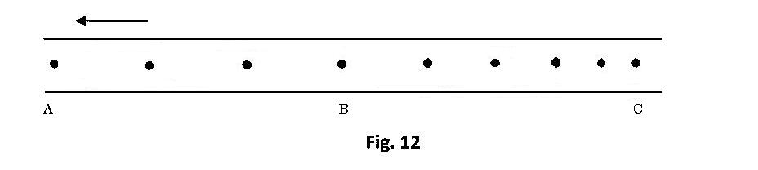
If the frequency used was 50 Hz, distance A$B=12cm and BC=7.2cm,$ determine
i) the velocities between AB and BC (2mks)
$$T=\frac{1}{f}=\frac{1}{50}=0.02sec$$
V_{AB}=$\frac{12}{0.06}=200cm/s$
1

V_{BC}=$\frac{7.2}{0.02×5=0.1}=72cm/s$
1

ii) the acceleration of the trolley. (2mks)
1

a=$\frac{v-u}{t}=\frac{200-72}{0.08}=\frac{128}{0.08}=1600cm/s^{2}$=16m/s²
1

(b) An object is released to fall vertically from height of 100m. At the same time another object is projected vertically upward with velocity of 40m/s.
(i) Calculate the time taken before the objects meet (3mks)
$s=\frac{1}{2}$gt² 0m/s
100$-x=\frac{1}{2}×10×t^{2}$ (100-x)m

100$-x=5t^{2}$……………….(i)
$x=40t-\frac{1}{2}×10×t^{2}$
1
X m
$x=40t-5t^{2}$…………………………..(ii)
$40t-x=5t^{2}$ 40m/s
$100-x=40t-x$
1
$$40t=100$$
$t=2.5s$
1

(ii) At what height do the objects meet? (1mk)
$x=40\left(25\right)-5(2.5)$²
$x=100-31.25=68.75m$
1
(c)State two assumptions that were made when deriving the equation of continuity. (2mks)
- Fluid is non-viscous any two
1
1
- Fluid is incompressible
- Flow is streamline/steady

13.(a) State Archimedes’ principle (1 mk)
When a body is partially or totally immersed in a fluid,it experiences an upthrust
equal to the weight of the fluid displaced.
1

(b)A block of length 50 cm, cross-sectional area of 5cm² and density 1.4 g/cm³ is completely immersed in a liquid of density 1.08 g/cm³ find
(i) The mass of the block (2 mks)

1
$$V=Ah=5×50=250{cm}^{3}$$
$m=ρ×V=1.4×250=350g or 0.350kg$
1

(ii) The weight of the block in the liquid. (3 mks)
$W=Mg=0.35×10=3.5N$
1
Upthrust = weight of liquid displaced=$ρ×V×g=1080×\frac{250}{1000 000}×10=2.7N$
1
Weight of the block in liquid=$3.5-2.7=0.8N$
1

(iii) The apparent loss in weight of the block if three quarter of it is immersed in
the liquid. (2 mks)
1
volume of water=$50×5×\frac{3}{4}=187.5cm$³ = volume of liquid displaced
1
weight of liquid displaced =$\frac{187.5×1080×10}{1000 000}=2.025N=Upthrust$
1
apparent loss in weight of the block=$3.5-2.025=1.475N$

14.(a)Define specific latent heat of fusion (1mk)
Quantity of heat required to change a unit mass ofa substance from solid to liquid at a constant temperature
1
(b)You are provided with the following apparatus:
A filter funnel, a thermometer, a stop watch, ice at 0°C, an immersion heater rated
P watts, a beaker, a stand, boss and clamp and a weighing machine.
Describe an experiment to determine the specific latent heat of fusion of ice. Clearly state the measurements to be made. (4mks)
  - Weigh the empty beaker and record its mass M_{o}
  - Switch the heater on for time t. Collect the melted water in the beaker and record the new mass M₁
  - Mass pf melted ice = M₁ – M_{o} 1
  - pt = (M₁ - M_{o})L 1
  - Determine the specific latent heat of fusion
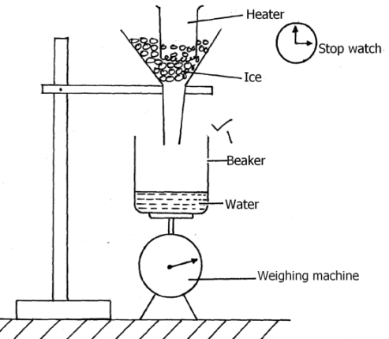

(c)200 g of ice at 0°C is added to 400g water in a well lagged calorimeter of
mass 40g.The initial temperature of the water was 40°C. If the final temperature of
the mixture is X°C,
(Specific latent of fusion of ice L = 3.36 x 10⁵ Jkg⁻¹, specific heat capacity of water,
c = 4200Jkg⁻¹K⁻¹, specific heat capacity of copper = 400 Jkg⁻¹K⁻¹.)
(i) Derive an expression for the amount of heat gained by ice to melt it and raise its
temperature to X°C (2mks)
Q = ML + McΔθ1
1
$$67200+420x$$
(ii) Derive an expression for the amount of heat lost by the calorimeter and its content
when their temperature falls to X°C. (2mks)
Q = M_{c}C_{c}Δθ + M_{w}C_{w}Δθ
1
(iii) Determine the value of X. (3mks)

Heat lost = heat gained
67200 + 420x = 67840 – 1696x 1
(420 + 1696)x = 67840 – 67200
2116x = 640 1
x = 0.293ºC 1
15.(a) The moon goes round the earth at constant speed. Explain why it is true to say that the moon is accelerating. (1 mark)
The direction is continuously changing.This implies change in velocity
hence acceleration.
1

(b) A string of negligible mass has a bucket tied at the end. The string is 60cm long and the buckets has a mass of 45g. The bucket is swung horizontally making 6 revolutions per second. Calculate:
(i) the angular velocity. (1 mark)
1
$$ω=2πf=2×3.142×6=37.704rad/s$$
(ii) the centripetal acceleration. (2 marks)
1
$a=\frac{v^{2}}{r}=rω^{2}=37.704×37.704×0.6=852.955m/s$²
1

(iii) the tension on the string. (2 marks)
1
1
$T=F$_{c}=$mrω$²$=0.045×0.6×37.704×37.704=38.38N$

(iv) the linear velocity. (1 mark)
$V=rω=0.6×37.704=22.62m/s$
1

(c)Figure 6 shows a body of mass;$m=200g$ attached to the centre of a rotating table with a string . The radius of the string was varied and different values of angular velocity recorded. The mass of the body remained constant throughout the experiment.
ω
r
String

fig.6
The results obtained for angular velocity and radius were used to plot the following graph;
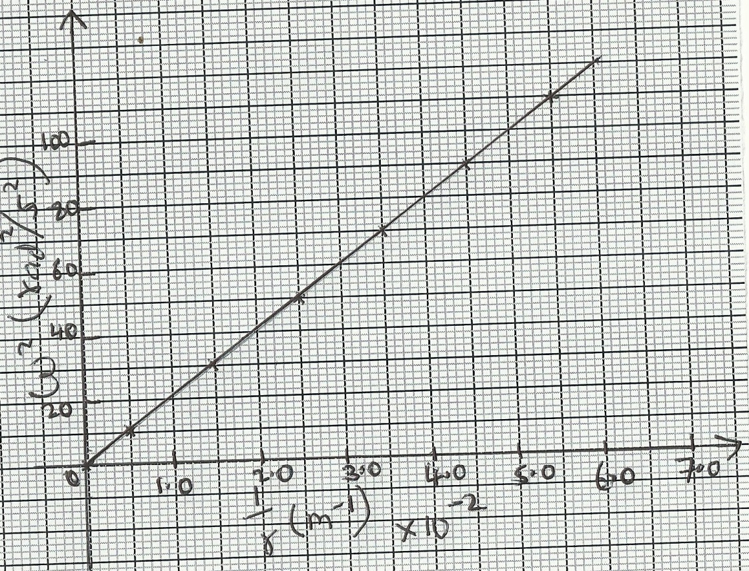
From the above graph;
(i)Calculate the value of the slope. (2mks)
1
$\frac{50-0}{2.5-0}=20.0N/Kg$
1
(ii)If $ω$² and $\frac{1}{r}$ are related by the equation; $ω$²$=\frac{p}{r}×\frac{1}{m}$ , find the value of P. (2mks)
$\frac{p}{m}=slope$
1
$p=m×slope=20×0.2=4.0N$
1

(iii)State the significance of P. (1mk)
It represents centripetal force
1

