

233/2
CHEMISTRY
PAPER 2
MARKING SCHEME

- a) P – 2.8.81
Y – 2.8 1
b) P occurs in molecules of two atoms covalently bonded out. These molecules are held by weak van der Waals ¹/₂ Forces. This atoms in Q are held by weak van der Waals forces¹/_{2.} The van der Waals forces are easily broken with ion temperatures.
c) Y – 2.8.3
P – 2.8.7
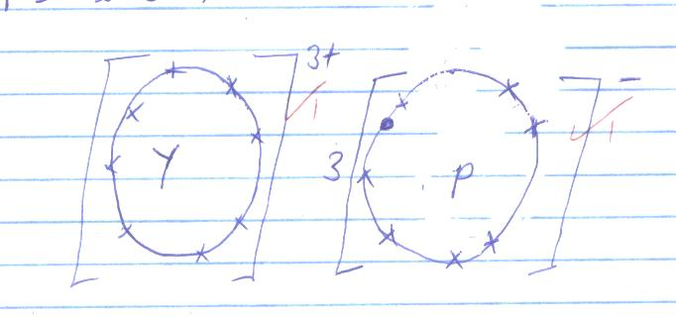
d) Y has a higher charge than X 1
e) i) P 1
ii) Y 1
f) i) 4X_{(s)} + O_{2(g)} → 2X₂O_{(s)} 1 /
2X_{(s)} + O_{2(g)}→X₂O_{2(s)}
ii) 2X_{(s)} + 2H₂O_{(l)} → 2XOH_{(aq)} + H_{2(g)} 1
g) Element Z 1
Has 4 valence electrons which it cannot but only share1
- I i) Propanoic acid 1
ii) Ethylethanoate1
iii) But – 1 – yne 1
II a) i) Oxidation ¹/₂
Potassium mangante VII¹/₂
Acidified medium¹/₂
ii) Dehydration¹/₂
Concentrated sulphur (VI) acid¹/₂
Room temperature¹/₂
b)
Mg_{(s)} + 2CH₃COOH → (CH₃COO)₂Mg + H_{2(g)}1
c) Methylethanoate1
d) Substitutional reaction 1
e) Polythene1
Uses: Used to make pallages1
High density kitchen ware
Food boxes bowl and buckets
(Any correct one 1mark)
f) $\frac{39200}{28}1=$14001
- a) Nitrogen gas
Hydrogen gas
Iron catalyst1 (all)
b) 4NH_{3(g)} + 5O_{2(g)} $\underset{→}{Pt}$ 4NO_{(g)} + 6H₂O_{(g)}

c) 6HNO_{3(aq)} + S_{(s)} → H₂SO_{4(aq)} + 6NO_{2(g)} + 2H₂O_{(g)} 1(brown gas)
d) Reducing property1
e) i) NH₄NO₃ 1
ii) 80g NH₄NO₃→ 28g N₂1
? → 14g N₂
$\frac{14 ×80}{28}$ = 40g1
f) Manufacture of fertilizers1
Manufacture of nitric acid1
Softening hard water
(Two correct answers for 2 mks)
- a) C1 – has the largest positive electrode potential1
b) i) Electrode C = C²⁺_{(aq)} + 2e⁻ → C_{(s)} 1
Electrode D = D_{(s)} → D²⁺_{(aq)} + 2e⁻1
ii) From electrode D towards electrode C1
c) i) Cu_{(s)} → Cu²⁺_{(aq)} + 2e⁻
ii) Q = It
Q = 0.4 x 2.5 x 3600 ¹/₂
= 3600c¹/₂
2 x 96500 c = 64g¹/₂
3600c = ?
$\frac{3600 ×64}{2 ×96500}$ = 1.19378g¹/₂
d)
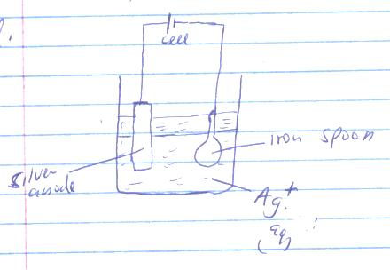
Silver anode
Ag⁺ (aq)
Iron spoon
1 – Electrolyte Ag⁺ _{(aq)}
1 – Electrodes correctly set

- i) 945 $±$ 5cm³ 1
ii)
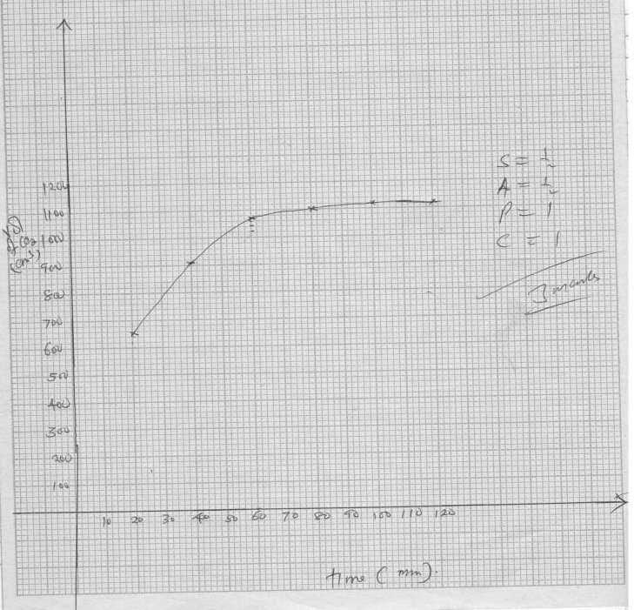
Conditions
- Both axis must be labelled otherwise penalise fully
- The scale selected must cover ½ of the grid provided Otherwise penalise fully

iii) Rate = $\frac{∆V}{∆t}$ = $\frac{1005-525 }{50}$1 = $\frac{480}{50}$ = 9.6 1cm³/mm
- Evidence of tangent at the 25th second for the curve emphasized
- Units must be indicated.
iv) CaCO₃ +2HCl _{(aq)}→CaCl_{2(aq)}+ CO_{2(aq)} + H₂O_{(l)} 1
Volume at 100th = 1120cm³
1 mole of CaCO₃ = 1mole of CO₂
100g = 22400cm³
? = 1120cm³
$\frac{100 ×1120}{2240}$ = 5 grams1
- a) Ore concentration – The process in which undesirable¹/₂ components of the ore (gangre) are removed to improve the quality of the ore¹/₂
b) Sulphur (IV) oxide1
c) CuFeS₂1, 2Cu(OH)₂ 2CuCO_{3,} Cu₂S Any 1 mark
d) 2CuFeS₂ + 4O_{2(g)} →Cu₂S_{(s)} + 2FeO_{(s)} +3SO_{2(g)} 1
e) Electrolysis1
N – FeO, Iron II oxide1
f) FeO + SiO₂ → FeSiO_{3(s)}1
g) i) Electrical wiring1
ii) Making water pipes, cooking utensils1
iii) Making coins
iv) Making ornaments
h) SO₂ - is a pollutant1 and can cause acid rain and green house effect1
- I) This is the heat change when an acid reacts with a base to produce one mole of water1
II) H⁺_{(aq)} + OH⁻_{(aq)} → H₂O_{(l)} 1
III) a) heat = m x C x $∆$T
Mass = 100cm³ $≅$100g¹/₂
$∆$T = 37.5 – 24.5 $≅$ 13$℃$¹/₂
Heat = 100 x 13 x 4.21
= 5460J1
b) Moles used in the reaction
$\frac{100 ×1}{1000}$ = 0.1 mole¹/₂
Molar heat
0.1 mole → ¹/₂ 5460J
$\frac{5460 }{0.1}$ = 54600J/mole
= 54.6kJ/mol
IV) This is because ethanoic acid is a weak acid 1 Which slightly dissociates in water. Some of the heat1 is used to dissociate the weak acid
V) HNO_{3(aq)} + KOH_{(aq)} → KNO_{3(aq)} + H₂O_{(l)} $∆$H = - 54.6 kJ/mol1
VI)
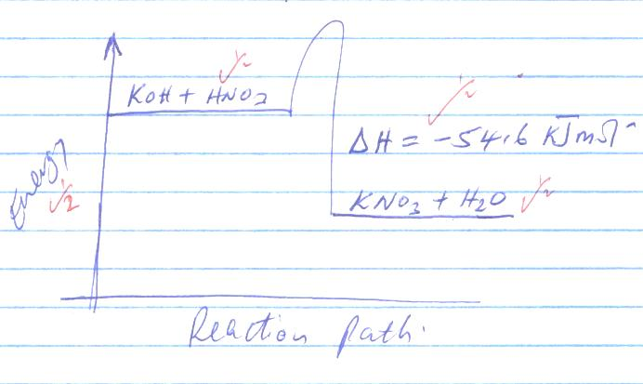
VII) The theoretical value is higher 1 than the practical one. There is heat lose is the surrounding1 during the experiment

