NAME ____________________________________ INDEX NO. _______________
SIGNATURE _______________ DATE _______________


MARYHILL GIRLS HIGH SCHOOL
MOCK EXAMINATIONS 2024
233/2
CHEMISTRY
PAPER 2
(THEORY) TIME: 2 HOURS

INSTRUCTIONS:
- Write your name, school and index number in spaces provided above.
- Sign and write the date of examination in spaces provided above.
- Answer ALL the questions in the spaces provided.
- Mathematical tables and silent electronic calculators may be used.
- All working must be clearly shown where necessary.

FOR EXAMINER’S USE ONLY
Question | Maximum score | Candidate’s score
1 | 12
2 | 13
3 | 10
4 | 11
5 | 8
6 | 11
7 | 15
Total score | 80

This paper consists of 11 printed pages.
Candidates should check to ensure that all pages are printed as indicated

- Study the information in the table below and answer the questions that follow. The letters do not represent the symbol of the elements.
Elements | Atomic number | Melting point ($℃$) | Boiling point ($℃$)
X | 11 | 97.8 | 890
Y | 13 | 660 | 2470
Z | 14 | 1410 | 2360
P | 17 | -101 | -35
Q | 18 | -189 | -186
R | 19 | 63.7 | 480

- Write the electron arrangement for ions formed by elements P and Y.
P (1 mark)
___________________________________________________________________________________
Y (1 mark)
___________________________________________________________________________________
- Why is it that the melting point and boiling point of elements P and Q are very low? (1 mark)
_________________________________________________________________________________________________________________________________________________________________________________________________________________________________________________________
- Element Y reacts with P forming a compound. Draw dots (•) and cross (x) diagrams for this. (2 marks)

- Explain why the melting point of Y is higher than that of X. (1 mark)
______________________________________________________________________________________________________________________________________________________________________
- Select an element which is :
- The most reactive non-metal. (1 mark)
___________________________________________________________________________________
- Can react with both acids and bases. (1 mark)
___________________________________________________________________________________

- Write an equation to show the reaction of element X with:
- Oxygen gas (1 mark)
______________________________________________________________________________________________________________________________________________________________________
- Water (1 mark)
______________________________________________________________________________________________________________________________________________________________________
- Which element has the greatest tendency of forming covalent compounds? Explain. (2 marks)
_________________________________________________________________________________________________________________________________________________________________________________________________________________________________________________________
- I) Give the systematic names of the following compounds.
i) CH₃CH₂COOH (1 mark)
___________________________________________________________________________________
ii) CH₃COOCH₂CH₃ (1 mark)
___________________________________________________________________________________
iii) CHCCH₂CH₃ (1 mark)
___________________________________________________________________________________
II) The scheme below shows a series of reactions starting with ethanol. Study it and answer the questions that follow:
Products
Mg
Step I
Product X + H₂O
Heat
Step II
CH₃COOH
CH₃CH₂OH

Methanol/ Conc. H₂SO₄

NaOH _{(aq)}
Step III
CH₂ = CH₂

CH₃COONa
Step IV
Step V
CH₄
CH₂ - CH₂

K

Excess Cl₂
U.V light
Compound Z

- Name the types of reactions, reagents and conditions in steps:-
i) Step II
Name ($\frac{1}{2}$ mark)
___________________________________________________________________________________
Reagents ($\frac{1}{2}$ mark)
___________________________________________________________________________________
Condition ($\frac{1}{2}$ mark)
___________________________________________________________________________________
ii) Step III
Name ($\frac{1}{2}$ mark)
___________________________________________________________________________________
Reagent ($\frac{1}{2}$ mark)
___________________________________________________________________________________
Condition. ($\frac{1}{2}$ Mark)
___________________________________________________________________________________
- Write the equation for the reaction that take place in step I (1 mark)
______________________________________________________________________________________________________________________________________________________________________
- Name the product X (1 mark)
______________________________________________________________________________________________________________________________________________________________________
- Identify the process leading to the formation of compound Z (2 marks)
______________________________________________________________________________________________________________________________________________________________________
- Name compound K and state one of its uses. (2 marks)
______________________________________________________________________________________________________________________________________________________________________
- If the RMM of K is 39,200. Determine the value of n. (2 marks)
__________________________________________________________________________________________________________________________________________________________________________________________________________________________________________________________________________________________________________________________________________________________________________________________________________________________________________________________________________________________________________________
- The scheme below shows various reactions starting with ammonia. Study it and answer the questions that follow.
Step II
H₂O
CuO_{(s)}
Heat Step I
Catalyst T
H₂O
O₂
Step III
S _{(s)}
Cu _{(s)}
Ammonium hydroxide
Ammonia
Brown solid
Compound D
Compound B
Nitric (V) acid
Brown fumes
Black solid C
Step IV
Heat

- List the raw materials used in the manufacture of ammonia by Haber process (1 mark)
______________________________________________________________________________________________________________________________________________________________________
- Write an equation that occurs between ammonia and oxygen in the presence of a catalyst T. (1 mark)
______________________________________________________________________________________________________________________________________________________________________
- Using an appropriate equation explain how the reaction in step III occurs (2 marks)
_________________________________________________________________________________________________________________________________________________________________________________________________________________________________________________________
- Identify the property of ammonia applied in step I (1 mark)
___________________________________________________________________________________
- i) Write the formula of compound D (1 mark)
___________________________________________________________________________________
ii) Calculate the mass of compound D that would contain 14g of nitrogen
(H = 1, N = 14, O = 16) (2 marks)
__________________________________________________________________________________________________________________________________________________________________________________________________________________________________________________________________________________________________________________________________________________________________________________________________________________________________________________________________________________________________________________
- State two uses of ammonia gas. (2 marks)
_________________________________________________________________________________________________________________________________________________________________________________________________________________________________________________________
- The table below gives the standard electrode potentials for metals represented by letters A, B, C and D. Study it and answers the questions that follow.
Metals | Standard electrode potential (volts)
A | - 0.44
B | - 2.38
C | + 0.34
D | - 0.85
- Which metal represents the strongest oxidizing agent? Give a reason. (2 marks)
_________________________________________________________________________________________________________________________________________________________________________________________________________________________________________________________
- Metals C and D were connected to form a cell as shown in the diagram below.
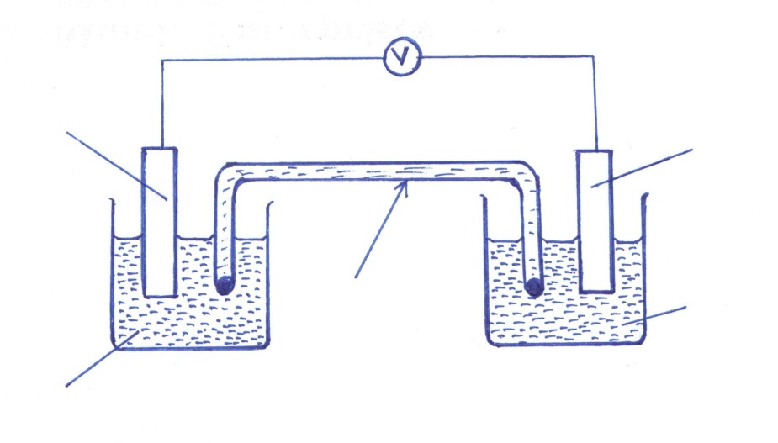
Salt bridge with saturated solution of potassium nitrate
C²⁺_{(aq)}
Metal C
D²⁺_{(aq)}
Metal D

i) Write the equations that occur at electrodes
I) C (1 mark)
__________________________________________________________________________________
II) D (1 mark)
__________________________________________________________________________________
ii) Indicate on the diagram, with an arrow the direction in which electrons flow. (1 mark)
- What is the function of salt bridge? (1 mark)
______________________________________________________________________________________________________________________________________________________________________
- During electrolysis of aqueous copper II sulphate using copper electrodes, a current of 0.4 amperes was passed through the cell for 2.5 hours.
i) Write an ionic equation for the reaction that took place at the anode. (1 mark)
______________________________________________________________________________________________________________________________________________________________________
ii) Determine the change in mass of the anode which occurred as a result of the electrolysis process (Cu = 64, 1 Faraday = 96500 coulombs) (2 marks)
_____________________________________________________________________________________________________________________________________________________________________________________________________________________________________________________________________________________________________________________________________________________________________________________________________________________________________________________________________________________________________________________________________________________________________________________________________
- An iron spoon is to be electroplated with silver. Draw a labelled diagram of the apparatus that could be used to carry out this process. (2 marks)

- a) A pure calcium carbonate weighing 7.5g was placed in a flask with 50cm³ of dilute hydrochloric acid. The flask was kept at constant temperature and the carbon (IV) oxide evolved was collected in a graduated flask. The volume of carbon (IV) oxide was recorded every 20 minutes interval (some of CaCO₃ remained undissolved at the end of the experiment) the results of the experiment are given in the table below. Study it and answer the questions that follow.
Time from the start of reaction | Volume of CO₂ formed at s.t.p. in cm³
20 | 655
40 | 910
60 | 1065
80 | 1100
100 | 1120
120 | 1120
i) On the grid provided plot a graph of the volume of carbon (IV) oxide formed against time. (3 marks)
ii) From the graph determine the volume of the gas collected after 43 seconds. (1 mark)
______________________________________________________________________________________________________________________________________________________________________
iii) Determine the rate of reaction at the 25th minute (2 marks)
_______________________________________________________________________________________________________________________________________________________________________________________________________________________________________________________________________________________________________________________________________________________________________________________________________________________________
iv) What mass of CaCO₃ will react with the acid after 100 seconds? (2 marks)
_______________________________________________________________________________________________________________________________________________________________________________________________________________________________________________________________________________________________________________________________________________________________________________________________________________________________
- The flow chart below outlines some processes involved during extraction of copper. Study it and answer the questions that follow:-
Concentrated copper Ore
I
Gas K
Hot air
Hot air
Silica
Slag M
Roasting furnace I
Smelting Furnace

Smelting Furnace II

Blister copper

Pure copper

Process Q
Gas K
Cu₂ S + N

- Explain the meaning of ore concentration. (1 mark)
______________________________________________________________________________________________________________________________________________________________________
- Name gas K (1 mark)
___________________________________________________________________________________
- Write the chemical formula of one of the ores used in the process. (1 mark)
______________________________________________________________________________________________________________________________________________________________________

- Write a balanced chemical equation for the reaction that takes place in the roasting furnace. (1 mark)
______________________________________________________________________________________________________________________________________________________________________
- Identify process Q and substance N (1 mark)
______________________________________________________________________________________________________________________________________________________________________
- Write a balanced chemical equation for the reaction in which the slag is formed. (1 mark)
______________________________________________________________________________________________________________________________________________________________________
- State two uses of copper metal. (2 marks)
_________________________________________________________________________________________________________________________________________________________________________________________________________________________________________________________
- Give two effects that the above process could have on the environment. (2 marks)
_________________________________________________________________________________________________________________________________________________________________________________________________________________________________________________________
- In an experiment to determine the heat of neutralization of 100cm³ of 1M Nitric acid and 100cm³ of potassium hydroxide. The following results were obtained.
Initial temperature of acid = 24.0$℃$
Initial temperature of alkali = 25.0$℃$
Final temperature of the mixture of acid and alkali = 37.5$℃$
i) Define heat of neutralization (1 mark)
______________________________________________________________________________________________________________________________________________________________________
ii) Write an ionic equation for the reaction between nitric (V) acid and potassium hydroxide. (1 mark)
______________________________________________________________________________________________________________________________________________________________________
iii) Calculate:
- The amount of heat produced during the experiment
(Take specific heat capacity of solution = 4.2 Jg⁻¹K⁻¹, density of solution = 1g/cm³) (3 marks)
_______________________________________________________________________________________________________________________________________________________________________________________________________________________________________________________________________________________________________________________________________________________________________________________________________________________________
- The molar heat of neutralization for this reaction. (2 marks)
_______________________________________________________________________________________________________________________________________________________________________________________________________________________________________________________________________________________________________________________________________________________________________________________________________________________________
iv) Explain why if the experiment was carried using Ethanoic acid of equal volume and molarity, the molar heat of neutralization is less. (2 marks)
_________________________________________________________________________________________________________________________________________________________________________________________________________________________________________________________
v) Write down the thermochemical equation for the reaction between nitric (V) acid and potassium hydroxide (2 marks)
______________________________________________________________________________________________________________________________________________________________________
vi) Draw an energy level diagram for neutralization reaction between potassium hydroxide and nitric (V) acid above. (2 marks)

vii) The theoretical value of the enthalpy of neutralization of above reaction is 57.2 KJ how does this value compare with the value calculated in III (b) above. Explain. (2 marks)
____________________________________________________________________________________________________________________________________________________________________________________________________________________________________________________________________________________________________________________________________________

