
ACK JOINT EVALUATION EXAMINATION JUNE 2024
Kenya Certificate of Secondary Education
233/3__________________________CHEMISTRY____________________________ PAPER 3
(PRACTICAL)
JULY 2023 TIME: 2 HOURS 15 MIUTES
Name……………………………………………………… Index No……………………………
School………………………………………………………………………………………………
Candidate signature……………………………………….. Date…………………………………
INSTRUCTION TO CANDIDATE:
- Write your NAME and INDEX NUMBER and name of your school in the space provided above
- SIGN and WRITE the date of examination in the spaces provided above.
- Answer all the questions in the spaces provided.
- KNEC mathematical tables and silence calculator may be used.
- All workings MUST be clearly shown necessary.
FOR EXAMINER USE ONLY
QUESTION | MAXIMUM SCORE | CANDIDATE SCORE
1 | 21
2 | 12
3 | 07
TOTAL SCORE | 40

This paper consists of 6 printed pages.
Candidate should check the question paper to ensure that all the pages are printed as
indicated and that no questions are missing.

- You are provided with:
- Sodium hydroxide solution E
- 0.25M dibasic acid solution F
- Hydrochloric acid solution G
You are required to:
- Standardize sodium hydroxide solution E using solution F.
- Determine the heart of the hydrochloric acid solution G with sodium hydroxide solution F hence determine its concentration in moles per liter.
Procedure I
Fill the burette with solution E. Pipette 25 cm³ of dibasic acid solution F and place it in a clean conical flask. Add to it 2 drops of phenolphthalein indicator and titrate against sodium hydroxide solution E from burette. Record your results in table 1 below. Repeat the procedure two more times and complete table 1 below. (4mks)
Table 1
 | I | II | III
Final burette reading (cm³)
Initial burette reading (cm³)
Volume of solution E used (cm³)

- Determine the average volume of sodium hydroxide solution E used (1 mark)

- Determine the number of moles of sodium hydroxide solution E used (2 marks)

- Determine the concentration of sodium hydroxide solution E in moles per liter (1 mark)

Procedure II
Using a clean measuring cylinder, measure 30 cm³ of solution G and transfer it to a 250 ml plastic beaker. Record the initial temperature of solution G to the nearest 0.5⁰C in table 2 below. Wash the measuring cylinder. Use it to measure 10cm³ of solution E and add it to solution G in the plastic beaker. Stir gently with the thermometer and record the highest steady temperature attained in the table 2 below. Continue adding 10cm³ portions of solution E in the content of the plastic beaker, stirring with the thermometer and recording the highest steady temperature after each addition in the table 2 below until 80 cm³ of solution E has been added. (3 marks)

Volume of solution (cm³) | 0 | 10 | 20 | 30 | 40 | 50 | 60 | 70 | 80
Temperature of the mixture (⁰C)
Changes in temperature , T (⁰C)

- Complete table 2 above by filling in the change in temperature, T values (1 mark)
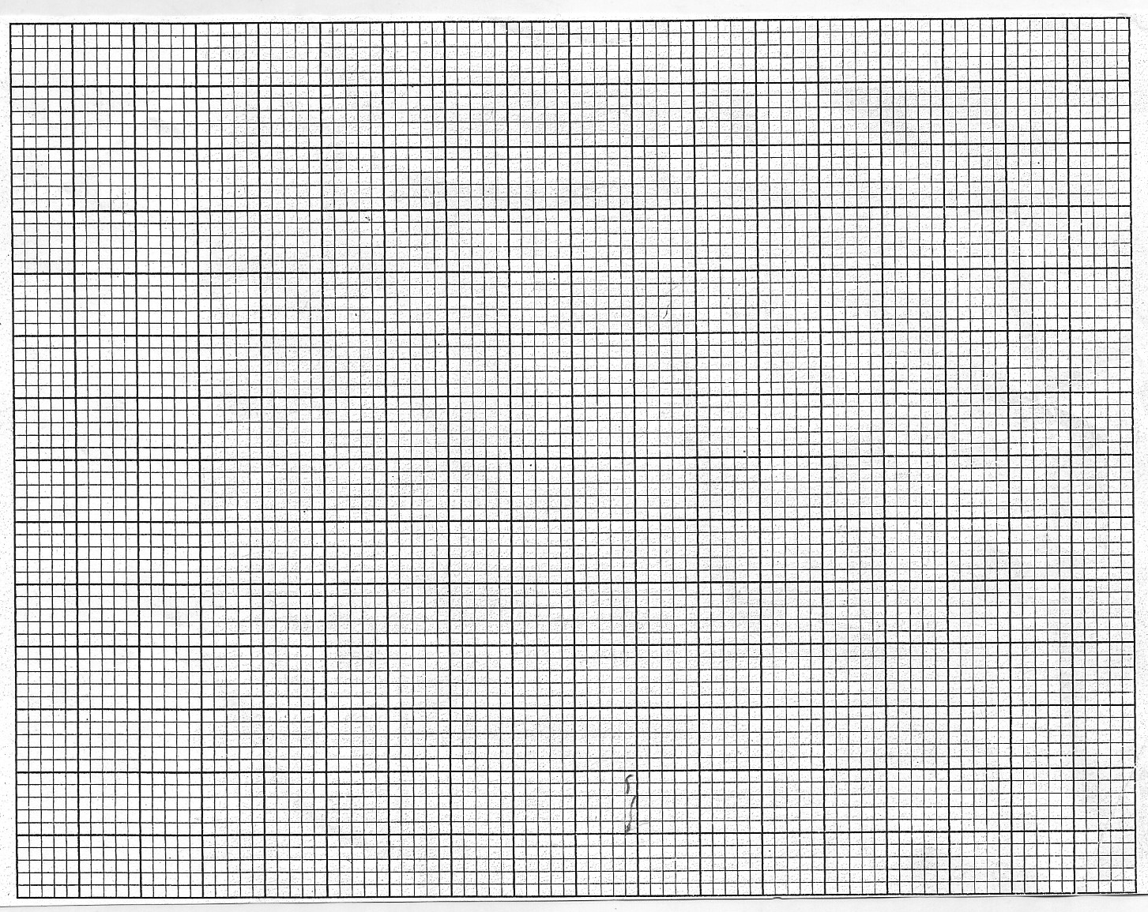
- Plot a graph of change in temperature, T against volume of solution E added (3 marks)

- Using your graph;
- Determine the maximum change in temperature, T ss (1 mark)

- Determine the volume of sodium hydroxide E that completely neutralized 30cm³ of solution G. (1 mark)

- Calculate the heat evolved when 30cm³ of solution G react with the volume of solution E stated in c(ii) above (specific heat capacity =4.2Jg⁻¹K⁻¹, density of solution =1 g/cm³) (2 marks)

- Given that the molar heat of neutralization of hydrochloric acid is -57.2 kJmol^{-1,} determine the concentration of hydrochloric acid solution G in moles per litre. (2 marks)

- You are provided with solid H. Carry out the following tests on it and record the observations and references made in the spaces provided.
- Put solid H in a clean dry boiling tube and at to it about 15cm³ of distilled water. Shake the mixture thoroughly and filter. Wash and preserve the residue for use in part (c) below.
Observations | Inferences
(1 mark) | (1 mark)

- Divide the filtration into three portions.
- To the first portion, add 2-3 drops of acidified barium nitrate solution
Observations | Inferences
(1 mark) | (1 mark)

- To the second portion, add sodium hydroxide solution dropwise until in excess
Observations | Inferences
(1 mark) | (1 mark)

- To the third portion, add ammonia solution dropwise until in excess
Observations | Inferences
(1 mark) | (1 mark)

- Using a clean spatula, transfer the residue obtained in (a) above carefully into a clean dry boiling tube. Add to it about 5cm³ of nitric acid (V) acid. PRESERVE the resulting solution for use in (d) below.
Observations | Inferences
(1 mark) | (1 mark)

- To a portion of the solution preserved in (c) above, add ammonia solution dropwise until in excess.
Observations | Inferences
(1 mark) | (1 mark)

- You are provided with solid J. Carry out the tests below on it and record observations and inferences in spaces provided
- Scoop solid J on a clean dry spatula and heat it in a non –luminous flame.
Observations | Inferences
(1 mark) | (1 mark)

- Put the remaining solid J in a clean dry boiling tube and add to it about 10 cm³ of distilled water, divide the resulting solution into two portions
Observations | Inferences
(1 mark) | (1 mark)

- To the first portion, add 2-3 drops of acidified potassium manganate (VII)
Observations | Inferences
(1 mark) | (1 mark)

- To the second portion, add 2-3 drops of acidified potassium dichromate (vi) solution
Observations | Inferences
(1 mark) | (1 mark)

