
ACK JOINT EVALUATION EXAMINATION JUNE 2024

NAME: ………………..……..………………………………………………………………..
SCHOOL: ………………………………..……………………………………………………
INDEX NO: .…………..…..…….… CANDIDATE’S SIGNATURE: ….….……………...
DATE: ………………………….
233/1
CHEMISTRY
PAPER 1
TIME: 2 HOURS
K.C.S.E ACK JOINT EVALUATION TEST 2024
MUMIAS DIOCESE
INSTRUCTIONS TO CANDIDATES:
- Write your name and INDEX number in the spaces provided.
- Sign and write date of examination in the spaces provided above
- All working must be clearly shown IN THE SPACES PROVIDED where necessary.
- Knec LOG TABLES AND NON-PROGRAMMABLE calculators may be used
- All answers must be given in English
For examiners use only
Question | 1 | 2 | 3 | 4 | 5 | 6 | 7 | 8 | 9 | 10 | 11 | 12 | 13
Score

Question | 14 | 15 | 16 | 17 | 18 | 19 | 20 | 21 | 22 | 23 | 24 | 25 | 26
Score

Question | 27 | 28 | Total | 80
Score |  |  | score
- a) Define the term solubility (1mk)
………………………………………………………………………………………………………………………………………………………………………………………………………………
b) calculate the solubility of a salt given that 15g of the salt can saturate 25cm3 at room temperature. (2mks)
………………………………………………………………………………………………………………………………………………………………………………………………………………
………………………………………………………………………………………………………………………………………………………………………………………………………………
- Starting with sodium metal , describe how a solid sample of sodium hydrogen carbonate can be prepared. (2mks)
………………………………………………………………………………………………………………………………………………………………………………………………………………
……………………………………………………………………………………………………………………………………………………………………………………………………………….
………………………………………………………………………………………………………………………………………………………………………………………………………………
- Describe how you can distinguish between CuO, MnO₂ and FeS using dilute hydrochloric acid only. (3mks)

……………………………………………………………………………………………………………………………………………………………………………………………………………………………………………………………………………………………………………………………………………………………………………………………………………………………………………………………………………………………………………………………………………………………………………………………………………………………………………………………………………………………………………………………………………………………………………………………………………………………………………………………………………………………………………………………………………………………………… 4. Write the equations for the reactions that take place during electrolysis of
magnesium Sulphate solution using platinum electrodes at the:
(i)Anode (1 Mk)
………………………………………………………………………………………………………
(ii) Cathode (1 Mk)
………………………………………………………………………………………………………………………………………………………………………………………………………………
iii) give the name of the material that can be used as the electrode instead of platinum (1MK)
………………………………………………………………………………………………………
5. Study the following part of the solvay process for the manufacture of sodium carbonate and answer the questions that follows: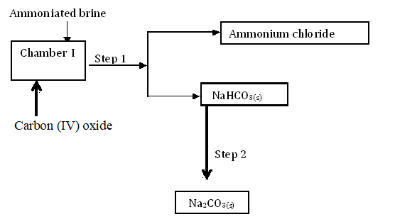

- State the main source of Carbon (IV) oxide in the process. (1 mk)
………………………………………………………………………………………………………
………………………………………………………………………………………………………Write down the overall equation for the reaction in chamber I. (1m k)
………………………………………………………………………………………………………………………………………………………………………………………………………………

- Name process in
- step 1. ( ½ mk)
……………………………………………………………………………………………………

ii) step 2 ( ½ mk) ………………………………………………………………………………………………………

- Calcium carbonate reacts with dilute hydrochloric acid as shown in the equation below
CaCO_{3(s)} + 2HCl_{(aq)} → CaCl_{2(aq)} + CO_{2(g)} + H₂O_{(l)}
State two ways in which the rate of the reaction above can be increased (2mks)

………………………………………………………………………………………………………………………………………………………………………………………………………………
………………………………………………………………………………………………………………………………………………………………………………………………………………
………………………………………………………………………………………………………………………………………………………………………………………………………………

7.Study the scheme below hence answer the questions that follow.
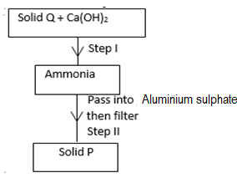

- Identify
- solid Q. …………………………………………………………………….. ( ½ mk)
ii) condition necessary for step 1 to take place ( ½ mk)
……………………………………………………………………………………………………………..

b) Write an ionic equation for the reaction in Step II. (1 mk)
………………………………………………………………………………………………………………………………………………………………………………………………………………
c) describe a chemical test for ammonia ( 1mk)
……………………………………………………………………………………………………………………………………………………………………………………………………………….
8. 45.0cm³ of aqueous sodium hydroxide containing 12.0 g per litre of sodium hydroxide were completely neutralized by 0.441 g of dibasic acid. Determine the relative formula mass of the dibasic acid (Na =23.0, O=16.0; H=1.0) (3mks)
………………………………………………………………………………………………………………………………………………………………………………………………………………
………………………………………………………………………………………………………………………………………………………………………………………………………………
………………………………………………………………………………………………………………………………………………………………………………………………………………
………………………………………………………………………………………………………………………………………………………………………………………………………………
………………………………………………………………………………………………………

9. Study the following flow chart and answer the questions that follow.
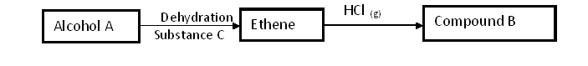

- Write the formula of
I Alcohol A ( ½ mk)
……………………………………………………………………………………………………
II Compound B ( ½ mk)
…………………………………………………………………………………………………..
(ii) Name substance C (1mk)

…………………………………………………………………………………………………………
10. If chlorine gas is passed over heated iron fillings and the product dissolved in water, a yellow solution is formed.
- Identify the yellow solution. (1 mk)

……………………………………………………………………………………………………

- What would be observed if aqueous sodium hydroxide solution was added to the yellow solution?
(1 mk)
……………………………………………………………………………………………………………………………………………………………………………………………………
- Write an ionic equation for the reaction between the yellow solution and sodium hydroxid (1 mk)
……………………………………………………………………………………………………………………………………………………………………………………………………

11. Under certain conditions, carbon(IV) oxide react with water to form methanol and oxygen as shown in the reaction below
2CO_{2(g)} + 4H₂O_{(l)} → 2CH₃OH_{(l)} +3O_{2(g)} ; ∆H=+1452kJ
What would be the effect equilibrium
- Of Increase of pressure on the mixture? Explain (1mks)
…………………………………………………………………………………………………
…………………………………………………………………………………………………
- When the oxygen formed is liquefied? Explain (1 mks)
…………………………………………………………………………………………………
…………………………………………………………………………………………………
12. In terms of structure and bonding, explain the following.
  - Graphite is used as a lubricant. (1 mk)
…………………………………………………………………………………………………
…………………………………………………………………………………………………

  - Alluminium is better conductor of electricity then magnesium. (1 mk)
…………………………………………………………………………………………………
…………………………………………………………………………………………………

  - Water is a liquid at room temperature while hydrogen sulphide is a gas. (1 mk)
…………………………………………………………………………………………………
…………………………………………………………………………………………………

13. The diagram below illustrates an experiment to investigate the conduction of electricity in liquids. Study it and answer the questions that follows.

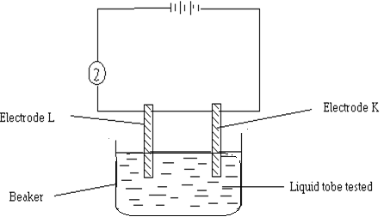

  - State one mistake in the set-up. (1mk)
………………………………………………………………………………………………………………

  - If the liquid in the beaker was benzene. State what expected at the bulb? Explain (2mks)
……………………………………………………………………………………………………………………………………………………………………………………………………………………………………………………………………………………………………………………………………………….
14.The diagrams below were set up by form 4 students to investigate methods of preventing rusting.

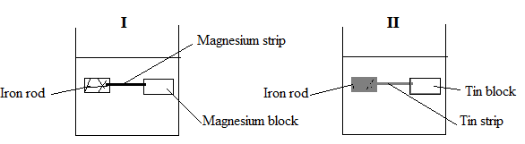

(i) | It was observed that rusting occurred in set up II and not in set up I. Explain. (1mk)
 | …………………………………………………………………………
ii) What is the name given to this method of preventing rusting (1mk)
………………………………………………………………………………………
(iii) | State one other method of preventing rusting in iron. (1mk)
…………………………………………………………………………………………………………………………………………………………………………………………………………
15 . Study the information given in the table below and answer the questions
below the table:

Bond | Bond energy (kjmol⁻¹)
C H  CI CI  C CI  H CI | 414  244  326  431

Calculate the enthalpy change for the reaction.
CH_{4 (g)} + Cl_{2 (g)} CH₃Cl _{(g)} + HCl _{(g)} (3 marks)
.................................................................................................................................................................................................................................................................................................................................................................................. ........................................................................................................................................................................................

16. A student was supplied with a colourless liquid suspected to be water.
(i) Describe one chemical test that could be carried out to show that the liquid was water.
……………………………………………………………………………………………………………………
……………………………………………………………………………………………………………………
………………………………………………………………………………………………………………….
(ii) How could it have been shown that one liquid was pure water? (1mk)
…………………………………………………………………………………………………………………………
……………………………………………………………………………………………………………………….
(iii) Name two substances that react to form pure water. (1mk)
…………………………………………………………………………………………………………………………………………………………………………………………………………………………………………………….
17. a) The diagram below represents an apparatus found in a chemistry laboratory.
Give its name. and use (1 mark)

………………………………………………………………………………………………………………
b) Draw and name the apparatus used for
- Holding liquids for boiling

- Holding solids that are heated strongly

- Study the crude oil fractionating column in the diagram below. U

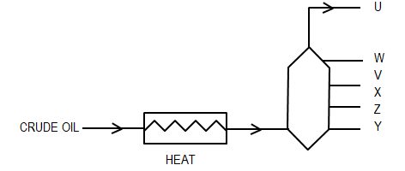

- How would you expect the temperature to vary from U to Y? (½mk)

……………………………………………………………………………………….
- For each fraction given below, state at what position U, V, W, Z and Y it will be collected. (2½mks)
Compound with Position collected
C15 - C25 atoms ……………………………………
C4- C15 atoms …………………………………….
Compound with Position collected
C20 – Upwards …………………………………….
C8 - C16 atoms ……………………………………
C1 - C4 atoms ……………………………………
19. An element G is atomic number 3, relative atomic mass 6.94 and consists of two isotopes of mass numbers 6 and 7 respectively

  - What is the mass number of the more abundant isotope of G? (1mk)
………………………………………………………………………………………………..

  - Calculate the relative abundance of each of the isotopes. (2mks)
…………………………………………………………………………………………………………………………………………………………………………………………………………………………………………………………………………………………………………………………………………………………………………………………………………………………………………………………………………………………………………………………………………………………………………………………………………………………………………………………………………………………………………………………………………………………………………………………..

20. a) Potassium manganate (VII) reacts with chloride salts to produce chlorine. Both chlorine and potassium manganate (VII) are strong oxidizing agents. Which one of the two is the stronger oxidizing agent? Explain your answer (2marks)
…………………………………………………………………………………………………………..
…………………………………………………………………………………………………………..
…………………………………………………………………………………………………………..
…………………………………………………………………………………………………………..

  - Chlorine and sulphur (IV) oxide are bleaching agents; explain the difference in their bleaching action. (1mk)

…………………………………………………………………………………………………………..
…………………………………………………………………………………………………………..
…………………………………………………………………………………………………………..

21. Study the flow chart below and answer the questions that follow.

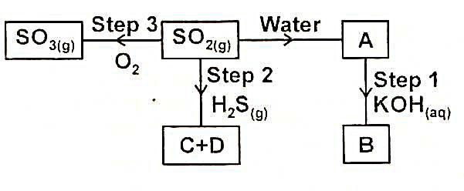

  - Name the substance (1mk)
- A ………………………………………………………………………………………………………….

- B ………………………………………………………………………………………………………….
  - State the property of S02 exhibited in step 2. (1mk)
…………………………………………………………………………………………………………..
…………………………………………………………………………………………………………..
22. An organic compound K was analysed and found to contain carbon, hydrogen and oxygen only. 1.29g of K on complete combustion gave 2.64g of carbon (IV) oxide
and 0.81g of water. Find the empricial formula of K. (C = 12, H = 1, O = 16). (3 marks)
…………………………………………………………………………………………………………..
…………………………………………………………………………………………………………..
…………………………………………………………………………………………………………..
…………………………………………………………………………………………………………..
…………………………………………………………………………………………………………..
…………………………………………………………………………………………………………..
…………………………………………………………………………………………………………..
…………………………………………………………………………………………………………..
…………………………………………………………………………………………………………..

23. An experiment was carried out to detriment the presence of substanceI, J, K and L in mixture M. the result obtained are shown in figure below.
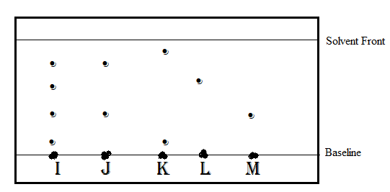
a)Name the method of separation illustrated in figure 2 1 mark
…………………………………………………………………………………………………………..
b)Select
i)One substance which contains a component not present in T 1 MARK
…………………………………………………………………………………………………………..

II)Substance which is least soluble in the solvent used 1 mk
…………………………………………………………………………………………………………..
24.Calculate the heating value of methanol CH₃OH given that 0.87g of the fuel burn in air to raise the temperature of 500g of water from 20ºC to 27ºC.(C-12.0,H=1.0 O=16.0). (3mks)

…………………………………………………………………………………………………………..
…………………………………………………………………………………………………………..
…………………………………………………………………………………………………………..
…………………………………………………………………………………………………………..
…………………………………………………………………………………………………………..
…………………………………………………………………………………………………………..
…………………………………………………………………………………………………………..
…………………………………………………………………………………………………………..
…………………………………………………………………………………………………………..
…………………………………………………………………………………………………………..
25. give the IUPAC names of compounds whose formulae are given below
a) CH₃CH₂CH₂COOH
…………………………………………………………………………………………………………..

b) CH₃(CH₂)₃OH
…………………………………………………………………………………………………………..

c) O
CH₃ C O CH₂CH₃
…………………………………………………………………………………………………………..

26a) Name and ore from which copper could be extracted (1mk)
…………………………………………………………………………………………………………..
…………………………………………………………………………………………………………..
- Draw a well labelled diagram showing the set-up that is used in electronic purification of copper (2mks)

27. Calculate the mass of nitrogen-13 that remains from 4g after one hour if the half-life period of nitrogen-13 is 10minutes. (2mks)
…………………………………………………………………………………………………………..
…………………………………………………………………………………………………………..
…………………………………………………………………………………………………………..
…………………………………………………………………………………………………………..

28. i) State the Gay-Lussac’s Law. (1mk)
…………………………………………………………………………………………………………..
…………………………………………………………………………………………………………..

(ii) 15cm³ of a gaseous hydrocarbon reacted completely with 45cm³ of oxygen. 30cm³ of carbon (IV) oxide were formed. Determine the formula of the hydrocarbon given that all volumes of gases were measured under the same conditions of temperature and pressure. (3mks)
…………………………………………………………………………………………………………..
…………………………………………………………………………………………………………..
…………………………………………………………………………………………………………..
…………………………………………………………………………………………………………..
…………………………………………………………………………………………………………..
…………………………………………………………………………………………………………..
…………………………………………………………………………………………………………..

