KABIANGA SCHOOL MOCK EXAM 2024

441/ 2 -HOME SCIENCE -Paper 2
Time: - 2 hours

Name………………………………………… Index Number……………………………………...
Candidate’s Signature ………………….…...……….. Date ………………………………………

Kenya Certificate of Secondary Education 2024
HOME SCIENCE
(CLOTHING CONSTRUCTION)
PAPER 2
PRACTICAL
TIME: 2 ½ HOURS

Instructions to candidates

- This paper consists of 3 printed pages.
- Candidates should check the question paper to ascertain that all pages are printed and no questions are missing.
- A pattern of a girl’s blouse is provided. You are advised to study the sketches, instructions and the layout carefully before you begin the test.

Turn over

A pattern of a child’s dress is provided. You are advised to study the sketches, the question paper and the layout carefully before you begin the test.

Materials provided
- Pattern pieces
- Dress front
- Dress back
- Sleeve
- Sleeve binding and ties
- Sleeve opening facing
- Front neck facing
- Back neck facing
- Plain light weight cotton fabric 70cm long by 90cm wide
- Sewing thread to match fabric
- One large envelope

The test
Using the materials provided, cut out and make up the RIGHT HALF of the child’s dress to show the following
- The making of a French seam at the shoulder
- The joining of the side seam with a neatened open seam
- The preparation of a faced sleeve opening
- The joining of the under arm seam using a neatened open seam
- The binding of the lower edge of the sleeve and preparation of the tie ends
- The preparation and attachment of the sleeve.
NB: Do not neaten or trim the arm hole seam allowance
- The preparation and attachment of the neck facings

At the end of the examination, firmly sew on on to your work on a single fabric a label bearing your name and index number. Remove the needles and pins from your work, then fold your work carefully and place it in the envelope provided.
Do not put scraps of fabric in the envelope.

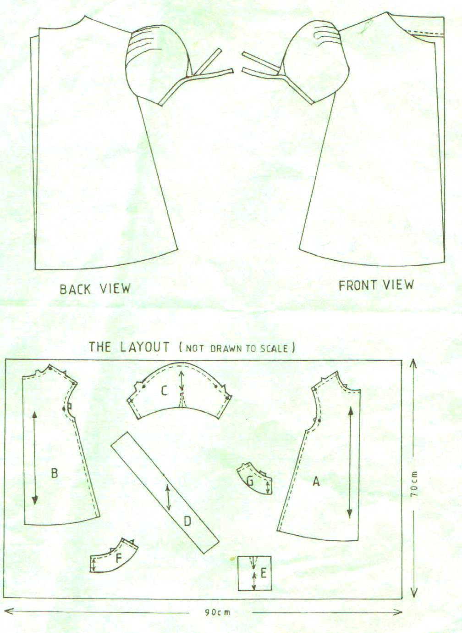

THIS IS THE LAST PRINTED PAGE

