312/2
GEOGRAPHY
Paper 2
July 2024
Time: 2 ¾ Hours

ACK DIOCESE OF MUMIAS
JOINT EVALUATION 2024
Kenya Certificate of Secondary Education (K.C.S.E)

MARKING SCHEME
SECTION A (25 marks)
Answer all the questions in this section in the answer sheets provided.
1. a) What is fish farming? (2mks)
Fish farming is the rearing of fish in ponds and dams
b) List down three physical factors that favour fishing in North West pacific. (3mks)
The convergence of the cold oya siwo current and the warm kuro siwo The broad continental shelf along the coastline
The indented coastline with several islands
The mountainous landscape hinders agriculture
2. (a) Give two conditions necessary for the construction of a dam (2mks)
- A river must possess enough water where the regime is fairly constant
- There must be a large river catchment area
- The underground rock should be hard and impermeable
- The manpower must be highly skilled
- Enough capital availability.
- The rivers cross profile should be narrow
- The presence of rapids and water falls
(b) State three reasons why Africa’s hydro-electric power is not fully developed?
- The big rivers as Niger, Nile, Volta, Zambezi and Orange have their waters immersely reduced by evaporation because they pass across dry regions
-Huge dams have to be constructed to regulate the flow of water on the rivers
-Building of dams demands great technical know-how which Africa lacks
-Shortage of finances to train the people and purchase the power generating equipment
-African industries are in their infancy hence low demand for Hydro-Electric Power-low demand
(3mks)

3. a) Below is a map of the Ruhr industrial region in Germany.
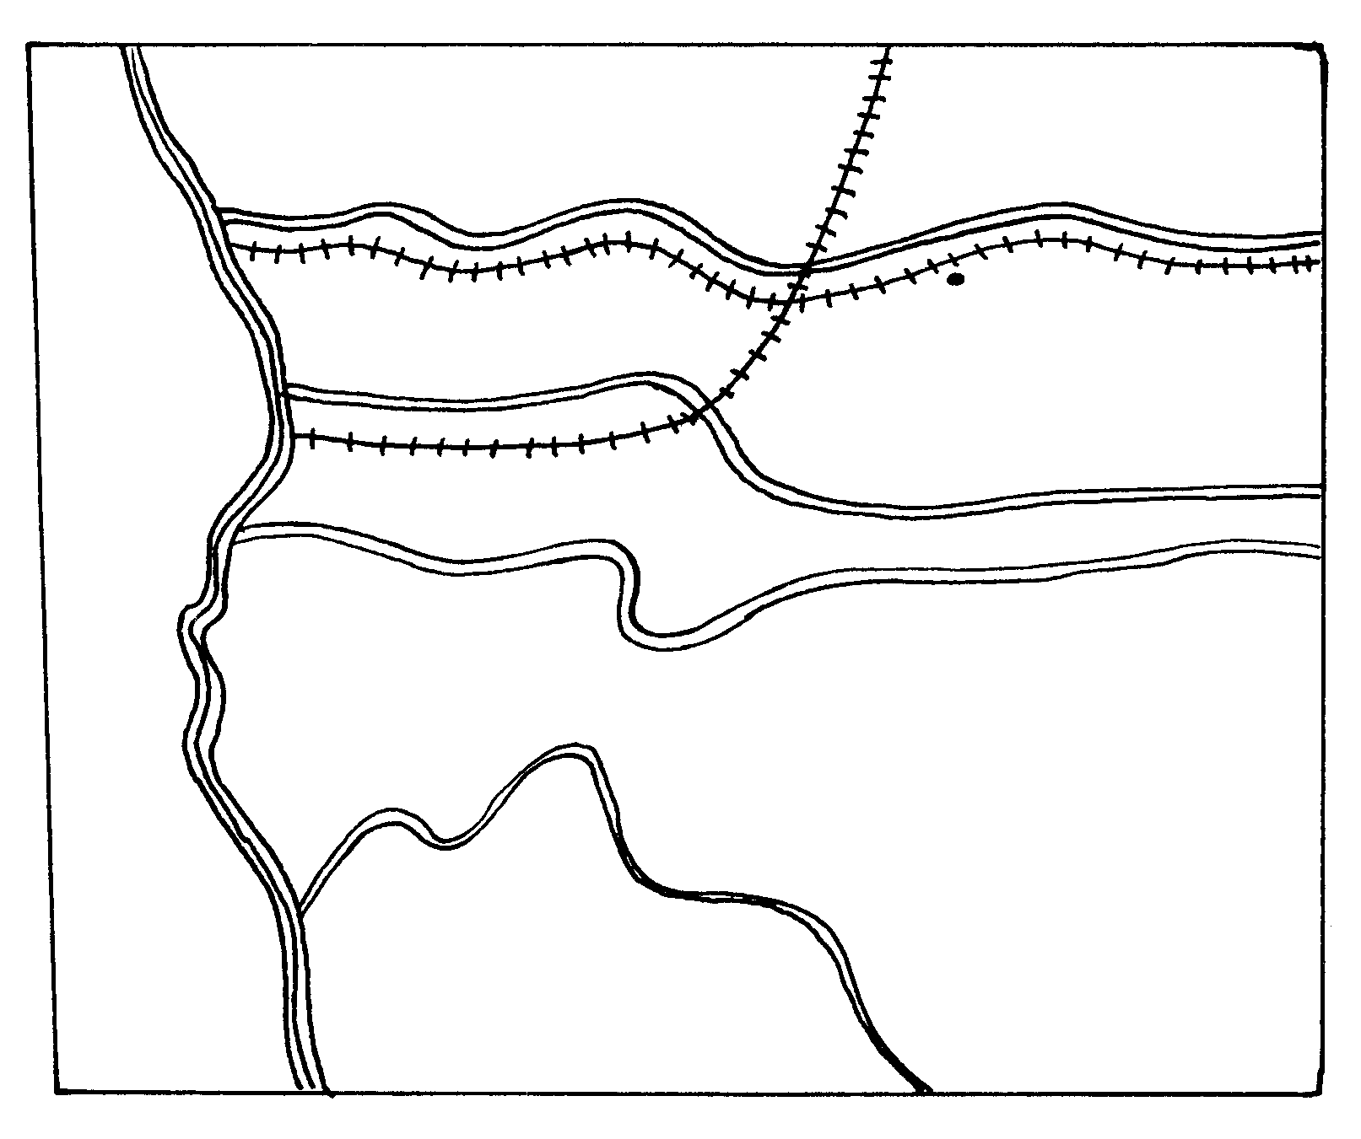
River Q
Z. CANAL
T
R. Rhine
R. Wupper
DUSSELDOLF
River S
ESSEN
River P
HAMM
Canal W
R. RHINE
Give the name of
(i) The river marked Q (1mk)
Lippe
(ii) The town marked T (1mk)
Dortmund
(iii) The canal marked Z (1mk)
Ems
b) Give TWO reasons why the Ruhr region has become of little importance as an industrial centre in recent years. (2mks)
- The decline of use of coal as a source of energy in the industries.
- Depletion of prime minerals especially coal and iron in the area.
- Competition for activities from upcoming industrial centres.
4. a) State two factors which have contributed to decline in infants mortality in Kenya.
(2mks)
- Improved medical facilities
- Improved diet for mother infants.
- Improved education for parents especially mothers - Improved education for parents especially mothers. (2mks)
b) Identify three problems resulting from decline in population in industrialized countries. (3mks)
- Shortage of manpower which makes labour expensive
- Underfilisation of social facilities such as school.
- High old age dependence ratio
- There is rural depopulation due to increased urbanization.
- - There is rural depopulation due to increased urbanization.
(3mks)
5. a) Name two environmental hazards that have affected Kenya in the recent years
(2mks)
- Floods
- Drought / desertification
- Land slides.
- Overpopulation
- Soil erosion
- Pollution
b) Give three causes of noise pollution in Nairobi city. (3mks)
- Booming music in night clubs / musicstones / Matatus.
- Hosting of motor vehicles in the city.
- Noise from flying aircrafts over the town.
- Loud noise from industrial centres / factories.
- Noise from barking street dogs.
- Noise from human beings / shouting / crying / touting/ singing

SECTION B
Answer Question 6 and any other two questions.
6. The table below shows tea production in Kenya in thousands metric tonnes`
Tea production (000s of metric tones)
Zones | 2001 | 2002 | 2003
Kericho | 35 | 20 | 25
Nandi | 20 | 15 | 25
Kisii | 25 | 20 | 15
Kiambu | 15 | 12 | 15
Embu | 10 | 8 | 10
Meru | 5 | 15 | 10
TOTAL | 110 | 90 | 100

- i) Using a scale of 1cm to represent 5000 tonnes, draw a compound bar graph to represent the data provided above (6mks)
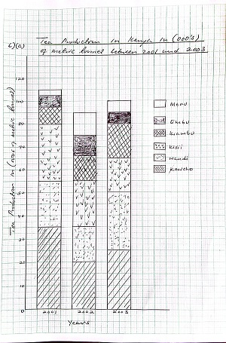

ii) What are the disadvantages of using compound bar graphs to present data? (3mks)
- It takes time to draw because of many calculations involved
- The value of individual components of the same bar are difficult to establish at a glance
- There is a limited number of components that can be represented on a single bar because very long bars are difficult to interpret
- Values of many variables are placed together on one bar giving a wrong impression

- i) State four physical conditions favouring tea growing in Kenya (4mks)
-Warm temperature throughout the year (15◦C-30◦C).
-Heavy and well distributed rainfall (1000-2000mm annually).
-Deep and slightly acidic soils.
-High altitude of about 1000-3000m above sea level.
-The areas are free from frost.
-Gently sloping land which is well drained.
-The tea growing areas do not experience strong violent winds.
ii) Explain four problems facing tea farmers in Kenya (8mks)
- Pests e.g. weevils and beetles which attack tender leaves supposed to be picked.
-Diseases e.g. root rot which causes the bush to wither, dry and eventually die.
-Hail stones which fall on tea bushes causing damage e.g. in Kericho and Nandi.
-Fluctuations of world prices which causes the farmers to lose morale and neglect or uproot the crop.
-Shortage of rainfall leading to reduction in leaf production.
-Transport problems in some areas due to dilapidated roads which cause spoilage of harvested tea before it reaches the factory.
-Shortage of labour in some tea growing areas where young people have migrated to towns.
-Shortage of capital to meet production costs.
- Suppose students were to carry out a field study on a tea growing area of Kericho. Give four reasons why a pre-visit is necessary. (4mks)
-To determine appropriate routes to be taken
-Enables to get guiding documents from officials
-Helps one to identify the appropriate methods of data collection
-Helps to identify appropriate equipment to be used

7. Use the map of East Africa below to answer question (a) (i)
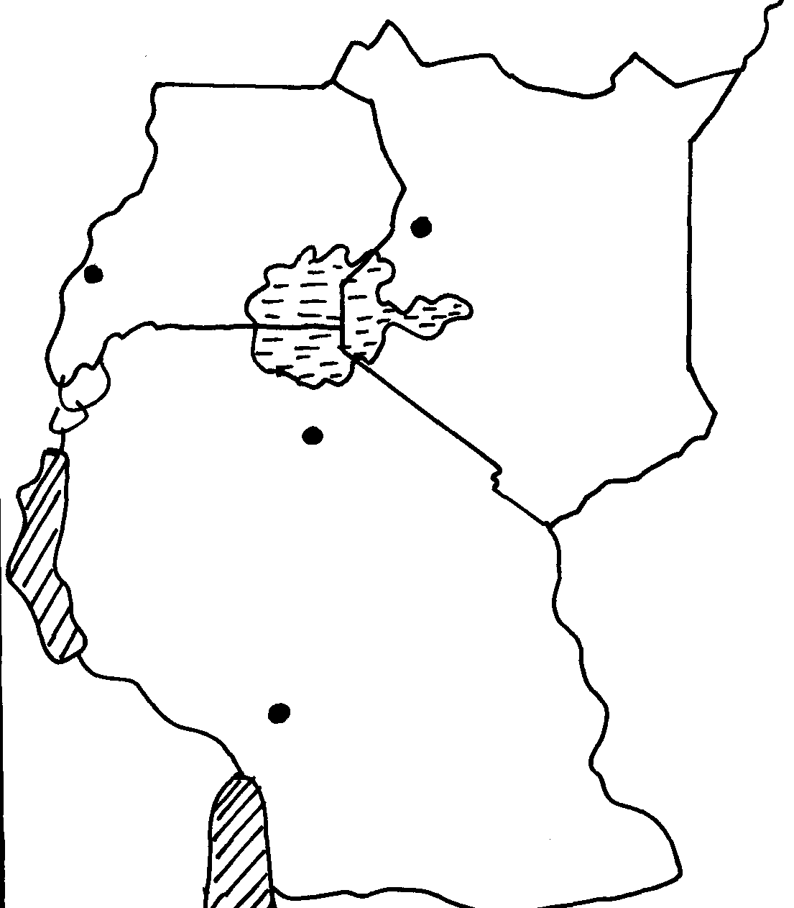
W
Z
Y
X

(a) (i) Name the minerals mined in the areas marked W, X, Y and Z (4mks)

W – Flousper
X – Iron
Y – Gold
Z - Copper
(ii) Give four ways in which minerals occur (4mks)
- Veins and lodes
- Reefs
- Seams/Beds/Layers
- Alluvial deposits
- weathered products
- oil pools/wells
(b) Identify any five factors that influence the exploitation of minerals (5mks)
- value of mineral
- Quality of ore
- size of deposit
- capital
- method of mining
- transport costs
- market for the mineral
- political influence
- Labour
(c) Explain any four problems associated with mining (8mks)
- Renders land useless for other economic activities such as agriculture (dereliction) due to open pits left on land and heaps of rock waste litter dumped on land.
- Pollutes the environment e.g. atmospheric pollution from dust and smoke from tractors
- Leads to loss of bio-diversity due to destruction vegetation which also destroys habitats of various animals leading to their destruction also.
- Causes soil degradation e.g. by loosening the soil which makes it vulnerable to agents of erosion like wind and water
- Causes mass wasting when explosives and heavy equipment used in mining shake the ground making weathered materials to move faster down slope under the influence of gravity.
(d) List any four main minerals mined in Kenya (4mks)
- Limestone
- Flousper
- Trona
- Diatomite
- Salt

8) a) (i) Define re-afforestation (2mks)
- This is the planting of trees in areas where trees have been cut down/forest have been cleared/deforestation has taken place
(ii) State four reasons why afforestation should be encouraged in Kenya (4mks)
- To ensure continuous supply of wood fuel/timber/herbal medicine/raw materials for paper making
- To protect water catchment areas/create micro-climate to maintain hydrological cycle
- To create scenic beauty/for Aesthetic value
- To expand the habitat for wildlife/conservation of wildlife
- To create employment opportunities
- To reduce importation of forest products/foreign exchange
(iii) Name three provinces in Canada where forestry is practiced on large scale (3mks)
- British Columbia
- Quebec
- New Brunswick
- Ontario
- Edward Island
- Newfound land
b) Explain three problems which hinder the Kenya government efforts to manage and
Conserve forest (6mks)
- Prolonged drought leads to drying up of some trees
- Some wild animals damage trees through uprooting/trampling
- Rapid increase in population has led to encroachment into forest land hence destruction of trees/ high demand for fuel
- Occurrence of forest fires which have led to destruction of large areas under forest
- Illegal logging/Indiscriminate cutting of trees thereby reducing/depleting indigenous species
- Attacks by pest/diseases lead to destruction of trees
c) Explain three factors that favour the growth of natural forest on the slopes of Mount Kenya (6mks)
- Cool climates in the Kenya highlands favour the growth of trees
- High rainfall ranging between 1000-2000mm favour the growth of trees
- Rugged landscape in some areas which discourage settlements and agriculture leaving growing of trees as the only alternative
- Varied altitude which favours the growth of different types of trees due to varied temperatures
and rainfall
- Creation of forest reserves which enables the forest to develop without interference from humans
- Fertile volcanic soils within the Kenyan highlands favour growth of trees
d) Identify four factors that favour exploitation of forest in Canada (4mks)
- Mild winters which facilitate transportation of logs throughout the year
- Availability of water from rivers i.e. river Ottawa for pulp and paper industries
- Availability of cheap and efficient transport system of ferrying logs to factories e.g.
rivers/floating on ice
- Availability of ready market in Canada & U.S.A for the forest products
- Availability of a lot of HEP harnessed from many rivers with waterfalls i.e. River Ottawa provide power for paper industries
- Valley bottoms along the coast provide good sites for the paper mills and there is clay which is used in smoothening the paper

9). a (i) Give three differences between a national park and a game reserve. (3mks)
National Park Game Reserve
  - Set aside for the preservation of - Set aside for the conservation of wildlife.
scenery vegetation, animals and historic sites.
  - Managed by the central government - Managed by local authorities
  - No human activity except tourism - Limited human activity e.ggrazing
  - Fenced - May not be fenced

(ii) Name four tourist attraction sites found in the coastal region of Kenya. (4mks)
  - Sandy beaches for sand bathing
  - Marine wildlife
  - Historical sites e.g. Vasco da Gama Pillar and Fort Jesus.
  - Coastal culture and traditions.
  - Modern beach hotels.

b) (i) State two negative effects of tourism on the social life of Kenyans. (2mks)
  - Moral degradation.
  - Increase in sexual immorality.
  - Adoption of foreign dressing styles.
  - Drug trafficking / drug abuse
  - Spread of foreign ideologies
  - Spread of sexually transmitted diseases
(ii) State four reasons why domestic tourism should be encouraged in Kenya. (4mks)
  - Helps to create awareness of one own country.
  - Help to compensate for the use of tourist facilities during the low season.
  - Encourage interaction between the people of Kenya hence promoting national unity
  - Enable the country to generate income locally.
c) State four measures that the Kenya government is taking to promote tourism. (4mks)
- Improvement of roads leading to tourist destinations.
- Marketing Kenya as a tourist destination by the Kenya tourist board.
- Improvement of security at the tourist sites.
- Encouraging of domestic tourism.
- Opening up of other tourist sites / starting of alternative forms of tourism e.g. Ecotourism.
d) Explain four ways in which tourism has influenced infrastructure. (8mks)
- Has encouraged the development of access roads to the parks and reserves .
- Encouraged development of international airports and small air strips.
- Led to provision of clean water to the parks and towns.
- Hotels and lodges have been built along the Kenya coast and in the parks

10). (a) Explain four factors which influence the importation and exportation of goods in and out of Kenya (8mks)
- Difference in natural resources which makes it necessary to trade with other countries or areas in order to obtain goods and resources which are not found in their area.
- population whereby large population or one with high purchasing power provides a large and ready market for goods and services encouraging trade.
- demand and supply of goods and services.
    - If the supply is low and the demand is high, prices go up stimulating trade.
    - When the supply is more and the demand is low, prices go down discouraging trade.
-Adequate and efficient means of transport and communication encourage trade because bulky goods can be transported quickly and overlong distances from producers to consumers. - Trade restrictions can encourage or discourage trade. Tariffs- taxes, Quotas, Trade Agreements and total ban
- Trading Blocks or economic Unions/Associations among countries aimed at promoting regional trade among members states can encourage trade between members and discourage trade with non members.

(b) (i) Differentiate between visible and invisible trade. (2mks)
- visible trade involves trading in tangible goods while invisible involves trading in services
(ii) Explain four challenges facing trading activities among the East African Countries. (8mks)
  - They produce the same goods especially agricultural hence they can’t sell to each other
  - Different taxes and tarrifs on goods being imported or exported that is unfriendly to some countries.
  - Requirement for passports for traders to cross from one country to the other which discourages traders.
  - Roads and railways connecting the countries are not fully developed making transportation from remote areas to be very expensive and time consuming.
  - Differences in the value of their currencies which creates a feeling of superiority and inferiority among the traders.

(c ) (i) Name two products Kenya exports to other countries (2mks)
  - Tea
  - Cut flowers
  - Fish
  - Tourism
  - Coffee
  - Miraa
  - cement
(ii) State five ways in which trade is of significance to Kenya. (5mks)
  - creates numerous job opportunities through numerous industries set up
  - goods with a high demand stimulate industrial growth
  - Kenya acquires foreign currency through international trade
  - Development of roads and railways
  - Revenue through licence fees
  - Expansion of agriculture encouraging farmers to plant more

