
ACK JOINT EVALUATION EXAMINATION JUNE 2024

312/2
GEOGRAPHY
Paper 2
July 2024
Time: 2 ¾ Hours

ACK DIOCESE OF MUMIAS
JOINT EVALUATION 2024
Kenya Certificate of Secondary Education (K.C.S.E)

INSTRUCTION TO CANDIDATES
- Answer all the questions in Section A.
- In Section B answer, question six and any other two questions.

For Examiner’s use only
SECTION | QUESTIONS | MAXIMUM SCORE | CANDIDATE’S SCORE
A | 1-5 | 25
B | 6 | 25
B | 7 | 25
B | 8 | 25
B | 9 | 25
B | 10 | 25
 | TOTAL | 100

SECTION A (25 marks)
Answer all the questions in this section in the answer sheets provided.
1. a) What is fish farming? (2mks)
b) List down three physical factors that favour fishing in North West pacific.
(3mk)
2. (a) Give two conditions necessary for the construction of a dam (2mks)
(b) State three reasons why Africa’s hydro-electric power is not fully developed?
(3mks)
3. a) Below is a map of the Ruhr industrial region in Germany.
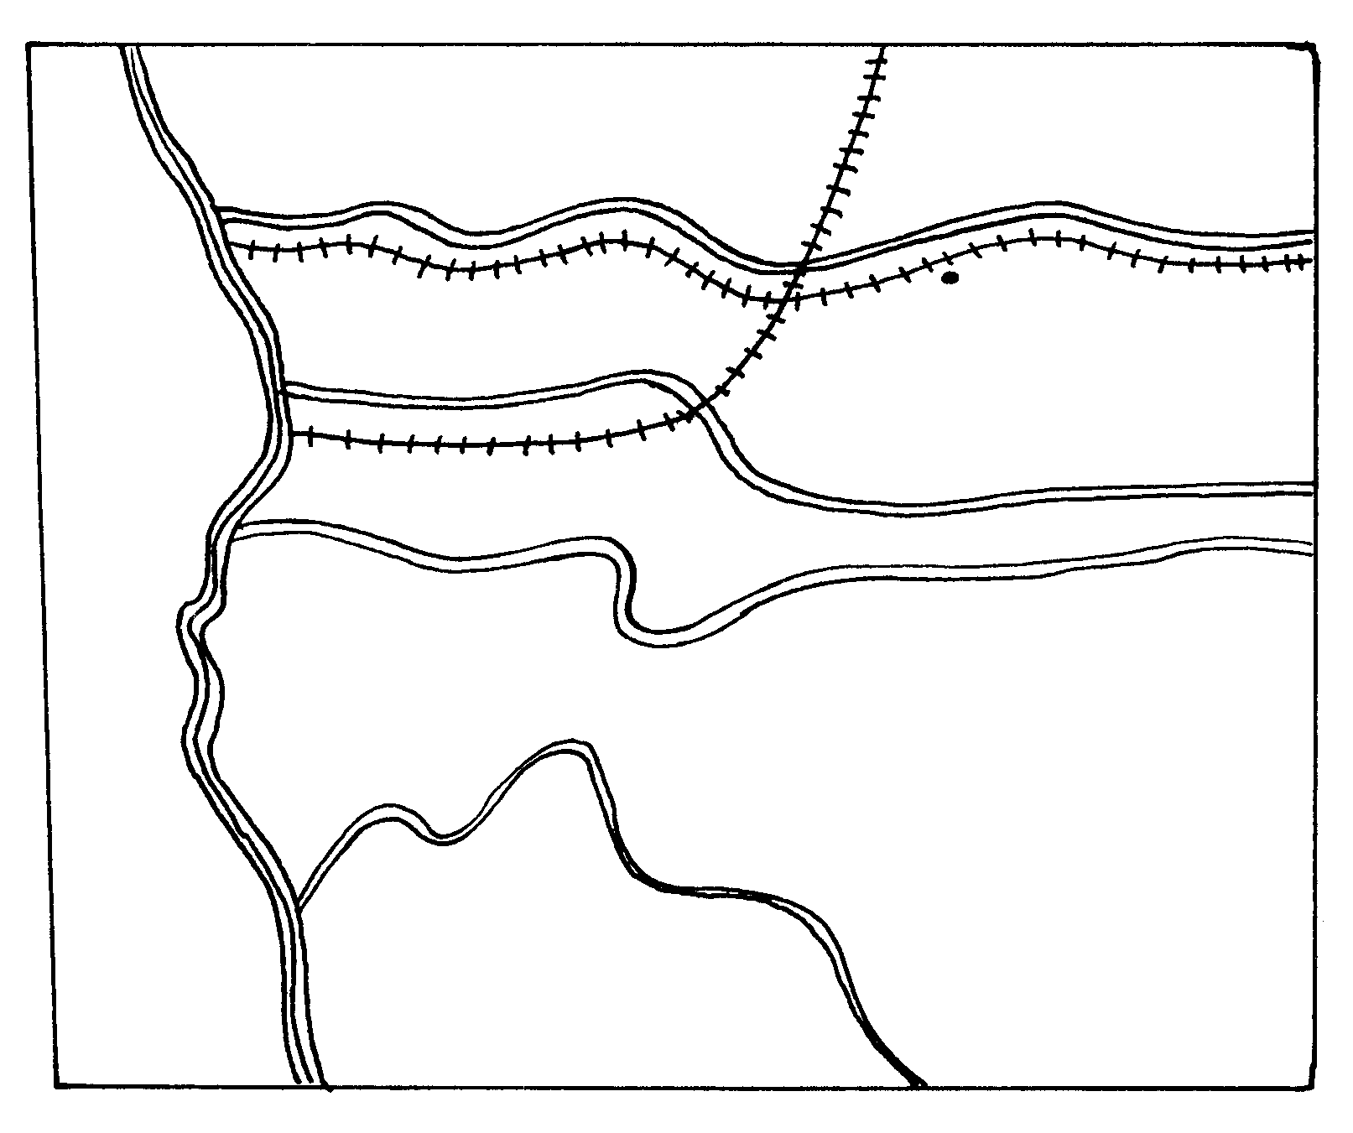
River Q
Z. CANAL
T
R. Rhine
R. Wupper
DUSSELDOLF
River S
ESSEN
River P
HAMM
Canal W
R. RHINE
Give the name of
(i) The river marked Q (1mk)
(ii) The town marked T (1mk)
(iii) The canal marked Z (1mk)
b) Give TWO reasons why the Ruhr region has become of little importance as an industrial centre in recent years. (2mks)
4. a) State two factors which have contributed to decline in infants mortality in Kenya.
(2mks) (2mks)
b) Identify three problems resulting from decline in population in industrialized countries. (3mks)
(3mks)
5. a) Name two environmental hazards that have affected Kenya in the recent years
(2mks)
b) Give three causes of noise pollution in Nairobi city. (3mks)
(3mks) *Nym *

SECTION B
Answer Question 6 and any other two questions.
6. The table below shows tea production in Kenya in thousands metric tonnes`
Tea production (000s of metric tones)
Zones | 2001 | 2002 | 2003
Kericho | 35 | 20 | 25
Nandi | 20 | 15 | 25
Kisii | 25 | 20 | 15
Kiambu | 15 | 12 | 15
Embu | 10 | 8 | 10
Meru | 5 | 15 | 10

- i) Use a compound bar graph to present the data provided above (6mks)
ii) What are the disadvantages of using compound bar graphs to present data? (3mks)
- i) State four condition favouring tea growing in Kenya (4mks)
ii) Explain four problems facing tea farmers in Kenya (8mks)
- Suppose students were to carry out a field study on a tea growing area of Kericho. Give four reasons why a pre-visit is necessary. (4mks)

7. Use the map of East Africa below to answer question (a) (i)
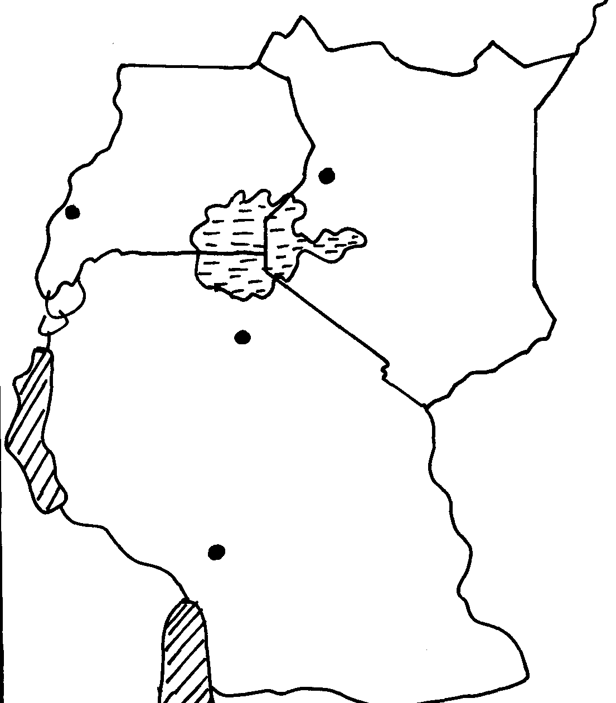
W
Z
Y
X

(a) (i) Name the minerals mined in the areas marked W, X, Y and Z (4mks)
(ii) Give four ways in which minerals occur (4mks)
(b)Identify any five factors that influence the exploitation of minerals (5mks)
(c) Explain any four problems associated with mining (8mks)
(d) List any four main minerals mined in Kenya (4mks)
8) a) (i) Define re-afforestation (2mks)
(ii)State four reasons why afforestation should be encouraged in Kenya (4mks)
(iii)Name three provinces in Canada where forestry is practiced on large scale (3mks)
b) Explain three problems which hinder the Kenya government efforts to manage and
Conserve forest (6mks)
c) Explain three factors that favour the growth of natural forest on the slopes of Mount Kenya (6mks)
d) Identify four factors that favour exploitation of forest in Canada (4mks)

9). a (i) Give three differences between a national park and a game reserve. (3mks)
(ii) Name four tourist attraction sites found in the coastal region of Kenya. (4mks)
b) (i) State two negative effects of tourism on the social life of Kenyans. (2mks)
(ii) State four reasons why domestic tourism should be encouraged in Kenya. (4mks)
c) State four measures that the Kenya government is taking to promote tourism. (4mks)
d) Explain four ways in which tourism has influenced infrastructure. (8mks)

10). (a) Explain four factors which influence the importation and exportation of goods in and out of Kenya (8mks)
(b) (i) Differentiate between visible and invisible trade. (2mks)
(ii) Explain four challenges facing trading activities among the East African Countries. (8mks)
(c ) (i) Name two products Kenya exports to other countries (2mks)
(ii) State five ways in which trade is of significance to Kenya. (5mks)

