ACK MUMIAS DIOCESE JOINT EXAM 2024
MARKING SCHEME
1. (a) Identify two minerals that make up the continental crust (2marks)
- Silica
- Aluminium
(b)State three causes of earth movement (3 marks)
-Magma movement - convectional current
-Gravitational force - Isostatic movements
2. The diagram below shows an example of a local wind.
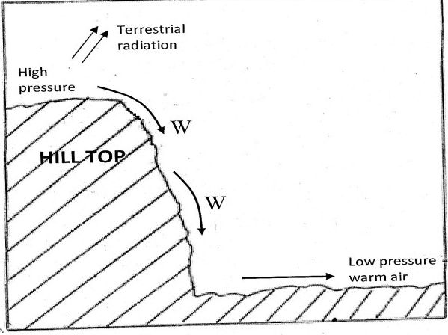
a) Name the wind (1 mark)
Katabatic wind
b) Describe how the wind occurs (4 marks)
- At night, the air over the hill tops and mountain slopes is cooled faster compared to the air at the valley bottoms
- The air at the hill tops become denser and with higher pressure while at the valley bottoms the air becomes warm/light and with lower pressure
- Air over the valley is warmed and rises
- Cool air over the hill tops move to the valley by gravity to replace the rising air as katabatic winds
3. a) Name the scale used to measure the magnitude of an earthquake. (1mk)
- Richter scale.
b) List three causes of earthquakes. (3mks)
- Energy released within the mantle.
- Blasting of rocks/ bombs explosion.
- Construction of large water reservoir.
- Folding / faulting .
- Isostatic adjustment.
- Movement of magma within earth’s crust/ volcanicity.
- Gravitative pressure.
- Collision of tectonic plate.

4. The diagram below represents the structure of the atmosphere. Use it to answer question (a).
(a) i) Name (i) the parts marked P and Q.
P - Mesosphere (1 mark)
Q - Thermosphere/lonosphere (1 mark)

(ii) the layer of discontinuity marked R.
R – Tropopause (1 mark)
(b) State two characteristics of the weather conditions in the troposphere.
- Temperatures decrease with an increase in height/normal lapse rate / the rate decrease
is 1°C for 160 metres of ascend/0.650C per 100 m/6.5 per 1000m
- Pressure falls with an increase in height/altitude.
- The speed of wind increases with an increase in height.
- It contains most of the atmospheric water vapour/clouds.
Any 2 x 1 = 2 marks

5. a) State two conditions necessary for the development of Karst scenery (2 marks)
- An area of limestone /chalk/dolomite rocks
- Thick layers of calcium carbonate rocks
- Hard and well jointed rocks
- Moderate to abundant rainfall
- A low water table
- Warm / Hot climate Any first 3 correct answers 1 x 2 = 2mks

b) Give two reasons why there are few settlements in Karst landscapes (3 marks)
- The areas are rocky
- They have thin soils
- They have poor vegetation
- There is inadequate water supply
- They have rugged surfaces Any first 2 correct answers 1 x 2 = 2mks

SECTION B
6. Study the map of Mumias 1:50,000 provided and answer the questions that follow.
a) i) Name two scales that have been used in the map (2 marks)
- Linear scale
- Ratio scale
ii) Give the magnetic variation of the map at the time it was drawn (2 marks)
2⁰19^{I}
iii) Identify three physical features in grid square 6042 (3 marks)
- Swamp
- River
- River valley
- Plain
b) i) Name two districts in Western Province in the area covered by the map (2 marks)
- Kakamega district
- Busia district
ii) Give the approximate longitudinal location of Mumias town (2 marks)
34⁰29^{I}
c) i) Draw a rectangle measuring 8cm by 4 cm to represent the area bounded by eastings 62 and 66 and northings 34 and 35 (1 mark)
ii) In the rectangle, mark and label the following:
  - River Lusimu (1 mark)
  - Bridge (1 mark)
  - All weather road loose surface (1 mark)
  - Woodland (1 mark)

Rectangle for area bounded by eastings 62 and 66 and northings 38 and 35

d) i) Citing evidence from the map, state two social services in the area covered by the map (4 marks)
Education services – schools
Health services -hospital
Religious services –mission/convent
Residential services – Built up areas
ii) Describe the drainage of the area covered by the map (5 marks)
- The main drainage feature are rivers
- There are many permanent rivers
-There are seasonal swamps
- R. Nzoia is the main river
- There are disappearing riverseg grid sq. 5636
- Most tributaries join rivers forming dendritic drainage pattern
- River Lusimu/Nzoia have meanders
- River Nzoia flows from North East to South West
7. (a) (i) What is a watershed (2 marks)
A watershed is a line/ boundary of dry land separating two drainage basins
(ii) Explain three ways by which a river transports its load (6 marks)
Suspension: - Light insoluble materials such as silt and sand are carried and maintained within the turbulence of the water while some float on the surface of the water.
Traction: - Large particles/ boulders are pushed and rolled along the river bed by the force of moving water.
Saltation/hydraulic lift: - Some particles/ pebbles which are fairly heavy are moved in a series of short hops and jumps along the river bed

(b) Study the diagram given below and answer questions that follow
i) Name the features marked W, X and Z (3 marks)
W – Wind gap/ dry valley
X – Elbow of capture
Z – Misfit river/ victim/ under-fit/ beheaded river
ii) Explain the process of river capture (5 marks)
- Two rivers flow adjacent to each other/ share a watershed.
- The more powerful river erodes vertically faster than the weaker one thus it flows at a lower level than the other one.
- The more powerful river erodes its valley towards the valley of the other river through headward erosion.
- Eventually the powerful river joins the valley of the weaker river.
- The powerful river diverts the head waters of the weaker river into its channel.

c) Give three characteristics of a river in its youthful stage (3 marks)
- Steep river gradient
- The river valley is deep
- Narrow river channel
- V-shaped valley
- The flow of the river is fast
- Vertical erosion is dominant
- The river has interlocking spurs
- Some parts of the river course have rapids/ waterfalls/ cataracts
- The river has a small volume of water

d) Explain three economic importance of a river to human activities (6 marks)
- Rivers supply water for domestic and industrial use.
- Some rivers provide water for irrigation
- Some rivers provide port facilities e.g. Kilindini harbour on river mwachi
- Navigable rivers provide route-ways for transportation Some rivers provide sites for generation of H.E.P
- Some rivers are sources of building materials like sand.
- Some rivers are sources of alluvial minerals like gold and diamond which are mined and sold earning income.
- Some rivers deposit alluvial soils along their flood plains hence supporting agriculture
- Some rivers provide rich fishing grounds which provide fish as a source of protein for people
- Some rivers provide spectacular features like waterfalls/ rapids attracting tourists earning a country foreign exchange

8. a) i)Define the term rock (2 marks)
An aggregate/agglomeration of mineral particles forming part of the earth’s crust
ii) Describe the formation of chemically formed sedimentary rocks (5 marks)
- Running water dissolves rock minerals on the land
- Dissolved minerals are carried in solution form into lakes/seas
- The minerals react with other chemicals in the water to form precipitates/evaporation takes place and precipitates form
- The precipitates accumulates on the sea/ lake in layers
- The precipitates are then compressed and compacted into rocks.
- The rocks formed are chemically formed sedimentary rocks
b) i) State three reasons why sedimentary rocks are widely spread at the coast (3 marks)
- The coastal plain is a lowland thus encourages deposition of sediments from rivers that form sedimentary rocks
- The coastal land emerged from the sea/ ocean where deposition of sediments had taken place
- The presence of shallow continental shelf which provide a condusive environment for formation of coral rocks

ii) State three changes that occur on sedimentary rocks when they are subjected to intense heat and pressure (3 marks)
- The colour of the rock changes
- The rock structure is altered
- New minerals are formed
- Rock minerals are re-crystallized
- Rock particles become compacted
c) Explain 4 ways in which rocks contribute to the economy of Kenya (8 marks)
- Some rocks are a source of income when sold improving the standards of living
- Some rocks such as limestone are raw materials for cement industries
- Some rocks weather to form fertile soils that support agriculture
- Some rocks such as granitic tors are tourist attractions thus earn foreign exchange
- Some rocks such as soapstone can be curved into artifacts that are sold to generate income
- Gemstones can be used to make ornaments that can be sold to earn income
-Some rocks contain minerals which can be extracted to provide revenue

d) Your class is planning to carry out a field study on rocks.
i) State three ways in which you will prepare for the study (3 marks)
- Seek permission
- Conduct a pre visit/ reconnaissance
- Adjust objectives and hypotheses
- Choose methods of data collection
- assemble necessary tools
- Prepare a working schedule
- Divide learners into groups
- Draw a route map
ii) Why would they need magnifying lens (1 mark)
- Viewing the rock crystals to determine the shape/ size

9. Below is a world map showing the distribution of fold mountains. Use it to answer question (a).
(a) (i) Name the fold mountains marked A and B (2 marks)
A –Himalayas
B - Akwapin
ii) Give the orogenies during which the fold mountains marked X and Y were formed (2 marks)
X – Hercynian orogeny
Y – Alpine orogeny
iii) Apart from fold mountains, name three other features resulting from folding (3 marks)
- Synclinal valleys/depressions
- Rolling plains
- Ridge and valley landscape
- Inter-montane plateau
- Inter-montane basin
- Escarpments
- Fold mountains
(b) With the aid of a well-labelled diagram, explain how a nappe fold is formed (6 marks)
- Rock layers are subjected to compressional forces.
- Intense folding leads to the formation of an over fold.
- Increased pressure on the over fold results in the formation of a recumbent fold.
- When pressure is very great, a fracture occurs along the axis in the recumbent fold producing a thrust-plane.
- The upper part of the recumbent fold slides forward over the lower part along the plane forming an overthrust/nappe fold.
Text – 4 marks
Diagram – 2 marks
(c) Explain three positive significance of folding to human activities (6 marks)
- Fold Mountains are sources of rivers that provide water for generation of H.E.P/domestic use/irrigation/industrial use.
- Fold Mountains are often forested and provide timber which is used in the building and construction industry/medical/aesthetic/wildlife habitat.
- Some fold mountains have exposed valuable minerals deposits which are mined.
- Fold Mountains are tourist attractions/snow covered slopes encourage sporting activities thus earning countries foreign exchange.
- The windward slopes of Fold Mountains receive high rainfall which enhances crop growing/livestock rearing.
- Some fold mountains may act as barrier to transport and communication/make the construction of transport and communication lines difficult/expensive.
- The rugged nature of some fold mountains landscapes hinder human settlement/agricultural activities.
- The leeward slope of some Fold Mountains create rain shadow effect which result into aridity discouraging crop farming / encourages livestock farming.

(e) Your class intends to carry out a field study on folding;
(i) State three reasons why you would require a route map (3 marks)
- To help identify the direction to be followed.
- To help in preparing a working schedule.
- To help in locating features for the study.
- To help estimate distance to be covered.
- To guide in estimating time for the field study.
- To help to estimate the cost of the study.
(ii) Name three secondary sources of information you are likely to use before the actual fieldwork (3 marks)
- Geography notes
- Internet/electronic media
- Journals/magazines
- Maps
- Newspapers
- Photographs/video tapes
- Professionals/botanists/forest officers
- Relevant text books

10. a) i) Define the term sea (2 marks)
A sea is a large salty water surrounded by land or inland salty body of water without connection
Large salty water body joined or separated from ocean through submerged rock strains / smaller division of oceans
ii) Give two causes of oceans currents (2 marks)
- Winds
- Earth rotation
- Shape of the landmasses
- Differences in water temperatures
b) Explain the factors that cause movement of ocean waters (6 marks)
-Prevailing winds - Wind blows over the water surface causing a frictional drag that makes the water to move horizontally towards the same direction with that of wind.
-The earth’s rotation - In the northern hemisphere, winds and current are deflected to the right while in the southern they are deflected to the left.
-Shape of the land masses - Due to land mass ocean current changes direction and follows the outline of the coasts.
Salinity of water - Highly saline water is denser thus causing sinking and less saline water floats hence the vertical movement.
- Convergence of the surface current makes water to sink and move vertically downwards.
c) i) List four types of tides (4 marks)
- Perigean
- Apogean
- Neap
- Spring
ii) Using a well labeled diagram, describe the formation of a Tombolo (7 marks)
A bar starts developing form the land towards an island due to wave deposition. The spit grows until it links the mainland to an offshore island
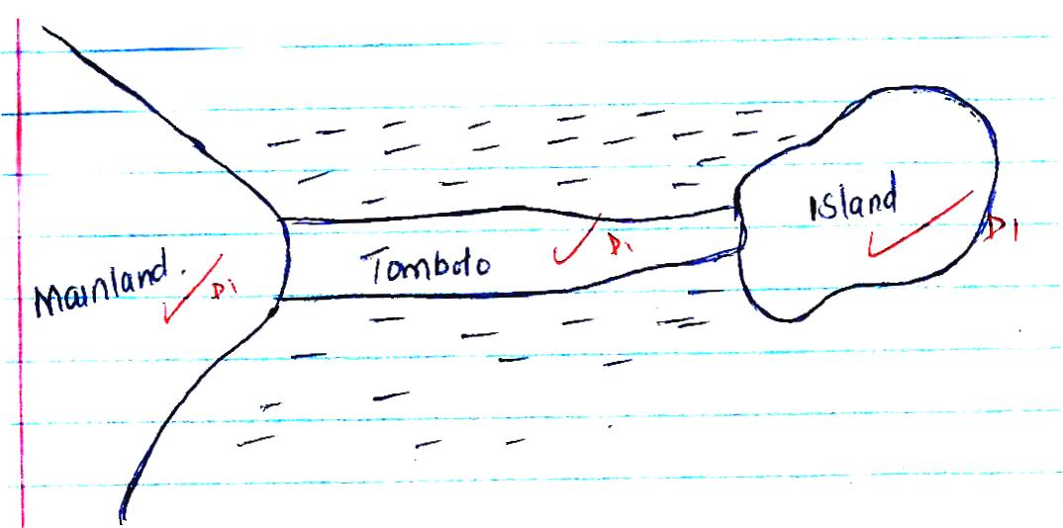
A Tombolo is a bar that is made of sand or shingle a links the mainland to an offshore island

d) Explain two economic benefits of oceans to man (4 marks)
- Oceans provides building materials e.g. sand, coral rocks
- Oceans modify the climate of the adjacent lands thus enhancing agricultural activities.
- Oceans are used by water vessels thereby enhancing transport/communication.
- Oceans provide sites for recreational activities thus promoting tourism.
- Oceans are habitats for aquatic life hence encouraging fishing.
- Oceans contain minerals which are extracted for economic development.
- Ocean waves/tides are harnessed to generate electric power for industrial/domestic use.
- Oceans provide water for cooling industrial plants.

