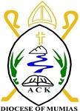
ACK JOINT EVALUATION EXAMINATION JUNE 2024
NAME: ………………………………………….…ADM NO: ……………….
SCHOOL…………………………………………..INDEX NO: ….................
312/1
GEOGRAPHY
PAPER 1
ACK MUMIAS DIOCESE EXAM
FORM 4
JULY 2024
INSTRUCTIONS TO CANDIDATES
i) This paper consists of two sections A and B
ii) Answer all questions in section A
iii) In section B, answer question 6 and any other two questions.
For Examiner’s use only
SECTION | QUESTION | MAXIMUM SCORE | CANDIDATE’S SCORE
A | 1-5 | 25
B | 6 | 25
B |  | 25
B |  | 25
TOTAL SCORE |  | 100

SECTION A
Answer all the questions in this section
1. (a) Identify two minerals that make up the continental crust (2marks)
(b)State three causes of earth movement (3 marks)
2. The diagram below shows an example of a local wind marked W.
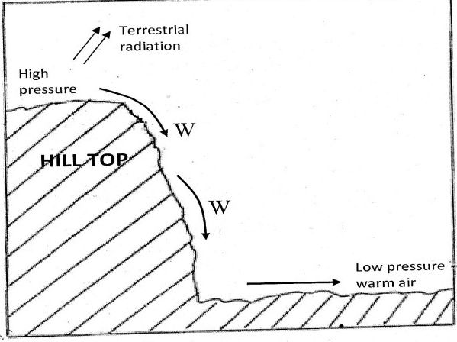
a) Name the wind (1 mark)
b) Describe how the wind occurs (4 marks)
3. a) Name the scale used to measure the:
i) intensity of an earthquake
ii) magnitude of an earthquake (2 marks)
- Give three natural causes of earthquakes (3 marks)
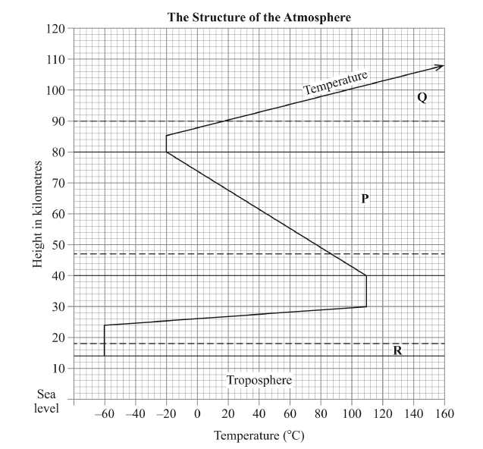
4. The diagram below represents the structure of the atmosphere. Use it to answer question (a).

(a) Name
(i) the parts marked P and Q (2 marks)
(ii) the layer of discontinuity marked R. (1 mark)
b) State two characteristics of the weather conditions in the troposphere (2 marks)
5. a) State two conditions necessary for the development of Karst scenery (2 marks)
b) Give two reasons why there are few settlements in Karst landscapes (3 marks)

SECTION B
In this section, answer question 6 and any other two questions.
6. Study the map of Mumias 1:50,000 provided and answer the questions that follow.
a) i) Name two scales that have been used in the map (2 marks)
ii) Give the magnetic variation of the map at the time it was drawn (2 marks)
iii) Identify three physical features in grid square 6044 (3 marks)
b) i) Name two districts in Western Province in the area covered by the map (2 marks)
ii) Give the approximate longitudinal location of Mumias town (2 marks)
c) i) Draw a rectangle measuring 8cm by 4 cm to represent the area bounded by eastings 63 and 65 and northings 34 and 35 (1 mark)
ii) In the rectangle, mark and label the following:
  - River Lusimu (1 mark)
  - Bridge (1 mark)
  - All weather road loose surface (1 mark)
  - Woodland (1 mark)
d) d) i) Citing evidence from the map, state two social services in the area covered by the map (4 marks)
ii) Describe the drainage of the area covered by the map (5 marks)
7. (a) (i) What is a watershed (2 marks)
(ii) Explain three ways by which a river transports its load (6 marks)
(b) Study the diagram given below and answer questions that follow.

i) Name the features marked X, W and Z (3 marks)
ii) Explain the process of river capture (5 marks)
c) Give three characteristics of a river in its youthful stage (3 marks)
d) Explain three economic importance of a river to human activities (6 marks)
8. a) i)Define the term rock (2 marks)
ii) Describe the formation of chemically formed sedimentary rocks (5 marks)
b) i) State three reasons why sedimentary rocks are widely spread at the coast (3 marks)
ii) State three changes that occur on sedimentary rocks when they are subjected to intense heat
(3 marks)
c) Explain four ways in which rocks contribute to the economy of Kenya (8 marks)

d) Your class is planning to carry out a field study on rocks.
i) State three ways in which you will prepare for the study (3 marks)
ii) Why would they need magnifying lens (1 mark)

9. Below is a world map showing the distribution of fold mountains. Use it to answer question (a).

(a) (i) Name the fold mountains marked A and B (2 marks)
ii) Give the orogenies during which the fold mountains marked X and Y were formed
(2 marks)
iii) Apart from fold mountains, name three other features resulting from folding (3 marks)
(b) With the aid of a well-labeled diagram, explain how an overthrust fold is formed (6 marks)
(c) Explain three positive significance of folding to human activities (6 marks)
(e) Your class intends to carry out a field study on folding;
(i) State three reasons why you would require a route map (3 marks)
(ii) Name three secondary sources of information you are likely to use before the actual fieldwork (3 marks)
10. a) i) Define the term sea (2 marks)
ii) Give two causes of oceans currents (2 marks)
b) Explain three factors that cause movement of ocean waters (6 marks)
c) i) List four types of tides (4 marks)
ii) Using a well labeled diagram, describe the formation of a Tombolo (7 marks)
d) Explain two economic benefits of oceans to man (4 marks)

