BRISINGA - 2024
233/2
CHEMISTRY PP2 SCHEME
FORM 4
JULY - 2024

(SCHOOL OF CHOICE)

1. a)i) Separation of different salts by making use of the differences in solubility in the same solvent.
ii) I. L
II. (175 – 8.0)g = 9.5g (jej without units)

b) i) Water containing Ca²⁺ and Mg²⁺ ions/does not lather easily with soap
ii) Used in beer brewing
iii) Sodium ions displaces Ca²⁺ & Mg²⁺ ions; causing them to precipitate out.

c) i) I. Copper carbonate/Copper sulphate
II. Co₂ / SO₂
²⁺
ii) CU (NH₃)₄

iii) CU²⁺⁽_{aq)} + 2OH⁻_{(aq)} Cu(OH)_{(s)}

2. i) Platinum – Rhodium
ii) Neutralization
iii) 2HNO_{3(aq)} + H₂S_{(g)} 2NO_{2(g)} + 2H₂O_{(l)} + S_{(s)}
iv) Silver is less reactive (Lower in the reacting series) hence cannot displace copper.
v) Fertilizer
Food preservative
Fireworks

vi) NH₄NO₃ (NH₂)₂CO (Urea)
% of nitrogen = $\frac{RAM}{RFM} ×100$ $\frac{28 X 100}{60}$ = 46.67%
$\frac{28 X 100}{80}$ = 35.0%
iv) It contains higher contents of Nitrogen

3. ( a ) - colors/dyes
- perfumes/ esters 2x½ =1mk
- Stabilizers
- tetraoxophosphate
( b ) (i) Heating.
(ii)
( c ) (i) Neutralization
(ii) Sodium hydroxide
(iii) sodium dodecene benzene sulphonate/ sodium alkylbenze sulphonate 1mk
( d ) (i) Soapless detergent form compounds salts of calcium and magnesium hence do not form scum with hard water.
(ii) The active ingredients, such as benzene sulphonate are non-biodegradable and they hence accumulate and end up in the bodies of organism.
( e ) (i) Esterification
(iii) Conc. Sulphuric acid
It absorbs the molecules of water formed during the reaction hence forward reaction proceeds to produce water to replace the amount withdrawn.
Hydrolyzing agent 1mk

4. ( a ) T₂ has the highest electron affinity or it is the most electropositive.
( b ) P and T or P(s)/ P⁺ (aq)//T⁻(aq)/^{½}T₂(g)
( c ) S(s) + P⁺(aq) S²⁺(aq) + P(s)
Solution:
S(s)/S²⁺(aq)//P⁺(aq)/P(s)
E.m.f = E red - E oxid
= (-2.92) – ( -0.44 )
= - 2.48v
Hence the voltage is –ve and therefore reaction cannot take place.
( d ) P(s)|P+(aq) // Q+(aq)| Q(s) = +3.44V 1mk
1mk for calculating the emf ( +3.44v)
( e ) (i) 4OH⁻(aq) 2H₂O(1) + O₂(g) + 4e⁻
(ii) Introduce a burning wooden splint at the mouth of gas jar filled with a gas A. The gas extinguishes a burning splint with a pop sound.
(iii) 2moles of gas A are produced at cathode while only 1 mole of gas B is produced at the anode by the same quantity of electricity. WTTE
( f ) Q = It
24000 cm³ = (2 × 96500) C
480 cm³ = ?
= 2 × 96500 × 480
24000
= 3860C
Q = It but Q = 3860C
3860C = I × 18× 60
I = 3860C
18 × 60
= 3.57 A
5. ( a ) Transition elements
( b ) G is more reactive than J
G requires less energy to lose its one outer electron than 2 electrons for j
( c ) K has a larger atomic raius than L.K has less effective nuclear attraction which makes its radius to be larger than that of L.
( d )
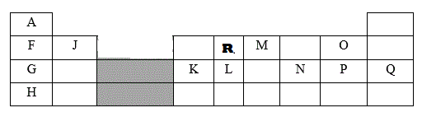
( e ) KP₃
( f ) Ionic bond; F (metal) transfers electrons to O (non metal).
( g) G: 2.8 ; M: 2.8
( h) Can lose one electron in its outer energy level like members of group 1 to be stable
Can gain one electron to be stable like members of group VII.
6. a)i) Suphuric (IV) Oxide ½
ii) 2CuFeS_{2(s)} + 4O_{2(g)} 3SO_{2(g)} + 2FeO_{(s)} + Cu₂S_{(s)} 1
iii) Fe²⁺ ½
iv) Carbon (II) Oxide / CO_{(g)} ½
v) Reduction ½
Copper (I) Oxide is reduced by coke to copper metal
vi) - To make electrical appliances
- To make coins
- In roofing and making gutters
- To make alloy such as brass and bronze
b)i) X – Molten sodium chloride ½
gas Y - Chlorine ½
ii) Less dense than molten sodium Chloride ½
Has low melting point ½
Crystallises faster than calcium
(iii) At high temperature, steel would react with chlorine formed, but graphite is inert even at high temperature
(iv) Add water then evaporate to form sodium hydroxide (NaOH)
2NaHg_{(l)} + 2H₂O_{(l)} // 2NaOH_{(ag)} + 2Hg_{(s)} + H_{2(g)}
7.
5. a) heat change when one mole of water is formed by the reaction of H+ ions and OH- ions (1 mark)
b) The table below shows temperature reached when equal volumes of an alkaline solution of 1.5M concentration was reacted with 0.95M sulphuric (VI) acid.
s=1
p=1
c=1 (1 mark each total 3mks)

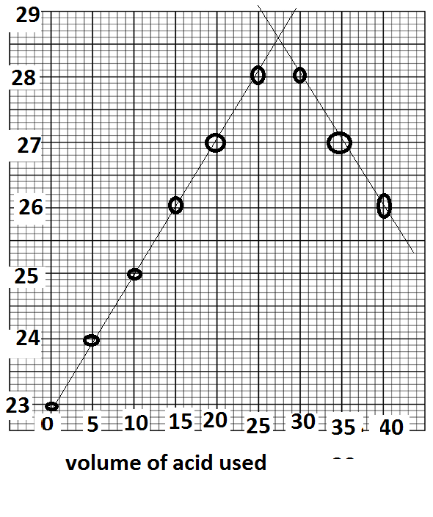
Highest temperature reached in ⁰ C
c. From the graph determine

use correct graph reading = 27.7cm³(1 mark)
the temperature change use graph(23-28.5)
don’t penalize –ve sigh
d. Calculate the heat change for the above reaction density of solution 1g/cm³, Specific Heat Capacity 4.2g/J/K (2mks)
(4.2 x (27.7+30) x(23-28.5)) = -1333.87J
e. Calculate the molar heat of neutralization for the reaction (2mks)
0.026315M = --1333.87J
1M = -50.65kJ/mol

