BRISINGA 2024 DERIES
GEOGRAPHY PP1 SCHEME
1. (a) Name two theories of the origin of the earth.
- Passing star theory
- Nebula cloud theory
(2x1=2marks)
(b) State three effects of the rotation of the earth.
- Causes day and night
- Causes deflection of winds and ocean currents
- Causes rising and falling of tide
- A difference of 1 hour between two longitudes 15 degrees apart
- Causes difference in atmospheric pressure on the surface of the earth
- Vaviation in the speed of air masses
(3x1=3marks)
2. a) (i) Name three types of vegetation
• Natural vegetation
• Derived vegetation
• Cultivated vegetation/planted (3 x 1 =3mks)
b) Use the diagram below of a mountain vegetation zone of a mountain in
Kenya to answer the following questions.
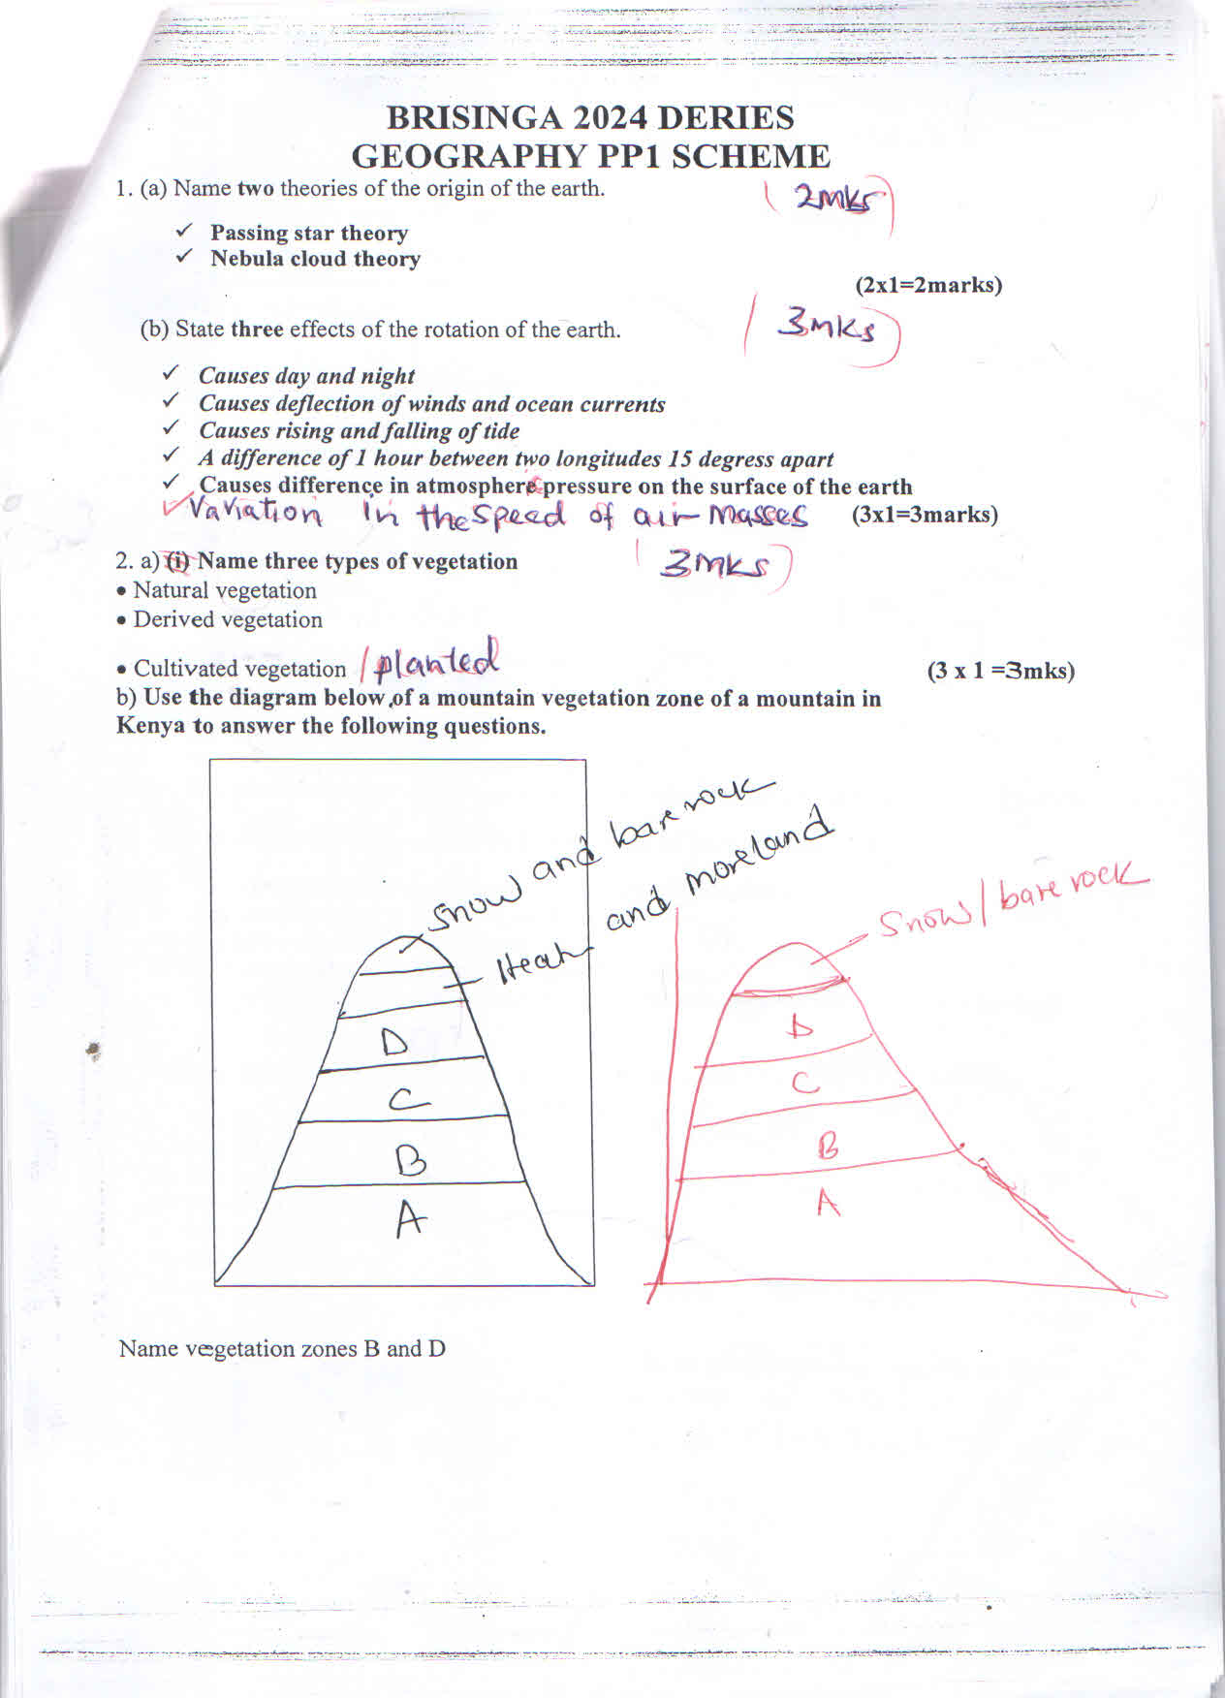

Name vegetation zones B and D
• B Rainforest
• D - Hearth and moorland (2x1=2)
3. (a) Name two major earthquakes zones of the world.
- The Circum-Pacific belt/Ring of fire
- The Mediterranean-Himalayan belt
- Great Rift valley belt
- Mid Atlantic Ocean belt (2x1=2marks)
(b) State three causes of earthquakes.
- Gravitative pressure
- Isostatic adjustment
- Magma movement in the crust
- Volcanic eruptions
- Building reservoirs
- Collision of tectonic plates
- Movement trains
- Use of explosives during mining/quarrying (3x1=3marks

4. a). Identify three sources of underground water.
- Rain water
- Melting glacier/melt water
- Water bodies like sea, ocean and lake water
- Magmatic water or water tapped in rocks underground/ plutonic water (3x1=3)
b) Give conditions necessary for the development of a karst landscape?
- The rainfall should be moderate to high/ humid conditions.
- The temperatures should be high/ hot conditions
- Presence of a hard / well jointed rocks
- The water table should be deep below the surface.
- The area should have thick lime stone / chalk / dolomite on the surface and beneath
(3x1=3).
5. List three features formed as a result of action of water in arid areas.
- Wadis
- Inselberg
- Pediments and pediplains
- Playa and Salinas
- Messas and buttes
- Dry river valley
- Alluvial fan
- Bajada/Bahada (3x1=3)
b). State two significance features of action of wind and water in arid areas. (2 mks)
- Features such as barchans and zeugen are tourist attractions that earns the country foreign exchange.
- Loess form deep soils that promote Agriculture.
- Sand harvested is used for building and construction.
- Salt flats are economically used for salt production (3x1=3)
6. Study the map of MUMIAS 1:50,000 (SHEET 101/2) provided and answer the following questions.
a) i) Name two map sheets to the North of Mumias map (2 mks)
- Bungoma 88/3
- Malakisi 87/4 (Uganda 64/4)
- Tororo (Kenya 87/3) Uganda 64/3

ii) Identify two districts represented by the area covered by the map (2 mks)
- Busia
- Kakamega
- Bungoma
- Siaya
iii) What is the vertical interval (IV) of Mumias map extract (1 mk)
- 20M
b) i) Name two human made features found in grid square 5536.
- Huts/Settlement
- Main track (motorable)
- Other tracks (Foot path
ii) Give two types of settlement patterns found on the Eastern part of Mumias town (2 mks)
- Linear
- Clustered/nucleated
- Radial

c) i) State two types of Rivers found in the area covered by the Map (2 mks)
- Permanent rivers – with examples
- Disappearing/vanish ire/short Rivers – specific example

ii) Explain two ways in which drainage has influenced the distribution of settlement (4 mks
- There is no settlement in the seasonal swamp due to poor drainage/fear of flooding attack by water borne diseases
- There are few settlements along the lower section of River Nzoia due to fear of flooding/attack by water borne disease/aquatic animals
- There is linear settlement along River Nzoia in grid square 6439 due to provision of water for use.
- There are nucleated settlement around seasonal swamps due to the area being flood plain may contain fertile alluvial soils for agriculture/River Lusimu due to provision of water for use.
d) Citing evidence from the map give two functions of Mumias . (2 mks)
- Residential huts, build ups/ training school
- Health medical centre as evidenced by presence of dispensary/mission hospital
- Religious centre as evidenced by presences of /converts
- Transport centre as evidenced by presence of all-weather roads loose surface/mission tracks (motorable) dry weather roads/other tracks and footpaths
e) Draw a rectangle 20cm by 16cm to represent the area enclosed by Easting 46 and 51and Northing 40 and 44.
i) On the rectangle mark and name
- Woodland
- Bumala Dam
- Pypypus swamp
20cm

16cm

ii) Calculate the new scale of your drawing
New scale of drawing = original scale x scale factor
($1cm rep 1km$
1:1,000,000
7. a) Define the term Magma. (2 mks)
- It is molten rock under the Earth’s crust

b) Distinguish between a sill and a dyke (2 mks)
- A sill is near horizontal/tabular sheet of igneous rock formed from solidified magma intruded between bedding plane while a dyke is a layer of intrusive rock which cuts near vertical/discordaully across the bedding plane.
c) The diagram below represents a composite volcano. Name the feature marked P,Q and R
(3 mks)
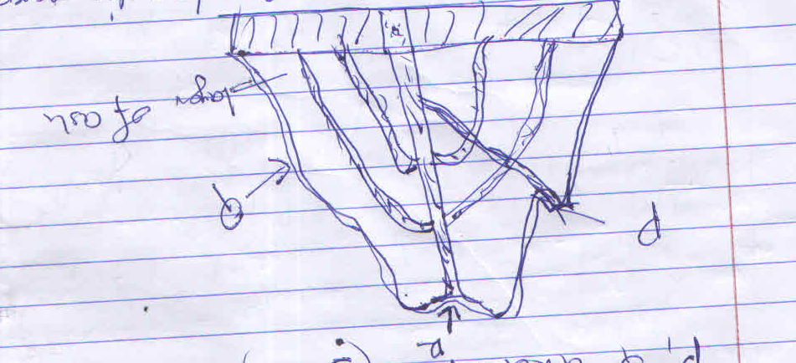

- P:Conalet/subsiding cone/acidic pares tic cone
- Q: Layer of Lava
- R: Crater

d) Describe how the following features are formed
i. Geyser (5 mks)
- Rain water percolates down in cracks in the rocks. The water gets into contact with hot igneous rocks
- The water is super-heated and gases/steam form. Pressure builds up in the cracks. The pressure causes steam and water to be ejected explosively as jet to the surface intermittently
- The water and the steam are emitted intermittently as pressure levels changes
- Example lake Bogoria
ii. A lava plateau (5 mks)
- It is formed when magma reaches the surface of the earth through a series of fissures/ cracks
- The lava is extremely fluid ultra-Basic/less viscous
- The lava spread evenly over a large area/long distance
- The lava cools slowly and solidifies forming
- Flat raised table like feature/land referred to us a plateau

e) Explain four ways in which volcano features influence human activities (8 mks)
- Volcanic highlands or mountain are a source of Rivers which provide water for domestic/industrial/agricultural use
- Volcanic rocks weather down to form fertile volcanic soils which support agriculture
- Volcanic rocks are important building materials in the construction industry
- Volcanic features eg granites tours are a tourist attraction which promote tourism
- Volcanic mountain or highlands influence formation of relief rainfall which encourage agricultural activities
- Volcanic highlands modify temperature making them attractive to human settlements
- Volcanic features e.g steam jets and geysers provide suitable sites for geothermal powers
(4 x 2 = 8 mks) (features should be mentioned)

8. a) Give three processes in the hydrological cycle (3 mks)
- Precipitation
- Evaporation/Transpiration/evapotranspiration
- Surface run off/overland flow
- Infiltration
- Percolation(3x1=3mks)

b)i) What is River rejuvenation (2 mks)
- This is the renewal of the Rivers erosive ability/activity/power
ii) Give four causes of River rejuvenation (6 mks)
  - Increase in River discharge
  - Change in rock resistance
  - Unequal regional subsidence
  - Regional/local uplift of land/fall in sea level/drop in sea level (4 x 1=4 mks)
The diagram below shows a Bird’s foot delta. Use it to answer questions
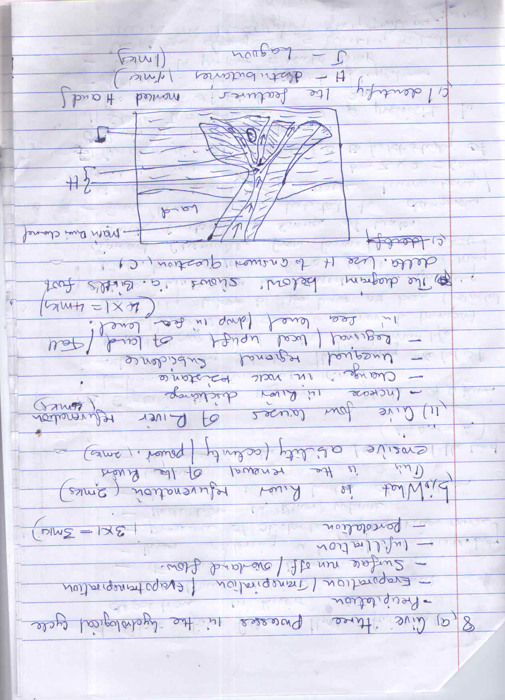

c) Identify the features marked H and J (2 mks)
- H- Distributaries
- J: Lagoon

d) State four factors that facilitate deposition in River (4 mks)
- Reduction in River gradient
- Freezing of River water
- River entering a large/calm waterbody
- Presence of obstacles on the river course
- Reduction in River volume
- Increase in the width of the River channel
- Increase in the amount/size of the Load (Any 4 x 1=4 mks)

e) Explain three negative effects of a River to human environment (6 mks)
- When Rivers floods they destroy a lot of property/crop/lead to loss of human life
- Wide/deep Rivers are a barrier to transport especially where bridges have not been constructed
- Rivers water can be a medium for spreading water born disease, since flood water may spread chemicals from farms/human waste which contaminates sources of water
- Some Rivers are a habitat to dangerous animals which may attack human beings/destroy crops (any 3x2=6mks)

f) You class is set to conduct a field study of a River in its old stage
i) State two reasons for a previsit to the area of study (2 mks)
- Helps in adjusting objectives/hypothesis
- Helps to prepare a route map
- Helps in designing a working schedule
- Helps in identifying likely problems (2 x1=2mk)
- Helps in identifying suitability of an area for the study
- Any relevant point

ii) State two activities you will carry out to determine why deposition occurs at this stage.(2 mks)
- Measuring of gradient/observe the slope
- Finding out the nature of the load
- Finding out the amount of the load; establishing the velocity of the River
- Observing obstacles in the River channel
- Measure the width of the River(2 x1 = 2 mks)

9a) i). Name three types of tides. (3marks)
- Spring tides
- Neap tides
- Perigean tides
- Apogean tides(3x1=3mks)
ii). Describe two processes by which waves erode. (4marks)
- Hydraulic action - the swash/breaking waves hit against the cliffs shattering the rocks./The force of breaking waves compress air into the cracks in the cliff face and parts of the rocks may break off.
- Abrasion/corrasion rock fragments carried by waves are used as a tool to grind against the cliff face as the waves break. Rock fragments carried by the backwash erode the sea floor.
- Solution/corrosion - The solvent and chemical action of the sea water dissolves and removes the soluble materials that are found in the cliff/sea floor.
- Attrition - Particles that are carried by waves are constantly colliding against each other. This wears them into smaller sizes. (3mks)
(2x 2 =4mks)
b) Using well labeled diagrams, explain how each of the following features is formed.
i) A spit (5marks) ⎫
- The direction of a coastline/orientation of the coast changes towards the land- across a river estuary or bay entrance. ⎫
- The long-shore drift maintains its straight course towards a shallow shore/land. ⎫
- The long-shore drift comes across a headland which disrupts its smooth flow. ⎫ The materials carried by the long shore drift are deposited along the coasts. ⎫
- Deposition continues, extending into a bay/mouth of a river with one end attached to the land. ⎫
- Eventually, ridge with one end attached to the land and the other projecting into the sea is formed. This is a spit.

ii) A blowhole (5mks) ⎫
- A line of weakness/cracks develop at the roof of a cave. ⎫
- Wave erosion act on the crack from cave roof upwards. ⎫
- Weathering by solution act on crack from the surface downwards. ⎫
- These processes widen the vertical crack with time to form a hole. ⎫
- The vertical hole or shaft which connects the cave’s roof to the surface is called a blowhole.
c) Some students carried out a field study on coastal features found along the coast of Kenya.
i) List three features formed as a result of emergence highland coasts that they
are likely to have studied. (3marks)
    - Raised beaches.
    - Raised wave cut platforms.
    - Raised cliffs.
    - Raised caves and notches.
    - Raised archs, stacks, and stumps.
    - Raised geo
    - Raised blow hole.
    - Raised notches (3x1=3mks)
- ii) State three methods the students may have used to record their data.
(3mks.
Filling in questionnaires
Labeling samples
Video recording/Filming/photographing
Drawing sketches
Note taking
Tabulating(
iii) Outline two ways in which features resulting from coastal emergence
are of significance to Kenya.(2 mks)
- Some of the coastal marine habitats; provide area for research.
- Some submerged coasts favour the development of deep sheltered harbours; suitable for construction of ports.
- Some fiords provide breeding grounds for fish; providing man with food and income. iv. Some coastal features/ floods/ sand beaches/ cliff e.t.c; provide sceneries for tourist attraction; thus promoting foreign exchange.
- Some raised coral reefs are a source of limestone; used for manufacturing cement/ building materials.
- Some coastal areas support growth of mangrove trees; used as building poles.
- Some coastal soils/ sandy soils; are not suitable for cultivation of crops.
- Some lagoons, mudflats, coastal marshes and coral reefs form good habitats; for marine life or conservation.
- Some irregular/discordant/irregular coasts with inlets; facilitate breeding of fish; thus promoting fishing industry.
- Some emerged coastal plains provide land for settlement
- Some fossils that form at the shallow continental shelves; are mined, refined and used as energy sources.
- Some coastal features such as beaches and cliffs are steep; thus discourage settlements. Some emerged coastal lands have infertile soils due to sand, gravel or bare rocks; unsuitable for agriculture.
- Deposited sands, bars and coral reefs are barrier to transport as they can cause ship wrecking if vessels hit them.(2x1 = 2mks)
10. (a) i) Give three examples of non-metallic minerals. (3 marks)
- Coal
- Carbon
- Nitrates
- Graphite
- Silica
- Fluorspar
- Soda ash (3x1=3marks)
ii) Why is industrial diamond used in shaping hard stones and metals? (1 mark)
- It’s the hardest mineral.
- It does not break easily.
- it maintains its sharpness for long (1x1=1mark)
(b) i) Give two examples of hypabyssal igneous rocks. (2 marks)
- Dolerite
- Porphyry
- Rhyolite
- Lamprophyre
- Granophyre
- Porphyrite
- Diabase
(2x1=2marks)
ii) State two reasons why sedimentary rocks are wide spread in the coastal plain of Kenya. (2 marks)
- The coastal plain is a low land which has facilitated deposition of sediments.
- The shallow continental shelf has conducive environment for the formation of coral rocks.
- The coastal lands emerged from submerged lowlands where coral reefs/polyps were once living.
- Mouth of several rivers which deposit the loads with the flood plain
- High temperatures facilitate formation of chemically formed sedimentary rocks
(2x1=2marks)

(c) Describe the following processes of formation of metamorphic rocks:
- Thermal Metamorphism (4 marks)
- The original rock is subjected to intense heat.
- The heat is due to the contact with hot magma
- The magma melts the minerals of the original rocks
- Eventually cool and solidify to form a different rock. (4x1=4marks)

- Dynamic Metamorphism (4 marks)

- Original rock is subjected to intense pressure.
- The pressure is caused by compressional forces when the crustal plates collide.
- The great pressure changes the minerals line in the rock structure.
- The rock changes their physical appearance and characteristics forming a new rock (4x1=4marks)
(d) Suppose you were to carry out a field study on rocks within the vicinity of your school.
- Name three secondary sources of information you would use for preparation of the study. (3 marks)
- Journals/magazines/periodicals/newspapers/pamphlets on rocks
- Maps/geological maps on rocks
- Geography text books
- Statistical abstracts on rocks (3x1=3marks)
- State three activities you would carry out during the field study. (3 marks)
- Collecting rock samples
- Taking photographs of different rocks
- Drawing sketches
- Taking notes
- Labeling samples
- Interviewing
(3x1=3marks)
- State three problems you are likely to experience during the study (3 marks)
- Difficulty in identifying of the different types of rock
- Accidents such as slipping and falling
- Attack by wild animals
- Difficulty in climbing steep slopes

