Name………………………………………….… Adm No………………. Class…………….

Candidate’s Signature…………………….…………….….…...Date……………………….

School: ……………………………………………………………………………………………….

GEOGRAPHY PP1
FORM 4
JULY - 2024

BRISINGA MOCK – 2024 SERIES
Kenya Certificate of Secondary Education
Instructions
- This paper consists of two sections A and B
- Answer all the questions in section A
- Answer question 6 and any other two questions from section B.
- Candidates should answer the questions in English.
FOR EXAMINER’S USE ONLY

Section | Questions | Maximum  Score | Candidate’s  Score
A | 1 - 5 | 25
B | 6 | 25
 |  | 25
 |  | 25

SECTION A
Answer all questions in this section
1. (a) Name two theories of the origin of the earth. (2 mks)
(b) State three effects of the rotation of the earth. (3 mks)
2. a) (i) Name three types of vegetation (3 mks)

(b) Use the diagram below of a mountain vegetation zone of a mountain in
Kenya to answer the following questions.
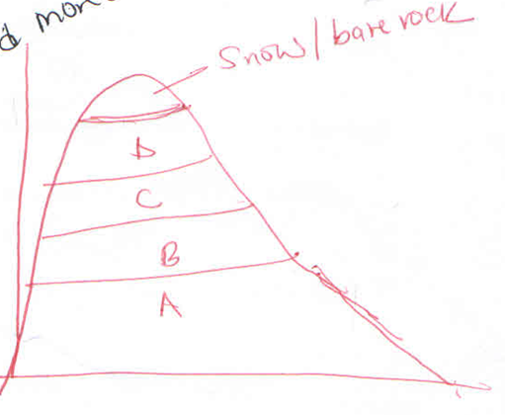
Name vegetation zones B and D (2 mks)
3. (a) Name two major earthquakes zones of the world. (2 mks)
(b) State three causes of earthquakes. (3 mks)

4. a). Identify three sources of underground water. (3 mks)
b). Give two conditions necessary for the development of a karst landscape? (2mks)
5. a) List three features formed as a result of action of water in arid areas. (3 mks)
b). State two significance of resultant features of action of wind and water in arid areas. (2 mks)

6. Study the map of MUMIAS 1:50,000 (SHEET 101/2) provided and answer the following questions.
a) i) Name two map sheets to the North of Mumias map (2 mks)
ii) Identify two districts represented by the area covered by the map (2 mks)
iii) What is the vertical interval (VI) of Mumias map extract (1 mk)
b) i) Name two human made features found in grid square 5536. (2 mks)
ii) Give two types of settlement patterns found on the Eastern part of Mumias (2 mks)
c) i) State two types of Rivers found in the area covered by the Map (2 mks)
ii) Explain two ways in which drainage has influenced the distribution of settlement. (4 mks)
d) Citing evidence from the map give two functions of Mumias town. (2 mks)
e) Draw a rectangle 20cm by 16cm to represent the area enclosed by Easting 46 and 51 and Northing 40 and 45.
i) On the rectangle mark and name
- Woodland
- Bumala Dam
- Pypypus swamp
20cm

16cm

ii) Calculate the new scale of your drawing
7. a) Define the term magma (2 mks)
b) Distinguish between a sill and a dyke (2 mks)
c) The diagram below represents a composite volcano. Name the feature marked P,Q and R
(3 mks)
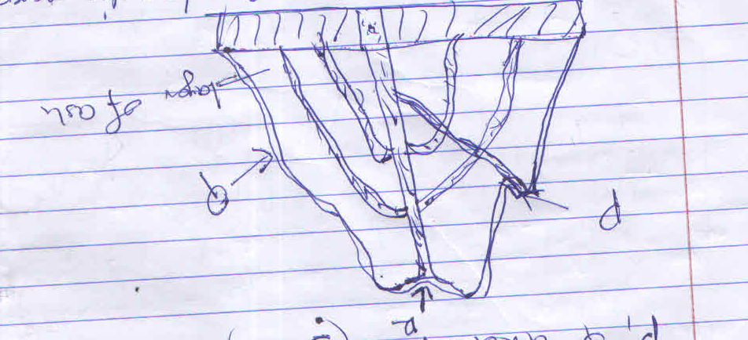

d) Describe how the following features are formed
i. Geyser (5 mks)
ii. A lava plateau (5 mks)
e) Explain four ways in which volcano features influence human activities (8 mks)
8. a) Give three processes in the hydrological cycle (3 mks)
b)i) What is River rejuvenation (2 mks)
ii) Give four causes of River rejuvenation (6 mks)
The diagram below shows a Bird’s foot delta. Use it to answer questions

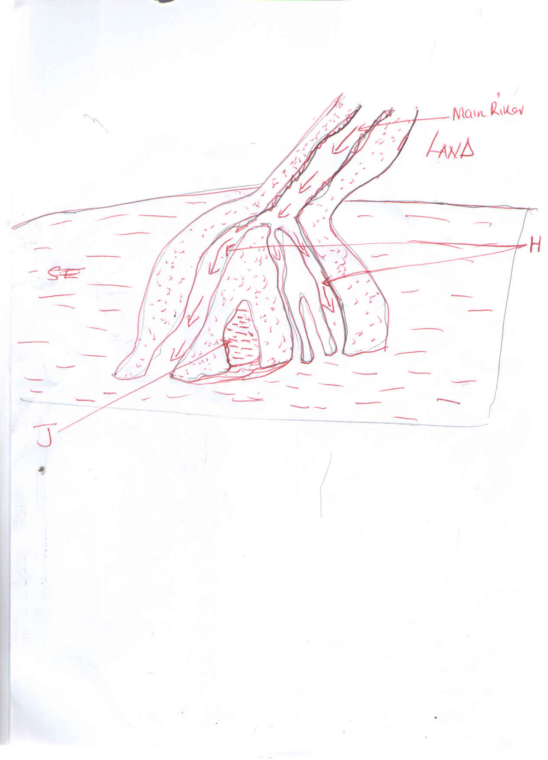
c) Identify the features marked H and J (2 mks)
d) State four factors that facilitate deposition in River (4 mks)
e) Explain three negative effects of a River to human environment (6 mks)
f) You class is set to conduct a field study of a River in its old stage
i) State two reasons for a previsit to the area of study (2 mks)
ii) State two activities you will carry out to determine why deposition occurs at this stage.(2 mks)
9a) i). Name three types of tides. (3marks) ii). Describe two processes by which waves erode. (4marks)
b) Using well labeled diagrams, explain how each of the following features is formed.
i) A spit (5marks) ii) A blowhole (5marks)
c) Some students carried out a field study on coastal features found along the coast of Kenya.
i) List three features formed as result of emergence of highland coasts that they
are likely to have studied. (3marks)
ii) State three methods the students may have used to record their data. (3mks.
iii) Outline two ways in which features resulting from coastal emergence
are of significance to Kenya. (2 mks)
10. (a) i) Give three examples of non-metallic minerals. (3 marks)
ii) Why is industrial diamond used in shaping hard stones and metals? (1 mark)
(b) i) Give two examples of hypabyssal igneous rocks. (2 marks)
ii) State two reasons why sedimentary rocks are wide spread in the coastal plain of Kenya. (2 marks)
(c) Describe the following processes of formation of metamorphic rocks
Thermal Metamorphism (4 marks)
Dynamic Metamorphism (4 marks)
(d) Suppose you were to carry out a field study on rocks within the vicinity of your school.
- Name three secondary sources of information you would use for preparation of the study. (3 marks)
- State three activities you would carry out during the field study. (3 marks)
- State three problems you are likely to experience during the study (3 marks)

