BSJE JOINT EXAMINATION
- 2024 -
Kenya Certificate of Secondary Education
312/1 GEOGRAPHY PAPER 1
July, 2024 TIME: 2 ¾ Hours

Name: …………………………………… Admission No: …………School: ……………..…. Stream: …………………….. Signature: …………….
312/1 - GEOGRAPHY
Monday, 22nd July, 2024
Morning
7.00am - 9.45am

Instructions to Candidates
- Write your Name and Index Number in the spaces provided above.
- Write the name of your school and class in the spaces provided.
- Sign and write the date of the examinations in the spaces provided.
- This paper consists of two sections; A and B
- Answer all the questions in section A.
- Answer question 6 and any other two questions from section B.
- Answers must be written in the spaces provided at the end of question 10.
- This paper consists of 15 printed pages.
- Candidates should check the question paper to ascertain that all the pages are printed as indicated and that no questions are missing.
- Candidates should answer the questions in English.
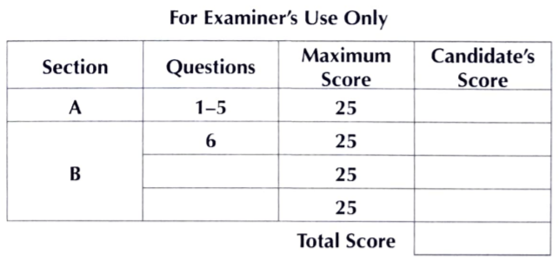
SECTION A
Answer all the questions in this section.
- (a) The local time at Helsinki, Finland (60⁰North, 28⁰Eeast) is 9.40 a.m. Calculate the local time at New Orleans, USA (45⁰South, 90⁰West). (3 marks)
(b) Differentiate between a solstice and an equinox. (2 marks)

- (a) How does isostatic adjustments of the crustal rocks cause earth movements? (2 marks)
(b) Name three major plate boundaries of the earth. (3 marks)

- The figure below shows some of the world’s ocean currents. Use it to answer the question (a).
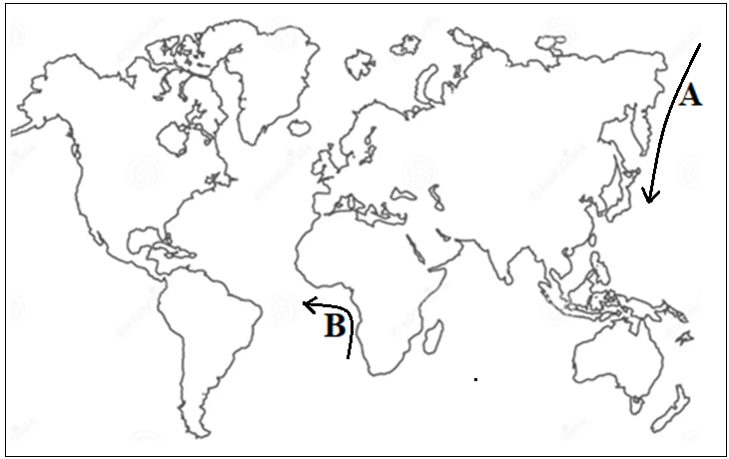
- Name the ocean currents marked A and B. (2 marks)
- State two factors that influence the growth of coral polyps. (2 marks)

- (a) Give two fold mountain orogenies. (2 marks)
(b) State three effects of fold mountains on climate. (3 marks)

- (a) State three problems of volcanoes. (3 marks)
(b) Give three life cycles of a volcano. (3 marks)

SECTION B
Answer question 6 and any other two questions in this section.
- Study the map of Mumias, East Africa 1:50,000 (Kenya) (sheet 101/2) provided and answer the following questions.
- (i) Give two scales used in the map extract. (2 marks)
(ii) What is the altitude of the lowest point covered by the map? (2 marks)
- (i) Describe the drainage of the area covered by the map. (4 marks)
(ii) Give two indices to adjoining sheets to the eastern part Mumias. (2 marks)
- (i) Giving evidence, state four relief features found in the area covered by the map. (4 marks)
(ii) Calculate the area of the land bound between the River Nzoia and the Regional boundary to the south of northing 30. (2 marks)
- (i) Reduce by 50% the area bound by eastings 53 and 61 and northing 36 and 44. (2 marks)
(ii) On the frame, mark and name the following:
- Riverine vegetation; (1 mark)
- Loose surface road; (1 mark)
- River Lairi. (1 mark)
- Citing evidence from the map, identify four social activities offered area covered by the map. (4 marks)

- (a) (i) Apart from the Rift Valley name two other relief features that were formed as result of faulting. (2 marks)
(ii) With the aid of a well labeled diagram, describe how a Rift Valley is formed by compressional forces. (8 marks)
(b) Explain four effects of faulting on human activities. (8 marks)
(c) Students are planning to carry out a field study of an area affected by faulting
- State four reasons why it is important for the students to have a pre-visit of the area. (4 marks)
- One of the ways they would use to collect data is through direct observation. State three disadvantages of direct observation in the study of such an area. (3 marks)

- (a) (i) Define the term glaciation. (2 marks)
(ii) Name three ways in which ice moves outwards from its area of accumulation. (3 marks)
(b) State three factors that influence glacial erosion. (3 marks)
(c) The diagram below shows some features of glaciation erosion. Use it to answer the questions that follow.
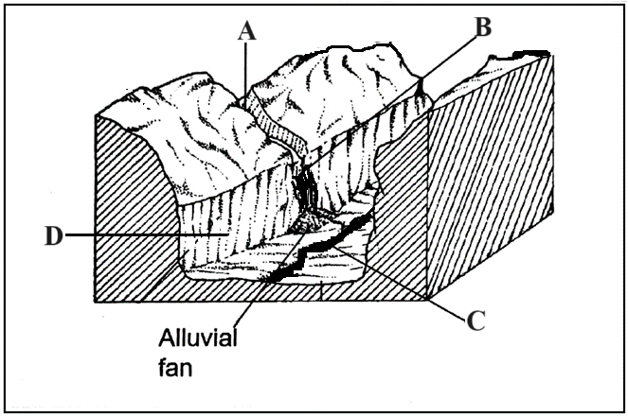
- Name the parts labeled A, B and C. (3 marks)
- Describe how the part labeled D is formed. (5 marks)
(d) List three depositional features of glaciation in lowland areas. (3 marks)
(e) Explain three problems of glaciation in the environment. (6 marks)

- (a) (i) Define the term micro climate. (2 marks)
(ii) State five ways in which human activities influences the climate of a given place. (5 marks)
(b) The map below shows the climatic regions of Kenya. Use it to answer the questions that follow.
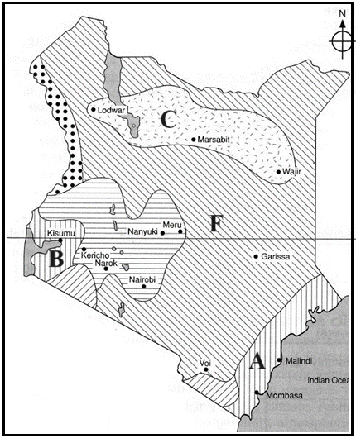
- Give the features responsible for the climatic types labeled B and F. (2 marks)
- Name the climatic types marked A and C. (2 marks)
(c) Describe the characteristics of equatorial climate. (5 marks)
(d) (i) State three possible solutions to aridity and desertification. (3 marks)
(ii) Explain three effects of climate change in the world today. (6 marks)

- (a) Give three processes that lead to formation of lakes (3 marks)
(b) (i) Describe the formation of Lake Victoria (5 marks)
(ii) State four ways how Lake Victoria influences the climate of the surrounding areas. (4 marks)
(c) (i) Explain three causes of salinity in Lake Magadi. (6 marks)
(ii) Apart from Lake Magadi, name two other lakes in Kenya that are saline. (2 marks)

(d) Members of your class plan to conduct a field study of Lake Naivasha
- Why would they need a route map to the lake? (2 marks)
- State three problems affecting the lake they may observe during the study. (3 marks)

……………………………………………………………………………………………………………………………………………………………………………………………………………………………………………………………………………………………………………………………………………………………………………………….
…………………………………………………………………………………………………………………………………………………………………………………………………………………………………………………………………………………………………………………………………………………………………………………………………………………………………………………………………………………………………………………….
……………………………………………………………………………………………………………………………………………………………………………………………………………………………………………………………………………………………………………………………………………………………………………………….
…………………………………………………………………………………………………………………………………………………………………………………………………………………………………………………………………………………………………………………………………………………………………………………………………………………………………………………………………………………………………………………….
……………………………………………………………………………………………………………………………………………………………………………………………………………………………………………………………………………………………………………………………………………………………………………………….
…………………………………………………………………………………………………………………………………………………………………………………………………………………………………………………………………………………………………………………………………………………………………………………………………………………………………………………………………………………………………………………….
……………………………………………………………………………………………………………………………………………………………………………………………………………………………………………………………………………………………………………………………………………………………………………………….
…………………………………………………………………………………………………………………………………………………………………………………………………………………………………………………………………………………………………………………………………………………………………………………………………………………………………………………………………………………………………………………….
……………………………………………………………………………………………………………………………………………………………………………………………………………………………………………………………………………………………………………………………………………………………………………………….
…………………………………………………………………………………………………………………………………………………………………………………………………………………………………………………………………………………………………………………………………………………………………………………………………………………………………………………………………………………………………………………….
……………………………………………………………………………………………………………………………………………………………………………………………………………………………………………………………………………………………………………………………………………………………………………………….
…………………………………………………………………………………………………………………………………………………………………………………………………………………………………………………………………………………………………………………………………………………………………………………………………………………………………………………………………………………………………………………….
……………………………………………………………………………………………………………………………………………………………………………………………………………………………………………………………………………………………………………………………………………………………………………………….
…………………………………………………………………………………………………………………………………………………………………………………………………………………………………………………………………………………………………………………………………………………………………………………………………………………………………………………………………………………………………………………….
……………………………………………………………………………………………………………………………………………………………………………………………………………………………………………………………………………………………………………………………………………………………………………………….
…………………………………………………………………………………………………………………………………………………………………………………………………………………………………………………………………………………………………………………………………………………………………………………………………………………………………………………………………………………………………………………….
……………………………………………………………………………………………………………………………………………………………………………………………………………………………………………………………………………………………………………………………………………………………………………………….
…………………………………………………………………………………………………………………………………………………………………………………………………………………………………………………………………………………………………………………………………………………………………………………………………………………………………………………………………………………………………………………….
……………………………………………………………………………………………………………………………………………………………………………………………………………………………………………………………………………………………………………………………………………………………………………………….
…………………………………………………………………………………………………………………………………………………………………………………………………………………………………………………………………………………………………………………………………………………………………………………………………………………………………………………………………………………………………………………….
……………………………………………………………………………………………………………………………………………………………………………………………………………………………………………………………………………………………………………………………………………………………………………………….
…………………………………………………………………………………………………………………………………………………………………………………………………………………………………………………………………………………………………………………………………………………………………………………………………………………………………………………………………………………………………………………….
……………………………………………………………………………………………………………………………………………………………………………………………………………………………………………………………………………………………………………………………………………………………………………………….
…………………………………………………………………………………………………………………………………………………………………………………………………………………………………………………………………………………………………………………………………………………………………………………………………………………………………………………………………………………………………………………….
……………………………………………………………………………………………………………………………………………………………………………………………………………………………………………………………………………………………………………………………………………………………………………………….
…………………………………………………………………………………………………………………………………………………………………………………………………………………………………………………………………………………………………………………………………………………………………………………………………………………………………………………………………………………………………………………….
……………………………………………………………………………………………………………………………………………………………………………………………………………………………………………………………………………………………………………………………………………………………………………………….
…………………………………………………………………………………………………………………………………………………………………………………………………………………………………………………………………………………………………………………………………………………………………………………………………………………………………………………………………………………………………………………….
……………………………………………………………………………………………………………………………………………………………………………………………………………………………………………………………………………………………………………………………………………………………………………………….
…………………………………………………………………………………………………………………………………………………………………………………………………………………………………………………………………………………………………………………………………………………………………………………………………………………………………………………………………………………………………………………….
……………………………………………………………………………………………………………………………………………………………………………………………………………………………………………………………………………………………………………………………………………………………………………………….
…………………………………………………………………………………………………………………………………………………………………………………………………………………………………………………………………………………………………………………………………………………………………………………………………………………………………………………………………………………………………………………….
……………………………………………………………………………………………………………………………………………………………………………………………………………………………………………………………………………………………………………………………………………………………………………………….
…………………………………………………………………………………………………………………………………………………………………………………………………………………………………………………………………………………………………………………………………………………………………………………………………………………………………………………………………………………………………………………….
……………………………………………………………………………………………………………………………………………………………………………………………………………………………………………………………………………………………………………………………………………………………………………………….
…………………………………………………………………………………………………………………………………………………………………………………………………………………………………………………………………………………………………………………………………………………………………………………………………………………………………………………………………………………………………………………….
……………………………………………………………………………………………………………………………………………………………………………………………………………………………………………………………………………………………………………………………………………………………………………………….
…………………………………………………………………………………………………………………………………………………………………………………………………………………………………………………………………………………………………………………………………………………………………………………………………………………………………………………………………………………………………………………….
……………………………………………………………………………………………………………………………………………………………………………………………………………………………………………………………………………………………………………………………………………………………………………………….
…………………………………………………………………………………………………………………………………………………………………………………………………………………………………………………………………………………………………………………………………………………………………………………………………………………………………………………………………………………………………………………….
……………………………………………………………………………………………………………………………………………………………………………………………………………………………………………………………………………………………………………………………………………………………………………………….
…………………………………………………………………………………………………………………………………………………………………………………………………………………………………………………………………………………………………………………………………………………………………………………………………………………………………………………………………………………………………………………….
……………………………………………………………………………………………………………………………………………………………………………………………………………………………………………………………………………………………………………………………………………………………………………………….
…………………………………………………………………………………………………………………………………………………………………………………………………………………………………………………………………………………………………………………………………………………………………………………………………………………………………………………………………………………………………………………….
……………………………………………………………………………………………………………………………………………………………………………………………………………………………………………………………………………………………………………………………………………………………………………………….
…………………………………………………………………………………………………………………………………………………………………………………………………………………………………………………………………………………………………………………………………………………………………………………………………………………………………………………………………………………………………………………….
……………………………………………………………………………………………………………………………………………………………………………………………………………………………………………………………………………………………………………………………………………………………………………………….
…………………………………………………………………………………………………………………………………………………………………………………………………………………………………………………………………………………………………………………………………………………………………………………………………………………………………………………………………………………………………………………….
……………………………………………………………………………………………………………………………………………………………………………………………………………………………………………………………………………………………………………………………………………………………………………………….
…………………………………………………………………………………………………………………………………………………………………………………………………………………………………………………………………………………………………………………………………………………………………………………………………………………………………………………………………………………………………………………….
……………………………………………………………………………………………………………………………………………………………………………………………………………………………………………………………………………………………………………………………………………………………………………………….
…………………………………………………………………………………………………………………………………………………………………………………………………………………………………………………………………………………………………………………………………………………………………………………………………………………………………………………………………………………………………………………….
……………………………………………………………………………………………………………………………………………………………………………………………………………………………………………………………………………………………………………………………………………………………………………………….
…………………………………………………………………………………………………………………………………………………………………………………………………………………………………………………………………………………………………………………………………………………………………………………………………………………………………………………………………………………………………………………….
……………………………………………………………………………………………………………………………………………………………………………………………………………………………………………………………………………………………………………………………………………………………………………………….
…………………………………………………………………………………………………………………………………………………………………………………………………………………………………………………………………………………………………………………………………………………………………………………………………………………………………………………………………………………………………………………….
……………………………………………………………………………………………………………………………………………………………………………………………………………………………………………………………………………………………………………………………………………………………………………………….
…………………………………………………………………………………………………………………………………………………………………………………………………………………………………………………………………………………………………………………………………………………………………………………………………………………………………………………………………………………………………………………….
……………………………………………………………………………………………………………………………………………………………………………………………………………………………………………………………………………………………………………………………………………………………………………………….
…………………………………………………………………………………………………………………………………………………………………………………………………………………………………………………………………………………………………………………………………………………………………………………………………………………………………………………………………………………………………………………….
……………………………………………………………………………………………………………………………………………………………………………………………………………………………………………………………………………………………………………………………………………………………………………………….
……………………………………………………………………………………………………………………………………………………………………………………………………………………………………………………………………………………………………………………………………………………………………………………….
…………………………………………………………………………………………………………………………………………………………………………………………………………………………………………………………………………………………………………………………………………………………………………………………………………………………………………………………………………………………………………………….
……………………………………………………………………………………………………………………………………………………………………………………………………………………………………………………………………………………………………………………………………………………………………………………….
…………………………………………………………………………………………………………………………………………………………………………………………………………………………………………………………………………………………………………………………………………………………………………………………………………………………………………………………………………………………………………………….
……………………………………………………………………………………………………………………………………………………………………………………………………………………………………………………………………………………………………………………………………………………………………………………….
…………………………………………………………………………………………………………………………………………………………………………………………………………………………………………………………………………………………………………………………………………………………………………………………………………………………………………………………………………………………………………………….
……………………………………………………………………………………………………………………………………………………………………………………………………………………………………………………………………………………………………………………………………………………………………………………….
…………………………………………………………………………………………………………………………………………………………………………………………………………………………………………………………………………………………………………………………………………………………………………………………………………………………………………………………………………………………………………………………………………………………………………………………………………………………………………………………………………………………………………………………………………………………………………………………………………………………………………………………………………………………………………….
……………………………………………………………………………………………………………………………………………………………………………………………………………………………………………………………………………………………………………………………………………………………………………………….
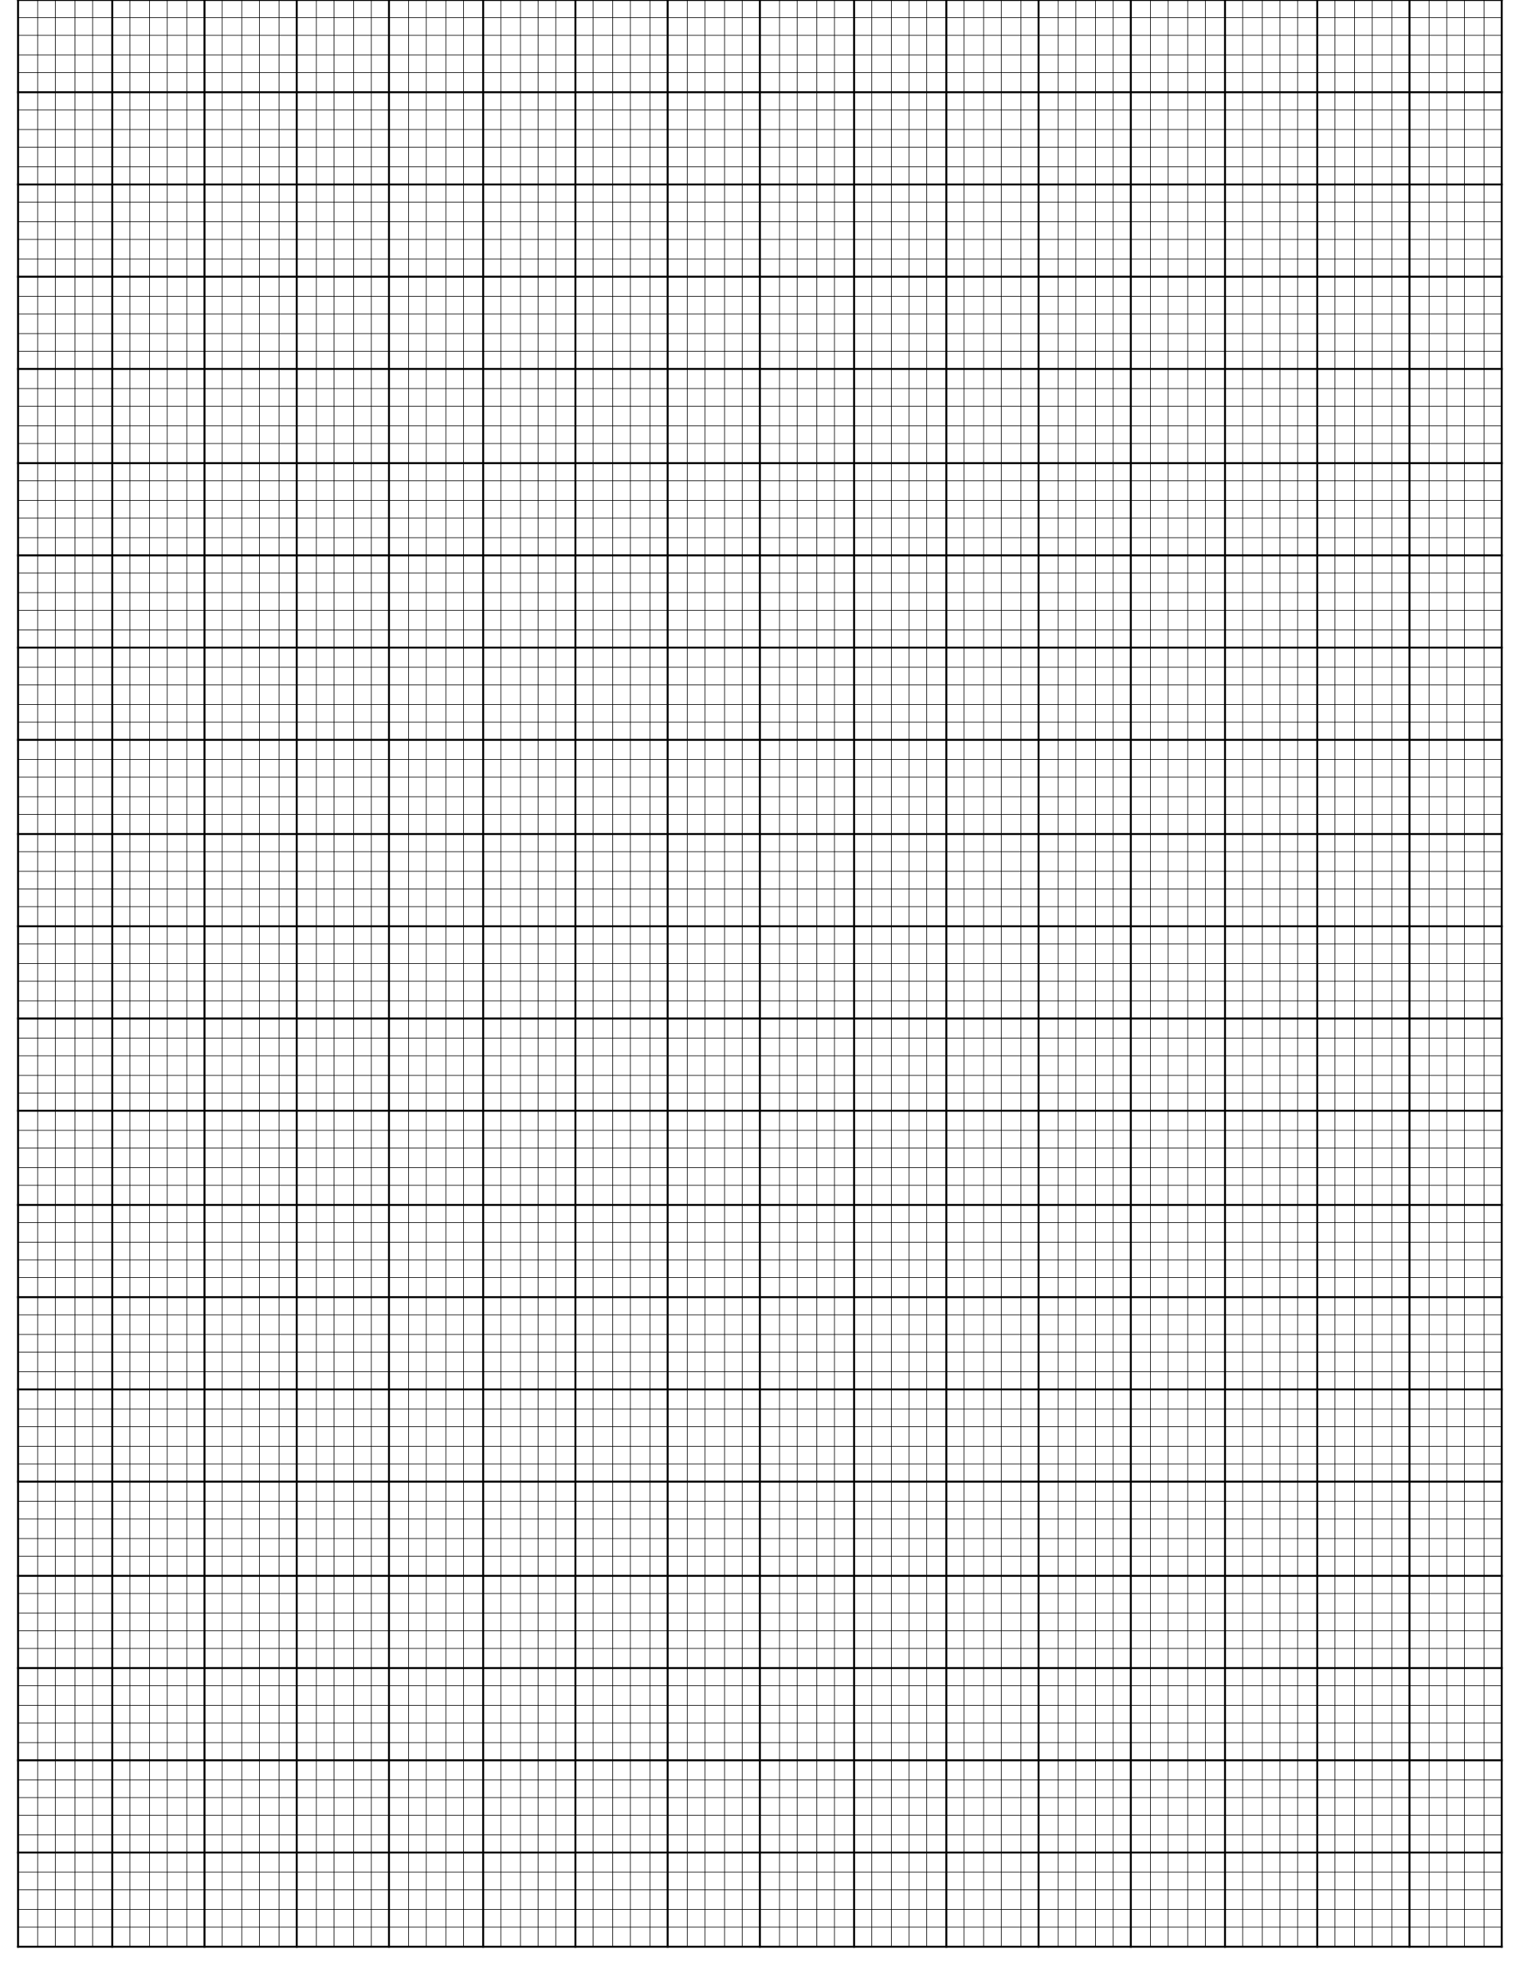

- THIS IS THE LAST PRINTED PAGE -

