**BSJE JOINT EXAMINATION**

**- 2024 -**

***Kenya Certificate of Secondary Education***

**MARKING SCHEME**

**CONFIDENTIAL**

**SECTION A**

1. a) **Name two oil producing countries in the Middle East**.

* Saudi Arabia United Arab Emirates
* Iraq Syria
* Iran Qatar
* Kuwait Yemen

**2x1=2mks**

b**) Mention three uses of copper.**

* In metallurgical industries/making of metals
* To make electrical cables
* To manufacture boilers/pipes/tubes/radiators
* To make alloys with other metals

**3x1=3mks**

2. a**) What is agro-forestry?**

* The practice of planting tree, growing of crops and keeping of livestock on the same piece of land.

**1x2=2mks**

b) **Give three characteristics of coniferous forests in Canada.**

* The trees are conical in shape
* The tree species occur in pure stands
* The trees grow tall and have straight trunks
* The trees have narrow needle-like leaves
* The trees bear cover
* The trees have wide shallow roots
* The forests are evergreen
* The forests have no undergrowth

**3x1=3mks**

3. a) **State two physical conditions that favour tea growing in the Kenya highlands.**

* Cool to warm conditions/moderate temperatures/150C-200C
* High rainfall/1000mm-2000mm annually/wet conditions.
* Well distributed rainfall throughout the year.
* Frost free conditions.
* Deep well drained soils red volcanic soils
* Gently sloping/undulatimg landscape for good drainage
* High altitude/1000m-2400m asl
* Slightly acidic volcanic soils

**2x1=2mks**

b) **Outline three problems facing oil palm farming in Nigeria**.

* Attack by pests and diseases/root rot/anthracnose/blast
* Farmers plant poor varieties leading to low yield
* Poor payment discourages farmers
* Poor farming methods lowers production and quality
* High cost of farm inputs hence unaffordable to farmers
* Impassable roads delay delivery of produce to the market.
* Competition from other vegetable oils reduces palm oil market

**3x1=3mks**

4. a) **Identify two dairy cattle breeds kept in Denmark.**

* White holstein
* Danish red
* Danish jersey
* Danish Holstein

**2x1=2mks**

b**) Highlight three similarities of commercial beef farming in Kenya and Argentina.**

* In both countries the cattle are mainly reared in areas of natural grazing/natural pasture.
* In both countries gross breeding of beef cattle is common/scientific method of beef production.
* In both countries beef cattle are reared mainly in ranches.
* In both countries beef cattle/beef products are meat for local and foreign market.
* In both countries cattle breeds are largely similar.

**3x1=3mks**

5.)a)**Name two towns in Kenya that started as agricultural collection centres**.

* Nakuru
* Nyahururu
* Eldoret
* Kitale
* Nyeri
* Nanyuki

**2x1=2mks**

b) **State three characteristics of Central Business District Zone of an urban centre.**

* Has tall buildings / sky crappers
* Has very high rental value
* Has very limited space
* Has vertical extension of buildings to maximize on land use
* It is the centre of traffic focus
* Has limited surface parking space
* Has traffic jams during rush hours
* Underground parking space is common
* Traffic flow is constant and slow
* Has high population density during the day and low at night

**3x1=3mks**

**SECTION B**

**6. (a) The table below shows the value of export crops from Kenya between 2019and 2022 in million Ksh. Use it to answer questions below.**

|  |  |  |  |  |
| --- | --- | --- | --- | --- |
| **Crop /year** | **2019** | **2020** | **2021** | **2022** |
| Maize | 224 | 210 | 360 | 286 |
| Coffee | 168 | 190 | 267 | 310 |
| Tea | 320 | 280 | 299 | 388 |
| Horticultural | 200 | 240 | 315 | 461 |
| **Total** | **912** | **920** | **1241** | **1445** |

1. **Calculate the total export value for tea.**

|  |  |  |  |
| --- | --- | --- | --- |
| 320+ | 280 + | 299+ | 388 =ksh.1287million/1,287,000,000 **2x1=2mks** |
|  |  |  |  |

**(ii) Using a scale of 1cm to represent Ksh. 100 million, draw a cumulative bar graph to represent the data above.**

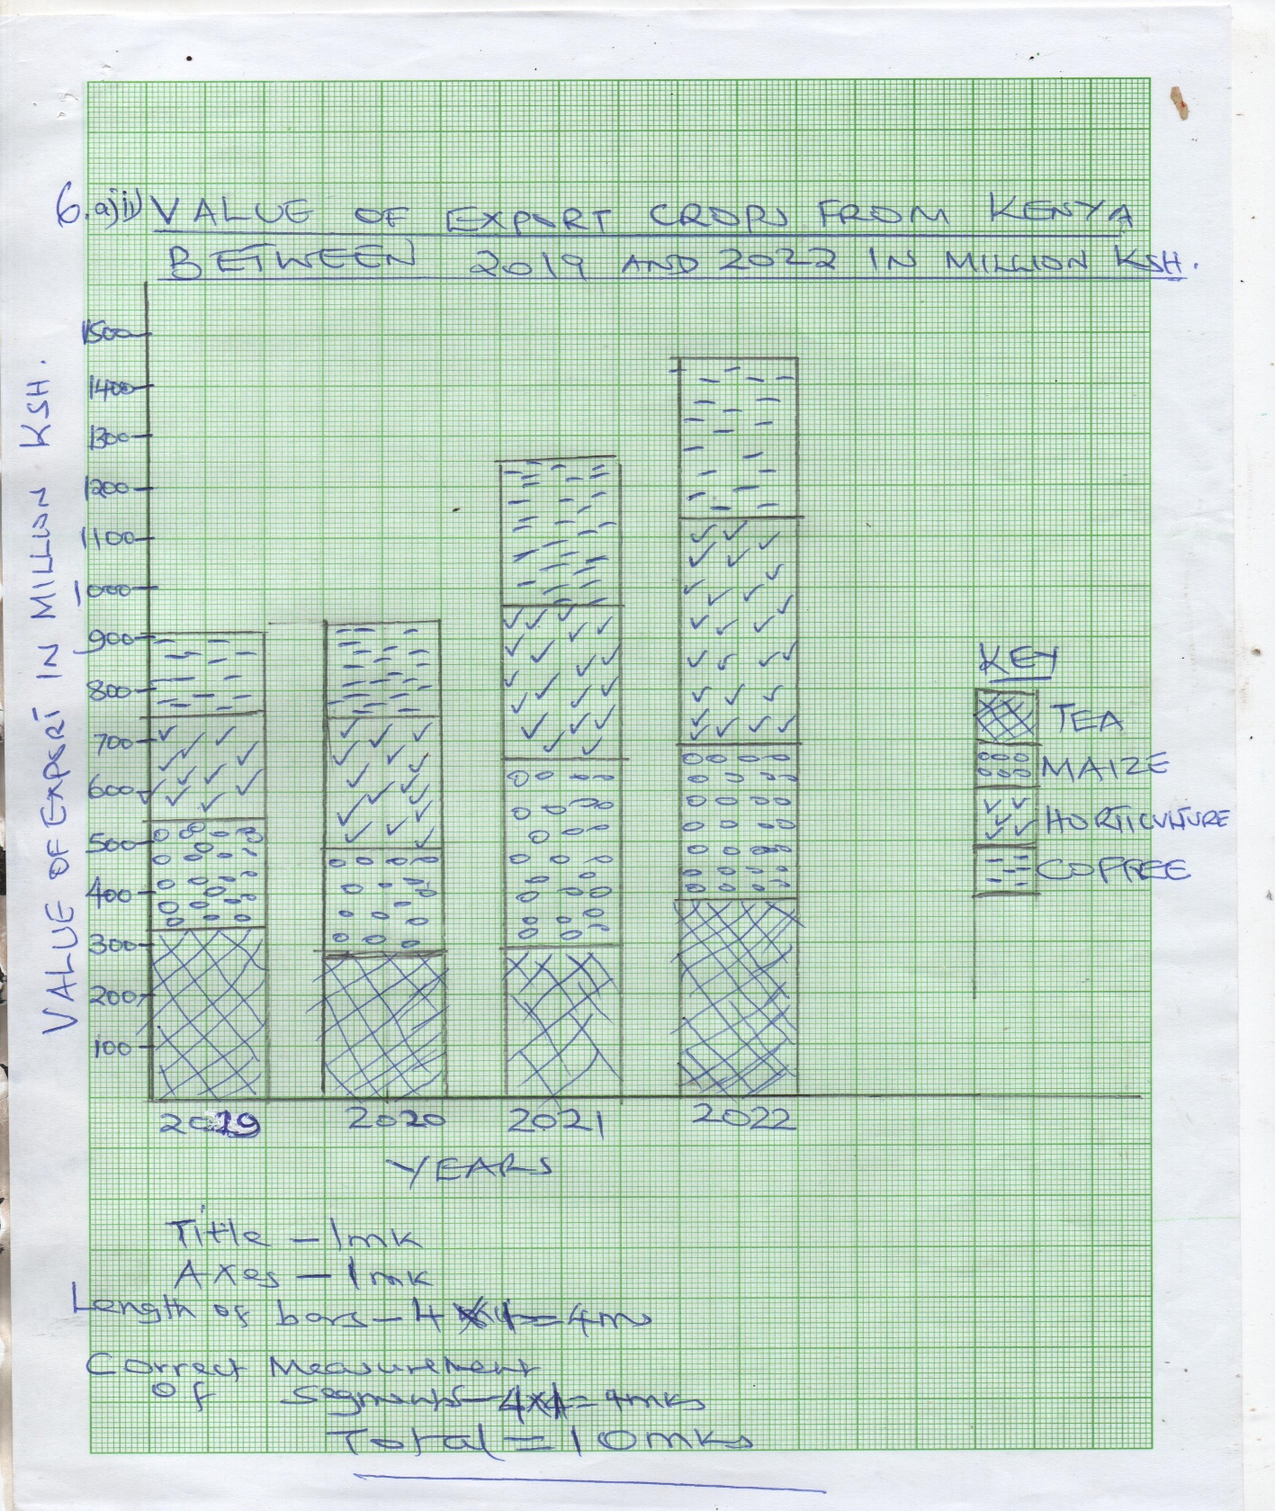

b) **Distinguish between the following terms Balance of trade and Balance of payment**.

* Balance of trade refers to the difference in value between a country’s visible exports and invisible exports while balance of payments is the balance of all transaction involving both visible and invisible trade of a country

c) **Highlight three common problems facing the African regional trading blocs**.

* Civil wars taking place in some countries which cause insecurity and affect trade between countries.
* The flow of goods and services between the states is still low because of poverty among the people
* The member countries are not at the same level of industrialization, making some countries to rely on those that are more industrialized.
* Some countries produce similar goods making the volume of trade to be low and less rewarding.
* Free trade affect industries as imported goods without taxes are cheaper than the locally produced goods.
* Poor transport and communication between member states limit th e flow of goods and services.
* Some member states fail to remit their annual subscriptions which affect the operation of the organization.
* Political differences among leaders of the member states may affect co-operation among them

**3x1=3mks**

d) **Explain how the future of international trade can be improved in Kenya**.

* Improving international transport and communication links for efficient transaction.
* Exploring new markets in order to avoid over reliance on European market/traditional markets.
* Trade agreements signed by Kenya and various countries may help to increase volume of trade.
* Processing some of the agricultural products before export/ EPZ in order to add value hence increase income.
* Setting up of industries in the neighbouring countries by some Kenyan entrepreneurs to increase volume of trade.
* Intensifying marketing internationally to create awareness on locally produced goods.
* Diversifying the country’s exports/ export more types of goods in order to minimize competition.
* Implementation of vision 2030 will lead to increased production hence increased trade.
* Joining more trading blocs to widen market for the Kenyan goods e.g. COMESA and EAC.
* Improve security to guarantee safety for traders/goods.
* Diversify the country’s export to expand markets/minimize competition.
* Revise trade barriers to cope ease free flow of goods

**4x2=8mks**

7a) i) **Differentiate between land reclamation and land rehabilitation.**

* Land reclamation is a process by which unproductive land is converted to productive land and used for crop farming or settlement while land rehabilitation is the restoration of land that had been destroyed through human activities to its former productivity

**1x2=2mks**

ii) **Give five objectives of tsetse fly control in Lambwe valley in Homabay County**.

* To control and suppress population of tsetse flies.
* To treat people with sleeping sickness.
* To create land for agriculture and settlements
* To treat domestic animals and reduce their infection with nagana
* To treat wild animals which acted as tsetse flies host.

**5x1=5mks**

b) Give **four** methods used to reclaim land in Netherlands.

* Building dykes.
* Planting reed vegetation.
* Digging drainage ditches/canals.
* Pumping water from the polders
* Constructing underground drainage pipe
* Treating soil with chemicals
* Flashing soil with freshwater.

**4x1=4mks**

c**) Describe the stages followed in reclaiming and preparing land from the sea for agricultural use in Netherlands**.

* Protective dykes are constructed to enclose the area to be reclaimed.
* Ring canals are constructed to carry out water back into the sea.
* Pumping stations are installed/built to pump water from the land to the ring canal.
* Water is pumped out of the area.
* Reeds are sown to drain excess water/check weeds.
* Drainage ditches are cut into the land and drainage pipes laid.
* More pumping stations put to
* Area is divided into rectangular blocks using inner dykes and canals.
* Soils are treated with chemicals to lower salinity flushed with fresh water to remove excess salt from the soil.
* Pumping out of the water from fresh water is then continuous.
* Experimental crops are planted.

**6x1=6mks**

d) **Explain four differences between land reclamation in Kenya and Netherlands**

* In Kenya the reclaimed land is relatively small while areas reclaimed in the Netherlands are large.
* In Kenya irrigation is used as a means of reclaiming dry areas while irrigation in the Netherlands is used to lower salinity of the soil in reclaimed lands.
* In Kenya simple methods like digging canals ditches to drain water from the land while in the Netherlands highly advanced methods like draining land from the sea/ creating a polder are used.
* In Kenya dykes are used to control water floods while in the Netherlands dykes protect the reclaimed land from invasion by the sea.
* In Kenya land is reclaimed from marginal areas and swamps while in the Netherlands it is from the sea.
* Drought resistant crops are planted in marginal areas while in the Netherlands hardy crops/ oats/barley are planted in the polders.
* In Kenya there is low market for irrigated crops while in the Netherlands there is a large market for irrigated crops.

**4×2=8mks**

**8) a) State four ways in which game reserves are of benefits to the communities living near them.**

* The game reserves offer employment opportunities to the communities living near them.
* The management of the game reserves provides social amenities to the communities.
* The communities are allowed to graze their animals in the game reserve.
* Access roads to the same reserves benefits the communities.
* The income earned from the game reserves by the local authority is used to provide services to the communities.
* Sometimes member of the communities are given meat when animals have been culled.
* Educational institutions local near the game reserves have easy access for educational research
* Increase market for local products **4x1= 4mks**

b) **State five difficulties that African counties face in the conservation of forests.**

* Aridity/low rainfall has reduced area under forests.
* High population growth has led to clearance of forests to allow human settlement.
* The high demand for forest resource (e.g. timber and fuel) has led to chronic felling of forest trees.
* Government’s policy of settling people in forested areas has led to their decline.
* Frequent forest fires have contributed to the destruction of forests.
* Attacks by pests and diseases has led to destruction of trees.

**1x5=5mks**

c) **Explain the significance of conserving the environment.**

* To maintain soil fertility /soil moisture for sustainable food production/supply.
* Helps to reduce global warming/effects of greenhouse gases/modify temperature.
* To preserve genetic resources for future generation/prosperity
* To preserve aesthetic value/beauty /provide recreational facilities /wildlife to promote tourism
* To sustain raw materials for manufacturing industries to produce goods for trade/employment opportunities.
* To reduce pollution that cause diseases to plants/animals thus good health.
* To protect endangered species of wildlife.
* For protecting water catchment areas/wetlands/sustain hydrological cycle.
* To sustain human life with required resources.
* To preserve herbs with medicinal value
* To prevent desertification which destroys environmental resources.
* To preserve cultural heritage.
* To ensure proper utilization of available natural resources without destruction/wastage /depletion

**3x2=6mks**

 d)i)Define the term **game ranching**.

* Refers to rearing of a particular species of wild animals in a ranch where land carrying capacity is observed

**2x1=2mks**

ii) **Explain three differences between tourism in Kenya and Switzerland**.

* Kenya has tropical climate which is warm and sunny most of the year encouraging sun-bathing while Switzerland has temperate climate which encourages winter sports/skiing
* Kenya has varied and beautiful coastal scenery/ Rift valley/volcanic mountains while Switzerland has varied scenery with snowcapped mountains and glaciated landscape.
* Kenya being far from Europe gets fewer tourists than Switzerland which is centrally located in Europe and gets more tourists.
* Kenya’s reports of insecurity scare away potential tourists while Switzerland has a policy of neutrality/ peaceful atmosphere that encourages more tourists.
* Kenya has poorly maintained transport network making it difficult to access tourists sites while in Switzerland transport network is efficient to tourists’ sites.
* The training of personnel in tourism industry in Switzerland is more advanced that in Kenya thus enabling the personnel to provide higher quality service to tourists.
* The accessibility to financial and services such as the use of credit cards by the tourists in Kenya is limited to large urban areas, whereas in Switzerland similar facilities and services are widespread promoting easy transaction to tourists.
* Kenyan’s low purchasing power limits their ability to travel as tourists while Switzerland the high purchasing power enables people to travel as tourist.
* Kenya has coastal beaches while Switzerland has lake sole beaches.
* In Kenya, wild animals are found in their natural habitat/game parks While in Switzerland wildlife are found in a zoo.
* In Kenya there is diversity/varied culture from different tribe that attract tourist while in Switzerland has people with inherent hospitality encouraging tourists.
* Kenyans speak few international languages hence limited communication with the tourists while Switzerland has diversity languages that make communication with tourists easy.

**3x2=6mks**

9) a(i) **Distinguish between industry and industrialization**.

* Industrialization is setting up of more industries/is the process and pace/speed at which a country and community sets and undergoes to establish more industries.
  + - * OR
* The process of change from primary to secondary and tertiary production while an industry is an establishment set up to process and transform raw materials to more complex material of great value.

**1x2=2mks**

(ii)**State five factors that have influenced industrial development in Thika**.

* A rich agricultural hinterland of Thika town provides raw materials.
* River Channia provided fresh water for industrial use.
* Well-developed road and railway provide transport services required for industrialization.
* Proximity to Nairobi provides large market.
* Availability of power.
* Availability of labour.
* Availability of expansive flat land for industrial growth.

**1x5=5mks**

b) **Explain four factors that have led to the rapid development of automobile (car) industries in Japan.**

* The mountainous and rugged terrain together with thin discourages agriculture hence more emphasis on industrial development.
* Availability of capital acquired from other industries like fishing/ship building/ together with financial assistance from the government have helped in the setting up and expansion of the industry.
* Large population provides large domestic market /large external market for the cars has encouraged the industry.
* Japanese have advanced technology a fact that has promoted efficient methods of production of high quality goods that are competitive in the world market.
* There are many sea ports that ease the importation of raw materials and exportation of finished cars.
* Japan has skilled industrious workforce which enhance efficiency in production.
* The large source of power from her H.E.P and imported oil has encouraged the growth of Automobile industries.
* Permafrost soil inhibits agriculture and hence Japanese have turned to automobile and electronic industries.
* The government emphasis on technical and science oriented education.
* Well-developed transport and strategic location of japan has facilitated the movement of goods/ services/raw materials.

**4x2=8mks**

c) **Give four factors that hinder expansion of geothermal power production in Kenya.**

* Inadequate capital to develop more plants
* Low level of technology in exploitation of geothermal
* Few potential areas which are scattered
* Danger of the ground sinking
* High cost of developing geothermal power plant

**1x4=4mks**

d**) Explain three benefits of rural electrification.**

* Encourages setting up of industries in rural areas stimulating decentralization of industries.
* Encourages people to invest more in rural areas thus higher living standards/development of juakali/services industries
* Reduces cutting of trees for wood fuel as electricity is available for domestic use.
* Improves social amenities in rural areas reducing rural-urban migration.
* Encourages development of horticulture farms since it would be possible to store perishable products

**3x2=6mks**

10. **The diagram below shows the demographic transition of a given region.Use it to answer the questions that follow:**

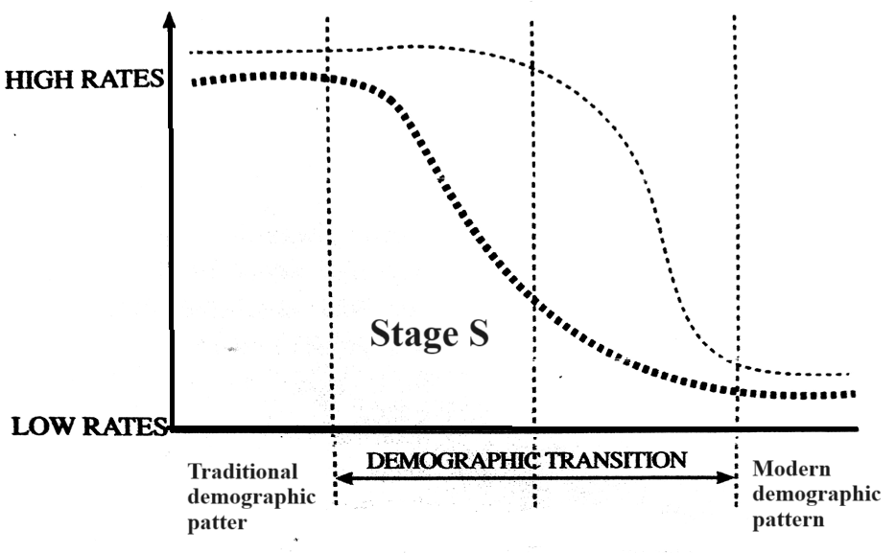

a)i) **Give three characteristics of stage S.**

* High birth rates
* Declining death rates.
* High population growth rate.

**3x1=3mks**

]ii) **State three reasons for the high death rates in the traditional stage.**

* Inadequate medical care.
* Rampant / wide spread diseases.
* Malnutrition / inadequate food supply.
* Frequent wars.

**3x1=3mks**

b) **Highlight four problems that arise from population decline**.

* Labour shortages/inadequate labourforce/manpower.
* High cost of maintaining ageing population/high dependency ratio in old ages.
* Low market / demand for goods and services/decline in industries.
* Rural depopulation.
* Inadequate use of natural resources/under exploitation of resources.
* Environmental degradation in the neglected regions.
* Reduction in revenue collection
* There is high cost of transport/services
* Underutilization of social amenities
* There is limited investment
* Limited defence

**4x1=4mks**

c) **Outline three ways in which climatic factors have influenced the distribution of population in Sweden.**

* Chilly/ cold conditions discourages settlement in the northern part of the country.
* Southern part has dense settlement as they are warm and have summer rainfall.
* The country has long winters and short summers.

**3x1=3mks**

d) **Explain four effects of rural-rural migration to the receiving areas**.

* Leads overuse of land resources and low production
* Leads to congestion/land pressure/fragmentation.
* Some social evils may be transferred to receiving rural areas.
* Idle land is utilized/developed
* Plantations get adequate labour
* More land is put under agriculture leading to more food production.
* Creates market for goods produced due to increased population.
* Some people get employment in plantations thus raising their living standards.

**4x2=8marks**

e) **Compare population characteristics in Kenya and Sweden under the following sub headings**.

i) **Age structure**

* Kenya has large number of young people and children while in Sweden there is ageing ageing population with few children.

**1x2=2mks**

ii) **Fertility rate**

* Kenya has high fertility rate while Sweden has lower fertility rate.

**1x2=2mks**