BSJE JOINT EXAMINATION
- 2024 -
Kenya Certificate of Secondary Education
312/2 GEOGRAPHY PAPER 2
July, 2024 TIME: 2 ¾ Hours

Name: ………………………………… Admission No: ………… School: ………… Stream: …………………….. Signature: …………….
312/2 - GEOGRAPHY
Wednesday, 24th July, 2024
Morning
7.00am - 9.45am

Instructions to Candidates
- Write your Name and Index Number in the spaces provided above.
- Write the name of your school and class in the spaces provided.
- Sign and write the date of the examinations in the spaces provided.
- This paper consists of two sections; A and B
- Answer all the questions in section A.
- Answer question 6 and any other two questions from section B.
- Answers must be written in the spaces provided at the end of question 10.
- This paper consists of 14 printed pages.
- Candidates should check the question paper to ascertain that all the pages are printed as indicated and that no questions are missing.
- Candidates should answer the questions in English.
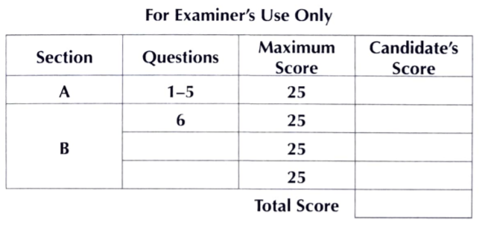

SECTION A
Answer all questions in this section.
1. (a) Name two oil producing countries in the Middle East. (2 marks)
(b) Mention three uses of copper. (3 marks)
2. (a) What is agro-forestry? (2 marks)
(b) Give three characteristics of coniferous forests in Canada. (3 marks)
3. (a) State two physical conditions that favour tea growing in the Kenya highlands. (2 marks)
(b) Outline three problems facing oil palm farming in Nigeria. (3 marks)
4. (a) Identify two dairy cattle breeds kept in Denmark. (2 marks)
(b) Highlight three similarities of commercial beef farming in Kenya and Argentina. (3 marks)
5. (a)Name two towns in Kenya that started as agricultural collection centres. (2 marks)
(b) State three characteristics of Central Business District Zone of an urban centre. (3 marks)

SECTION B
Answer Question 6 and any other two question from this section.
6. (a) The table below shows the value of export crops from Kenya between 2019and 2022 in million Ksh. Use it to answer questions below.
Crop /year | 2019 | 2020 | 2021 | 2022
Maize | 224 | 210 | 360 | 286
Coffee | 168 | 190 | 267 | 310
Tea | 320 | 280 | 299 | 388
Horticultural | 200 | 240 | 315 | 461
Total | 912 | 920 | 1241 | 1445

- Calculate the total export value for tea. (2 marks)
(ii) Using a scale of 1cm to represent Ksh.100 million, draw a cumulative bar graph to represent the data above. (10 marks)
(b) Distinguish between the following terms Balance of trade and Balance of payment.
(2 marks)
(c) Highlight three common problems facing the African regional trading blocs. (3 marks)
(d) Explain how the future of international trade can be improved in Kenya. (8 marks)

7. (a) (i) Differentiate between land reclamation and land rehabilitation. (2 marks) (ii) Give five objectives of tsetse fly control in Lambwe Valley in Homabay County.
(5 marks)
(b) Give four methods used to reclaim land in Netherlands. (4 marks) (c) Describe the stages followed in reclaiming and preparing land from the sea for agricultural use in Netherlands. (6 marks)
(d) Explain four differences between land reclamation in Kenya and Netherlands. (8 marks)

8. (a) State four ways in which game reserves are of benefits to the communities living near them.
(4 marks)
(b) State five difficulties that African counties face in the conservation of forests. (5 marks)
(c) Explain the significance of conserving the environment. (8 marks)
(d) (i)Define the term game ranching. (2 marks)
(ii) Explain three differences between tourism in Kenya and Switzerland. (6 marks)

9 (a) (i) Distinguish between industry and industrialization. (2 marks)
(ii)State five factors that have influenced industrial development in Thika. (5 marks)
(b) Explain four factors that have led to the rapid development of automobile (car) industries in Japan. (8 marks)
(c) Give four factors that hinder expansion of geothermal power production in Kenya. (4 marks)
(d) Explain three benefits of rural electrification. (6 marks)

10. The diagram below shows the demographic transition of a given region. Use it to answer the questions that follow.
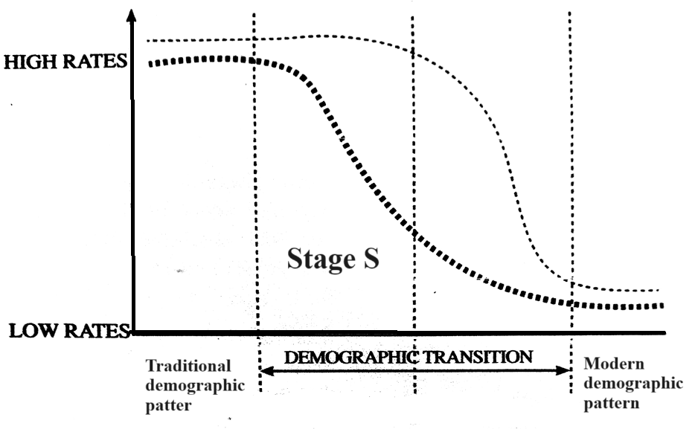
- (i) Give three characteristics of stage S. (3 marks)
(ii) State three reasons for the high death rates in the traditional stage. (3 marks) (b) Highlight four problems that arise from population decline. (4marks)
(c) Outline three ways in which climatic factors have influenced the distribution of population in Sweden. (3 marks)
(d) Explain four effects of rural-rural migration to the receiving areas. (8 marks)
(e) Compare population characteristics in Kenya and Sweden under the following sub headings.
(i) Age structure. (2 marks)
(ii) Fertility rate. (2 marks)

……………………………………………………………………………………………………………………………………………………………………………………………………………………………………………………………………………………………………………………………………………………………………………………………………………………………………………………………………………………………………………………………………………………
………………………………………………………………………………………………………………………………………………………………………………………………………………………………………………………………………………………………………………………………………………………………………………………………………………………………………………………………………………………………………………………………………………………………………………………………………………………………………………………………
……………………………………………………………………………………………………………………………………………………………………………………………………………………………………………………………………………………………………………………………………………………………………………………………………………………………………………………………………………………………………………………………………………………
………………………………………………………………………………………………………………………………………………………………………………………………………………………………………………………………………………………………………………………………………………………………………………………………………………………………………………………………………………………………………………………………………………………………………………………………………………………………………………………………
……………………………………………………………………………………………………………………………………………………………………………………………………………………………………………………………………………………………………………………………………………………………………………………………………………………………………………………………………………………………………………………………………………………
………………………………………………………………………………………………………………………………………………………………………………………………………………………………………………………………………………………………………………………………………………………………………………………………………………………………………………………………………………………………………………………………………………………………………………………………………………………………………………………………
……………………………………………………………………………………………………………………………………………………………………………………………………………………………………………………………………………………………………………………………………………………………………………………………………………………………………………………………………………………………………………………………………………………
………………………………………………………………………………………………………………………………………………………………………………………………………………………………………………………………………………………………………………………………………………………………………………………………………………………………………………………………………………………………………………………………………………………………………………………………………………………………………………………………
……………………………………………………………………………………………………………………………………………………………………………………………………………………………………………………………………………………………………………………………………………………………………………………………………………………………………………………………………………………………………………………………………………………
………………………………………………………………………………………………………………………………………………………………………………………………………………………………………………………………………………………………………………………………………………………………………………………………………………………………………………………………………………………………………………………………………………………………………………………………………………………………………………………………
……………………………………………………………………………………………………………………………………………………………………………………………………………………………………………………………………………………………………………………………………………………………………………………………………………………………………………………………………………………………………………………………………………………
………………………………………………………………………………………………………………………………………………………………………………………………………………………………………………………………………………………………………………………………………………………………………………………………………………………………………………………………………………………………………………………………………………………………………………………………………………………………………………………………
……………………………………………………………………………………………………………………………………………………………………………………………………………………………………………………………………………………………………………………………………………………………………………………………………………………………………………………………………………………………………………………………………………………
………………………………………………………………………………………………………………………………………………………………………………………………………………………………………………………………………………………………………………………………………………………………………………………………………………………………………………………………………………………………………………………………………………………………………………………………………………………………………………………………
……………………………………………………………………………………………………………………………………………………………………………………………………………………………………………………………………………………………………………………………………………………………………………………………………………………………………………………………………………………………………………………………………………………
………………………………………………………………………………………………………………………………………………………………………………………………………………………………………………………………………………………………………………………………………………………………………………………………………………………………………………………………………………………………………………………………………………………………………………………………………………………………………………………………
……………………………………………………………………………………………………………………………………………………………………………………………………………………………………………………………………………………………………………………………………………………………………………………………………………………………………………………………………………………………………………………………………………………
………………………………………………………………………………………………………………………………………………………………………………………………………………………………………………………………………………………………………………………………………………………………………………………………………………………………………………………………………………………………………………………………………………………………………………………………………………………………………………………………
……………………………………………………………………………………………………………………………………………………………………………………………………………………………………………………………………………………………………………………………………………………………………………………………………………………………………………………………………………………………………………………………………………………
………………………………………………………………………………………………………………………………………………………………………………………………………………………………………………………………………………………………………………………………………………………………………………………………………………………………………………………………………………………………………………………………………………………………………………………………………………………………………………………………
……………………………………………………………………………………………………………………………………………………………………………………………………………………………………………………………………………………………………………………………………………………………………………………………………………………………………………………………………………………………………………………………………………………
………………………………………………………………………………………………………………………………………………………………………………………………………………………………………………………………………………………………………………………………………………………………………………………………………………………………………………………………………………………………………………………………………………………………………………………………………………………………………………………………
……………………………………………………………………………………………………………………………………………………………………………………………………………………………………………………………………………………………………………………………………………………………………………………………………………………………………………………………………………………………………………………………………………………
………………………………………………………………………………………………………………………………………………………………………………………………………………………………………………………………………………………………………………………………………………………………………………………………………………………………………………………………………………………………………………………………………………………………………………………………………………………………………………………………
……………………………………………………………………………………………………………………………………………………………………………………………………………………………………………………………………………………………………………………………………………………………………………………………………………………………………………………………………………………………………………………………………………………
………………………………………………………………………………………………………………………………………………………………………………………………………………………………………………………………………………………………………………………………………………………………………………………………………………………………………………………………………………………………………………………………………………………………………………………………………………………………………………………………
……………………………………………………………………………………………………………………………………………………………………………………………………………………………………………………………………………………………………………………………………………………………………………………………………………………………………………………………………………………………………………………………………………………
………………………………………………………………………………………………………………………………………………………………………………………………………………………………………………………………………………………………………………………………………………………………………………………………………………………………………………………………………………………………………………………………………………………………………………………………………………………………………………………………
……………………………………………………………………………………………………………………………………………………………………………………………………………………………………………………………………………………………………………………………………………………………………………………………………………………………………………………………………………………………………………………………………………………
………………………………………………………………………………………………………………………………………………………………………………………………………………………………………………………………………………………………………………………………………………………………………………………………………………………………………………………………………………………………………………………………………………………………………………………………………………………………………………………………
……………………………………………………………………………………………………………………………………………………………………………………………………………………………………………………………………………………………………………………………………………………………………………………………………………………………………………………………………………………………………………………………………………………
………………………………………………………………………………………………………………………………………………………………………………………………………………………………………………………………………………………………………………………………………………………………………………………………………………………………………………………………………………………………………………………………………………………………………………………………………………………………………………………………
……………………………………………………………………………………………………………………………………………………………………………………………………………………………………………………………………………………………………………………………………………………………………………………………………………………………………………………………………………………………………………………………………………………
………………………………………………………………………………………………………………………………………………………………………………………………………………………………………………………………………………………………………………………………………………………………………………………………………………………………………………………………………………………………………………………………………………………………………………………………………………………………………………………………
……………………………………………………………………………………………………………………………………………………………………………………………………………………………………………………………………………………………………………………………………………………………………………………………………………………………………………………………………………………………………………………………………………………
………………………………………………………………………………………………………………………………………………………………………………………………………………………………………………………………………………………………………………………………………………………………………………………………………………………………………………………………………………………………………………………………………………………………………………………………………………………………………………………………
……………………………………………………………………………………………………………………………………………………………………………………………………………………………………………………………………………………………………………………………………………………………………………………………………………………………………………………………………………………………………………………………………………………
………………………………………………………………………………………………………………………………………………………………………………………………………………………………………………………………………………………………………………………………………………………………………………………………………………………………………………………………………………………………………………………………………………………………………………………………………………………………………………………………
……………………………………………………………………………………………………………………………………………………………………………………………………………………………………………………………………………………………………………………………………………………………………………………………………………………………………………………………………………………………………………………………………………………
………………………………………………………………………………………………………………………………………………………………………………………………………………………………………………………………………………………………………………………………………………………………………………………………………………………………………………………………………………………………………………………………………………………………………………………………………………………………………………………………
……………………………………………………………………………………………………………………………………………………………………………………………………………………………………………………………………………………………………………………………………………………………………………………………………………………………………………………………………………………………………………………………………………………
………………………………………………………………………………………………………………………………………………………………………………………………………………………………………………………………………………………………………………………………………………………………………………………………………………………………………………………………………………………………………………………………………………………………………………………………………………………………………………………………
……………………………………………………………………………………………………………………………………………………………………………………………………………………………………………………………………………………………………………………………………………………………………………………………………………………………………………………………………………………………………………………………………………………
………………………………………………………………………………………………………………………………………………………………………………………………………………………………………………………………………………………………………………………………


- THIS IS THE LAST PRINTED PAGE -

