CaSPA ELDORET DIOCESE – EXAMINATION
GEOGRAPHY 312/1 MARKING SCHEME.
SECTION A (25MKS)
Answer all questions in this section.
1.a) State two factors which influence the solar insolation reaching the earth.(2mks)
- Cloud cover
- Nature of the earth’s surface
- Presence of dust, smoke, ice in the atmosphere 1x2

b) Describe how the Campbell stokes sunshine recorder is used to measure the duration of sunshine.
- Sun focuses its rays on the glass ball mounted on the metal frame.
- The rays are focused on a sensitized paper/ card on the metal frame.
- The apparent movement of the sun burns a line on the card.
- Line is continuous on a cloudless day or may have gaps on a cloudy day when sunshine is intermittent.
- Since the card is graduated in hours, the burnt sections are added up to find hours of sunshine for the day.
- New card is affixed every day. 3x1
2.a) Give any two types of folds.
- simple/symmetrical folds – anticlinorium – synclinorium complex
-Asymmetrical fold
- Overfold
- Isoclinal fold
- Recumbent
- Nappe/ over thrust any 2x1

b) In which countries are the following fold mountains located.
i) Appalachians – USA /United States of America 1x1
ii) Himalayas – Nepal, China, Pakistan, Bhutan, India 1x1
iii) Atlas – Morocco, Tunisia, Algeria 1x1

3.a) Differentiate between infiltration and percolation.
- Infiltration is the movement of water into the ground through pores in rocks & soil while
Percolation is the flow of water through soil and rocks. 2x1

b) State three factors that influence infiltration and percolation.
- Nature of surface rocks
-Texture of the soil
-Gradient of the land
- Vegetation cover
- Amount of rainfall received 1x3

- a) Identify any three processes of chemical weathering.
- Oxidation
- Carbonation
- Hydration
- Solution
- Hydrolysis 1 x 3

b) Describe the process of exfoliation in rocks.
-Homogenous rocks are heated up during the day and rapidly cooled during the night (in arid / semi-arid areas)
- Alternate heating and cooling causes outer layers of the rock to expand and contract respectively.
- Repeated alternate expansion and contraction causes stress on the outer layers.
- Cracks develop. Causing the outer layer to peel off.
-This peeling off leaves behind a smooth dome shaped rock known as exfoliation dome.

- a) State two causes of soil degeneration.
- Monocroping
- Over cultivation
- Soil erosion
- Change of soil PH
-Human activities. 1x2

b) Describe three measures that can be taken to control soil degeneration.
- Crop rotation
- Fallowing
- Cultivation along contours
- Connection of soil PH
- Soil conservation etc. 1x3

SECTION B (75 Marks)
Answer question 6 and any other two questions from this section.

- Study the map of Mumias 1:50,000 (sheet 101/2) provided and answer the following questions.
a.i) Measure the distance in kilometres of River Lusimu from the confluence with River Nzoia up to the bridge.
i) 8.6km – 0.1 (8.5 -8.7) 2x1
ii) What is the direction of Khamashia School from samanzi market?
North East 2x1
iii) Identify four human made features in grid squares 6636
-All weather road loose surface
- Main track (motorable)
- Foot path
- Built up area
- Huts

b) Draw a rectangle 14cm by 10cm to represent the area enclosed by easting 59 and 66 and northings 39 and 44. On it mark and label (2mks)

i)River Nzoia (1mk)
ii) Mwira school (1mk)
iii) Motorable track (1mk)
iv) Mayoni Market (1mk)

(See graph paper)

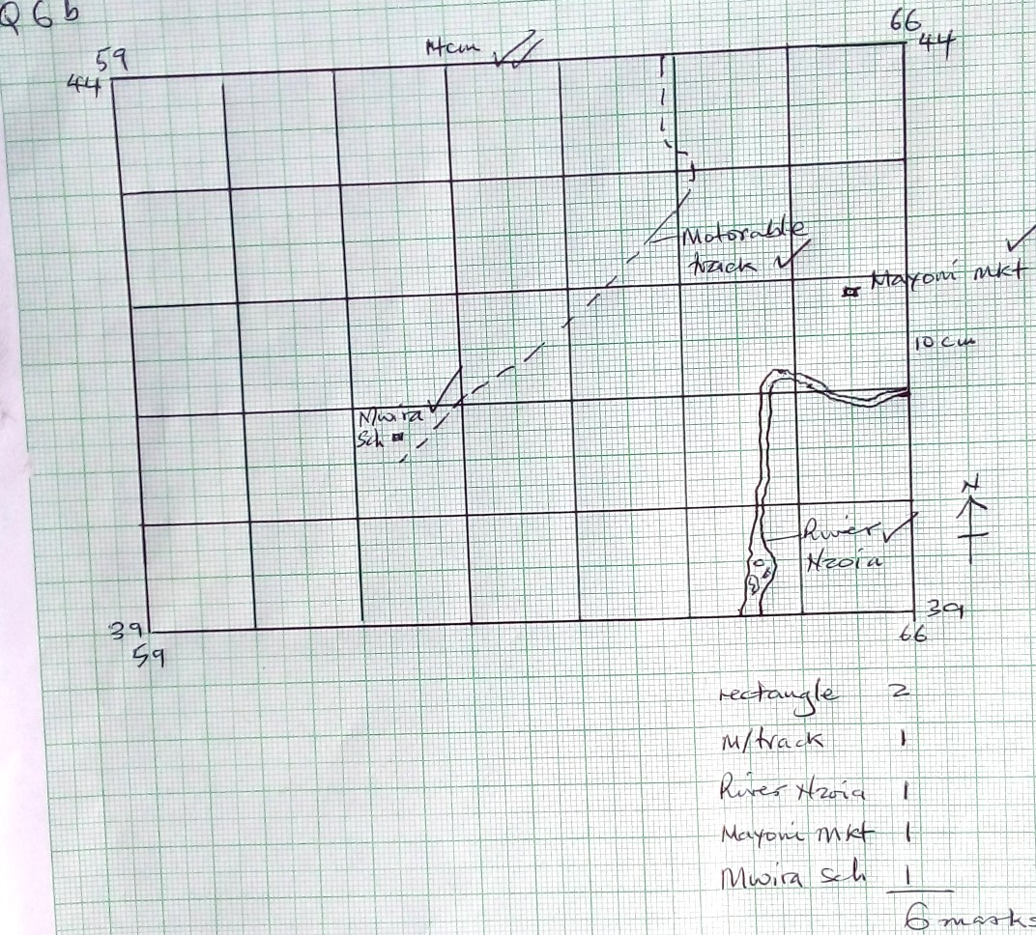

- Citing evidence from the map identify two common environmental hazards in the area covered by the map. (4mks)
Hazard | Evidence
Floods | Wide meandering river
Water born diseases | Swamps / seasonal swamps

- Describe the drainage of the area covered by the map. (7mks)
- There are many permanent rivers
- The main river is Nzoia
- The main river is wide

- Most rivers form dendritic patterns
- Main rivers flow towards the South west
- There are papyrus swamps
- There are seasonal swamps
- There are water reservoirs in the North West / near Nyapera and Bumala 1x7

- a) Define an earthquake.
- Refers to the trembling or shaking of crustal rocks due to shock waves originating from below the earths’ surface. 1x2
b) State three natural causes of earthquakes. (3mks)
- Tectonic movement
- Vulcanicity
- Isostatic adjustments

c) Differentiate between magnitude and intensity of earthquakes. (2mks)
- Magnitude is the amount of energy given off
By an earthquake measured on a Richter scale(0-8.9) while intensity describes how strong or hard the earth quake shakes the ground seen by looking at effects using mercalli scale (I – XII)

d) Name four earthquake prone areas on earth. (4mks)
- Mid oceanic ridges
- Volcanic Islands and trenches
- compressional boundaries / fold mountain regions
- extension boundaries
- Circum pacific belt.

- Explain four effects of earthquakes on human beings. (8mk)
- Damage property and infrastructure
- Leads to floods that kill people / tsunamis
- leads to fire out breaks due to broken gas pipes damaging property / killing people
- Trigger landslides’ burying property / people
- restrict construction of storay buildings.

f) Explain three measures that can be taken to reduce the effects of earthquakes. (6mks)
- Enforcement of a high standard building code
- Introduction of early warning system against tsunamis
- Performance of drills on survival skills / knowledge

8. a) Name any three relief features resulting from faulting.
-Escarpment - Rift valleys
- Horsts / Block mountains - tilt blocks
- Depressions. 1x3

b) Using well labeled diagrams, describe how the following types of faults are formed
i) Normal faults (4mks)
-Results from tension
- The dip slip fault causes the block above the fault to move down in respect to the lower block.
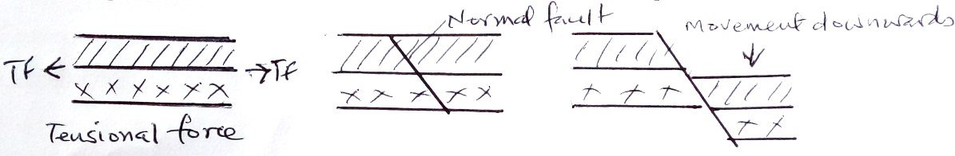
ii) Reverse faults (4mks)
-Compressional forces act on crustal rocks
- Afaultline forms in which one block remains static while the other block rides above it / hanging wall.
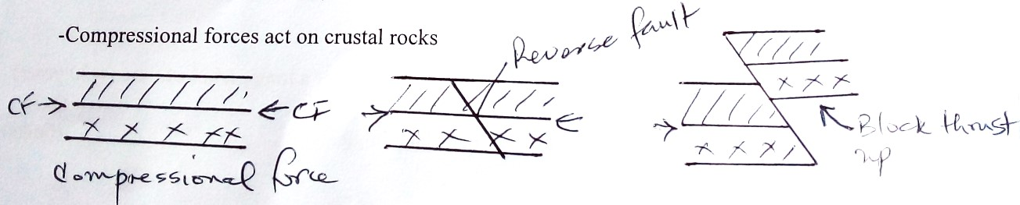
c) Describe five effects of faulting on drainage systems.
- Can lead to reversal of river courses
- Can create depressions which fill with water to form lakes
- Can lead to fault guided river patterns
- Can create crevices into which rivers disappear
- Can expose water tables leading to formation of springs.
- Can lead to formation of high mountains which form sources of rivers. 1x5

d) You are planning to carry out a field study on faulting.
i) Give three methods you will use to collect data
- Observing
-Interviewing
- Measuring
- Content analysis 1x3
ii) State three ways in which the information collected will be of use to the
local people
-They will get information on how the features formed.
-They will be informed about the disadvantages of faulting
-They will take precautions while farming and constructing structures.

iii) State three problems you are likely to face while collecting the information (3mks)
- Adverse weather conditions / heavy rains / windy / hot / cold
- In accessibility of some areas of interest
- Vast area of study
- Uncooperative respondents.
- a) Define Climate.
- Average weather conditions of a place observed over a long period of time.(> 30 years)
2x1
b) Describe six characteristics of Equatorial climate. (6mks)
- High temperatures throughout the year (27⁰C)
-Low pressure which cloud cover convectional rainfall with thunderstorms
-small diurnal rage of temperature (0⁰- 3.5⁰C)
- High rainfall throughout the year (1500-2000 mm p.a)
-Double rainfall maximum
-High humidity
-under influence of South East and North East trade winds.

c) Differentiate between aridity and desertification. (2mks)
-Aridity is the state of insufficient moisture leading to scarcity / absence of vegetation while Desertification is the encroachment on large areas of desert like conditions / low moisture scarcity vegetation.
d) Explain five ways by which human activities lead to aridity and desertification.(10mks)
- Deforestation leaves the ground base exposing it to erosion and death of plants.
- Overgrazing depletes vegetation leaving the ground base and without vegetation.
-Over cultivation / monoculture causes loss of soil structure making it loose and easy to resolve.
-Emission of gases from factories leads to global whelming accelerating the rate of aridity and desertification.
-Over population can invasion of rangelands by people seeking space for settlement and farming.
e) State five possible solutions to aridity and desertification. (5mks)
Legislation : Laws should be passed in parliament stipulating penalties to those who cut trees without permission.
-Some forests should be gazetted to product them from destruction.
-Security should be provided throughout to protect forests.
- the alternative sources of fuel like solar and bio – fuels to prevent overreliance on forests.
- Mount tree planting campaigns to replace and increase forest cover.
- Educate features on soil conservation measures for sustainable farming.
- Protect wetlands from everoachment by human beings by delimiting them/ setting and enforcing regulations on how near / far farming should be practiced near such wet lands.

- a) Name three features that form due to the action of water in arid areas.
- Wadi - Phyas
- Inselbergs - Salinas
-Mesas / buttes - Dry river valleys
-Pediments - Bajada / bahada 1x3
- Pedi plains
b) State four factors that influence the formation of dunes.
- Availability of sand
- Strength and direction of winds.
- Nature of the surface
- Presence of obstacles
- Vegetation Cover
- Presence of ground water 1x4

c) Explain three ways by which wind transports its load in deserts. (6mks)
Suspension – Light load is held in air turbulence and transported within the wind.
Saltation – Medium sized particle are moved in the direction of (wind in hops and jumps.
Surface creep – Heaver particles are produced by wind / roll forward for short distances at a time.
d) Use the diagram provided to answer the questions that follow.
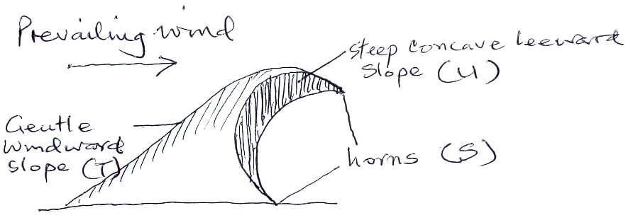
i)Name the parts labeled S,T, and U.
S- Horns
T- Gentle wind ward slope
U- Steep lee ward slope 1x3
ii) Besides seif dunes, name three other types of dunes.
- Barchans
- Transverse / wake dunes
- Draas
- Loess 1x3

- You are planning to carry out a field study on desert landforms.

i)Formulate three objectives for your study.
- To find out the area covered by the desert
- To identify the types of dunes / erosional features
- To find out the effect of water in arid areas etc. 1x3

ii) State three ways by which you will present your findings.
- Written reports
- Filled in questionnaires
- Tables
- Display photos
- Display sketches of features
- Play back videos etc. 1x3

E N D

CaSPA Eldoret Diocese Examinations 2024
312/1

