GEOGRAPHY
312/2 - PAPER 2
FORM 4
JUNE TRIAL EXAMINATION, 2024
MARKING SCHEME

SECTION A
Answer ALL the questions in this section.

1. The diagram below shows the occurrence of petroleum in the earth’s crust. Use it to answer question (a).
L
M
N
Non-porous rock
Non-porous rock

(a) Name the substances in the areas labeled L, M and N. (3 marks)
L - Gas
M - Oil/petroleum
N - Water
(b) State two ways in which Kenya can reduce the use of petroleum as a source of energy. (2 marks)
- Encourage people to use bicycles over short distances
- Developing alternative sources of energy.
- Encouraging people to use public transport.
- Improving traffic flow to reduce usage of petrol.
- Importing vehicles that consume less fuel.
- Improving the roads to avoid delays that increase consumption of petrol.
- Proper maintenance of vehicles to avoid high consumption of petrol.
2. (a) Give two methods used in preserving fish in Lake Turkana. (2 marks)
- Freezing
- Salting
- Canning
- Sun drying
- Smoking
(b) State three reasons why in East Africa, fresh water fishing is more developed than marine fishing. (3 marks)
- East Africa has a narrow continental shelf which is unsuitable for the growth of plankton.
- East Africa has a regular coastline thus making it unsuitable breeding grounds for fish.
- There is low demand for sea fish compared to fresh water fish among the people in East Africa.
- Inadequate capital to buy modern equipments which are required in sea fishing.
- East Africa faces stiff competition in the open sea from developed countries.
- Low levels of technology implies inadequate knowledge about deep sea fishing.
3. State three benefits of Domestic tourism in Kenya. ` (3 marks)

- Offers opportunities for recreation.
- Creates employment to many citizens.
- Fosters utilisation of underutilized hotels/facilities during low season.
- Promotes circulation of money within the country.
- Enables many Kenyans to learn about their country hence promote patriotism
- Facilitates interaction between various communities thus enhancing national integration.
- Increases consumption of local products hence promoting more production leading to economic growth.
- Enables people to understand and appreciate the need to conserve wildlife.
- Enables students to learn more about wildlife.
(Any 3x1=3mks)
4. (a) State three reasons why national parks have been established in Kenya. (3 marks)
- To protect the natural beauty.
- To conserve wildlife/plants and animals.
- To promote tourism/provide for recreations.
- Provide an environment for education and research.
(b) Apart from national parks, outline three other ways in which wildlife is conserved in Kenya. (3 marks)
- Encouraging individuals to set up game ranches
- Banning of trade in wildlife products.
- Encouraging wildlife conservation education.
- Employing anti-poaching unit/forest rangers in the gamepark.
- Setting up game/forest reserve.
- Promotion of peaceful co-existence between wildlife and human beings.
- Protecting endangered species in orphanages/ sanctuaries/ arboretum/ natural reserves
5. Identify five ways in which the government of Kenya promote export trade.(5 marks)
- By establishing export processing zones to increase exports.
- By signing trade agreements with other countries to boost exports.
- By organizing international exhibitions/trade fairs.
- By encouraging foreign investors to establish industries in Kenya.
- By providing roads/air/sea transport to enhance transportation of exports.
- By reducing duty on raw materials meant for the export market.
SECTION B.
Answer question 6 and any other two.
6. The table below shows East Africa’s Beef Export in 000’ tones from 1998 – 2001.
East Africa’s Reef Export in 000’ tones from 1998 – 2001.
Country | 1998 | 1999 | 2000 | 2001
Kenya | 30 | 40 | 36 | 25
Uganda | 20 | 25 | 27 | 54
Tanzania | 50 | 60 | 65 | 124

(a) (i) Draw a compound bar graph to represent the data above. Use a scale of 1cm to represent 10 thousand tones. (8 marks)
(ii) State two limitations of compound bar graph in representing data. (2 marks)
- It involves a lot of calculations which can be easily be done wrongly.
- Variables of different kinds are placed on one bar giving a false impression.
- There are difficulties in interpreting the graph for the bars are cumulative.
- Very many items cannot be represented using a compound graph.

(iii) Which year had the highest export of beef and by how many tonnes in the three countries? (2 marks)
- 2000
- 128,000 tonnes.
(b) (i) Name the exotic breeds of cattle reared in commercial ranches in Kenya. (2 marks)
- Aberdeen Angus
- Charolais
- Short horn
- SantaGertrudis
- Hereford
- Red Angus
- Galloway
(ii) Give three differences between beef cattle farming in Kenya and Argentina. (3 marks)
- In Argentina, the cattle ranches are scientifically managed, including artificial insemination while in Kenya, breeding is by bulls within the herd and scientific management is generally limited.
- In Kenya it is mainly carried out by pastoralists/subsistence farmer/ in a few ranches while in Argentina it is mainly carried out in large scale ranches which are better managed and mechanized.
- In Kenya overstocking amongst pastoralist is a major problem while in Argentina the numbers of animals are regulated according to land carrying capacity.
- In Kenya water for cattle is sometimes inadequate especially during the dry season while in Argentina there is constant supply of water which is supplied using wind pumps.
(c) Explain four measures taken by the government of Kenya to improve beef cattle farming. (8 marks)
- The government encourages research/the cross-breeding of traditional cattle breeds with exotic ones. This improves the quality of the animals.
- It strengthens community education to teach beef cattle farmers better livestock managements.
- It has constructed roads to make services accessible to farmers/make transportation of animals to markets easier.
- It encourages replacement of the coarse grass with nutritious pasture to improve the quality of animals.
- It has sunk boreholes/dug wells/ constructed dams to provide water for the animals.
- It has revived Kenya Meat Commission (KMC), a government parastatal that buys animals from farmers for slaughter.

7. (a) (i) Name two crops planted in Perkerra irrigation scheme. (2 marks)
- Maize
- Onions
- Chillies
- Water melon
- Paw paw.

(ii) Explain four physical factors that influenced the establishment of Perkerra irrigation scheme. (8 marks)
- Presence of river Perkerra which is permanent provides constant supply of water for irrigation.
- The gently sloping land/undulating land which allows the natural flow of water to the field by gravity.
- Availability of expansive land that is suitable for establishment of an irrigation scheme.
- The high temperature of the area is ideal for the growth of seed maize, onion, chillies and pawpaw.
- Deep, well drained loam soils which is ideal for a variety of crops.

(b) (i) Explain three benefits which Kenya gets from irrigation farming. (6 marks)
- It has saved the country’s foreign exchange since Kenya can rely on domestic rice thus importing little from other countries.
- It has created employment in the schemes, raising the standards of living of the people.
- It has led to availability of raw materials thus contributing to industrial development.
- It has raised the standards of living of the people because of the sale of crops, bringing them direct income.
- It has helped to resettle the landless people in some schemes like Mwea.
- Environmental hazards e.g. flooding has been controlled by the construction of dykes and dams.

(ii) State three ways in which the future of irrigation farming can be improved in Kenya. (3 marks)
- Construction of large dams to store enough water to irrigate more land all year round.
- There is need to make farmers participate fully in managing the irrigation schemes thus boosting their confidence and increasing production.
- The need to expand irrigation schemes in other areas which have the potential for irrigation.
- There is need to issue title deeds to encourage private ownership of the land and increase the production.

(c) Describe the stages in the reclamation of land from the sea in the Netherland. (6 marks)
- Protective dykes or walls one constructed to enclose the area to be reclaimed.
- Ring canals are constructed within the walls to divide the area into small reclamation portion.
- Pumping stations are installed to pump out sea water from the areas enclosed by the ring canals.
- The water is also pumped out of the area enclosed by the protective dykes.
- Fresh water is pumped into the polders and pumped out again to reduce the salt content in the soil.
- Special reeds are planted to help in the faster drying of the land and to rid it of excess salts.
- Drainage ditches are dug on the land and drainage pipes laid below the soil.
- Soils are then treated with chemicals to lower the salinity and the dry land is divided into plots.

8. The diagram below shows a mining method.
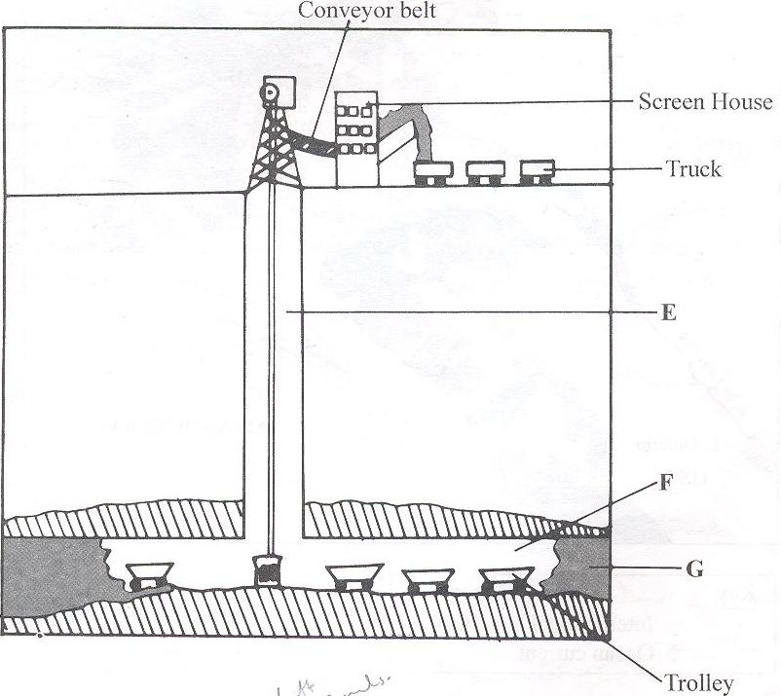
(a) (i) Name the parts marked E, F and G. (3 marks)
E - Main shaft/vertical shaft
F - Tunnel/horizontal shaft/gallery
G - Mineral ore
(ii) Describe how the method is used in mining. (6 marks)
- A vertical shaft is sunk to reach the mineral seams or beds.
- Horizontal tunnels are dug from the shaft to reach the mineral- bearing rock.
- Props are erected to support the roof of the tunnels.
- The rock ore is blasted with explosives or dug out using mechanical shovels and pick axes.
- Ore is transported on light rail tracks/conveyor belt to the base of the shaft
- The ore is then loaded onto a lift/cage for hoisting onto the surface.
(b) (i) Explain four ways in which soda ahs contributes to the economy of Kenya. (8 marks)
- Soda ash is exported to earn foreign exchange which is used in the economic development of the country.
- It creates employment opportunities to Kenyans hence improving living standards.
- Soda ash provides raw materials to the manufacturing industries leading to industrialization e.g. the glass manufacture.
- It has led to the development of social amenities in the area improving the living standards of the people around Magadi e.g. schools and hospitals.
- Has led to the growth of Magadi town.
- Soda ash has led to the growth of local and foreign tourism.
- It provides revenue to the government through taxation of the earnings from the sale of soda ash.
(ii) Give three uses of soda ash. (3 marks)
- Is a raw material for making glass.
- Is used in making detergents.
- Is used in some chemical industries/petroleum refining.
- Is used as a water softener/water treatment.
- Is in de-sulphurising steel
- Is used in paper industries.
(c) State five negative effects of mining on the environment. (5 marks)
- Dereliction of land due to the dumping of waste materials is an eyesore/destroys the natural beauty of the land.
- Pollution of the areas by noise/ blasts/ smoke and water pools are all health hazards.
- Mining disrupts the water table which may lead to shortage of water.
- The dumping of rock waste has led to the loss of biodiversity/destruction of natural vegetation.
- Mining takes up land that would have been used for agriculture interfering with food production.
- Mining displaces human settlement thus disrupting people and necessitating expensive resettlement process.
10. The diagram below represents the functional zones of an urban centre. Use it to answer the question (a).
X
Y
Agricultural land
Agricultural land
Central Business District

(a) (i) Name the zones marked X and Y. (2 marks)
X - Industrial zone/lower class housing
Y - Suburb area
(ii) State three functions of the Central Business District. (3 marks)
- Trading
- Administration
- Recreation
- Commerce/banking/insurance
- Location of light industries
(b) Give four causes of rural-urban migration in Kenya. (4 marks)
- Insecurity in some areas makes people move to safer places.
- Pastoral communities migrate from one rural areas to another in search of pasture/water for their livestock.
- Change in land tenure system and disputes cause people to move.
- Pressure on land makes people buy/look for land elsewhere.
- Setting up of government development projects cause displacement of people who are settled elsewhere.
- Natural hazards force people to migrate to other areas for safety.
(c) Explain five factors that led to the growth of Kisumu town. (10 marks)
- Its location at the shores of lake Victoria led to its growth as a lake port handling trade among the three East African countries.
- Kisumu was a regional administrative centre during the colonial period.
- The rich hinterland with mineral and agricultural resources provided raw materials for the development of industries and food supply for the town residents.
- The high population in the surrounding areas provided the required labour force for the development of industries.
- The nearby rivers and Lake Victoria provided fresh water for the industrial and domestic use.
- The well-developed means of transport/road/railway/airport makes the town easily accessible from other parts of the country.
- In 1901 Kisumu became a terminus for the Uganda railway allowing the influx and settlement of early Asian traders. This lead to commercial- development of the town.

(d) Compare the ports of Mombasa and Rotterdam under the following sub- headings:
(i) Mechanization of the ports. (2 marks)
- Rotterdam uses advanced technology in providing services at the port while Mombasa port has had very limited expansion in technology/less mechanized.
(ii) Site (2 marks)
- Mombasa is located on the drowned mouths of rivers Mwachi and Kombeni while Rotterdam is at the mouth of the river Rhine.
(iii) Transport links to the interior. (2 marks)
- Mombasa relies on road, railway, air and pipeline to the interior while Rotterdam has in addition, river Rhine and canals.
10 (a) Name two non governmental organizations that deals with environmental management and conservation in Kenya . (2marks)
- Green Belt Movement
- United Nations Environmental Program (UNEP)
- International Council for Research on Agroforestry (ICRAF)
- Kenya Energy and Environmental Organisation (KENGO)
- CARE-Kenya
- Wildlife and Environmental clubs
(b) State four causes of land pollution in Kenya. (4marks)

- The chemical fertilizers added to improve fertility.
- The pesticides, fungicides and herbicides to control pests and diseases.
- The presence of garbage heaps which stinks becoming breeding places for disease causing vectors and also making the land to look ugly.
- Heaping of the overburden on the land during mining.
- Open cast mining and quarrying rocks which leaves open pits that become water collections places that are breeding places for mosquitoes.
- Chemicals and explosives used during mining.
(c) Give reasons why water resources should be managed and conserved. (6marks)

- Clean water is needed for domestic /industrial use
- Water bodies provide a natural habitat for aquatic life like fish which provide income /food to people
- Water bodies provide sporting and other recreational activities that promote tourism
- Water in rivers /lakes is needed for production of HEP for domestic and industrial use
- Some rivers/lakes/oceans provide cheap water transport for bulky goods
- Water in large lakes/oceans provide a breeze/high humidity that modifies temperatures of the surrounding areas
- To ensure there is enough water supply for present and future generations
- To maintain the hydrological cycle
(d) Students from Barena school are planning to carry out a field study on water pollution in the nearby river.
- Give two methods of data collection they are likely to use during the study. (2marks)
- Observing
- Interviewing
- Collecting samples of water for testing
- Taking photographs of the sampled water
- Administering questionnaires

- State three follow up activities they may undertake after the field study. (3marks)
- Discussing the findings
- Groups presenting reports
- Laboratory tests of the water samples collected
- Displaying photographs taken
- Classifying pollutants
- Displaying labeled samples of water
- Summarizing data inform of tables
- Give three recommendations the students can make to be put in place to control pollution of rivers. (3marks)
- Planting trees in order to prevent soil erosion
- Educating people of the area to keep their environment clean
- Collection of plastics or pollutants
- Prosecution of those who pollute the environment
- Construction of proper sewage systems for proper flow of wastes to sewage works.
- People should use pit latrines
- Forcing ministries to treat pollutants
(e) Identify ways in which floods can be managed in Kenya. (5marks)
- Predicting floods and monitoring the water levels /volumes in the upper and middle river stages to reduce damage caused by floods
- Evacuating people in flood prone areas in time and settle them on higher grounds
- Flood prone areas can be utilized with large scale irrigation farming schemes
- Government should educate people in the flood prone areas on floods control and management measures
- The government should establish national programs to survey flood prone areas in order to easily offer relief services

