GEOGRAPHY
312/2 - PAPER 2
FORM 4
JUNE TRIAL EXAMINATION, 2024
TIME: 2¾ HOURS

Instructions:

- This paper has two sections A and B
- Answer ALL the questions in section A. In section B answer questions 6 and any other TWO questions.
SECTION A
Answer ALL the questions in this section.

1. The diagram below shows the occurrence of petroleum in the earth’s crust. Use it to answer question (a).
L
M
N
Non-porous rock
Non-porous rock

(a) Name the substances in the areas labeled L, M and N. (3 marks)
(b) State two ways in which Kenya can reduce the use of petroleum as a source of energy. (2 marks)
2. (a) Give two methods used in preserving fish in Lake Turkana. (2 marks)
(b) State three reasons why in East Africa, fresh water fishing is more developed than marine fishing. (3 marks)
3. State four benefits of Domestic tourism in Kenya. ` (4 marks)
4. (a) State three reasons why national parks have been established in Kenya. (3 marks)
(b) Apart from national parks, outline three other ways in which wildlife is conserved in Kenya. (3 marks)
5. Identify fiver ways in which the government of Kenya promote export trade. (5 marks)
SECTION B.
Answer question 6 and any other two.
6. The table below shows East Africa’s Beef Export in 000’ tones from 1998 – 2001.
East Africa’s Reef Export in 000’ tones from 1998 – 2001.
Country | 1998 | 1999 | 2000 | 2001
Kenya | 30 | 40 | 36 | 25
Uganda | 20 | 25 | 27 | 54
Tanzania | 50 | 60 | 65 | 124

(a) (i) Draw a compound bar graph to represent the data above. Use a scale of 1cm to represent 10 thousand tones. (8 marks)
(ii) State two limitations of compound bar graph in representing data. (2 marks)
(iii) Which year had the highest export of beef and by how many tonnes in the three countries? (2 marks)
(b) (i) Name the exotic breeds of cattle reared in commercial ranches in Kenya. (2 marks)
(ii) Give three differences between beef cattle farming in Kenya and Argentina. (3 marks)
(c) Explain four measures taken by the government of Kenya to improve beef cattle farming. (8 marks)
7. (a) (i) Name two crops planted in Perkerra irrigation scheme. (2 marks)
(ii) Explain four physical factors that influenced the establishment of Perkerra irrigation scheme. (8 marks)
(b) (i) Explain three benefits which Kenya gets from irrigation farming. (6 marks)
(ii) State three ways in which the future of irrigation farming can be improved in Kenya. (3 marks)
(c) Describe the stages in the reclamation of land from the sea in the Netherland. (6 marks)
8. The diagram below shows a mining method.
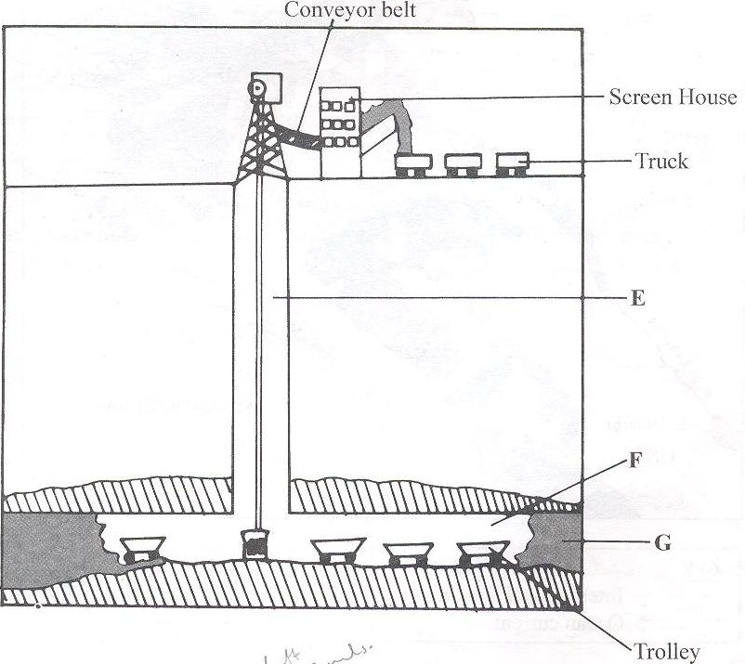
(a) (i) Name the parts marked E, F and G. (3 marks)
(ii) Describe how the method is used in mining. (6 marks)
(b) (i) Explain four ways in which soda ash contributes to the economy of Kenya. (8 marks)
(ii) Give three uses of soda ash. (3 marks)
(c) State five negative effects of mining on the environment. (5 marks)

9. The diagram below represents the functional zones of an urban centre. Use it to answer the question (a).
X
Y
Agricultural land
Agricultural land
Central Business District

(a) (i) Name the zones marked X and Y. (2 marks)
(ii) State three functions of the Central Business District. (3 marks)
(b) Give four causes of rural-urban migration in Kenya. (4 marks)
(c) Explain five factors that led to the growth of Kisumu town. (10 marks)
(d) Compare the ports of Mombasa and Rotterdam under the following sub- headings:
(i) Mechanization of the ports. (2 marks)
(ii) Site (2 marks)
(iii) Transport links to the interior. (2 marks)

10. (a) Name two non-governmental organizations that deals with environmental management and conservation in Kenya. (2marks)
(b) State four causes of land pollution in Kenya. (4marks)

(c) Give reasons why water resources should be managed and conserved.
(6marks)

(d) Students from Barena school are planning to carry out a field study on water pollution in the nearby river.
- Give two methods of data collection they are likely to use during the study. (2marks)
- State three follow up activities they may undertake after the field study. (3marks)
- Give three recommendations the students can make to be put in place to control pollution of rivers. (3marks)
(e) Identify ways through which floods can be managed in Kenya. (5marks)

