
MARANDA HIGH SCHOOL
Kenya Certificate of Secondary Education
MOCK EXAMINATIONS 2024

312/2 Geography Paper 2
May, 2024 Time: 2½ Hours

Name: ………………………………………….…….…… Adm No: ………………
Class: ………………Candidate’s Signature: ………..…….. Date:………………..
Instructions to candidates
- Write your name, admission number and class in the spaces provided above.
- This paper has two sections A and B
- Answer all the questions in SECTION A.
- Answer question 6 and any other two questions from SECTION B.
- All answers must be written in English.
- This paper consists of 15 printed pages.
- Candidates should check the question paper to ascertain that all the pages are printed as indicated and that no questions are missing.

For Examiner’s Use Only

Questions | Candidate’s  Score | Maximum  Score
1 -5 |  | 25
6 |  | 25
 |  | 25
 |  | 25
Total Score |  | 100

SECTION A
Answer all questions in this section
- (a) Define the term environment? (2 marks)
(b) List three sub branches of human geography. (3 marks)
- (a) Apart from dot maps,name any other type of statistical map (1 mark)
(b) Study the dot map below and use it to answer question 2(b).
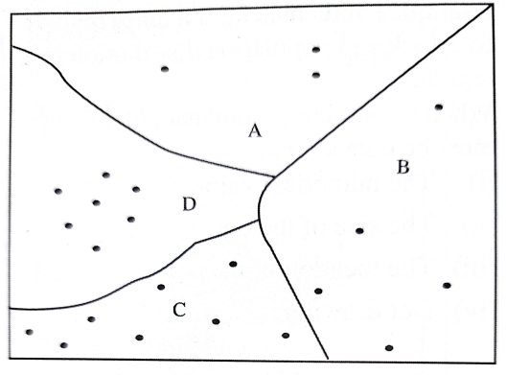
Dot value.1 dot represent 31,000 cows
Area of division C is 25,531.23km2
Calculate the population density of division C. (3 marks)
- (a) Name two major varieties of wheat grown in Kenya. (2 marks)
(b) Give three reasons for using a combine harvester in wheat harvesting. ( 3 marks)
- (a) Define the term urbanization. (2 marks)
(b) State four factors that lead to development of dispersed settlement (4 marks)
- (a) Identify two categories of energy sources (2 marks)
(b) The sketch map below shows Hydro electric power stations along river Tana. Use it to answer question b (i) and (ii) (3 marks)

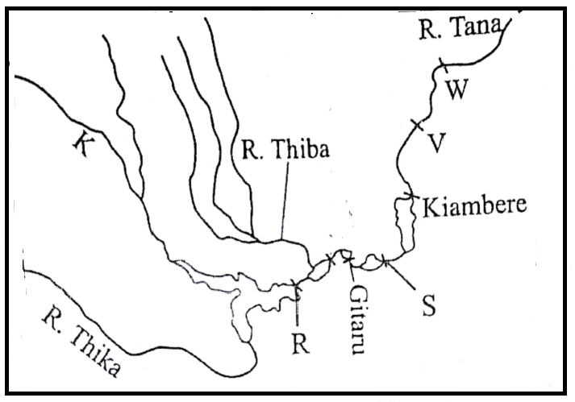
(i) Name the river marked K ( 1 mark)
(ii) Name the power station marked R and S (2marks)

SECTION B
Answer question 6 and any other two questions from this section.
- (a) The table below shows displaced persons by floods in Kenya in April to May 2024 long rain season in different counties. Study it and use it to answer question 6 (a) (i) and (ii)
County | Number of displaced persons
Kisumu | 41923
Busia | 16645
Nairobi | 34125
Tanariver | 18678
Garissa | 62890

(i) Draw a divided rectangle measuring 12cm to represent the above data. (8 marks)
(ii) State two conclusions that can be made from the divided rectangle drawn above. (2 marks)
(b (i) A part from floods, mention two other climatic hazards experienced in Kenya. (2 marks)
(ii) Name two rivers in Western Kenya that cause large scale flooding (2 marks)
(iii) Explain three human factors that lead to frequent flooding in Kenya. (6 marks)
(c) (i) What is water pollution? ( 2 marks)
(ii) Identify three legislative actions that have been taken by the Kenyan government to
combat pollution of water sources. (3 marks)

7. (a) (i) Differentiate between population and demography. (2marks) (ii) Give three factors that influence population growth. (3 marks)
(b) Study the figure below and use it to answer questions b(i) and (ii)
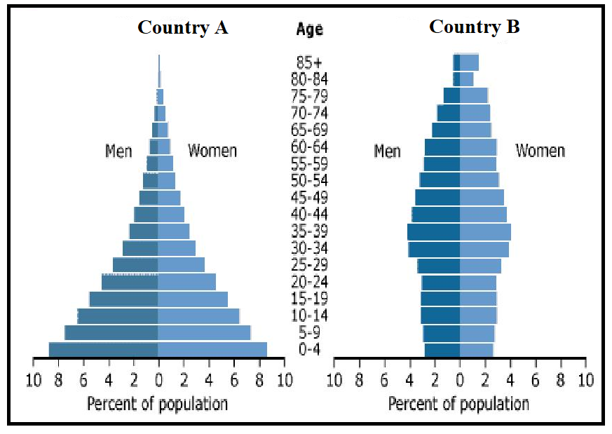
- Identtify the stages of demographic transition for country A and country B. (2 marks)
- State three characteristics of the population representated by pyramid B. (3 marks)
(c) (i) Differentiate between emigration and immigration (2 marks)
(ii) Explain three factors that cause urban to rural migration in Kenya (6 marks)
(d) Explain how the following factors have influenced population distribution in Kenya and Sweden
- Mountains (2 marks)
- Mining (2 marks)
(e) Give three differences between population trends in Kenya and Sweden. (3 marks)

- (a) (i) Name two forms of internal trade in Kenya. . (2 marks)
(ii) Name two major imports to Kenya from European Union. ( 2 marks)
(b) Explain how the following factors influence trade in Kenya.
- Transport (2 marks)
- Demand for goods (2marks)
(c) State three problems facing internal trade in Kenya. (3 marks)
(d) Explain four ways in which Kenya will benefit from the renewed East African Community.
( 8 marks)
(e) Explain how trade restrictions have influenced external trade in Kenya. (6 marks)

- (a) Define the term industralisation. ( 2 marks)
(b) (i) Identify two industries located in the Ruhr region of Germany. (2marks)
(ii) Explain how the following factors that led to the growth of industries named in b(i) above.
- Availability of capital (2 marks)
- Central geographical location. (2marks)
(c) Explain three ways in which Kenya has benefitted from assembling vehicles locally. ( 6 marks)
(d) State three problems that face industrial development in Kenya. ( 3 marks)
(e) You intend to carry out a field study on jua kali sheds in Kisumu;
(i) Construct a one day work schedule for the study. (4 marks)
(ii) State two reasons why you would conduct a pre- visit. (2 marks)
(ii) State two characteristics of jua kali industries you are likely to identify. (2 marks)
- (a) (i) Define communication? (2 marks)
(ii) State three recent developments that have taken place to improve mobile phone services in
Kenya. (3 marks)
(b) (i) Apart from canals, give other three waterways in Africa. (3marks)
(ii) Give three reasons why the suez canal is commonly used waterway in africa. (3 marks)
(c) Study the map of the Great Lakes and the St.Lawrence Sea way below and name features marked J, M and N. ( 3 marks)
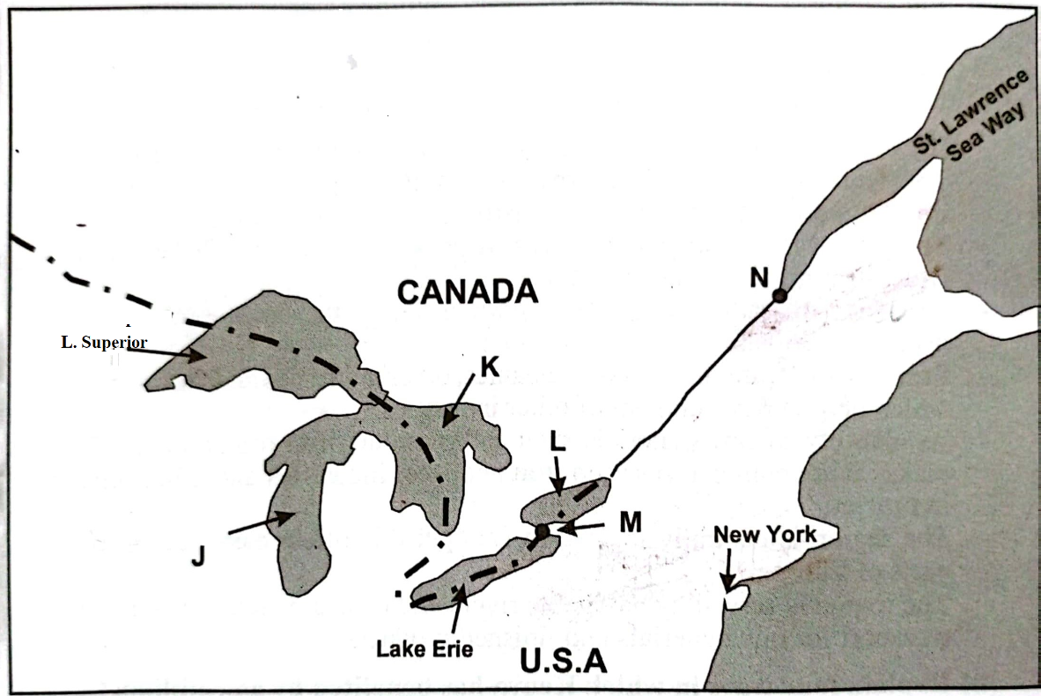
(d) Explain three ways in the Great Lakes andSt.Lawrence Sea way route has contributed to industrial development in the region (6 marks)
(e )State five measures the government has taken to reduce road accidents in Kenya. (5 marks)

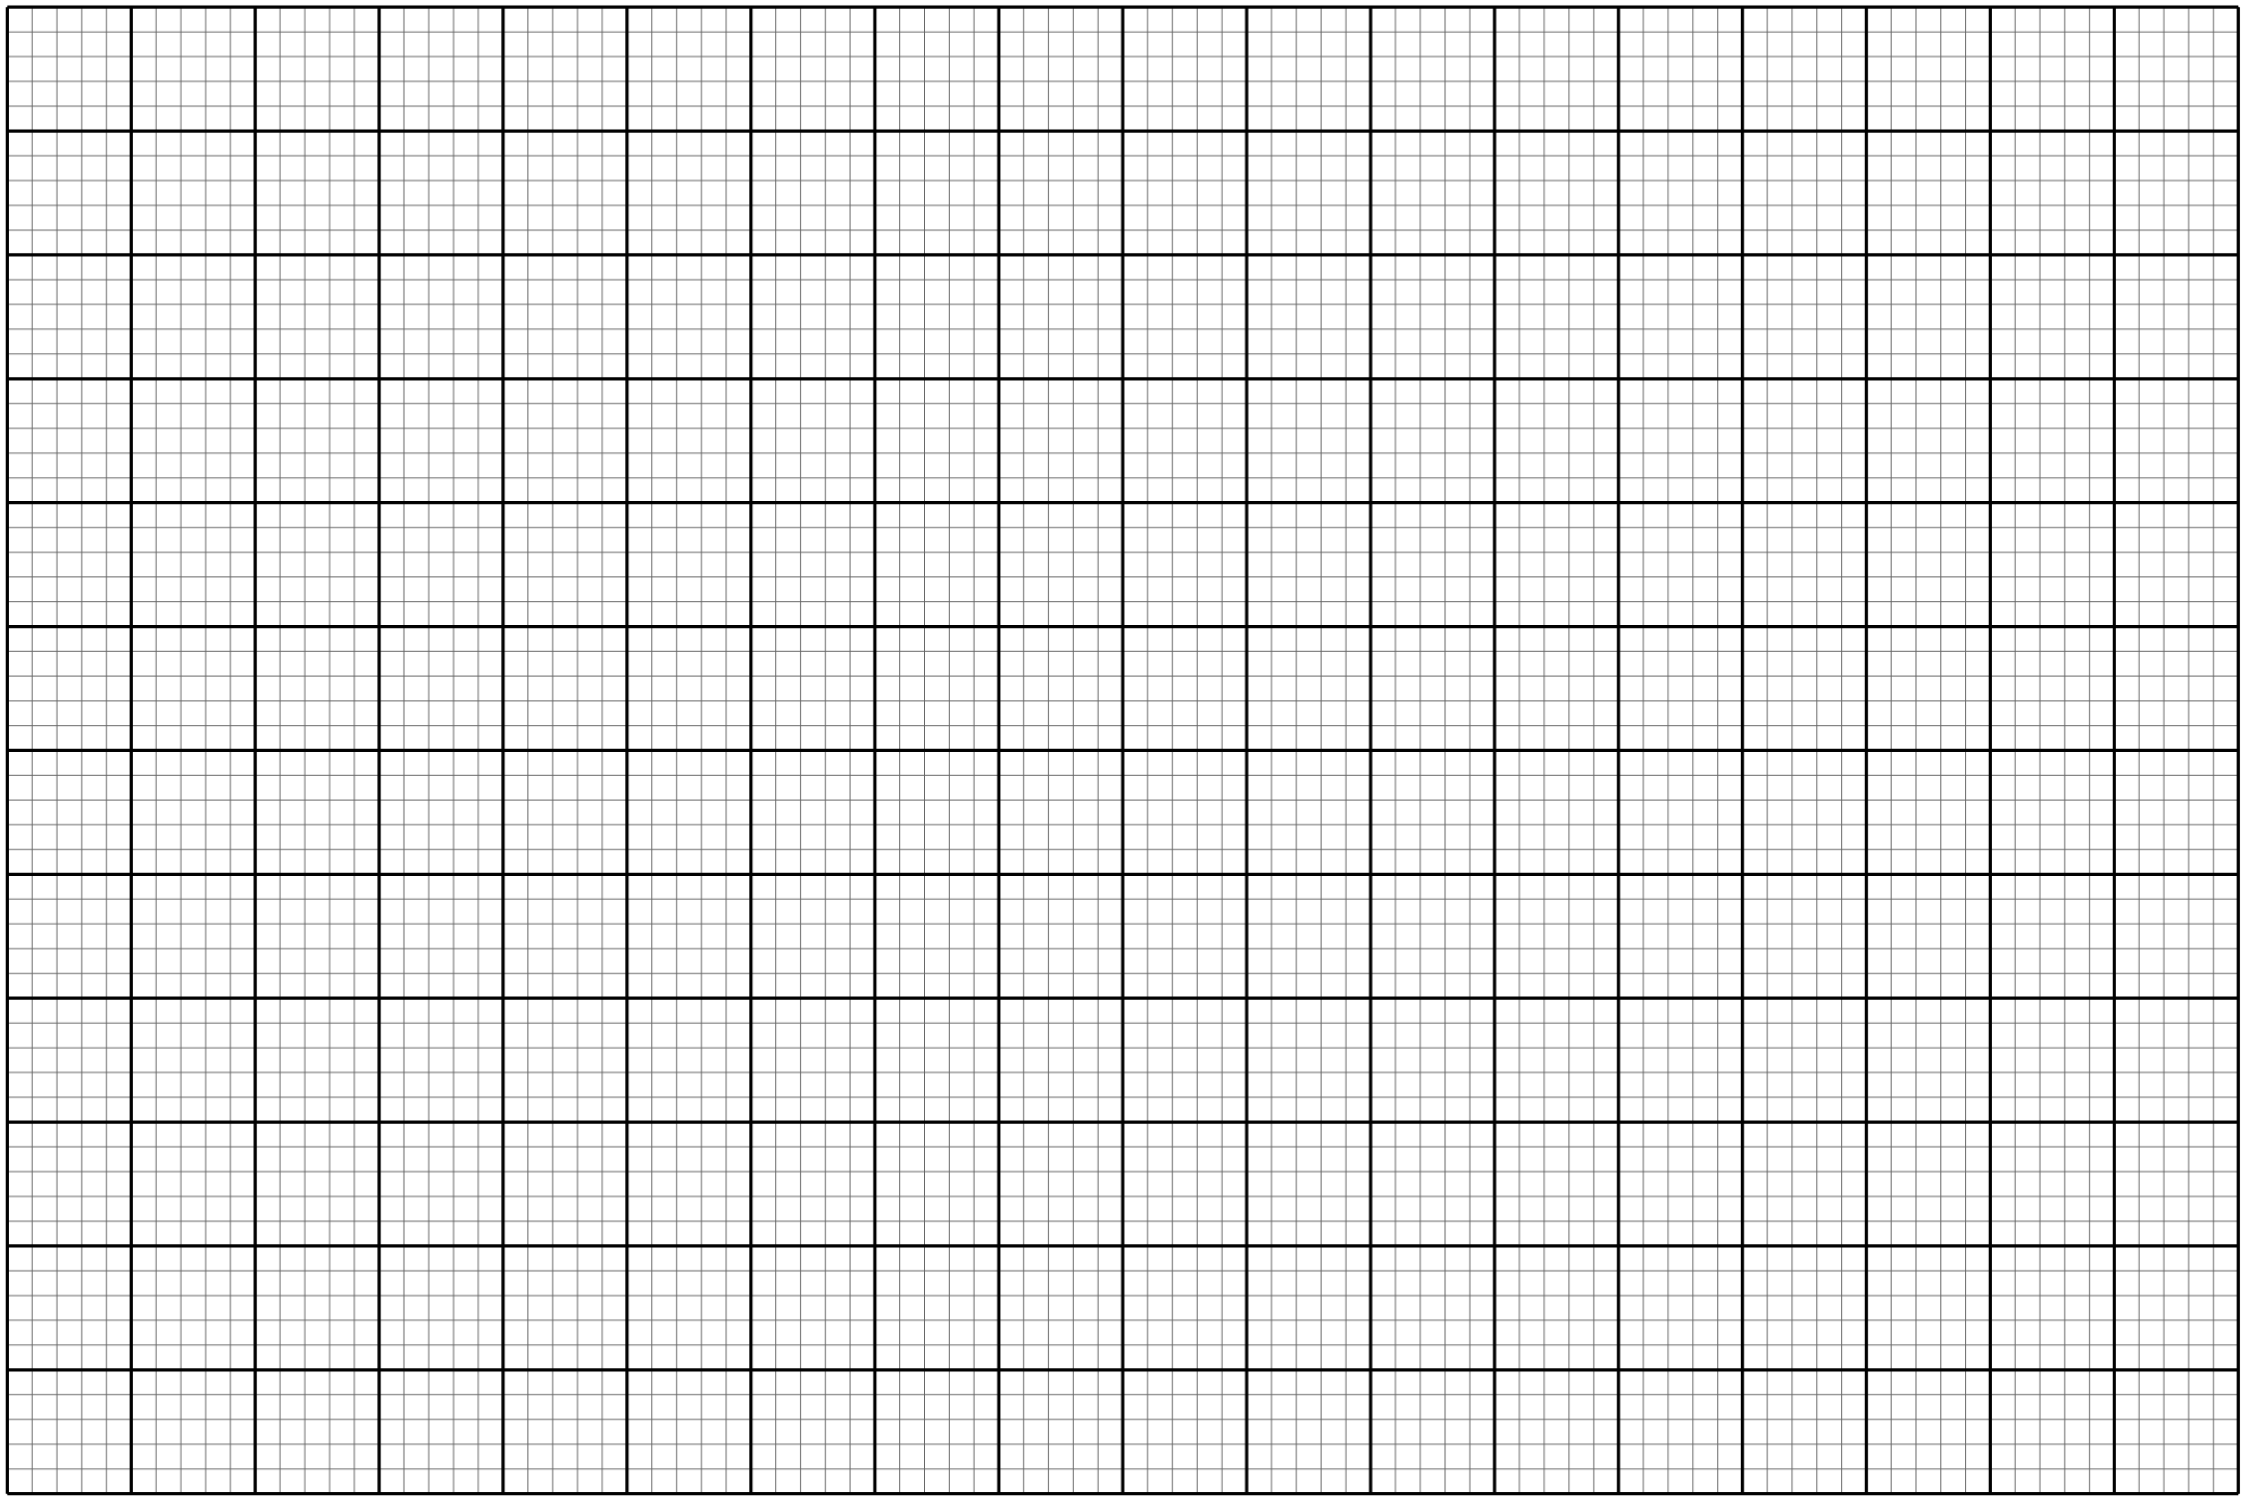
……………………………………………………………………………………………………………………………………………………………………………………………………………………………………………………………………………………………………………………………………………………………………………………………………………………………………………………………………………………………………………………………………………………………………………………………………………………………………………………………………………………………………………………………………………………………………………………………………………………………………………………………………………………………………………………………………………………………………………………………………………………………………………………………………………………………………………………………………………………………………………………………………………………………………………………………………………………………………………………………………………………………………………………………………………………………………………………………………………………………………………………………………………………………………………………………………………………………………………………………………………………………………………………………………………………………………………………………………………………………………………………………………………………………………………………………………………………………………………………………………………………………………………………………………………………………………………………………………………………………………………………………………………………………………………………………………………………………………………………………………………………………………………………………………………………………………………………………………………………………………………………………………………………………………………………………………………………………………………………………………………………………………………………………………………………………………………………………………………………………………………………………………………………………………………………………………………………………………………………………………………………………………………………………………………………………………………………………………………………………………………………………………………………………………………………………………………………………………………………………………………………………………………………………………………………………………………………………………………………………………………………………………………………………………………………………………………………………………………………………………………………………………………………………………………………………………………………………………………………………………………………………………………………………………………………………………………………………………………………………………………………………………………………………………………………………………………………………………………………………………………………………………………………………………………………………………………………………………………………………………………………………………………………………………………………………………………………………………………………………………………………………………………………………………………………………………………………………………………………………………………………………………………………………………………………………………………………………………………………………………………………………………………………………………………………………………………………………………………………………………………………………………………………………………………………………………………………………………………………………………………………………………………………………………………………………………………………………………………………………………………………………………………………………………………………………………………………………………………………………………………………………………………………………………………………………………………………………………………………………………………………………………………………………………………………………………………………………………………………………………………………………………………………………………………………………………………………………………………………………………………………………………………………………………………………………………………………………………………………………………………………………………………………………………………………………………………………………………………………………………………………………………………………………………………………………………………………………………………………………………………………………………………………………………………………………………………………………………………………………………………………………………………………………………………………………………………………………………………………………………………………………………………………………………………………………………………………………………………………………………………………………………………………………………………………………………………………………………………………………………………………………………………………………………………………………………………………………………………………………………………………………………………………………………………………………………………………………………………………………………………………………………………………………………………………………………………………………………………………………………………………………………………………………………………………………………………………………………………………………………………………………………………………………………………………………………………………………………………………………………………………………………………………………………………………………………………………………………………………………………………………………………………………………………………………………………………………………………………………………………………………………………………………………………………………………………………………………………………………………………………………………………………………………………………………………………………………………………………………………………………………………………………………………………………………………………………………………………………………………………………………………………………………………………………………………………………………………………………………………………………………………………………………………………………………………………………………………………………………………………………………………………………………………………………………………………………………………………………………………………………………………………………………………………………………………………………………………………………………………………………………………………………………………………………………………………………………………………………………………………………………………………………………………………………………………………………………………………………………………………………………………………………………………………………………………………………………………………………………………………………………………………………………………………………………………………………………………………………………………………………………………………………………………………………………………………………………………………………………………………………………………………………………………………………………………………………………………………………………………………………………………………………………………………………………………………………………………………………………………………………………………………………………………………………………………………………………………………………………………………………………………………………………………………………………………………………………………………………………………………………………………………………………………………………………………………………………………………………………………………………………………………………………………………………………………………………………………………………………………………………………………………………………………………………………………………………………………………………………………………………………………………………………………………………………………………………………………………………………………………………………………………………………………………………………………………………………………………………………………………………………………………………………………………………………………………………………………………………………………………………………………………………………………………………………………………………………………………………………………………………………………………………………………………………………………………………………………………………………………………………………………………………………………………………………………………………………………………………………………………………………………………………………………………………………………………………………………………………………………………………………………………………………………………………………………………………………………………………………………………………………………………………………………………………………………………………………………………………………………………………………………………………………………………………………………………………………………………………………………………………………………………………………………………………………………………………………………………………………………………………………………………………………………………………………………………………………………………………………………………………………………………………………………………………………………………………………………………………………………………………………………………………………………………………………………………………………………………………………………………………………………………………………………………………………………………………………………………………………………………………………………………………………………………………………………………………………………………………………………………………………………………………………………………………………………………………………………………………………………………………………………………………………………………………………………………………………………………………………………………………………………………………………………………………………………………………………………………………………………………………………………………………………………………………………………………………………………………………………………………………………………………………………………………………………………………………………………………………………………………………………………………………………………………………………………………………………………………………………………………………………………………………………………………………………………………………………………………………………………………………………………………………………………………………………………………………………………………………………………………………………………………………………………………………………………………………………………………………………………………………………………………………………………………………………………………………………………………………………………………………………………………………………………………………………………………………………………………………………………………………………………………………………………………………………………………………………………………………………………………………………………………………………………………………………………………………………………………………………………………………………………………………………………………………………………………………………………………………………………………………………………………………………………………………………………………………………………………………………………………………………………………………………………………………………………………………………………………………………………………………………………………………………………………………………………………………………………………………………………………………………………………………………………………………………………………………………………………………………………………………………………………………………………………………………………………………………………………………………………………………………………………………………………………………………………………………………………………………………………………………………………………………………………………………………………………………………………………………………………………………………………………………………………………………………………………………………………………………………………………………………………………………………………………………………………………………………………………………………………………………………………………………………………………………………………………………………………………………………………………………………………………………………………………………………………………………………………………………………………………………………………………………………………………………………………………………………………………………………………………………………………………………………………………………………………………………………………………………………………………………………………………………………………………………………………………………………………………………………………………………………………………………………………………………………………………………………………………………………………………………………………………………………………………………………………………………………………………………………………………………………………………………………………………………………………………………………………………………………………………………………………………………………………………………………………………………………………………………………………………………………………………………………………………………………………………………………………………………………………………………………………………………………………………………………………………………………………………………………………………………………………………………………………………………………………………………………………………………………………………………………………………………………………………………………………………………………………………………………………………………………………………………………………………………………………………………………………………………………………………………………………………………………………………………………………………………………………………………………………………………………………………………………………………………………………………………………………………………………………………………………………………………………………………………………………………………………………………………………………………………………………………………………………………………………………………………………………………………………………………………………………………………………………………………………………………………………………………………………………………………………………………………………………………………………………………………………………………………………………………………………………………………………………………………………………………………………………………………………………………………………………………………………………………………………………………………………………………………………………………………………………………………………………………………………………………………………………………………………………………………………………………………………………………………………………………………………………………………………………………………………………………………………………………………………………………………………………………………………………………………………………………………………………………………………………………………………………………………………………………………………………………………………………………………………………………………………………………………………………………………………………………………………………………………………………………………………………………………………………………………………………………………………………………………………………………………………………………………………………………………………………………………………………………………………………………………………………………………………………………………………………………………………………………………………………………………………………………………………………………………………………………………………………………………………………………………………………………………………………………………………………………………………………………………………………………………………………………………………………………………………………………………………………………………………………………………………………………………………………………………………………………………………………………………………………………………………………………………………………………………………………………………………………………………………………………………………………………………………………………………………………………………………………………………………………………………………………………………………………………………………………………………………………………………………………………………………………………………………………………………………………………………………………………………………………………………………………………………………………………………………………………………………………………………………………………
THIS IS THE LAST PRINTED PAGE

