Kenya Certificate of Secondary Education
233/2 - CHEMISTRY - PAPER 2
TTIME – 2 HOURS

Name:_________________________________________ Index Number:_____________
School:________________________________________ Date:______________________
Candidate’s Signature:__________________________

Instructions to candidates
- Write your Name and Index Number in the spaces provided above.
- Sign and write the date of examination in the spaces provided.
- Answer all the questions in the spaces provided in the question paper.
- KNEC mathematical tables and electronic calculators may be used for calculations.
- All workings MUST be clearly shown where necessary.
- Candidates should check the question paper to ascertain that all the pages are printed as indicated and that no questions are missing.
- Candidates should answer the questions in English.

FOR EXAMINERS USE ONLY
Questions | Maximum Score | Candidate’s Score
1 | 13
2 | 11
3 | 14
4 | 08
5 | 09
6 | 11
7 | 14
TOTAL | 80

- (a) The Grid below represents part of the periodic table. Study it and answer the questions that follow. The letters do not represent the actual symbols of the elements.

X |  |  |  |  |  |  |  | L
 |  |  |  |  |  |  |  | Q
Y |  |  |  | W

(i) State and explain which element is the most reactive metal.
(2 marks)
___________________________________________________________________________________________________________________________________________
___________________________________________________________________________________________________________________________________________

(ii) Element Q forms a compound with X and another with carbon. Write down the formulae of the two compounds. (2 marks)

___________________________________________________________________________________________________________________________________________
___________________________________________________________________________________________________________________________________________

(b) Explain the difference in atomic size of elements Y and W. (2 marks)

___________________________________________________________________________________________________________________________________________
___________________________________________________________________________________________________________________________________________

(c ) Give a reason why the relative atomic masses of some elements such as chlorine are not whole numbers,. (1 mark)

___________________________________________________________________________________________________________________________________________
(d) The table below gives elements represented by letters T, U, V, W, X and Y. The atomic numbers of the elements are also given.

Element | T | U | V | W | X | Y
Atomic number | 12 | 13 | 14 | 15 | 16 | 17
Electronic arrangement of the ion

Complete the above table by giving the electronic arrangement of the ion of each of the elements. (6 marks)

- (a) During the test for nitrates, a brown ring is observed.
Write a chemical formula of the brown ring. (1 mark)

___________________________________________________________________________________________________________________________________________
(b) Study the flow chart below and answer the questions that follow.

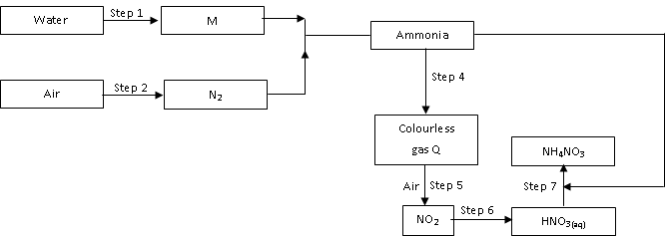

(i) Name element M ______________________________________ (1 mark)

(ii) Why is it necessary to use excess air in step 4.
(1 mark)
___________________________________________________________________________________________________________________________________________
(iii) Identify gas Q ______________________________________ (1 mark)

(iv) Write an equation for reaction in step 7. (1 mark)

___________________________________________________________________________________________________________________________________________
(v) Give one use of ammonium nitrate. (1 mark)

___________________________________________________________________________________________________________________________________________
(vi) State the conditions required in step 4. (1 mark)

___________________________________________________________________________________________________________________________________________
(c ) State and explain the observations that would be made if a sample of Sulphur is heated with concentrated nitric acid. (2 marks)

___________________________________________________________________________________________________________________________________________
___________________________________________________________________________________________________________________________________________
(d) Bleaching by Sulphur (IV) oxide is temporary but bleaching by chlorine is permanent. Explain. (2 marks)

___________________________________________________________________________________________________________________________________________
___________________________________________________________________________________________________________________________________________
- The diagram below represents the energy change in a reaction between Sulphur (IV) Oxide and oxygen gases without a catalyst.

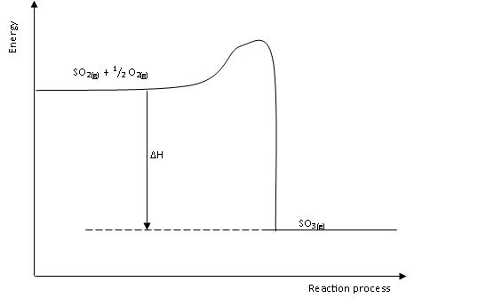

- Indicate on the diagram the reaction path when a catalyst is used. Give reasons for your answer. (2 marks)

________________________________________________________________________
- State with reason whether the profile represents an exothermic or endothermic reaction process. (2 marks)

___________________________________________________________________________________________________________________________________________
___________________________________________________________________________________________________________________________________________
- Study the following exothermic reactions.

HCl_{(aq)} + NaOH_{(aq)} Nacl_{(aq)} + H₂O_{(l)} ; ∆H₁
Hcl_{(g)} + NaOH_{(aq)} Nacl_{(aq)} + H₂O_{(l)} ; ∆H₂
NaOH_{(s)} + (aq) NaOH_{(aq)} ; ∆H₃
(i) Which of the ∆H values above is the highest? Give a reason for your answer. (2 marks)

___________________________________________________________________________________________________________________________________________
___________________________________________________________________________________________________________________________________________

(ii) Draw an energy cycle diagram involving ∆H₁ ∆H₂ and ∆H₃

- Use the enthalpies of hydration and lattice below to answer the questions that follow.

Ions / compound | kJ/mol
K⁺ | ∆H_{Hyd} = -322
Li⁺ | ∆H_{Hyd} = -519
I⁻ | ∆H_{Hyd} = -293
Cl⁻ | ∆H_{Hyd} = -364
KI | ∆H_{Latt} = +632
LiCl | ∆H_{Latt} = + 846

(i) Calculate the enthalpy of solution of potassium iodide. (3 marks)

___________________________________________________________________________________________________________________________________________
___________________________________________________________________________________________________________________________________________
___________________________________________________________________________________________________________________________________________
(ii) Represent on an energy level diagram, the enthalpy of solution of lithium chloride, including its enthalpy of hydration and the reverse of its lattice energy. (2 marks)

___________________________________________________________________________________________________________________________________________
___________________________________________________________________________________________________________________________________________

- Sodium hydroxide was at one time manufactured by the Gossage Process in which sodium carbonate and calcium hydroxide were reacted together in solution.

- (i) Write the equation for the reaction of sodium carbonate with calcium hydroxide. (1 mark)

___________________________________________________________________________________________________________________________________________

(ii) Give the name of the process you would use to separate sodium hydroxide from the other product of the reaction. (1 mark)

___________________________________________________________________________________________________________________________________________________________________________________________________________________
___________________________________________________________________
- Sodium hydroxide solution reacts with many cations in solution to give precipitates. Write the ionic equation for the reaction and give the colour of the precipitate formed, when sodium hydroxide solution reacts with;

(i) Ion (III) Chloride solution (2 marks)

Equation_______________________________________________________

Colour of precipitate____________________________________________

(ii) Copper (II) Sulphate solution. (2 marks)

Equation_______________________________________________________

Colour of precipitate____________________________________________

- Today, sodium hydroxide is manufactured by electrolysis.

(i) Name the raw materials in this process. (1 mark)

___________________________________________________________________
________________________________________________________________________
(ii) State one by-product of the industrial manufacture of sodium hydroxide. (1 mark)

________________________________________________________________________
___________________________________________________________________
- The rate of radioactive decay (in counts per minute) of an isotope was measured at intervals over a number of days, the results were as shown in the table below.

Time (days) | 0 | 1 | 2 | 3 | 4 | 5 | 6 | 7
Decay rate | 1000 | 820 | 660 | 520 | 420 | 340 | 260 | 170

- On the grid provided below, draw a graph of decay rate against time. (3 marks)

- From the graph determine the half-life of the radioactive isotope.
(2 marks)
________________________________________________________________________
___________________________________________________________________
________________________________________________________________________
___________________________________________________________________
- 12g of the radioactive isotope decayed for a period of 9 days. How many grams of it remained. (3 marks)

________________________________________________________________________
___________________________________________________________________
________________________________________________________________________
___________________________________________________________________
________________________________________________________________________
___________________________________________________________________
- State one use of radioactive isotope. (1 mark)

________________________________________________________________________
___________________________________________________________________
- Study the oxidation potential of the elements below and answer the questions that follow. The elements are in their actual symbols.

Half cell | E^{θ}(volts)
Fe_{(s)} / Fe_{(aq)}²⁺ | +0.44
Sn_{(s)} / Sn_{(aq)}²⁺ | +0.14
Ag_{(s)} / Ag_{(aq)}⁺ | -0.80
Fe_{(s)} / P_{t} / Fe_{(aq)}³⁺ | -0.77

- Identify the strongest reducing agent and the strongest oxidizing agent.

- Strongest reducing agent _________________________(1 mark)
- Strongest Oxidizing agent_________________________(1 mark)
- (i) Draw a cell diagram for Fe_{(s)} /Fe_{aq}²⁺ half-cell and Ag_{(s)} / Ag_{(ag)}⁺ half-cell. (3 marks)

(ii) Determine the e.m.f of the cell drawn in b(i) above. (2 marks)

________________________________________________________________________
___________________________________________________________________
________________________________________________________________________
___________________________________________________________________
- (i) Explain whether or not it is possible to stir a solution of silver ions with iron spoon. (1 mark)

________________________________________________________________________
___________________________________________________________________
(ii) Write the cell notation for Sn_{(s)} / Sn_{(aq)}²⁺ half-cell and Ag_{(s)}/Ag_{(aq)}⁺
half-cell

________________________________________________________________________
___________________________________________________________________

- State two functions of salt bridge in an electrochemical cell.
(2 marks)
________________________________________________________________________
___________________________________________________________________
________________________________________________________________________
___________________________________________________________________

- (a) With the help of equations explain how;

(i) Sodium metal reacts with pure ethanol. (1 mark)

________________________________________________________________________
___________________________________________________________________
(ii) Ethanol and ethanoic acid reacts when equal volumes of the two substances are mixed together and warmed with a few drops of concentrated Sulphuric Acid. (1 mark)

________________________________________________________________________
___________________________________________________________________
(b) Explain the meaning of each of the following terms used in the soapy detergent manufacture.

(i) Saponification (1 mark)

________________________________________________________________________
___________________________________________________________________
(ii) Salting out (1 mark)

________________________________________________________________________
___________________________________________________________________

(c ) (i) Write the general chemical formula of a soapless detergent.
(1 mark)
___________________________________________________________________
___________________________________________________________________
(ii) Explain briefly how soapless detergent removes grease particles during washing process. (2 marks)

________________________________________________________________________
________________________________________________________________________
___________________________________________________________________
___________________________________________________________________
(iii) State one advantage and one disadvantage of soapless detergent.
- Advantage (1 mark)

___________________________________________________________________
___________________________________________________________________
- Disadvantage (1 mark)

___________________________________________________________________
___________________________________________________________________
(d) Below is the structure of a polymer Nylon 6,6.
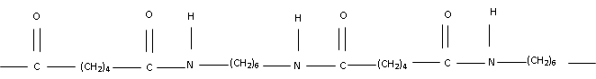

(i) Draw the structure of the monomer of Nylon 6,6. (2 marks)

(ii) Given the molecular mass of Nylon 6,6 is 544. Determine the number of monomer in Nylon 6,6 (N=14, H=1, C=12, O=16)
(3 marks)

___________________________________________________________________
___________________________________________________________________
___________________________________________________________________
___________________________________________________________________
___________________________________________________________________
___________________________________________________________________
___________________________________________________________________

THIS IS THE LAST PRINTED PAGE

