Kenya Certificate of Secondary Education
233/1 - CHEMISTRY - PAPER 1
TIME – 2 HOURS

Name:_________________________________________ Index Number:_____________
School:____________________________________Date:______________________
Candidate’s Signature:__________________________

Instructions to candidates

- Write your Name and Index Number in the spaces provided above.
- Sign and write the date of examination in the spaces provided.
- Answer all the questions in the spaces provided in the question paper.
- KNEC mathematical tables and electronic calculators may be used for calculations.
- All workings MUST be clearly shown where necessary.
- Candidates should check the question paper to ascertain that all the pages are printed as indicated and that no questions are missing.
- Candidates should answer the questions in English.

FOR EXAMINERS USE ONLY

Questions | Maximum Score | Candidate’s Score
1 - 13 | 80

- Study the set up shown below and use it to answer the questions that follows.

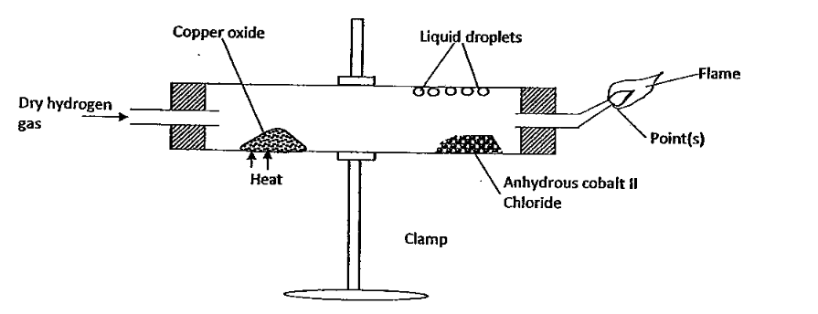
- State the observations made at the end of the experiment on:-

(i) The cobalt II chloride papers. (1 mark)

(ii) Copper II Oxide powder. (1 mark)

- (i) Why was excess hydrogen ignited? (1 mark)

(ii) Write a fully balanced equation for the reaction occurring at the flame at point(s) (1 mark)

- A student used the reaction between steam and heated magnesium metal to collect a dry sample of hydrogen gas. Complete the diagram to collect the gas. (3 marks)
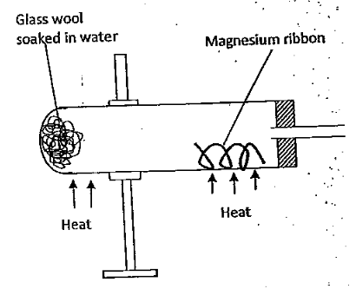
Write the equation for the reaction producing the hydrogen gas in the above reaction.
(1 mark)

- The following diagram represents a set up showing how changes of state from solid to liquid cold be investigated.
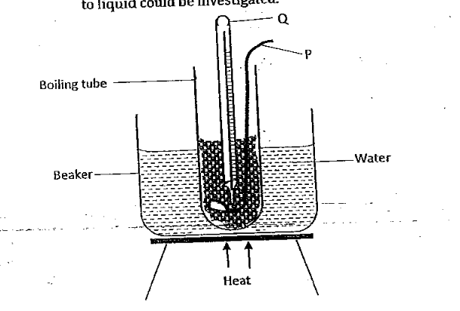
Identify the apparatus P and Q and state their uses.

P (1 mark)

Q (1 mark)

- (a) Define the term “Gay Lussac’s Law. (1 mark)

(b) When 100cm³ of gaseous hydrocarbon (C_{x}H_{y}) burn in 400cm³ of oxygen, 100cm³ of oxygen is unused, 200cm³ of steam are formed. Deduce the equation for the reaction and the formula of the hydrocarbon. (2 marks)

- If it takes 30 seconds for 100cm³ of carbon (IV) oxide to diffuse across a porous plate. How long will it take 150cm³ of nitrogen (IV) oxide to diffuse across the same plate under similar conditions? (C=12.0, N=14.0, O=16.0) (2 marks)

- Define Charles Law. (1 mark)

- The table below shows the solubility of a salt at various temperatures.

Temperature ⁰C | Solubility (g/100g water)
0 | 36
40 | 30
80 | 25
100 | 22
120 | 20

- Define the term Fractional Crystallization. (1 mark)

- A saturated solution of the salt at 40⁰C was heated to 100⁰C. State and explain the observation made. (2 marks)

- Calculate the mass of salt formed when a saturated solution of the salt at 0⁰C is place in a water bath maintained at 100⁰C. (1 mark)

- Structures below are a representation of cleansing agents M and N.

(i) Identify the agents. (1 mark)

(ii)Write an equation for the compound formed when agent N is used with water containing calcium nitrate salt. (1 mark)

(iii)A water engineer analyzed water from a borehole and found out that it contained magnesium chloride impurities. State any two methods used to make the water suitable for washing using agent N. (1 mark)

- Calculate the percentage abundance of two other isotopes of element A with three isotopes, (30, 32, 35). Given that the R.A.M. is 30.5 and percentage abundance of 35 is 5% (2 marks)

- An element Z has ionic configuration of Z⁺ -2.8. The element is burned in excess oxygen and the product is then added to water. Write two possible equation for the reaction which took place. (2 marks)

- Phosphorus (III) oxide oxide has a lower melting point than calcium chloride. Explain.
(2 marks)

- Describe how you would prepare silver carbonate starting with silver. (3 marks)

- Use the table below to determine the enthalpy change for the reaction between hydrogen and chlorine. (3 marks)

Bond | Bond Energy kJ/mole
H-H | 435
H-Cl | 431
Cl-Cl | 244

- Explain why hydrogen sulphide cannot be used as a fuel, though it can burn to give out useful heat energy. (1 mark)

- (a) Explain why cryolite is added to aluminium oxide before electrolysis. (1 mark)

(b) During electrolysis 40,000 amperes was passed through a Hall cell for 10hours. Calculate the mass of aluminium deposited at the cathode in kg. (IF=96500,Al=27)
(3 marks)

- (a) Define the term half-life. (1 mark)

(b) A certain nuclide has a half life of 2.5 hours. What percentage of a given mass of the nuclide will be left after 7.5 hours. (2 marks)

- Explain how increase in temperature affects the rate of a given reaction. (2 marks)

- Write down the preliminary steps undertaken to concentrate an ore during extraction of metals. (2 marks)

- Write down the formula of the chief ore of Aluminium. (1 mark)

- Dilute Sulphuric (VI) acid was added to a compound P of magnesium. The solid reacted with the acid to form a colourless solution Q and a colourless gas R which formed a white precipitate when bubbled through lime water. Identify:- (1 ½ mark)

- Compound P

- Solution Q

- Colourless gas R

- During an experiment on the reduction of an oxide of copper, the following data was obtained.

Mass of empty boat | = | 25.0g
Mass of empty boat + oxide of copper | = | 29.0g
Mass of boat + copper after reaction | = | 28.2g

Determine the empirical formula (Cu=64, O=16) (3 marks)

- Calculate the number of atoms in 26.4g of calcium carbonate.
(Ca=40, C=12, O=16, L=6.02 x 10²³) (2 marks)

- Lead (II) nitrate was heated completely.

- Write an equation for heating lead (II) nitrate. (1 mark)

- Calculate the mass of the oxide formed given that 0.2 moles of the nitrate was heated. (Pb=207, O=16). (2 marks)

- Draw and name two branched isomers of the compound whose chemical formula is C₅H₁₂. (2 marks)

- (a) Complete the following table based on organic compounds. (1 mark)

 | Compound | Reagent needed for preparation
(i) | Ethyne
(ii) | Ethane

(b) Write chemical equations to represent the reaction in (a) above. (2 marks)

(i)

(ii)

(c ) An organic substance (Q) reacted with ethanoic acid to form pleasant smelling compound CH₃CHOOCH₂CH₂CH₃

(i) What conditions will be required to form the product? (1 mark)

(ii) If another compound with a chemical formula C₃H₆ has to be formed from compound Q what would be the conditions required in this process. (1 mark)

- (a) Give the formula of the Monomer used during the formation of the following polymer. (1 mark)

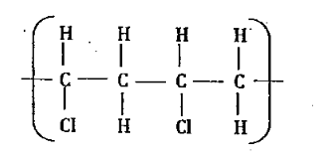

(b) State any use of the polymer in (a) above. (1 mark)

(c ) Other than using universal indicator explain how one can differentiate between the following chemicals. Propanol and Propanoic acid. (1 mark)

- The melting points of oxygen and sulphur are -216⁰C and 113⁰C respectively yet the two elements belong to group VI in the periodic table. Explain. (2 marks)

- Which type of Sulphur is formed under the following conditions?

 | Conditions | Type of Sulphur
(a) | Above 96⁰ |  | ( ½ mark)
(b) | Pouring boiling Sulphur into cold water |  | ( ½ mark)
(c) | Rapidly cooling Sulphur Vapour |  | ( ½ mark)
(d) | Mixing Sodium thiosulphate with dilute hydrochloric acid. |  | ( ½ mark)

- When dry Chlorine is passed over heated iron in a combustiontube, a brown solid forms on the cooler parts of the combustion tube.

- Name the brown solid. (1 mark)

- Why does the brown solid form on the cooler parts of the combustion? (1 mark)

- What will be the pH of the solution formed when the brown solid is dissolved in water? (1 mark)

- Chlorine gas is poisonous yet it is used to treat water. Explain. (1 mark)

- The diagrams below shows the apparatus used to investigate one of the properties of carbon.
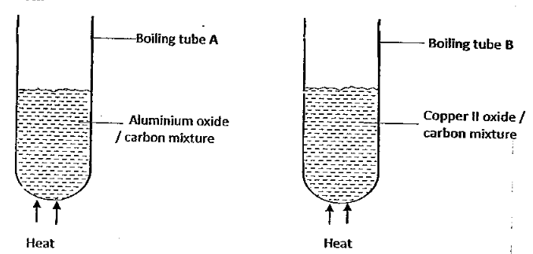
State and explain the observations made in each boiling tube. (2 marks)

- The diagrams below shows the apparatus used to investigate the properties of carbon IV oxide gas.
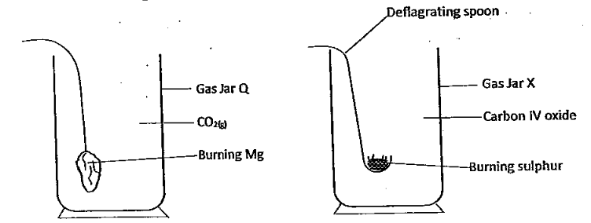
- State and explain the observations made in each gas jar. (2 marks)

- State one industrial use of carbon (IV) oxide. (1 mark)

