NAME……………..………………………………………… INDEX NO……...........………………..………
CANDIDATE’S SIGNATURE…………… DATE………..………………….……………..
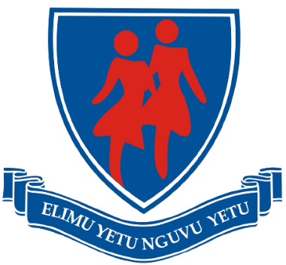

STAREHE GIRLS’ CENTRE MOCK EXAMINATION 2024
313/2
CHRISTIAN RELIGIOUS EDUCATION
Paper 2
TIME: 2 ½ HOURS

- (a) What is revealed about John in Zachariah songs (Benedicts) Lk 1: 76 – 79 (6 marks)
(b) Give seven teachings of John the Baptist about Jesus Christ. (7 marks)
(c) Identify seven ways in which the church wins people for the kingdom of God.
(7 marks)

- (a) Describe the incident in which Jesus healed the man with a withered hand. Lk 6: 6 -11.
(7 marks)
(b) Outline seven instructions given by Jesus to the twelve disciples when he send them on a
mission. (7 marks)
(c) Show six ways in which the church prepares the youth for leadership roles in society. (6 marks)

3. (a) Describe the transfiguration of Jesus. (8 marks)
Luke 9: 28 – 36
(b) Identify seven reasons why Jesus taught in parables. (7 marks)
(c) Show six ways in which Christians prepare for the 2nd coming of Jesus. (6 marks)

4. (a) With reference to 1 Cor 12:12 – 27 show how Paul’s teaching on unity of believers is
illustrated in the image “body of Christ”. (8 marks)
(b) Explain six ways in which the gift of the Holy Spirit can be used to promote unity in the
church today. (6 marks)
(c) What activities do Christians engage in, to demonstrate their love for one another? (7 marks)

5. (a) Outline the various sources from which a Christian draws ethical judgement. (7 marks)
(b) In which seven ways have the youth abused the use of leisure time in Kenya today?
(c) Identify six causes of conflict in the family today. (6 marks)

6. (a) Outline the Christian teaching on wealth. (7 marks)
(b) Explain seven ways in which modern science and technology has improved human life. (7 marks)
(c) Identify ways in which Christians can help reduce pollution of the environment. (6 marks)

