MURANG’A HIGH SCHOOL TRIAL EXAMINATION
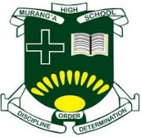
231/ 3 - BIOLOGY Paper -3
Time 1 ¾ hours

Name …………………………………………….……… Index Number…………………………..

Candidate’s Signature ………………….…...……….. Date ……………………………………

Instructions to candidates
- Write your name and class in the spaces provided above.
- Sign and write the date of examination in the spaces provided above.
- Answer ALL questions in the spaces provided.
- Additional pages MUST NOT be inserted.
- Candidates will be penalized for incorrect spelling especially of technical terms and for use of slovenly language
- You are required to spend the first 15 minutes of the 1¾hours allowed for this paper reading the whole paper carefully before commencing your work.
- This paper consists of 5 printed pages. Candidates should check the question paper to ascertain that
ALL the pages are printed as indicated and no questions are missing
For Examiner’s Use Only
Question | Maximum  Score | Candidate’s  Score
1 | 14
2 | 13
3 | 13
Total score | 40


Turn over

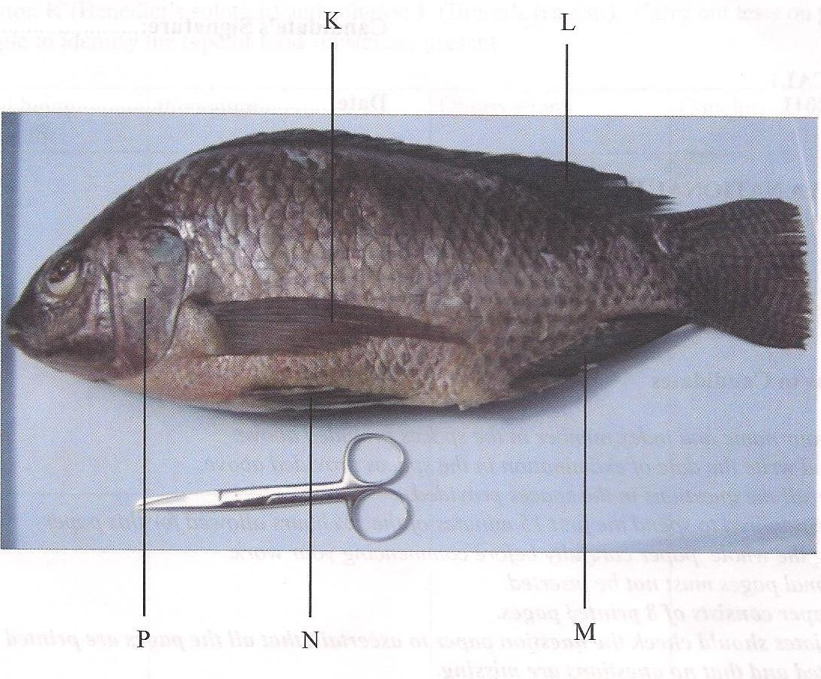
- Below is a photograph of a fish. Examine it and answer the questions that follow.

- List three observable features used to identify the class to which the organism shown on the photograph belongs [3mks]
……………………………………………………………………………………………………………………………………………………………………………………………………………………………………………………………………………………………………………………………………….

- The actual length of the pair of scissors next to the fish is 13 cm. Using this information, calculate the actual length of the fish. (3 marks)
……………………………………………………………………………………………………………………………………………………………………………………………………………………………………………………………………………………………………………………………………….

- Name all the observable structures that prevent the following movements of fish during swimming. (2marks)
  - Yawing …………………………………………………………………………………………………
  - Pitching…………………………………………………………………………………………………
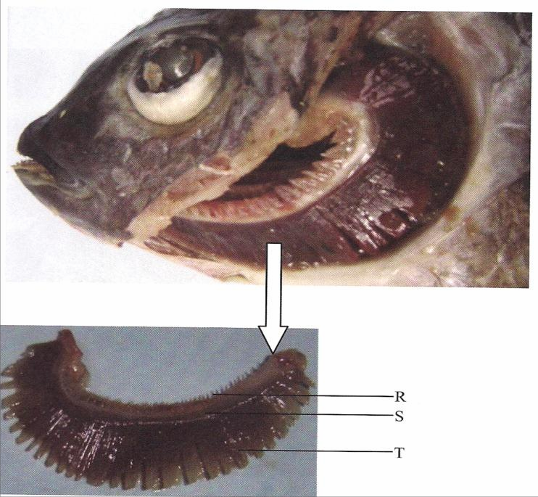
- The photograph below shows structures visible after

- Removing the part labeled P. The inset labeled figure 2 (a) is a magnified view of one of the structures.
  - Name the part labeled R, S and T (3 marks)
……………………………………………………………………………………………………………………………………………………………………………………………………………………………………………………………………………………………………………………………………….
  - Explain how each of the parts named in (d) (i) above is adapted to its function. (3 marks
……………………………………………………………………………………………………………………………………………………………………………………………………………………………………………………………………………………………………………………………………….
……………………………………………………………………………………………………………………………………………………………………………………………………………………………………………………………………………………………………………………………………….

- You are provided with a food sample labelled D in solution form. Using the reagents provided, carry out tests to identify the food substances in the food sample. (12mks)
FOOD SUBSTANCE | PROCEDURE | OBSERVATION | CONCLUSION
Proteins
Non-Reducing Sugar
Starch

3. The diagram below illustrates photographs of plants undergoing a certain process. Study them
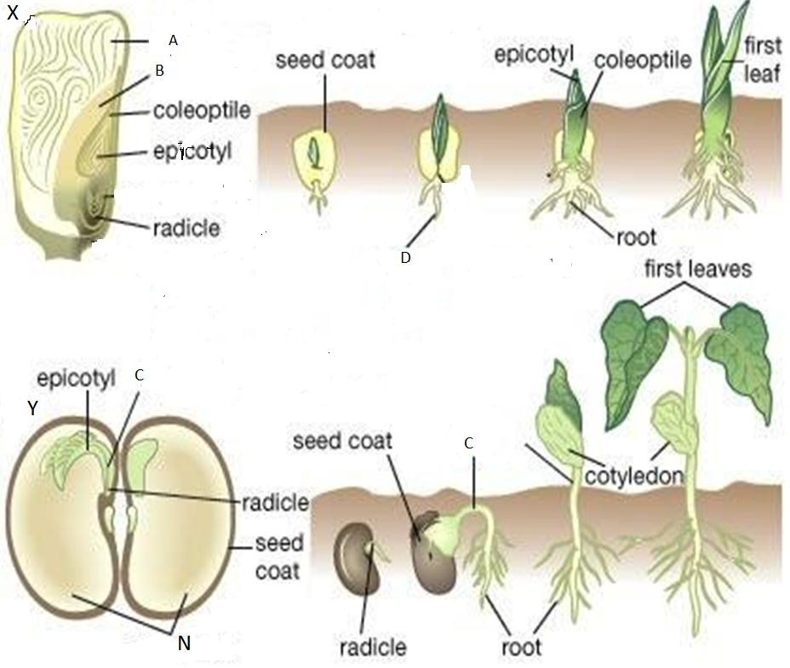
carefully and answer the questions that follow.

a) i) Name the process illustrated on the photograph. [1mk]
………………………………………………………………………………………………………
ii) State two differences in the way the process occurs as illustrated in X and in Y. [2mks]
………………………………………………………………………………………………………
b) i) State two roles of part C in the process illustrated above. [2mks]
………………………………………………………………………………………………………
………………………………………………………………………………………………………
ii) State two external factors that are necessary for the process above to take place. [2mks]
……………………………………………………………………………………………………………… ……………………………………………………………………………………………………………....
c) Name the parts labeled B and give its function
Name: ………………………………………………………………………………. [1mk]
Function: …………………………………………………………………………… [1mk]
- Using observable features only, name the classes to which the specimen X and Y belong, giving one reason in each case. [1mk]

SPECIMEN | CLASS | REASONS
X
Y

THIS IS THE LAST PAGE PRINTED

