**NAME ……………………………………………………………………… INDEX NO. ……………………………**

**CANDIDATES SIGNATURE …………………DATE …………………………………..**



**Kenya Certificate of Secondary Education Mock Examination 2024**

MATHEMATICS

**Paper 2**

**2½ Hours**

**Instructions**

* *Write your name and index number in the spaces provided at the top of this page*
* *The paper contains* ***two*** *sections: section one and section two****.***
* ***Show all the steps in your calculations, giving your answers at each stage in the spaces provided below each question.***
* *Marks may be given for correct working even if the answer is wrong.*
* ***Non-programmable*** *silent electronic calculators* ***and*** *KNEC mathematical tables may be used, except where stated otherwise.*

**For Examiner’s use only.**

**Section I**

|  |  |  |  |  |  |  |  |  |  |  |  |  |  |  |  |  |
| --- | --- | --- | --- | --- | --- | --- | --- | --- | --- | --- | --- | --- | --- | --- | --- | --- |
| **1** | **2** | **3** | **4** | **5** | **6** | **7** | **8** | **9** | **10** | **11** | **12** | **13** | **14** | **15** | **16** | **Total** |
|  |  |  |  |  |  |  |  |  |  |  |  |  |  |  |  |  |

**SECTION II (50 MARKS)**

|  |  |  |  |  |  |  |  |  |
| --- | --- | --- | --- | --- | --- | --- | --- | --- |
| 17 | 18 | 19 | 20 | 21 | 22 | 23 | 24 | **TOTAL** |
|  |  |  |  |  |  |  |  |  |

**GRAND TOTAL**

**SECTION 1** (50 MARKS)

1. Use logarithms (4 marks)

$$-_{3}^{1}$$

$$\left[\begin{aligned} 8.35 x 23.68 \\ \log{3.58}\end{aligned}\right]$$

1. Make x the subject of the formula (3 marks)

2x = $\sqrt{\frac{x^{2} - yP}{2 + y}}$

1. Without using tables or calculators evaluate (3 marks)

$$\frac{3}{2 - 3\sin{60° }}$$

4

1. Expand $\left(\begin{aligned}x + 1 \\ 2x\end{aligned}\right)$

Hence give the constant term (3 marks)

1. Y varies partly as square at x and partly inversely as square root of x. When x=4, y=13 and when x=9, y=79. Find the relationship between the variables. (3 marks)
2. The second, fourth and the sixteenth term of an increasing arithmetic progression are consecutive terms of a geometric profession. If the first term of the A.P is -3, find the common ratio of the G.P. (3 marks)
3. Solve for $θ$ given that; (3 marks)

2 cos $\frac{1}{2}$ $θ$ = $\frac{-4}{5}$ for -3600 3600

1. Find the centre and the radius of a circle whose equation is (3 marks)

2 + y - = 0

1. Complete the table given, for 00≤ x ≤ 1800 (1 mark)

|  |  |  |  |  |  |  |  |
| --- | --- | --- | --- | --- | --- | --- | --- |
|  | 0 | 30 | 45 | 90 | 135 | 150 | 180 |
| $$y=\sin{2x}$$ | 0 |  | 1 | 0 | -1 |  | 0 |

1. Draw the graph of y=sin2x, hence find the value of sin 2x = 0.4

(3 marks)

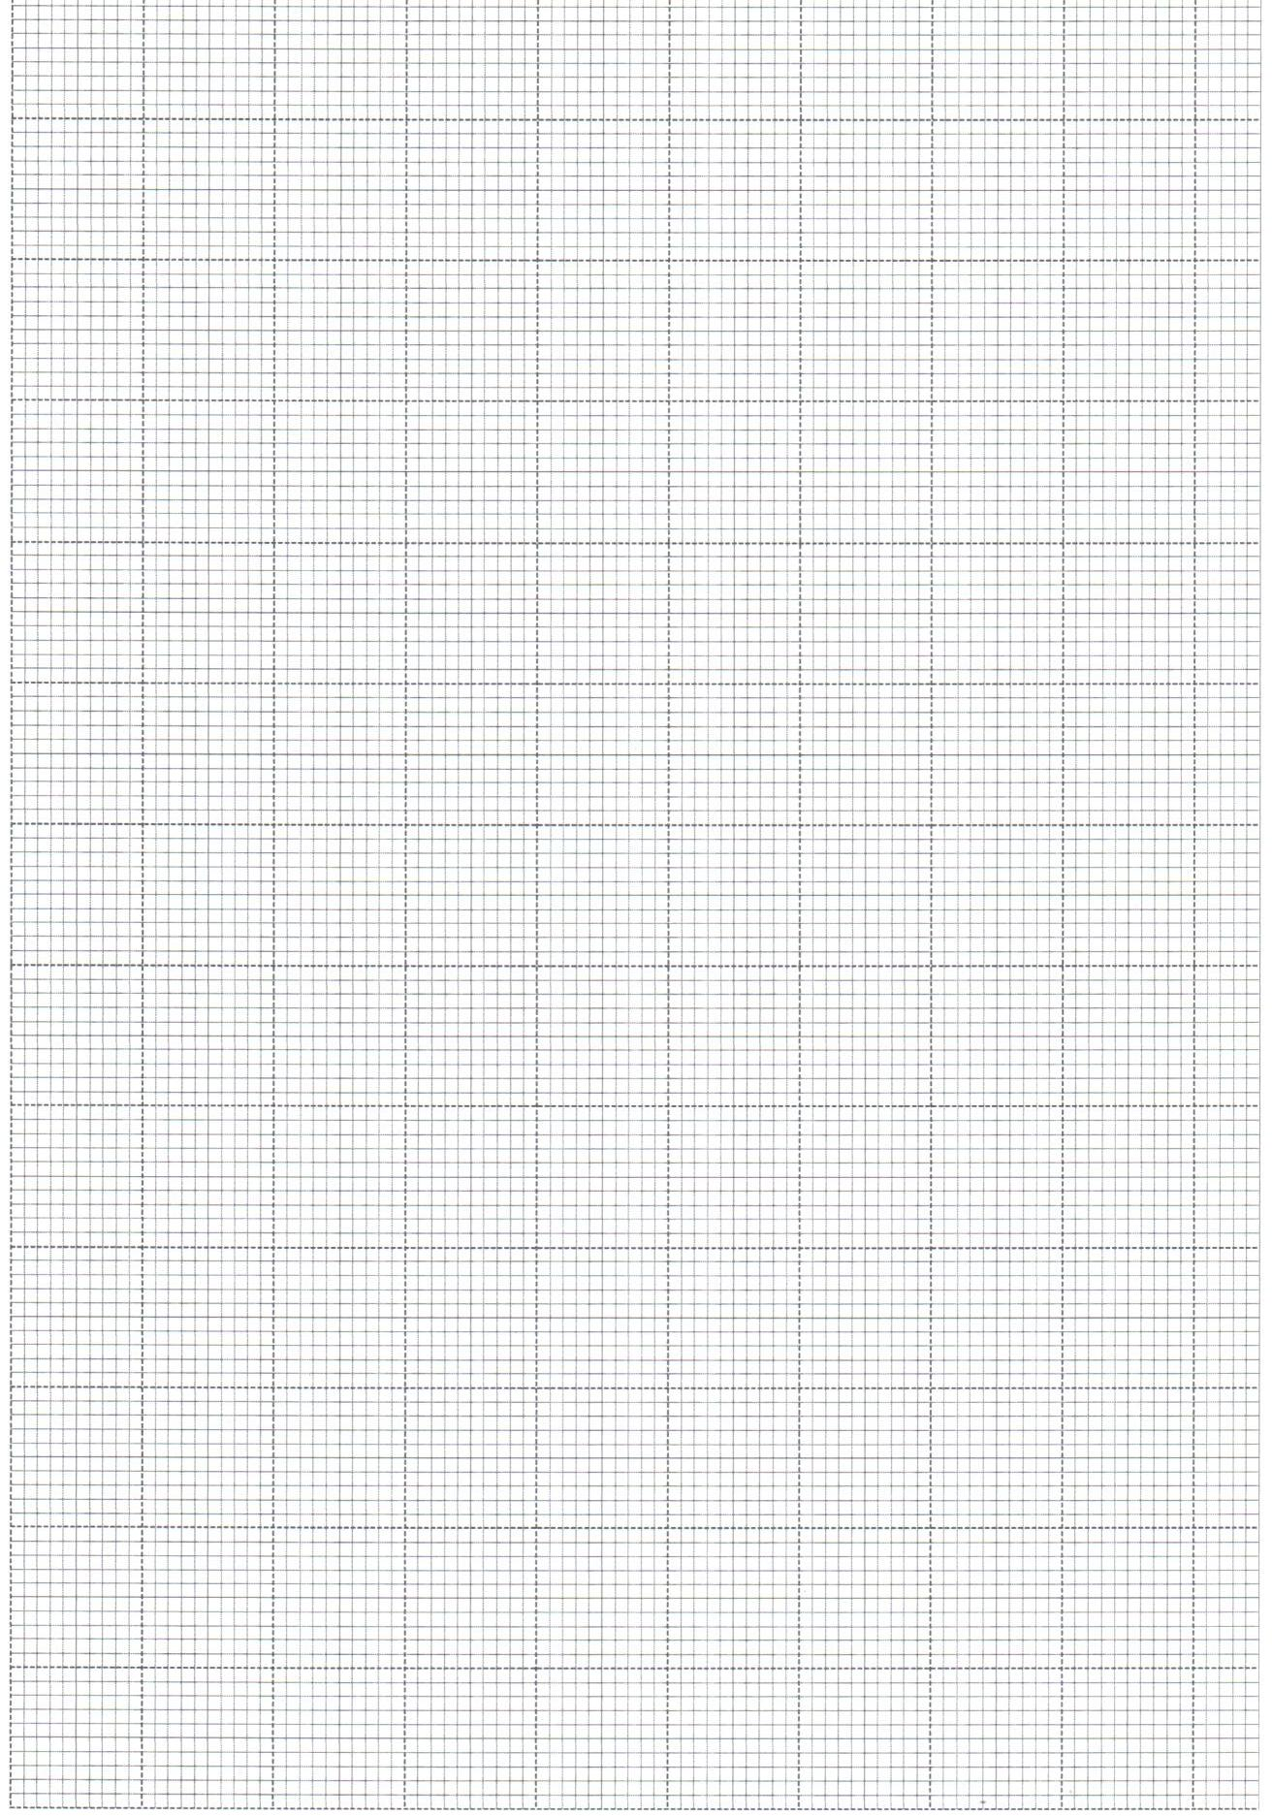

Y-axis

x-axis

1. Use the matrix method to solve the following pair of simultaneous equations (3 marks)

2n + 3m = 12

4m - 2n = 5

1. Mr. Omondi paid a tax of Kshs.2512 in the month of July. In that month he received a house allowance of sh.5000 and a tax relief of shs.1056. Use the table below to find his monthly basic salary in shillings. (3 marks)

|  |  |
| --- | --- |
| **Income in $ per month** | **Rate %** |
| 1. - 484   485 - 940  941 - 1396  1997 - 1852  Excess over 1852 | 10  15  20  25  30 |

1. The marked price of a lap top is Kshs.60,000. A customer buys it at shs.73500 on hire purchase terms. If the deposit paid is Kshs.7500 and an interest of 22 ½ % p.a is charged on the balance. Calculate the number of months it takes to clear the balance. (3 marks)
2. A man uses 100m of fencing to enclose a rectangular area using a wall on one side. Find the maximum possible area that can be enclosed. (3 marks)
3. A triangular prism has cross section ADE as shown. BC $∕∕$ DE, BC=4cm and DE=6cm. if the prism has a length of 10cm and density of 1.32 g/cm3. Calculate the mass of the prism of cross-section ABC. Given that the area of trapezium BCDE=36cm2

(3 marks)

A

4cm

6cm

E

D

C

B

>

>

1. Solve for t (3 marks)

2

= 3 – 2

1. Find the percentage error, $\frac{a+b}{c}$ given that a=3.0, b=4.24 and c=2.

(3 marks)

**SECTION II**

1. In the triangle below $\vec{OA}$ = a and OB $=b$. M is mid-point of AB and N is a point on OB such that ON= $1/3$ OB. AN and OM intersect at P

A

a

>

M

P

O

B

>

N

b

1. Express the following vectors in terms at a and b
2. AB (1 mark)
3. OM (1 mark)
4. AN (2 marks)
5. If OP=tOM and AP=sAN, express OP in two different ways hence find the values of t and s.

(5 marks)

1. State the ratio AN:NP (1 mark)
2. The table below shows height in cm of form 4 students in Westlands Secondary school.

|  |  |  |  |  |  |
| --- | --- | --- | --- | --- | --- |
| **Height (cm)** | 150-154 | 155-159 | 160-164 | 165-169 | 170-174 |
| **Frequency (f)** | 18 | 16 | 24 | 28 | 14 |

1. Using an assumed mean of 162, calculate;
2. Mean height (3 marks)
3. Standard deviation (3 marks)

b) If the heights of each student increases by 5cm. Write down

1. The new mean (1 mark)
2. The new standard deviation (1 mark)

(c ) calculate the 30th percentile (2 marks)

1. Two identical bags A and B contains identical balls. Bag A has 5 yellow balls and 2 red balls. Bag B has 4 yellow balls and 3 red balls. Two balls are drawn from each bag without replacement.
2. Draw a tree diagram to illustrate the above information (2 marks)
3. Find the probability that;
4. Both balls are yellow (2 marks)
5. The first ball is red and the second yellow (2 marks)
6. A red and yellow balls are picked (2 marks)
7. At least one ball is red (2 marks)
8. Using a ruler and compass only;
9. Draw triangle PQR in which PQ=7.5cm QR=5cm and angle PQR=600 (2 marks)
10. By shading the unwanted regions, find the position of S where S and Q are on opposite sides of PR such that:
11. Angle PSR ≤ 600 (2 marks)
12. PS ≥ SR (2 marks)
13. PS ≥ 5 cm (2 marks)
14. Area of triangle PSQ ≤ 7.5 cm2 (2 marks)
15. Use the graph to answer the question below

0

1

2

3

Y=x2 - 4

1. Using trapezium rule with 7 ordinates calculate the shaded area. (3 marks)
2. Using mid ordinate rule with 6 strips, estimate the area of the shaded region. (2 marks)
3. (i) Calculate the actual area of the shaded region. (3 marks)

(ii) Find the percentage error in using mid-ordinate rule (2 marks)

1. The positions at towns x and y are given to the nearest degree as x(400N, 124oE) and Y(400N, 560W)
2. Longitude difference (1 mark)
3. Find the distance in nautical miles between x and y along a parallel of a latitude.

(3 marks)

1. Find the distance xy via the north pole in nautical mile. (3 marks)
2. A plane flying at 200 knots leaves y at 2.00p.m. on Monday what time and day does it arrive at x via great circle. (3 marks)
3. A manufacturer wishes to mix two brands of drink so that the ingredient per litre of the mixture is at least 18 units of iron, 14 units of calcium and 20 units of alcohol. The ingredient per litre of the brand one is 4 units of iron, 2 units of calcium and 2 units of alcohol. The ingredient per litre of brand two is 2 units of iron, 2 units of calcium and 4 units of alcohol. One litre of brand one costs shs.10 and one litre of brand two costs shs.14.
4. Form inequalities representing the above information. (4 marks)
5. Represent the inequalities on the grid provided (3 marks)
6. From the graph, determine the minimum cost per litre of the new brand of drink obtained by mixing brand one with brand two. (3 marks)
7. The variables y and x are connected by the equation $y ={ax}^{n}$

|  |  |  |  |  |  |  |
| --- | --- | --- | --- | --- | --- | --- |
| $χ$ | 1 | 2 | 3 | 4 | 5 | 6 |
| $$Υ$$ | 4 | 22.6 | 62.4 | 128 | 224 | 352 |

1. Write the equation in the form of $y=mx + c$ (1 mark)
2. Draw a straight line graph on the grid provided and estimate the value of *a* and *n*. (7 marks)
3. Find the value of y when x=2.1 (2 marks)