NAME ……………………………………………………………………… INDEX NO. ……………………………

CANDIDATES SIGNATURE …………………DATE …………………………………..

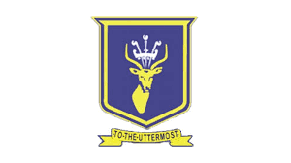

Kenya Certificate of Secondary Education Mock Examination 2024
MATHEMATICS
Paper 1
2½ Hours
Instructions

- Write your name and index number in the spaces provided at the top of this page
- The paper contains two sections: section one and section two.
- Show all the steps in your calculations, giving your answers at each stage in the spaces provided below each question.
- Marks may be given for correct working even if the answer is wrong.
- Non-programmable silent electronic calculators and KNEC mathematical tables may be used, except where stated otherwise.

For Examiner’s use only.
Section I
1 | 2 | 3 | 4 | 5 | 6 | 7 | 8 | 9 | 10 | 11 | 12 | 13 | 14 | 15 | 16 | Total

SECTION II (50 MARKS)

17 | 18 | 19 | 20 | 21 | 22 | 23 | 24 | TOTAL

GRAND TOTAL

SECTION 1

Answer all the questions in this section.

- Evaluate without using a calculator (3 marks)

11.8 x 7² - 11.8 x 5²

-18 + 6 ÷ 3 x -3

- The third number of four consecutive odd numbers is 2n + 3. Their sum is 1768. Find the numbers. (3 marks)

- Peter bought a shirt and sold it to Kamau at a profit of 10%. Kamau sold the same shirt to Rony at a price of Kshs.2700/= thus making a loss of 15%. Find the price Kamau bought the shirt from Peter. (3 marks)

- Three interior angles of an irregular hexagon are 108⁰, 162⁰ and 90⁰. The remaining three angles are all equal. Find the value of largest exterior angle. (3 marks)

- A, B and C are three points on a straight line (in that order) on horizontal ground. A and B are on the side of C. At C stands a vertical tower 173.2m high. The distance from A to B is 100m and the angle of elevation of the top of the tower from A is 30⁰. Find the angle of elevation of the top of tower from B. (3 marks)

- The figure below shows a prism ABCDEF with BC=8cm, AC=6cm and EB=8cm
D
E
C
A
F
B
8cm
6cm
8cm

Draw the net for above prism (2 marks)

- The line whose equation is 2x - 3y = 12 cuts the x-axis and y-axis at A and B respectively. Find the equation of the line equidistant from A and B. (3 marks)

- *Given that $q=7^{x}$ express the equation $7^{2x-1}+6×7^{x-1}=1$ interval of q. hence or otherwise find the value of x in the equation $7^{2x-1}+6×7^{x-1}=1$ (3 marks)

- Simplify completely

$\frac{2x+y}{x^{2}-xy}-\frac{2y+x}{xy-y^{2}}$ (4 marks)

- Solve the inequality (3 marks)*

$$\frac{3x-4}{-3}≤2≥\frac{x+1}{4}$$

hence list the integral values of x satisfying the inequality.

- Given A(2, 7), B(-6, -21) and C(1, 3.5). Show that the points A, B and C are collinear.
(3 marks)

- In a certain hospital, patients are treated by two doctors in consultation rooms. On average, one doctor takes 3 minutes while the other takes 5 minutes to treat a patient. If the two doctors start to treat patients at the same time, find the shortest time it takes to treat 200 patients. (3 marks)

- Water flows through a cylindrical pipe of diameter 4.2cm at a speed of 50m/minute. Calculate the volume of water delivered by pipe per minute in litres. (3 marks)

- From a ship C, a lighthouse A is 20km away on a bearing of 060⁰, while a lighthouse B is 30km on a bearing of 300⁰. Calculate the direct distance between the light houses to 3 sf.
(4 marks)

- Use reciprocal and square root tables to evaluate $\sqrt{0.007056}$ + $\frac{3}{23.4}$ to 4 decimal places
(3 marks)

- Evaluate without using mathematical table or calculator

$\sqrt{\frac{0.0625×2.56}{0.25×0.08×0.5}}$

SECTION II (50 MARKS)

Answer only five questions in this section

- The table below shows marks scored by 140 candidates in a test.

Marks | 1 – 10 | 11 – 20 | 21 – 30 | 31 – 40 | 41 - 50
No. of Candidates | 8 | 23 | 55 | 36 | 18

- Calculate the mean mark (3 marks)
- Calculate the median mark (3 marks)
- State the modal class (1 mark)
- Draw a frequency polygon for the mark (3 mark)

- Two towns A and B are 365km apart. A bus left town A at 8.15a.m. and travelled towards town B at 60km/hr. At 9.00 a.m. a car left town B towards town A at a speed of 100km/hr. The two vehicles met at town C which lies between town A and B.

- Find the time of the day the two vehicles met.

- Find the distance between towns A and C.

- At town C the driver of the car took 1 hour for lunch and followed the bus back to town B. Find how fast must the car move to arrive at town B same time as the bus.

- In the figure below ABCDEFGH is a frustum of a right pyramid the altitude of the frustum is 2cm
H
E
F
G
C
B
A
D
4cm
2.5cm
5cm
8cm

Calculate
- The altitude of the pyramid (2 marks)

- The volume of the frustum (2 marks)

- The angle between the bases of the frustum and the face ABGF (3 marks)

- The angle between base of the frustum and face ABHE (3 marks)

- (a) Triangle A(-4, 1), B(-2, 2) and C(-3, 3) is mapped onto A¹B¹C¹ by enlargement scale factor -1 centre (0, 3). On the grid provided draw the triangle ABC and its image A¹B¹C¹. State the co-ordinates of A¹B¹C¹. (4 marks) 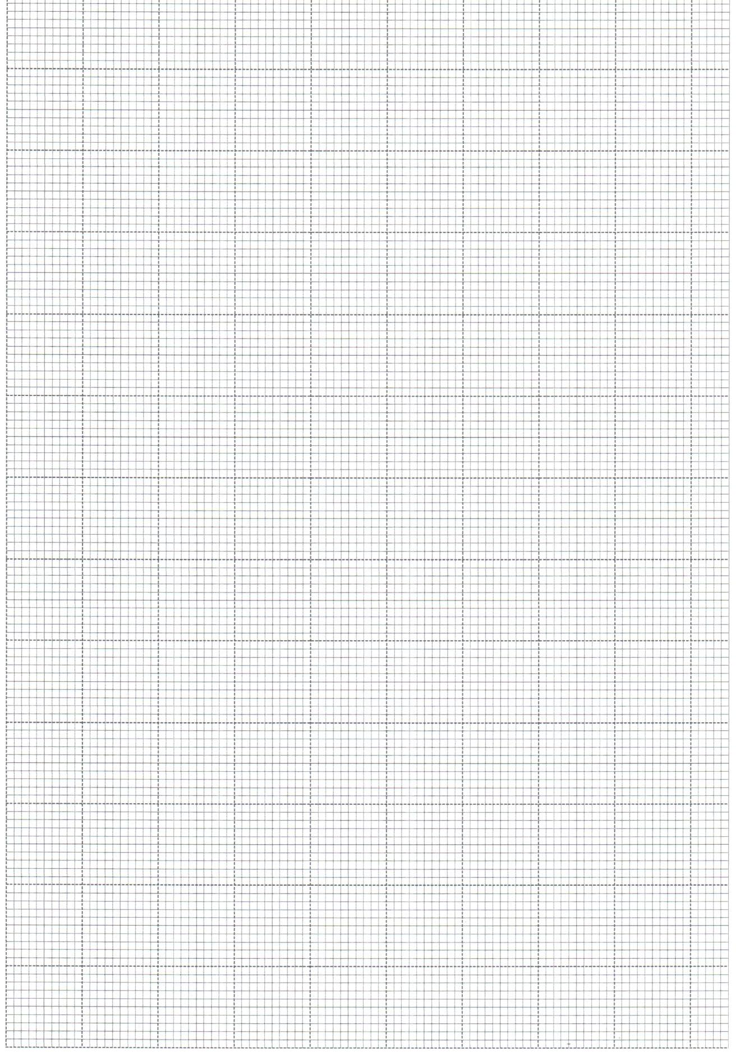

(b) Triangle A¹B¹C¹ is mapped onto A¹¹B¹¹C¹¹ by reflection on the line x + y = 0. Draw the image A¹¹B¹¹C¹¹ and state its co-ordinates (3 marks)

- Find the matrix of transformation which maps triangle A¹¹B¹¹C¹¹ onto ∆ABC
(3 marks)

- A particle moves along a straight line such that its velocity V mls from a given point is V=3t² – 10t + 3 where t is time in seconds. Find ;
- Acceleration of the particle when t= 2 seconds (2 marks)

- The time taken to reach the maximum height (3 marks)

- The distance covered during the 5th second (3 marks)

- Maximum velocity attained (2 marks)

- (a) Peter, John and Ronny working together take 30 minutes to slash a piece of land.
Peter and Ronny together take 40 minutes while Peter and John together take 45
minutes.
How long would each one of them take to slash the same piece of land. (6 marks)

(b) Two types of sugar P and Q are such that P costs sh.50 per kg and Q costs sh.60 per kg. In what proportion must P and Q be mixed so that by selling the mixture at shs.64.80 a profit 20% is realized. (4 marks)

- In the figure below SBT is the tangent to the circle at B. O is the centre of the circle. CB=3cm, AB=6cm and angle BAC=32⁰.

M
A
S
O●
C
3cm
6cm
32⁰
T
B

Find;
- The diameter of the circle (2 marks)

- Angle BOT (2 marks)

- Angle ACB (2 marks)

- Angle AMB (2 marks)

- Angle CBT (2 marks)
24. (a) The table below shows values of x and some values of y for the curve y=2x³ + x² + 5x + 2
for -3 ≤ x ≤ 3. Complete the table

X | -3 | -2 | -1 | 0 | 1 | 2 | 3
Y=$2x^{3} + x^{2}-5x+2$ | -28 |  |  | 2 | 0

(2 marks)
(b) On the grid provided, draw the graph of y=$x^{3}+ x^{2}2x3 + x2- 5x+2$ for $-3 ≤x ≤3$
Use the scale
2cm represent 1 unit on the x-axis
2cm to represent 20 units on the y=axis (3 marks)

c). (i) Use your graph to solve 2x³ + x² – 5x + 2 = 0 (1 mark)

(ii) By drawing a suitable straight line on the graph solve the equation

${2x}^{3} + x^{2}-5x+ =6x+ 12$ (4 marks)

