

**ACK MUMIAS DIOCESAN EVALUATION MOCK**

**EXAMINATIONS- KCSE JULY 2024**

**ACK DIOCESE OF MUMIAS SECONDARY SCHOOLS.**

**Kenya Certificate of Secondary Education**

**121/1 Paper 1**

**MATHEMATICS**

**ALT.A**

**JULY. 2024 - 2 $\frac{1}{2}$ Hours**

**Name: ……………………………………… Index Number: ………………**

**Student’s signature: ……………. Date: ……….…….Class: ……………….**

**Instructions to candidates**

* *Write your name, index number and class in the spaces*

*provided above.*

* *The paper contains* ***two*** *sections: Section I and Section II.*
* *Answer* ***all*** *the questions in Section I and* ***only five*** *questions from Section II*
* *All answers and working must be written on the question paper in the spaces provided below each question.*
* *Show all the steps in your calculations, giving your answers at each stage in the spaces below each question.*
* *Non – programmable silent electronic calculators and KNEC Mathematical tables may be used, except where stated otherwise.*

**For Examiner’s use only.**

**Section I**

|  |  |  |  |  |  |  |  |  |  |  |  |  |  |  |  |  |
| --- | --- | --- | --- | --- | --- | --- | --- | --- | --- | --- | --- | --- | --- | --- | --- | --- |
| 1 | 2 | 3 | 4 | 5 | 6 | 7 | 8 | 9 | 10 | 11 | 12 | 13 | 14 | 15 | 16 | Total |
|  |  |  |  |  |  |  |  |  |  |  |  |  |  |  |  |  |

**Section II**

|  |  |  |  |  |  |  |  |  |
| --- | --- | --- | --- | --- | --- | --- | --- | --- |
| 17 | 18 | 19 | 20 | 21 | 22 | 23 | 24 | Total |
|  |  |  |  |  |  |  |  |  |

**SECTION I. (50 marks)**

**Answer all questions in this section**

1. Simplify completely. $\frac{1}{2}+\frac{2}{5}÷\frac{3}{5}+\frac{7}{10}×\frac{6}{7}-\left(1\frac{1}{2}×\frac{1}{3}\right)$ (3mks)
2. The sum of interior angles of a triangle is given by the expression 2a+b while that of a quadrilateral is given by the expression 13a-b. calculate the values of a and b. (3mks)
3. Use reciprocal tables to evaluate. 1 $÷\frac{1}{9.31}+\frac{1}{8.934}$ (3mks)
4. Express $2.\ddot{83}$ as a fraction leaving your answer in the form $\frac{p}{q}$ (3mks)
5. In the diagram below, find the size of the angle labelled Q. (3mks)

53 $°$



Q



140 $°$

1. Evaluate without using a calculator or math table. (3mks)

$\frac{0.0064×6.25}{0.08×0.0025×0.4}$

1. Find all the integral values of $x$ which satisfy the inequality

3(1+ $x)<5x-11<x+45$ (3mks)

1. The arc length of a circle is a th of its circumference. If the area of the circle is 246.5cm2, find:
2. The angle subtended by the arc at the centre of the circle. (2mks)

1. The area of the sector enclosed by the arc. (2mks)
2. Find the angle $θ$ in degrees from the figure below. The equation of line ABC is $2x-3y+6=0$ (3mks)

C

B



$θ$

A 0

1. Solve for $x$ in the equation. (3mks)

${32}^{\left(x-3\right)}÷8^{\left(x-4\right)}=64÷2^{x}$

1. Line AB drawn below is a side of as trapezium ABCD.

A 8cm B

1. using a ruler and a pair of compasses only, complete trapezium ABCD in which AB is parallel to DC, <BAC =67.5°, AD= 5cm.BC=5.5cm and <ABC is acute. (3mks)
2. Measure the length of DC. (1mk)
3. Fatuma left Mumias for Nairobi on Tuesday at 2.30 am she arrived at Londiani after 3hrs 12 minutes. she stayed in londiani for 36 hrs and then left for Nairobi. she took 5hrs 25 minutes to arrive in Nairobi. Determine the day and time in 12hour system Fatuma arrived in Nairobi. (3mks)
4. The diagram below is triangle ABC in which BC=12cm, <ABC=80 $°$ and <ACB= 30 $°$.

A

80 $°$ 30 $°$ B 12cm C



Calculate, correct to 4 significant figures the area of triangle ABC. (3mks)

1. Given that **q**=5**t**-3**f** where **t= $\left(\begin{matrix}-2 \\ -3\end{matrix}\right)$** and **f= $\left(\begin{matrix}1 \\ -2\end{matrix}\right)$,** find
2. The column vector **q (**2mks)
3. Given that T1(3,2) is the image of T(0,-2) under a translation, find the translation vector. (1mk)
4. A piece of copper wire is bent in the shape of an isosceles triangle. The vertical angle is 40 $°$ and the height of the triangle is 5 cm. Find the length of the copper wire correct to 1 decimal place. (3mks)
5. An empty specimen bottle has a capacity of 300ml and a mass of 280g. calculate the mass of the bottle when it is full of a liquid whose density is 1.2g/cm3. (3mks)

**SECTION II (50 marks)**

**Answer any five questions in this section.**

17. The figure below shows rectangle ABCD. Use it to;

A **Y=mx+6** B

D(-7,2) **x+2y+3=0** C

1. State the value of m and the x-intercept of line DC. (2mks)
2. Determine;

i. The equation of side AD in double intercept form. (3 mks)

ii. The coordinates of the vertices A,B,C. (3mks)

iii. The area of the triangle ABC. (2mks)

1. A retailer planned to buy some computers from a wholesaler for a total of Kshs.1 800 000. Before the retailer could buy the computers, the price per unit was reduced by Ksh 4 000. This reduction in price enabled the retailer to buy five more computers using the same amount of money as originally planned. Taking x to be the price of each computer before the price decrease.

(a) Determine in terms of x the number of computers the retailer would have bought if the price wasn’t reduced. (1 mark)

(b) Determine in terms of x the number of computers the retailer bought after price reduction. (1 mark)

(c) Determine the value of x. (4 marks)

(d) Two of the computers purchased got damaged while in store, the rest were sold and the retailer made a 15% profit. Calculate the profit made by the retailer on each computer sold. (4 marks)

19. Without using a set square or a protractor, construct

a) Triangle ABC such AB= 6cm, BC = 4cm and <ABC= 300  Measure angle BAC. (2mks)

b) Measure length AC. (1mk)

c) Draw an escribed circle touching AB, AC and BC. (3mks)

d) Measure the radius of the circle. (1mk)

e) Find the differences in areas between that of a triangle and the circle. (3mks)

20. The masses, in kilograms, of patients who attended a clinic on a certain day were recorded as follows.

38 52 46 48 60 59 62 73 49 54 49 41 57

58 69 72 60 58 42 41 79 62 58 67 54 60

65 61 48 47 69 59 70 52 63 58 59 49 51

44 67 49 51 58 54 59 39 59 54 52

1. Starting with the class 35 – 39, and a class width of 5 and make a frequency distribution table for the data (2 marks)

1. Calculate;

(i) The mean mass; (2 marks)

(ii) The median mass. (3 marks)

1. On the grid provided draw a histogram to represent the data. (3 marks)

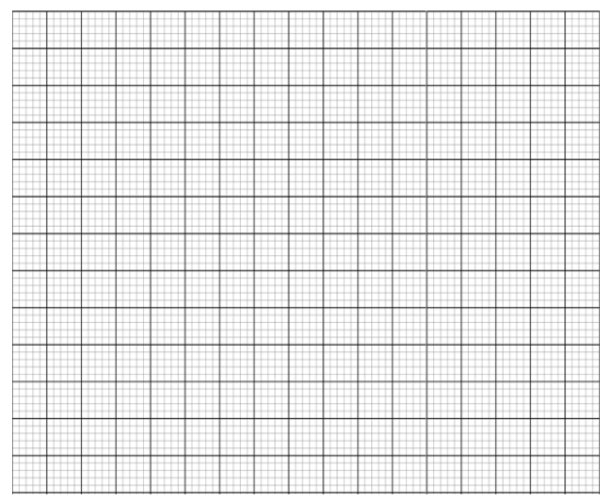

21. X, Y and Z are three quantities such that X varies directly as the square of Y and inversely as the square root of Z.

a) Given that X = 18 when Y = 3 and Z = 4, find X when Y = 6 and Z = 16. (5 marks)

b) If Y increases by 10% and Z decreases by 19%, find the percentage increase in X. (5 marks)

22. a. On the grid provided below, draw quadrilateral ABCD whose vertices are at (2,0), 𝐵(1,3), 𝐶(5, −1) 𝑎𝑛𝑑 𝐷(1, −2)(1 mk)



1. On the same axes , draw A’B’C’D’, the image of ABCD under a translation represented by vector 𝑇=($\begin{matrix}-1 \\ 2\end{matrix}$). (2 mks)
2. Draw the quadrilateral 𝐴′′𝐵′′𝐶′′𝐷′′ the image of A′B′C′D′ under a reflection in the line 𝑦 + 𝑥 = 0 on the same axes. State the coordinates of A”B”C”D”. (3 mks)
3. 𝐴′′′𝐵′′′𝐶′′′𝐷′′′ with vertices 𝐴 ′′′(−2,5),𝐵 ′′′(4,3), 𝐶 ′′′(-4,11),𝐷′′′(−6,3) is the image of 𝐴 ′′𝐵 ′′𝐶 ′′𝐷 ′′ under the transformation X. Draw 𝐴′′′𝐵′′′𝐶′′′𝐷′′′ and describe X fully. (3 marks)

e. State the type of congruency between quadrilateral ABCD and 𝐴′′𝐵′′𝐶′′𝐷′′.(1 mk)

23. Three solids, a cylinder, a sphere and a cone are such that their radii are equal. It is also given that their surface area are equal. If the volume of the sphere is 310.464𝑐𝑚3,

find the;

1. Radius of the sphere. (2mks)
2. Volume of the cylinder. (3mks)
3. Volume of the cone. (3 mks)

d. Curved surface area of the cylinder. (2 mks)

24. The equation of a curve is given as 𝑦 = 2𝑥 3 – 2− 5𝑥 + 3.

a. Find ;

i. The value of y when x = 2 (2mks)

ii. The equation of the tangent to the curve when x = 2. (4 mks)

1. Determine the turning points of the curve and their nature. (4 mks)

**This is the last printed page**