ACK DIOCESE OF MUMIAS
JOINT EVALUATION JULY 2024
AGRICULTURE 443/1
PAPER 1
TIME:2 HOURS
NAME…………………………………………………INDEX NO……………….
SCHOOL……………………………………………SIGNATURE……………
Instructions
1.Answer all questions in section A and B and any two questions in section C in the spaces provided after question 21
2. All answers must be written in English.
For examiner’s use only
SECTION | QUESTION | MAXIMUM MARKS | CANDIDATES’ SCORE
A | 1-14 | 30
B | 15-18 | 20
C |  | 20
C |  | 20
TOTAL |  | 90

MARKING SCHEME

SECTION A(30MKS)
- State four effects of high temperatures on crop production. (2mks)
-High evaporation rates leading to drying/wilting.
-Fast rate of growth/early maturity.
-High quality in some crops (e.g. pineapples and oranges)
-High incidences of diseases e.g. leaf rust in coffee.
-High incidences of pests eg Aphids in vegetables.
½ x4 =2 (First four)

- State four methods of weed control in Napier grass (Pennisetum parpureum) (2mks)
- Cultivation
- Slashing
- Uprooting
- Use of selective herbicides.
½ x4 =2 (First four)

- List four methods of improving labour productivity. (2mks)
- Labour supervision
- Giving incentives and improving terms and conditions of services.
- Farm mechanisation
- Training
½ x4 =2 (First four)

- Outline four problems on marketing vegetables. (2mks)
- Seasonality
- Perishability
- Bulkiness
- Poor transport system
- Changes in market demand
- Storage
- Lack of market information
½ x4 =2 (First four)

- (a) List three types of organic manure (1¹/₂ mks)
- Green manure
- Compost manure
- Farm yard manure
½ x 3=(1¹/₂mks) (First three)

(b) Outline three ways how crop rotation helps to maintain soil fertility. (1¹/₂mks)
- Inclusion of a legume helps in nitrogen fixation.
- Grass ley improves soil structure
- Maximum utilisation of soil nutrients.
- Helps to control parasitic weeds eg striga in cereals
- Helps to control pests/diseases.
½ x 3=(1¹/₂mks) (First three)

- (a) Differentiate between training and earthing up as used in crop production. (2mks)
Training : Practice of manipulating plants to grow in a designed direction/shape
Earthing up: Placement of soil in form of a heap around the base of the plant.
1x2 =2mks(mark as a whole.)

(b) State two effects of excess nitrogenous fertilizers in tomatoes. (1mk)
- Prolonged maturity.
-Cracking of fruits before maturity
-Blossom-end rot
-Excessive vegetative growth.
½ x2=1mk

- Outline four advantages of row planting. (2mks)
-Mechanisation possible
-Lower seed rate used.
-Plant population can be established /calculated.
-Easy to carry out cultural practices eg weeding, harvesting, spraying
½ x4 =2 (First four)

- State four functions of Young Farmers Club(YFC). (2mks)
-Participating in exhibitions and competitions at ASK shows
-Participating in National tree planting activities.
-Involvement and participation in exchange programmes ,both locallyand broad or to other African countries.
-involvement in workshops and seminars related to Agriculture.
-Involvement in agricultural projects at the club level
-Participation in YFC annual rallies.
½ x4 =2 (First four)

- Outline four effects of soil erosion. (2mks)
- Exposure of underground water pipes
- Destruction of wads.
- Sedimentation/silting in lakes,rivers ,fish ponds hence fish production reduces.
- Reduced agricultural production due to loss of top soil.
- -loss of useful soil living organisms.
- Eroded soils deposited in dams /rivers hence becoming shallow.
½ x4 =2 (First four)

- State four roles of trees in soil and water conservation. (2mks)
- -Protection of soil from raindrop erosion.
- Reduce evaporation through shade provision .
- Acts as wind breaks.
- The roots of trees bind soil particles together.
- Reduces the erosive power of running water through speed reduction.
- Decay leaves produce humus which improves water infiltration in the soil.
½ x4 =2 (First four)
- State four environmental factors that affect the effectiveness of a herbicide. (2mks)
- Wind
- Soil
- Light
- Temperature
- Rain
½ x4 =2 (First four)
12. State four advantages of a farmer holding a Land Title Deed. (2mks)
-farmers can secure credit facilities for land development for commercial farming
-minimises land disputes due to security of land tenure.
Investiment in long term development projects.
Source of income through leasing part/whole land parcel
½ x4 =2mks=(First four)

- Name four examples of joint products in product-product relationships (2mks)
- Mutton and skin
- Cotton lint and cotton seed
- Milk and butter
- Beef and hides
- Honey and wax.
½ x4 =2mks=(First four)

- List four different types of drainage. (2mks)
- Open ditches
- Cambered beds
- French drains
- Underground drain pipes
- Pumping
½ x 4=2mks (First four)

SECTION B (20MKS)
Answer all questions in this section in the spaces provided.

- The diagram below shows a common structures in water supply.
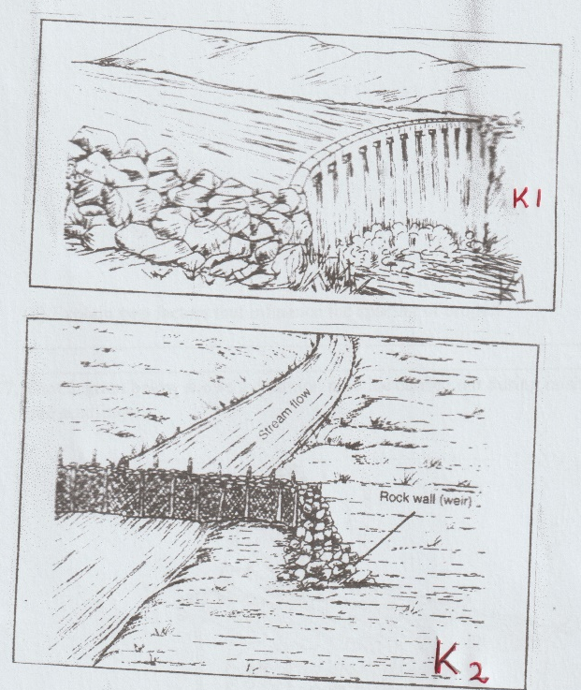

- Name structures labelled K₁ and K₂. (2mks)
K₁-_________________Dam
K₂-___________________Weir
1x2=2mks

- State two uses of K₁ (2mks)
- Collect water
- Store water
1x2 =2mks

- Name two types of hose pipes.
-plastic
Rubber
½ x 2=1mks
(1mk)
- (a) Maize is grown at a spacing of 90 cm X 30 cm.Calculate the plant population of maize planted in a plot measuring 29M x 22M. (3mks)

Plant pop = __Area
Spacing
P=29MX22M
90 X 30M
P=29 MX 22M
0.90MX 0.30M
P=638M² =2362.96296
0.27M²
P= 2363 plants

(b) Explain two factors that influence the spacing of crops. (2mks)
- Pests and diseases control-Difficult for pests/diseases to spread.
-Type of machinery hence wider spacing due to low nutrients supply.
-Size of the plant-Tall varieties of crops require wider spacing as short require clse spacing.
-Use of the crop-silage requires close ;human consumption requires wider spacing.
- Growth habit of the crop-Tillering /spreading crops eg Sweet potatoes are widely spaced than erect crops.
1x2 = 2mks)

- The diagram below shows a common practice carried out during raising of agroforestry tree seedlings.
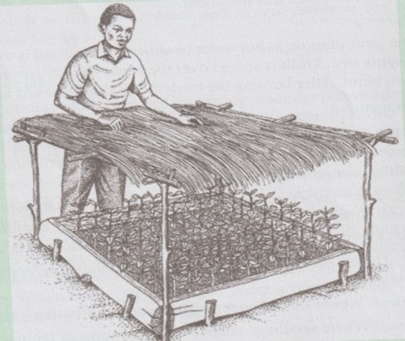

- State two roles of the shade erected over the nursery bed. (2mks)
Reduces evaporation of moisture
Reduces the impact of rain drops
1x 2 =2mks

- State two practices that are carried out during the growth of the seedlings. (2mks)
- Mulching
- Watering
- Weed control
- Pricking out
- Root pruning
- Pest control
- Disease control
- Hardening off
1x2 =2mks
- Define the term silvopastoral. (1mk)
Combination of growing trees /shrubs and keeping of livestock
1x1=1mk

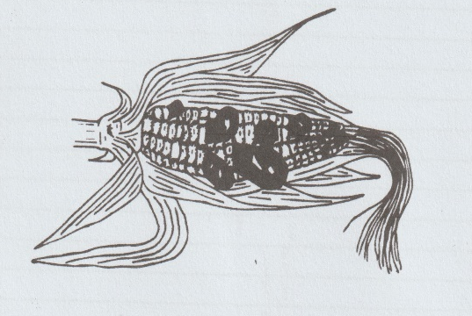
- The diagram below shows a maize cob attacked by a certain disease.

- Name the disease. (1mk)
Smut
1x1 =1mk

- State the causal organism of the disease named in (a) above. (1mk)
Fungus accept Ustilago maydis / Ustilago spp
1x1=1mk

- Name one other crop attacked by the disease. (1mk)
Wheat
Sugarcane
1x1=1mk

- State two control measures for the disease. (2mks)
- Hot water treatment
- Use of certified seeds.
- Crop rotation
- Field hygiene.
1x 2= 2mks
SECTION C (40 MARKS)
Answer any two questions in this section in the spaces provided after question 21.
- (a) Outline five farming practices that encourage minimum tillage. (5mks)
(b) Describe four field management practices carried out in carrot production. (8mks)
(c) Outline seven principles of co-operatives. (7mks)
- (a) Outline three precautions in harvesting of tea. (3mks)
(b)Outline five advantages of rotational grazing. (5mks)
(c) Explain six factors influencing the demand for a commodity. (6mks)
(d) State six advantages of sub-surface irrigation. (6mks)
- (a) Outline four disadvantages of burning vegetation cover during land clearing. (4mks)
(b)State six advantages of using vegetative materials for planting. (6mks)
(c) state four pieces of information contained in a purchase order. (4mks)
(d) Explain six cultural methods of weed control . (6mks)

SECTION C(40MKS)

19. (a) Outline five farming practices that encourage minimum tillage. (5mks)- application of herbicides
- Mulching
-Timing of cultivation
-Restricting cultivation to the area where seeds are .
-Establishing a cover crop on the field.
-Uprooting /slashing weeds in perennial crops.
1x5 =5mks)
(b) Describe four field management practices carried out in carrot production. (8mks)
- Thinning –remove excess carrot seedlings to attain a spacing of 3-4cm within the row.
- Weeding-uproot weeds/mulch to smoother weeds.
- Top dressing-apply nitogenious fertilizers 60kg N per hectare.
- Control pests-Spray using appropriate pesticides eg Aphids
- Earthing up-Earth up the carrots during weeding to encourage root expansion/heap soil around carrots
- Irrigation-Apply water during the dry season.
2x4=8mks

(c)Outline seven principles of co-operatives. (7mks
- Open membership-voluntary joining regardless of sex ,race,religion,education and political inclinations.
- Equal rights-one-man one vote principle and democracy.
- Principle of share limit-maximum number of allowed purchase of shares to avoid dominion by one member/members
- Interest on shares-Dividents distributed based by one member /members
- Withdrawal from membership -members are free to join or withdraw voluntarily and get back their share contribution.
- Loyalty-Members must be faithful and loyal to their cooperate
- Education –members informed about skills and affairs of co-operatives.
- Cooperative principles-Join the cooperative movement at different levels.
- Non-profit motive-Non profit making organisation
1x7 =7mks
20. (a) Outline three precautions in harvesting of tea.
- Do not compress the plucked leaves in the basket due to heating up hence low quality.
- Keep plucked tea in a cool /shaded area
- Plucked tea should be taken to the factory for processing on the same day it is harvested.
- Use woven sisal bags/baskets to encourage ventilation.
1x3 =3mks

( b) Outline five advantages of rotational grazing. (5mks)
- Livestock make maximum use of pasture
- Reduces the build up of pests and diseases.
- Animal waste is distributed evenly in all fields/paddocks.
- Possible to apply fertilizers /reseeding /weeding in parts of the pasture which are not in use.
- Excess pasture is given time to regrow before it is grazed on again.
1x5 =5marks

(c) Explain six factors influencing the demand for a commodity. (6mks)
- Population-increase in population leads to increase in demand for goods and services.
- Income- consumers with higher income buy more than those with low income.
- Preferences and tastes.-consumers may prefer certain goods to others and have unique tastes for others.
- Advertisement- may increase demand of goods and services.
- Price expectation-Future prices of certain commodities are likely to go up then the demand of such goods may go up currently or vice versa.
- Level of taxation-fewer consumers may afford highly taxed goods.
- Perishability-lowers demand of goods after deteriorating in quality.
- Future expectations/uncertainity-More of the good may be bought and stocked hence increased demand.
- Prices of related goods- The demand of a commodity increases if there is an increase in the price of a substitute.
- Beliefs,customs and taboos-some communities due to religious beliefs;pork is not consumed.
1x6 =(6mks)
(d) State six advantages of sub-surface irrigation. (6mks)
- Fungal diseases reduced since no water accumulation on leaves
- Economical use of water
- Minimizes possible theft of water pipes.
- Minimal erosion due to small water amounts oozing out.
- No construction of dykes, levelling or making level basins
- Minimizes labour requirements especially changing water pipes.
- Can be practised on both sloppy and flat land.
1x6 =6mks
- (a) Outline four disadvantages of burning vegetation cover during land clearing. (4mks)
- Destroys organic matter/ humus
- Destroys soil structure
- Kills usefull soil living micro-organism in the soil eg Nitrogen Fixing Bacteria.
- Accumulation of ash may change soil Ph leading to mineral nutrients imbalance
- Soil cover is destroyed hence exposure of soil of soil erosion agents.
1x4=4mks

(b)State six advantages of using vegetative materials for planting. (6mks)
- Faster maturity than those from seeds.
- Uniformity in qualities eg disease resistance ,seed size ,colour ,chemical composition.
- It’s possible to reduce many varieties of compatible crops on the same root stock
- Use of vegetative materials is easier and faster especially where seeds have long dorminancy periods.
- Seedless crops can be propagated /those whose seeds are not viable.
- Resulting plant has desirable shape and size for ease of harvesting /spraying.
1x6=6mks
(c) State four pieces of information contained in a purchase order. (4mks)
- Date of order
- Date of expected delivery
- The person who orders the goods.
- The person who authorised the order.
- Purchase order serial number
- The type of goods required.
- Quantities of the goods
1x4 =4mks

(d) Explain six cultural methods of weed control. (6mks)
- Mulching to smoother weeds.
- Timely planting so that crops establish early and smoother weeds.
- Proper spacing which creates little space for weed growth forming a canopy which suppresses weeds.
- Flooding which controls non-aquatic weeds in paddy rice fields.
- Clean seedbed-to have crops establish on clean seedbed from weeds.,
- Use of clean seed /planting materials which prevents introduction of weeds on the farm.
- Cover cropping-Effects of cover crops are similar to those of mulch in that they smoother the weeds.
- Crop rotation-some parasitic weeds eg striga are controlled when dicots are alternated with monocots.
1x6=6mks

