
ACK JOINT EVALUATION EXAMINATION JUNE 2024

AGRICULTURE 443/1
PAPER 1
TIME:2 HOURS
NAME…………………………………………………INDEX NO……………….
SCHOOL……………………………………………SIGNATURE……………
Instructions
1.Answer all questions in section A and B and any two questions in section C in the spaces provided after question 21
2. All answers must be written in English.
For examiner’s use only
SECTION | QUESTION | MAXIMUM MARKS | CANDIDATES’ SCORE
A | 1-14 | 30
B | 15-18 | 20
C |  | 20
C |  | 20
TOTAL |  | 90

SECTION A(30MKS)
Answer all questions in SECTION A in the spaces provided.
- State four effects of high temperatures on crop production. (2mks)
- _______________________________________________________________________________________________________________________________________________________________________________________________________________________________________________________________________________________________

- State four methods of weed control in Napier grass (Pennisetum parpureum) (2mks)
_______________________________________________________________________________________________________________________________________________________________________________________________________________________________________________________________________________________________
- List four methods of improving labour productivity. (2mks)
_______________________________________________________________________________________________________________________________________________________________________________________________________________________________________________________________________________________________
- Outline four problems on marketing vegetables. (2mks)
_______________________________________________________________________________________________________________________________________________________________________________________________________________________________________________________________________________________________
- (a) List three types of organic manure (1¹/₂ mks)
________________________________________________________________________________________________________________________________________________________________________________________________________________________
(b) Outline three ways how crop rotation helps to maintain soil fertility. (1¹/₂mks)
_______________________________________________________________________________________________________________________________________________________________________________________________________________________
- (a) Differentiate between training and earthing up as used in crop production. (2mks)
________________________________________________________________________________________________________________________________________________________________________________________________________________________
(b) State two effects of excess nitrogenous fertilizers in tomatoes. (1mk)
_______________________________________________________________________________________________________________________________________________
- Outline four advantages of row planting. (2mks)
_______________________________________________________________________________________________________________________________________________________________________________________________________________________________________________________________________________________________

- State four functions of Young Farmers Club(YFC). (2mks)
_______________________________________________________________________________________________________________________________________________________________________________________________________________________________________________________________________________________________
- Outline four effects of soil erosion. (2mks)
_______________________________________________________________________________________________________________________________________________________________________________________________________________________________________________________________________________________________
- State four roles of trees in soil and water conservation. (2mks)
_______________________________________________________________________________________________________________________________________________________________________________________________________________________________________________________________________________________________
- State four environmental factors that affect the effectiveness of a herbicide. (2mks)
_______________________________________________________________________________________________________________________________________________________________________________________________________________________________________________________________________________________________
- State four advantages of a farmer holding a Land Title Deed. (2mks)
_______________________________________________________________________________________________________________________________________________________________________________________________________________________________________________________________________________________________
- Name four examples of joint products in product-product relationships (2mks)
_______________________________________________________________________________________________________________________________________________________________________________________________________________________________________________________________________________________________
- List four different types of drainage. (2mks)
_______________________________________________________________________________________________________________________________________________________________________________________________________________________________________________________________________________________________

SECTION B (20MKS)
Answer all questions in this section in the spaces provided.

- The diagram below shows common structures in water supply.
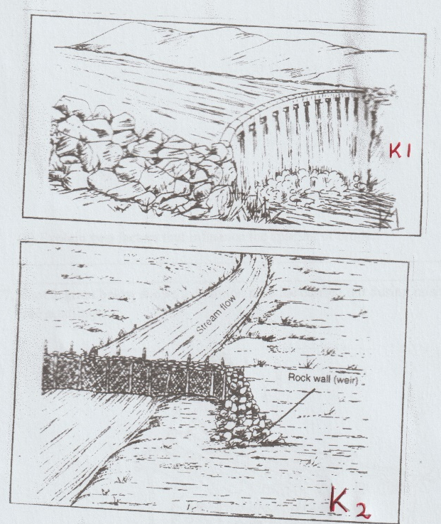

- Name structures labelled K₁ and K₂. (2mks)
K₁-_________________
K₂-___________________
- State two uses of K₁ (2mks)
__________________________________________________________________________________________________________________________________________
- Name two types of hose pipes. (1mk)
_________________________________________________________________________________________________________________________________________
- (a) Maize is grown at a spacing of 90 cm X 30 cm.Calculate the plant population of maize planted in a plot measuring 29M x 22M. (3mks)

(b) Explain two factors that influence the spacing of crops. (2mks)
________________________________________________________________________________________________________________________________________________
- The diagram below shows a common practice carried out during raising of agroforestry tree seedlings.

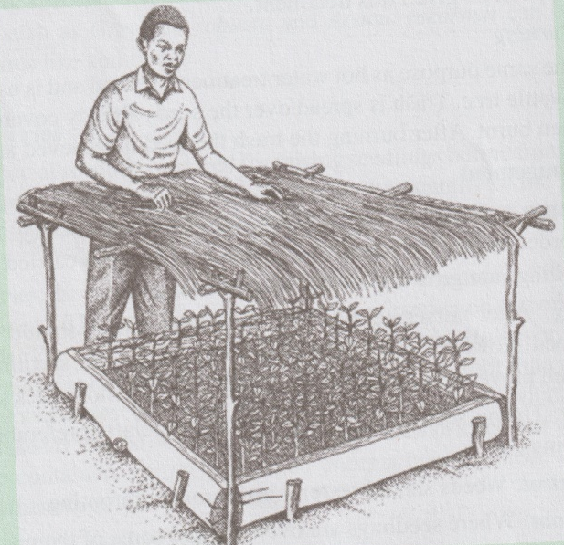

- State two roles of the shade erected over the nursery bed. (2mks)
__________________________________________________________________________________________________________________________________________
- State two practices that are carried out during the growth of the seedlings. (2mks)
__________________________________________________________________________________________________________________________________________
- Define the term silvopastoral. (1mk)
_______________________________________________________________________________________________________________________________________________________________________________________________________________

- The diagram below shows a maize cob attacked by a certain disease.
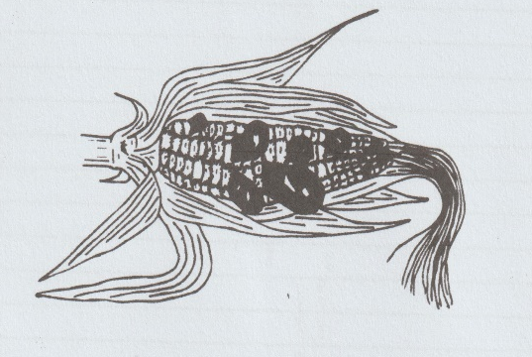

- Name the disease. (1mk)
_____________________________________________________________________
- State the causal organism of the disease named in (a) above. (1mk)
_____________________________________________________________________
- Name one other crop attacked by the disease. (1mk)
_____________________________________________________________________
- State two control measures for the disease. (2mks)
__________________________________________________________________________________________________________________________________________

SECTION C (40 MARKS)
Answer any two questions in this section in the spaces provided after question 21.
- (a) Outline five farming practices that encourage minimum tillage. (5mks)
(b) Describe four field management practices carried out in carrot production. (8mks)
(c) Outline seven principles of co-operatives. (7mks)
- (a) Outline three precautions in harvesting of tea. (3mks)
(b)Outline five advantages of rotational grazing. (5mks)
(c) Explain six factors influencing the demand for a commodity. (6mks)
(d) State six advantages of sub-surface irrigation. (6mks)
- (a) Outline four disadvantages of burning vegetation cover during land clearing. (4mks)
(b)State six advantages of using vegetative materials for planting. (6mks)
(c) state four pieces of information contained in a purchase order. (4mks)
(d) Explain six cultural methods of weed control . (6mks)

________________________________________________________________________________________________________________________________________________________________________________________________________________________________________________________________________________________________________________________________________________________________________________________________________________________________________________________________________________________________________________________________________________________________________________________________________________________________________________________________________________________________________________________________________________________________________________________________________________________________________________________________________________________________________________________________________________________________________________________________________________________________________________________________________________________________________________________________________________________________________________________________________________________________________________________________________________________________________________________________________________________________________________________________________________________________________________________________________________________________________________________________________________________________________________________________________________________________________________________________________________________________________________________________________________________________________________________________________________________________________________________________________________________________________________________________________________________________________________________________________________________________________________________________________________________________________________________________________________________________________________________________________________________________________________________________________________________________________________________________________________________________________________________________________________________________________________________________________________________________________________________________________________________________________________________________________________________________________________________________________________________________________________________________________________________________________________________________________________________________________________________________________________________________________________________________________________________________________________________________________________________________________________________________________________________________________________________________________________________________________________________________________________________________________________________________________________________________________________________________________________________________________________________________________________________________________________________________________________________________________________________________________________________________________________________________________________________________________________________________________________________________________________________________________________________________________________________________________________________________________________________________________________________________________________________________________________________________________________________________________________________________________________________________________________________________________________________________________________________________________________________________________________________________________________________________________________________________________________________________________________________________________________________________________________________________________________________________________________________________________________________________________________________________________________________________________________________________________________________________________________________________________________________________________________________________________________________________________________________________________________________________________________________________________________________________________________________________________________________________________________________________________________________________________________________________________________________________________________________________________________________________________________________________________________________________________________________________________________________________________________________________________________________________________________________________________________________________________________________________________________________________________________________________________________________________________________________________________________________________________________________________________________________________________________________________________________________________________________________________________________________________________________________________________________________________________________________________________________________________________________________________________________________________________________________________________________________________________________________________________________________________________________________________________________________________________________________________________________________________________________________________________________________________________________________________________________________________________________________________

