|  |  |  |
| --- | --- | --- |
| ***Name.*** | ***Class.*** | ***Index No. /*** |
|  |  | ***Date.*** |
|  |  | ***Signature*** |

**451/1**

**COMPUTER STUDIES**

**Paper 1**

**(Theory)**

**July 2024**

**2½ hours.**

***Mock Exams***

**INSTRUCTIONS TO CANDIDATES:**

**Instructions to Candidates**

1. Write your name and index number in the spaces provided above.
2. Sign and write the date of examination in the spaces provided above.
3. This paper consists of **TWO** sections: **A** and **B**.
4. Answer **ALL** the questions in section **A**.
5. Answer question **16** and any other **THREE** questions from Section **B**.
6. **ALL** answers should be written in the spaces provided on the question paper.

**For Examiner’s Use Only**

|  |  |  |
| --- | --- | --- |
| **Section** | **Questions** | **Score** |
| A | 1 – 15 |  |
| B | 16 |  |
| 17 |  |
| 18 |  |
| 19 |  |
| 20 |  |
| **Total Score** | |  |

**This paper consists of**  **printed pages**

**Candidates should check the question paper to ensure that all the**

**printed pages are printed as indicated and no questions are missing.**

***SECTION A (40 MARKS)***

1. There are a number of health and safety issues associated with the use of computers.

Draw arrows from the terms Health or Safety to the matching issue. Use a maximum of **four** arrows.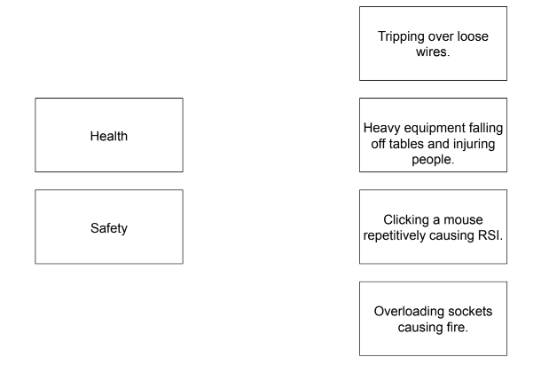

**(2 marks)**

2 Differentiate between computer functionality and purpose as used in computer classification. (2 mark)

...........................................................................................................................................................................................................................................................................................................................................................................................................................................................................

3. A company is setting up a video-conference. Name **four** computer hardware devices they would need. (2 marks)

......................................................................................................................................................................................................................................................................................................................................................................................................................................................................................................................................................................................................................................................................

4. Nekesa a mobile telephone. She uses the touch screen on her telephone to send emails to her customers. The touch screen breaks, stopping Nekesa from using it to type her emails.

(a) Identify **two** other input device that would be built into the mobile telephone that Magda could use to send an email to her customers. (2 marks)

............................................................................................................................................................................................................................................................................................................................................................................................................................................................................................

5, Gradhi uses a digital camera. The digital camera takes a photograph that is then converted into a digital image. Complete the paragraph about the operation of a digital camera, using the most appropriate terms from the list. Not all terms in the list need to be used.

• analogue-to-digital ,

• binary

• digital-to-analogue

• lens

• light

• mirror

• pixel

• reflection

• sensor

• storage

When Gradhi pushes the button to take a photograph, an aperture opens at the front of

the camera to allow ............. to stream in through the ................ This is captured by a sensor called a charge-coupled device. The .............................converter then converts each .............. into a digital value. (2 marks)

6. Keymoney stores confidential data on his computer. He uses the Internet regularly and is concerned about his data being viewed by unauthorised people. He currently has one software method to stop his data being viewed, which is a password. He wants to add other software methods to stop his data being viewed by unauthorised people. State **two** other software methods that Tamaz could use to stop his data being viewed by unauthorised people. (2 marks)

....................................................................................................................................................................................................................................................................................................................................................

7. State **three** functions of an operating system. (3 marks)

....................................................................................................................................................................................................................................................................................................................................................

8. State **three** ways by which one can prevent Vishing. (3 marks)

........................................................................................................................................................................................................................................................................................................................................................................................................................................................................................................................................................................................................................................................................................................

9.A school intends to introduce the use of ICT in processing its academic reports. State **three** benefits that the school will realise by adopting ICT. (3 marks)

.......................................................................................................................................................................................................................................................................................................................................................................................................................................................................................................................................................................................................................................................................................................

10. Robots are being used in the mining industry to dig up minerals from under the surface of the Earth. Give **three advantages** of using robots rather than humans to do this task. **(3 marks)**

...........................................................................................................................................................................................................................................................................................................................................................................................................................................................

….

11. Describe each of the following types of images used in DTP. (2 marks).

(a)Raster image

.............................................................................................................................................................

(b)Vector image

.........................................................................................................................................................

12. (a) Determine the octal equivalent of binary number 10111000110101 (2 marks)

…………………………………………………………………………..………………………………

……………………………………………………………………………………………………..……

(b) Determine the Hexadecimal equivalent of binary number 10111000110101 (2 marks)

…………………………………………………………………………………………………………..

……………………………………………………………………………………………………..……

13. Write each of the following data representation acronyms in full (3 marks)

(a)ASCII ...............................................................................................................................................

(b)EBCDIC...........................................................................................................................................

(c)BCD..................................................................................................................................................

14. A stopwatch uses six digits to display hours, minutes and seconds. The stopwatch is stopped at: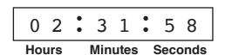

An 8-bit register is used to store each pair of digits.

Write the 8-bit binary numbers that are currently stored for the Hours, Minutes and Seconds.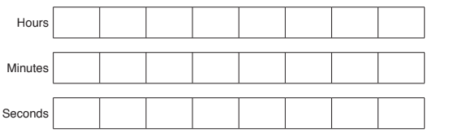

(3 marks)

15. Nyawara College is organising a reunion for its teachers who have left or retired. A systems analyst is creating a database for the college to store the details of its past teachers. A three-letter code

is used for the department. Part of the design of this database will involve the identification of

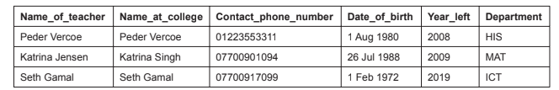

For the following fields write down the most appropriate validation check. Each validation

check must be different. (3 marks)

(i) Department ..................................................................................................................

(ii) Date_of_birth ................................................................................................................

(iii) Year_left .......................................................................................................................

***ANSWER QUESTION 16 AND ANY OTHER THREE QUESTIONS***

. 16(a). With the aid of a pseudocode, describe each of the following type of program control loop structures (4 marks)

(i) Repeat until loop

……….………………………………………………………………………………………………………

……….………………………………………………………………………………………………………

……….………………………………………………………………………………………………………

(ii) While loop

……….………………………………………………………………………………………………………

……….………………………………………………………………………………………………………

……….………………………………………………………………………………………………………

(b) Study the following flowchart then answer the questions that follow

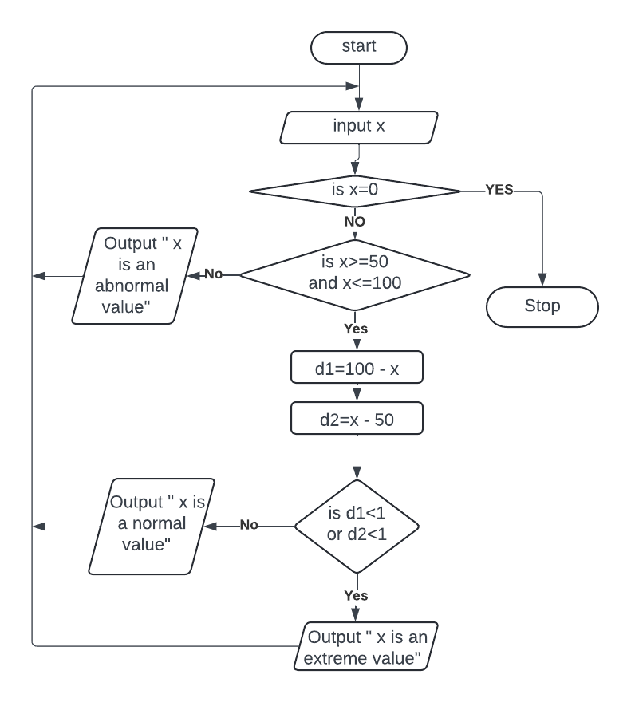

……….………………………………………………………………………………………………………

(i) Write the output of the flow chart for each of the following values of x.(3 Marks)

49_________________________

50_________________________

65_________________________

80_________________________

110________________________

100________________________

(ii) Translate the flowchart into a pseudocode (8 marks)

……….………………………………………………………………………………………………………

……….………………………………………………………………………………………………………

……….………………………………………………………………………………………………………

……….………………………………………………………………………………………………………

……….………………………………………………………………………………………………………

……….………………………………………………………………………………………………………

……….………………………………………………………………………………………………………

……….………………………………………………………………………………………………………

……….………………………………………………………………………………………………………

……….………………………………………………………………………………………………………

……….………………………………………………………………………………………………………

……….………………………………………………………………………………………………………

……….………………………………………………………………………………………………………

……….………………………………………………………………………………………………………

……….………………………………………………………………………………………………………

……….………………………………………………………………………………………………………

17 (a) List down **two** jobs that have been created because of computer networking. (1 mark)

……….………………………………………………………………………………………………………

……….………………………………………………………………………………………………………

(b) (i) Among the limitations of computer networking is the creation of digital divide in society. State the meaning of the term Digital divide. (1 mark)

……….………………………………………………………………………………………………………

……….………………………………………………………………………………………………………

(ii) Computer networking has resulted in job replacement and job displacement. State the meaning of each of the terms:

I. Job replacement (1 mark)

……….………………………………………………………………………………………………………

……….………………………………………………………………………………………………………

II. Job displacement (1 mark)

……….………………………………………………………………………………………………………

……….………………………………………………………………………………………………………

(c) State **two** ways by which computer networking facilitates communication. (2 marks)

……….………………………………………………………………………………………………………

……….………………………………………………………………………………………………………

……….………………………………………………………………………………………………………

……….………………………………………………………………………………………………………

(d) (i) Describe **three** types of cables used for communication in computer networks (3 marks)

……….………………………………………………………………………………………………………

……….………………………………………………………………………………………………………

……….………………………………………………………………………………………………………

……….………………………………………………………………………………………………………

(ii) Describe **two** ways by which computer networking achieves each of the following purposes:

(6 marks)

I. Resource sharing

……….………………………………………………………………………………………………………

……….………………………………………………………………………………………………………

II. Remote Communication

……….………………………………………………………………………………………………………

……….………………………………………………………………………………………………………

III. Cost Effectiveness

……….………………………………………………………………………………………………………

……….………………………………………………………………………………………………………

18 (a) State **three** purposes of an information system (3 marks)

……….………………………………………………………………………………………………………

……….……………………………………………………………………………………………………………….………………………………………………………………………………………………………

……….………………………………………………………………………………………………………

(b) Describe **three** methods of information gathering duing systems development.(3 marks)

……….………………………………………………………………………………………………………

……….……………………………………………………………………………………………………………….………………………………………………………………………………………………………

……….………………………………………………………………………………………………………

(c) Describe **three** stages of program development other than information gathering(3 marks)

……….………………………………………………………………………………………………………

……….……………………………………………………………………………………………………………….………………………………………………………………………………………………………

……….………………………………………………………………………………………………………

(d) Explain **three** types of feasibility studies carried out during systems development. (6 marks)

……….………………………………………………………………………………………………………

……….……………………………………………………………………………………………………………….………………………………………………………………………………………………………

……….……………………………………………………………………………………………………………….………………………………………………………………………………………………………

……….………………………………………………………………………………………………………

19 (a) (i) Name **two** types of errors that occur during data processing.(1 mark)

……….………………………………………………………………………………………………………

……….………………………………………………………………………………………………………

(ii) Describe **two** ways of determining data integrity during data processing(2 marks)

……….………………………………………………………………………………………………………

……….……………………………………………………………………………………………………………….………………………………………………………………………………………………………

……….………………………………………………………………………………………………………

(b) Differentiate between each of the following: (4 marks)

(i) sequential and serial methods of file organization used during data processing

……….………………………………………………………………………………………………………

……….………………………………………………………………………………………………………

……….………………………………………………………………………………………………………

……….………………………………………………………………………………………………………

(ii) interactive and real-time electronic data processing modes

……….………………………………………………………………………………………………………

……….……………………………………………………………………………………………………………….………………………………………………………………………………………………………

……….………………………………………………………………………………………………………

(c) Chepketieno is a wedding photographer. She wants to store 10 photographs on a USB flash memory drive for a customer. Each photograph is 100 pixels wide and 50 pixels high. Each pixel uses 8 bits to store a colour photograph. Calculate the total file size, in kilobytes (kB), of all the photographs. (4 marks)

……….………………………………………………………………………………………………………

……….……………………………………………………………………………………………………………….………………………………………………………………………………………………………

……….……………………………………………………………………………………………………………….………………………………………………………………………………………………………

……….………………………………………………………………………………………………………

(d) Use twos complement to subtract the base ten number -7 from -3. Leave your answer in base 10. (4 marks)

……….………………………………………………………………………………………………………

……….……………………………………………………………………………………………………………….………………………………………………………………………………………………………

……….……………………………………………………………………………………………………………….………………………………………………………………………………………………………

……….……………………………………………………………………………………………………………….………………………………………………………………………………………………………

……….……………………………………………………………………………………………………………….………………………………………………………………………………………………………

……….………………………………………………………………………………………………………

20. (a) The figure below is an extract of a spreadsheet. use it to answer the questions that follow.

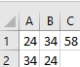

The formula =SUM(A$1:$B1) as been applied in cel C1.

(i) Write the formula as it would appear when copied to cell C2. (1 MARK)

……….………………………………………………………………………………………………………(ii) Write down the value that would appear in cell C2 (1 MARK)

……….………………………………………………………………………………………………………

(iii) Explain the value displayed in cell C2 (2 MARKS)

……….……………………………………………………………………………………………………………….………………………………………………………………………………………………………

……….……………………………………………………………………………………………………………….……………………………………………………………………………………………………………….………………………………………………………………………………………………………

……….………………………………………………………………………………………………………

(iv) Differentiate between a cell address and a cell reference as used in spreadsheet.(2marks)

……….……………………………………………………………………………………………………………….………………………………………………………………………………………………………

……….………………………………………………………………………………………………………

(b) (i) Differentiate between the terms exiting and closing as used in word processing (2 marks)

……….……………………………………………………………………………………………………………….………………………………………………………………………………………………………

……….………………………………………………………………………………………………………

(ii) state the meaning of each of the following word processing terms:

1. printing (1mark)

……….……………………………………………………………………………………………………………….………………………………………………………………………………………………………

……….………………………………………………………………………………………………………

1. saving (1 mark)

……….……………………………………………………………………………………………………………….………………………………………………………………………………………………………

……….………………………………………………………………………………………………………

(c) (i) Describe each of the following publications that can be produced by DTP

1. newsletter (1 mark)

……….……………………………………………………………………………………………………………….………………………………………………………………………………………………………

……….………………………………………………………………………………………………………

1. brochure (1 mark)

……….……………………………………………………………………………………………………………….………………………………………………………………………………………………………

……….………………………………………………………………………………………………………

(d) The Kaafya Community Centre has created a new database which stores the details of each of its members. Each member can choose either swimming or tennis as an activity. The fields in the database are name, address, contact number, gender and activity. Illustrate a design of a database form that could be used to capture this data (3 marks)