1. 0.0  [**Excretion and Homeostasis (42 Lessons)**](http://www.elimu.net/Secondary/Kenya/KCSE_Student/Biology/Form2/Excretion/KCSE%20Biology%20Curriculum%20Form%20I-Excretion.htm)
   * + 1. When blood sugar level is above the normal, it stimulates the liver cells; to convert excess glucose to glycogen / increase rate of respiration/ convert glucose to fats. (Thus lowering the blood glucose level back to normal);

2. - Diffusion;

* + Exudation;
  + Deposition;
  + Leaf fall;
  + Transpiration;

***Mark first three only (3 marks)***

3**. a) BLOOD SUGAR LEVEL AGAINST TIME**

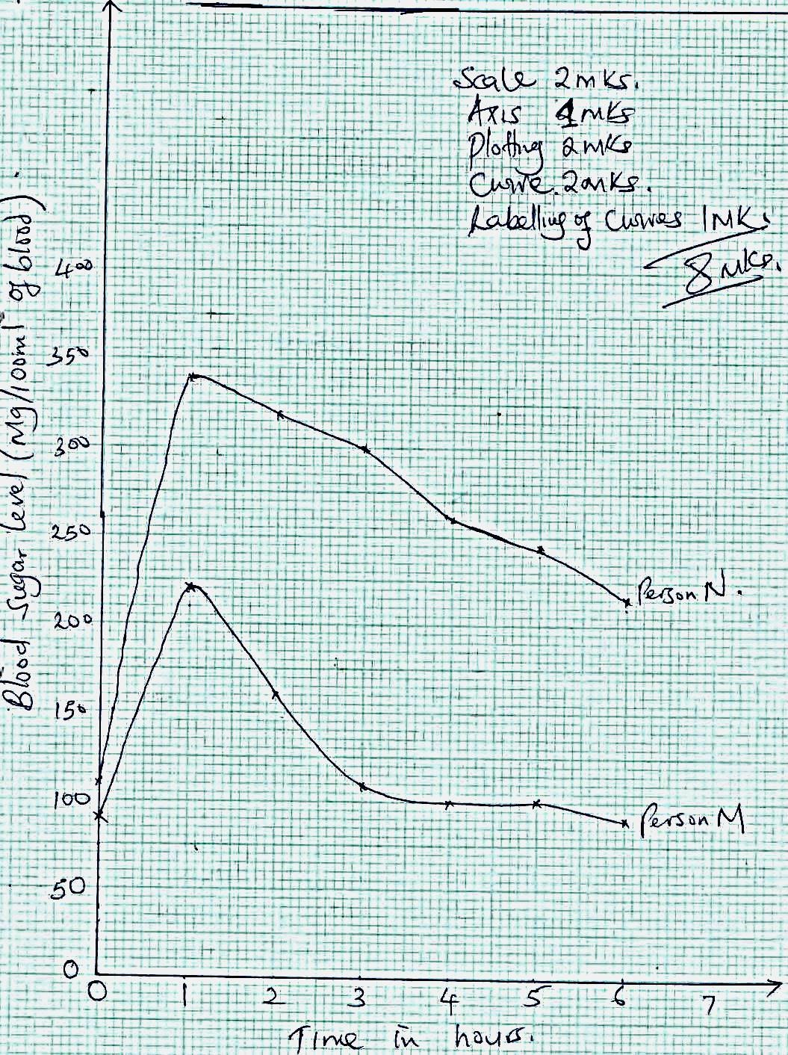

b) i) Blood sugar level rises rapidly in the first hour; due to absorption of glucose from ileum

into blood stream;

ii) Blood sugar level then starts declining as the person secrets insulin hormone (from the

pancreas); which stimulates the liver cells to convert excess glucose into glycogen; (to lower blood glucose level)

c) i) failure of the pancreas to secrete sufficient hormone insulin; which acts on the liver cells

to lower the blood sugar level when it rises above normal;

* 1. Regular intravenous injection of insulin; (so as to lower the blood sugar level);

d) i) The pancreas secretes glucagon hormone; which stimulates the liver cells to raise blood sugar level by reducing oxidation of glucose/stimulates the conversion of stored glycogen to glucose.

* 1. There would be no secretion of the hormone insulin; hence the blood sugar level would rise far above normal resulting into diabetes mellitus;

**Diabetes mellitus** – is a kidney disorder due to insufficient or no secretion of insulin by the pancreas, leading to high blood sugar level. (Hence presence of glucose in urine);

**Diabetes insipidus** – kidney disorder due to failure of the pituitary gland to secrete enough antidiuretic hormone; hence little or no water re – absorption in the kidney tubules;

***(Mark as a whole)***

4. Carbon (IV) oxide; ¹

Oxygen; ¹

Water vapour; Any 2 x 1

5. (a) Ammonia, urea, uric acid; ¹

(b) It requires little amount of water to eliminate/excrete; ¹

6. Carbon (IV) oxide;

7***.*** (a) (i) It is completely reabsorbed selectively in the proximal converted tubule.

(ii) Proteins have big molecules that cannot be ultra filtered in the glomerulus.

(b) - All the urea is excreted since it has no use in the body i.e. it is toxic.

- A lot of water is reabsorbed in the dictal convoluted tubule leaving much urea. Urea is actively secreted into the tubules;

(c) (i) Urea concentration will increase due to increase in deamination process; to eliminate excess amino acids.

(ii) The concentration of urea will go down; because some urea will be excreted through sweating;

8**. Regulation of blood sugar**.

When the blood sugar rises, it is detected by the hypothalamus; which stimulates the pancreas; to release insulin; through the blood the insulin gets to the liver; where it stimulates the conversion of excess glucose to glycogen and fats which are stored; the insulin also enhances rapid breakdown of glucose in the muscle cell; these events leads to a fall in blood sugar back to normal; When the blood sugar is low, the hypothalamus; stimulate the pancreas to release glucagon; which via the bloodstream; get to the liver, where it stimulates the liver to convert glycogen to glucose; and fats to glucose; there is also less breakdown of glucose in the cells; leading to a rise in the blood sugar level back to the norm; total 14mks, maximum 10mks.

9. (a) Reducing sugar test. (1mk);

b) When the mixture of urine and Benedict solution is heated the colour of the mixture turns from blue to green - to yellow – to orange/brown/red. (1mk); indicating the presence of reducing sugar (1mk);

1. (a) **Process**  **Products**

Exudation/guttation; Resins, gums, latex, rubber, calcium oxalate, salts, water.(any two) (2mks)

Transpiration/Diffusion; Water, carbon (IV) oxide, oxygen. (any two) (2mks)

Deposition/leaf fall; Tanins, caffeine, morphine, nicotine, cocaine (any two) (2mks)

1. a) A condition in which blood sugar level is high and uncontrolled. Caused by lack of insulin in the blood due to the malfunctions of pancreas; (1mk)

b) Administration of insulin injections/ tablets (1mk)

-Avoid foods rich in sugar

1. Amino acids are broken down into amino groups and carboxyl group deamination;

Amino group combines with hydrogen forming highly toxic ammonia which combines carbon (IV) oxide to form urea; (3mks)

1. Plants reuse some of their waste product; Animal do not

Produce lower metabolic waste than animals;

1. a) when the temperature is low (cold), the erector Pilli muscles contract; making hair follicles to stand erect; the hair follicles trap a layer of hair; between them which reduces heat loss due to poor heat conduction through them; when the temperature is high the erector Pilli muscle relax; thus making the hair lie flat; thus reducing the air trapped and more heat will be lost to the environment

Skin has sweat glands which secrete sweat; when temperatures are high water from the sweat evaporates taking away latent heat of vapourization; when temperature is low, no sweat is produced.

When temperature is high, the blood vessels vasodilate; and this encourages loss of heat; as more blood flow close to the skin surface; when temperatures are low, blood vessels vasoconstrict; less blood flows close to skin surface; hence less heat is lost to the environment.

Skin has an adipose tissue for insulation against heat loss.

* 1. Skin has a cornified layer made of dead cells; which protects the entry of bacteria and inner tissues from mechanical damage; the sebaceous gland, secret sebum; which has antiseptic properties; hence protects the body from bacteria. The skin has melanin pigment which protect the body from harmful U.V rays.

1. a. Glomerular filtrate;
   1. Ultra-filtration / pressure filtration;
   2. Antidiuretic hormone / vasopressin; Aldosterone;
2. a) Deamination of excess proteins / amino acids in the liver;
   1. Amino acids are used in the formation of foetal tissues; thus has less excess to be eliminated;
3. Insulin is produced which increases oxidation of glucose; facilitate conversion of glucose into glycogen / fats for storage; inhibits conversion of glycogen into glucose;
4. Exuddation / Guttation;
   * Transpiration / diffusion;
   * Deposition / leaf fall / abscission. (any two) (2mks)
5. **Mammalian Kidneys**

Blood reaches the kidney from the renal artery, which branches into the renal arterioles. Arterioles further branches into afferent arterioles, which drain into the glomerulus. Enclosed in the Bowman‟s capsule.

The afferent arteriole are wider than the efferent arterioles causing higher pressure to develop in the glomerulus, this causes ultrafiltration of the plasma into the Bowmans capsule, the liquid part of the blood is filtered out, forming glomerular filtrate. This filtrate contains both waste and useful products.

The filtrate moves to the proximal convolute tubules, where selective re-absorption of glucose, amino acids, and some water and vitamins takes place, re-absorption occurs by diffusion and active transport.

The filtrate passes in to the loop of henle where the concentration of sodium and chloride ions are raised to favour the reabsorption of water by osmosis. The filtrate that remains mainly consist of excretory products namely : urea, uric acid, excess water and mineral salts, these are passed to the distal convoluted tubules, where the remaining useful substances mainly water and mineral salts are re-absorbed.

The urea, uric acid, ammonia ions, excess water and excess mineral salts form urine which is removed through the ureter to the urinary bladder and later excreted out of the body.

**b) Green plants**

1. diffusion
2. waste product may be eliminated when concentration gradient exists, such products include carbon (iv) oxide through the lenticels and stomata. iii) Exudation refers to the process by which plants release wastes as components of their secretion such as latex, gums, salts resins, calcium pectate
3. Transpiration: this is the process by which plants lose excess water in the form of water vapor through the stomata, lenticels and cuticle into the atmosphere
4. Guttation
5. Leaves of certain plants such as potatoes and tomatoes have specialized gland called hydathodes at tips and margins which secrete droplets of water, this aids in elimination of excess water and some dissolved salts.
6. Deposition

Plants store little waste products in their harmless and insoluble form in tissues and organs such as leaves, fruits and flowers. The wastes are eliminates when these parts die or are shed off from the plant. Such waste include alkaloids,(nicotine, caffeine, oxalates) glycosides (sugar compounds such as plants oils and tannins.

1. (a) All is actively reabsorbed at the proximal convoluted tubule; (2mks)

b) Diabetes mellitus; (1mk)