Name: ……………………………………………………………Index No.:…………………….........
School.: ………………………………………………………….Candidate’s Sign:…………………….
CLASS..................................................................................... Date:…..………………………………
443/1
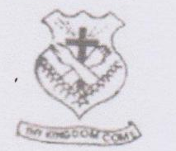

AGRICULTURE
PAPER 1
2024
TIME: 2HOURS

BRISINGA EXAMINATION
Date : 11th Thur. 2024
Time: 2.00pm – 4.00pm

2024
FORM FOUR
Kenya Certificate of Secondary Education.(K.C.S.E)
AGRICULTURE
PAPER 1
TIME: 2 HOURS

INSTRUCTIONS TO THE CANDIDATES
- Write your name and index number in the spaces provided above.
- This paper consists of three sections;-A, B and C.
- Answer all questions in section A and B and any two questions in section C
- All answer must be written in the spaces provided.
- This paper consist of 13 printed pages.
- Candidates should check the question papers to ascertain that all the pages are printed as indicated and that no questions are missing.
- Candidates should answer the question in English.

For Examiners Use Only
Section | Question | Maximum Score | Candidates Score
SEC -A | 1-15 | 30
SEC -B | 16-19 | 20
SEC- C | 20 | 20
SEC- C | 21 | 20
SEC- C | 22 | 20
 | TOTAL SCORE | 90

SECTION A (30 marks)
ANSWER ALL QUESTIONS IN THIS SECTION

1. State four reasons for practicing grafting in citrus production (2mks) …………………………………………………………………………………………
…………………………………………………………………………………………
…………………………………………………………………………………………
…………………………………………………………………………………………
2. Mention four types of soil erosion by water (2mks)
………………………………………………………………………………………… …………………………………………………………………………………………
…………………………………………………………………………………………
…………………………………………………………………………………………
3. Differentiate between coppicing and pinching out (2mks)
…………………………………………………………………………………………
…………………………………………………………………………………………
…………………………………………………………………………………………
…………………………………………………………………………………………
4. Give four benefits of possessing certificate of land ownership (2mks) …………………………………………………………………………………………
………………………………………………………………………………………… …………………………………………………………………………………………
…………………………………………………………………………………………
5. Give one reason why each of the following nursery management practices are carried out. (2mks)
(i) Hardening off
…………………………………………………………………………………………
…………………………………………………………………………………………
(ii) Watering before transporting seedlings from the nursery bed
…………………………………………………………………………………………
…………………………………………………………………………………………

6. Name four effects of excessive nitrogenous fertilizer application on tomatoes (2mks)
…………………………………………………………………………………………
…………………………………………………………………………………………
…………………………………………………………………………………………
…………………………………………………………………………………………
7. State four early maturing varieties of cabbages (2mks)
…………………………………………………………………………………………
…………………………………………………………………………………………
…………………………………………………………………………………………
…………………………………………………………………………………………
8. State four ways of determining national development. (2mks)
…………………………………………………………………………………………
…………………………………………………………………………………………
…………………………………………………………………………………………
…………………………………………………………………………………………
9. List four methods of land acquisition (2mks)
…………………………………………………………………………………………
…………………………………………………………………………………………
…………………………………………………………………………………………
…………………………………………………………………………………………
10. State four roles of trees in soil and water conservation (2mks)
…………………………………………………………………………………………
…………………………………………………………………………………………
…………………………………………………………………………………………
…………………………………………………………………………………………
11. State any four types of livestock farming (2mks)
…………………………………………………………………………………………
…………………………………………………………………………………………
…………………………………………………………………………………………
…………………………………………………………………………………………
12. a) State two ways by which a soil of pH 3 can be raised to pH 5 (1 mk)
…………………………………………………………………………………………
…………………………………………………………………………………………

b) Name any two types of soil structures (1mk)
…………………………………………………………………………………………
…………………………………………………………………………………………
13. State four factors that determine the number of secondary cultivation to be done on a seedbed (2mks)
…………………………………………………………………………………………
…………………………………………………………………………………………
…………………………………………………………………………………………
…………………………………………………………………………………………
14. Mention any four factors that should be considered when selecting site for making compost manure (2mks)
…………………………………………………………………………………………
…………………………………………………………………………………………
…………………………………………………………………………………………
…………………………………………………………………………………………
15. a) Define the following terms:
i) Opportunity cost (¹/₂ mk)
…………………………………………………………………………………………
…………………………………………………………………………………………
ii) Agricultural economics (¹/₂mk)
…………………………………………………………………………………………
…………………………………………………………………………………………
b) Give two types of farm records that a large scale farmer should keep (1mk)
…………………………………………………………………………………………
…………………………………………………………………………………………

SECTION B (20 marks)
ANSWER ALL QUESTIONS IN THIS SECTION
16. The diagram below shows a method of irrigation
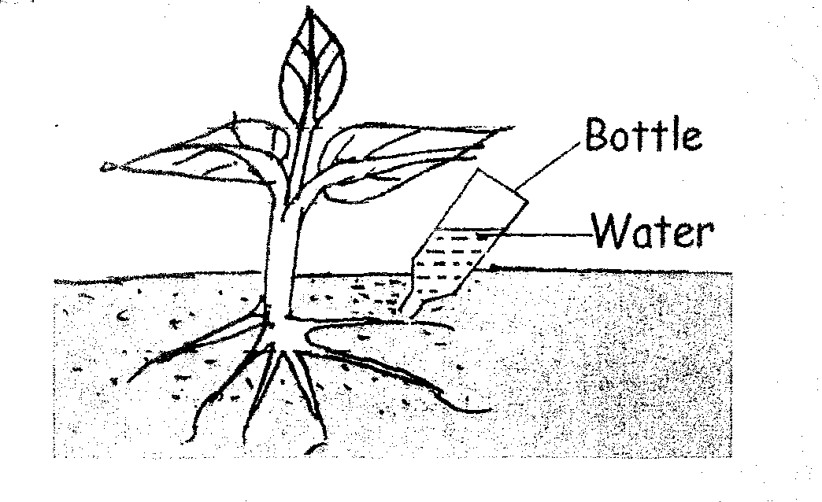
- Identify the method (1 mark)
…………………………………………………………………………………………
…………………………………………………………………………………………
b) State two advantages of the irrigation system named in (a) above. (2mks)
…………………………………………………………………………………………
…………………………………………………………………………………………
c) State any two factors to be considered when choosing the method of irrigation
to use in an area (2mks)
…………………………………………………………………………………………
…………………………………………………………………………………………
17. The diagram below is a tool used to harvest crops in the farm. Use it to answer the questions that follow
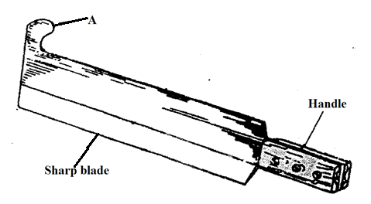

- Identify the tool represented above (1 mark)
…………………………………………………………………………………………
b) Name the crop harvested by use of the tool above. (1 mark)
…………………………………………………………………………………………
c) State one reason for maintaining the above tool. (1 mark)
…………………………………………………………………………………………
d) Give one reason why the crop named in (b) above should be cut at ground
level (1 mark)
…………………………………………………………………………………………
…………………………………………………………………………………………
e) Give a reason why the leaves of the crop should be removed after cutting
(1 mark)
…………………………………………………………………………………………
…………………………………………………………………………………………
18. An agronomist recommends application of 130kg N, 55kg P₂O₅ and 65kg K₂O after testing a soil sample. Calculate the amount of urea (46%N), Single super phosphate (20% P₂O₅) and Potassium chloride (50% K₂O) that should be applied on the land. (5mks)

19. The diagram below illustrates a weed
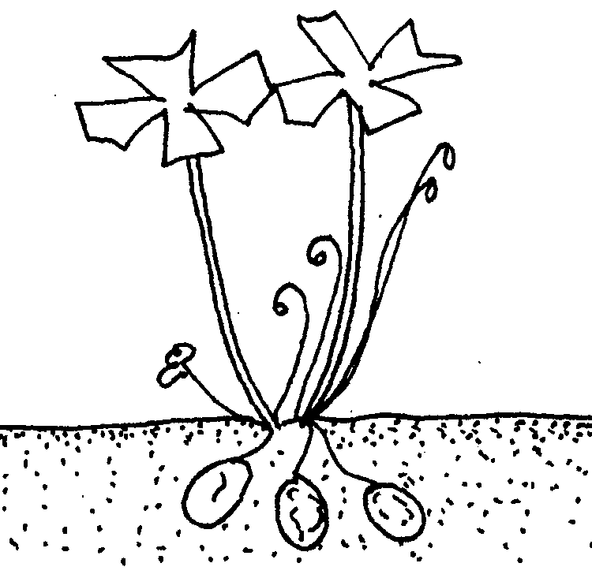
- Identify the weed (1 mark)
…………………………………………………………………………………………
- State one competitive ability of the weed illustrated above. (1 mark)
…………………………………………………………………………………………
…………………………………………………………………………………………
c) State two mechanical control measures for the weed above (2mks)
…………………………………………………………………………………………
…………………………………………………………………………………………
d) Classify the weed above according to plant morphology (1 mark)
…………………………………………………………………………………………
…………………………………………………………………………………………

SECTION C (40 MARKS)
ATTEMPT ANY TWO QUESTIONS IN THE SPACE PROVIDED

20. a) Describe five qualities of mother plant that should be considered when
selecting vegetative materials for planting (5 marks)
b) List seven benefits of using organic material for mulching (7 marks)
c) Describe the field production of nappier grass under the following
sub-headings
i) Planting (3 marks)
ii) Fertilizer and manure application (3 marks)
iii) Utilization (2marks)
21. a) Describe the procedure of silage making (8 marks)
b) State and explain four factors that determine the depth of planting (8 marks)
c) Outline four roles of Agriculture in Kenya’s economy (4 marks)
22. a) Outline seven effects of land fragmentation and subdivision (7 marks)
b) State and explain three methods of pruning (6 marks)
c) Describe the establishment of vegetative propagation nurseries (7 marks)
………………………………………………………………………………………………………………………………………………………………………………………………………………………………………………………………………………………………………………………………………………………………………………………………………………………………………………………………………………………………………………………………………………………………………………………………………………………………………………………………………………………………………………………………………………………………………………………………………………………………………………………………………………………………………………………………………………………………………………………………………………………………………………………………………………………………………………………………………………………………………………………………………………………………………………………………………………………………………………………………………………………………………………………………………………………………………………………………………………………………………………………………………………………………………………………………………………………………………………………………………………………………………………………………………………………………………………………………………………………………………………………………………………………………………………………………………………………………………………………………………………………………………………………………………………………………………………………………………………………………………………………………………………………………………………………………………………………………………………………………………………………………………………………………………………………………………………………………………………………………………………………………………………………………………………………………………………………………………………………………………………………………………………………………………………………………………………………………………………………………………………………………………………………………………………………………………………………………………………………………………………………………………………………………………………………………………………………………………………………………………………………………………………………………………………………………………………………………………………………………………………………………………………………………………………………………………………………………………………………………………………………………………………………………………………………………………………………………………………………………………………………………………………………………………………………………………………………………………………………………………………………………………………………………………………………………………………………………………………………………………………………………………………………………………………………………………………………………………………………………………………………………………………………………………………………………………………………………………………………………………………………………………………………………………………………………………………………………………………………………………………………………………………………………………………………………………………………………………………………………………………………………………………………………………………………………………………………………………………………………………………………………………………………………………………………………………………………………………………………………………………………………………………………………………………………………………………………………………………………………………………………………………………………………………………………………………………………………………………………………………………………………………………………………………………………………………………………………………………………………………………………………………………………………………………………………………………………………………………………………………………………………………………………………………………………………………………………………………………………………………………………………………………………………………………………………………………………………………………………………………………………………………………………………………………………………………………………………………………………………………………………………………………………………………………………………………………………………………………………………………………………………………………………………………………………………………………………………………………………………………………………………………………………………………………………………………………………………………………………………………………………………………………………………………………………………………………………………………………………………………………………………………………………………………………………………………………………………………………………………………………………………………………………………………………………………………………………………………………………………………………………………………………………………………………………………………………………………………………………………………………………………………………………………………………………………………………………………………………………………………………………………………………………………………………………………………………………………………………………………………………………………………………………………………………………………………………………………………………………………………………………………………………………………………………………………………………………………………………………………………………………………………………………………………………………………………………………………………………………………………………………………………………………………………………………………………………………………………………………………………………………………………………………………………………………………………………………………………………………………………………………………………………………………………………………………………………………………………………………………………………………………………………………………………………………………………………………………………………………………………………………………………………………………………………………………………………………………………………………………………………………………………………………………………………………………………………………………………………………………………………………………………………………………………………………………………………………………………………………………………………………………………………………………………………………………………………………………………………………………………………………………………………………………………………………………………………………………………………………………………………………………………………………………………………………………………………………………………………………………………………………………………………………………………………………………………………………………………………………………………………………………………………………………………………………………………………………………………………………………………………………………………………………………………………………………………………………………………………………………………………………………………………………………………………………………………………………………………………………………………………………………………………………………………………………………………………………………………………………………………………………………………………………………………………………………………………………………………………………………………………………………………………………………………………………………………………………………………………………………………………………………………………………………………………………………………………………………………………………………………………………………………………………………………………………………………………………………………………………………………………………………………………………………………………………………………………………………………………………………………………………………………………………………………………………………………………………………………………………………………………………………………………………………………………………………………………………………………………………………………………………………………………………………………………………………………………………………………………………………………………………………………………………………………………………………………………………………………………………………………………………………………………………………………………………………………………………………………………………………………………………………………………………………………………………………………………………………………………………………………………………………………………………………………………………………………………………………………………………………………………………………………………………………………………………………………………………………………………………………………………………………………………………………………………………………………………………………………………………………………………………………………………………………………………………………………………………………………………………………………………………………………………………………………………………………………………………………………………………………………………………………………………………………………………………………………………………………………………………………………………………………………………………………………………………………………………………………………………………………………………………………………………………………………………………………………………………………………………………………………………………………………………………………………………………………………………………………………………………………………………………………………………………………………………………………………………………………………………………………………………………………………………………………………………………………………………………………………………………………………………………………………………………………………………………………………………………………………………………………………………………………………………………………………………………………………………………………………………………………………………………………………………………………………………………………………………………………………………………………………………………………………………………………………………………………………………………………………………………………………………………………………………………………………………………………………………………………………………………………………………………………………………………………………………………………………………………………………………………………………………………………………………………………………………
THIS IS THE LAST PRINTED PAGE!

