Name………………………………………….… Adm No………………. Class…………….
Candidate’s Signature…………………….…………….….…...Date……………………….
School: ……………………………………………………………………………………………….
231/2
BIOLOGY
(THEORY)

PAPER 2

TIME: 2 HOURS

FORM FOUR
BRISINGA MOCK – 2024 SERIES
INSTRUCTIONS TO CANDIDATES
- Write your name, school and index number in the spaces provided above.
- Write the date of examination and sign in the spaces provided above.
- Answer ALL the questions in section A by filling in the spaces provided.
- In section B, answer question 6 (compulsory question) and any other one question from the remaining two questions. (i.e.7 or 8) in the spaces provided after question 8.
- Candidates may be penalized for false information and even wrong spellings of technical terms.
- This paper consists of 10 printed pages.
- Candidates should check to ensure that all pages are printed as indicated and no questions are missing.
- FOR OFFICIAL USE ONLY
Section | Question | Maximum score | Candidate’s score
A | 1 | 8
A | 2 | 8
A | 3 | 8
A | 4 | 8
A | 5 | 8
B | 6 | 20
B |  | 20
 | Total Score | 80

SECTION A (40MARKS)
Answer all questions in section A in the spaces provided.
- The following diagram represents a section of the mammalian hind limb
1
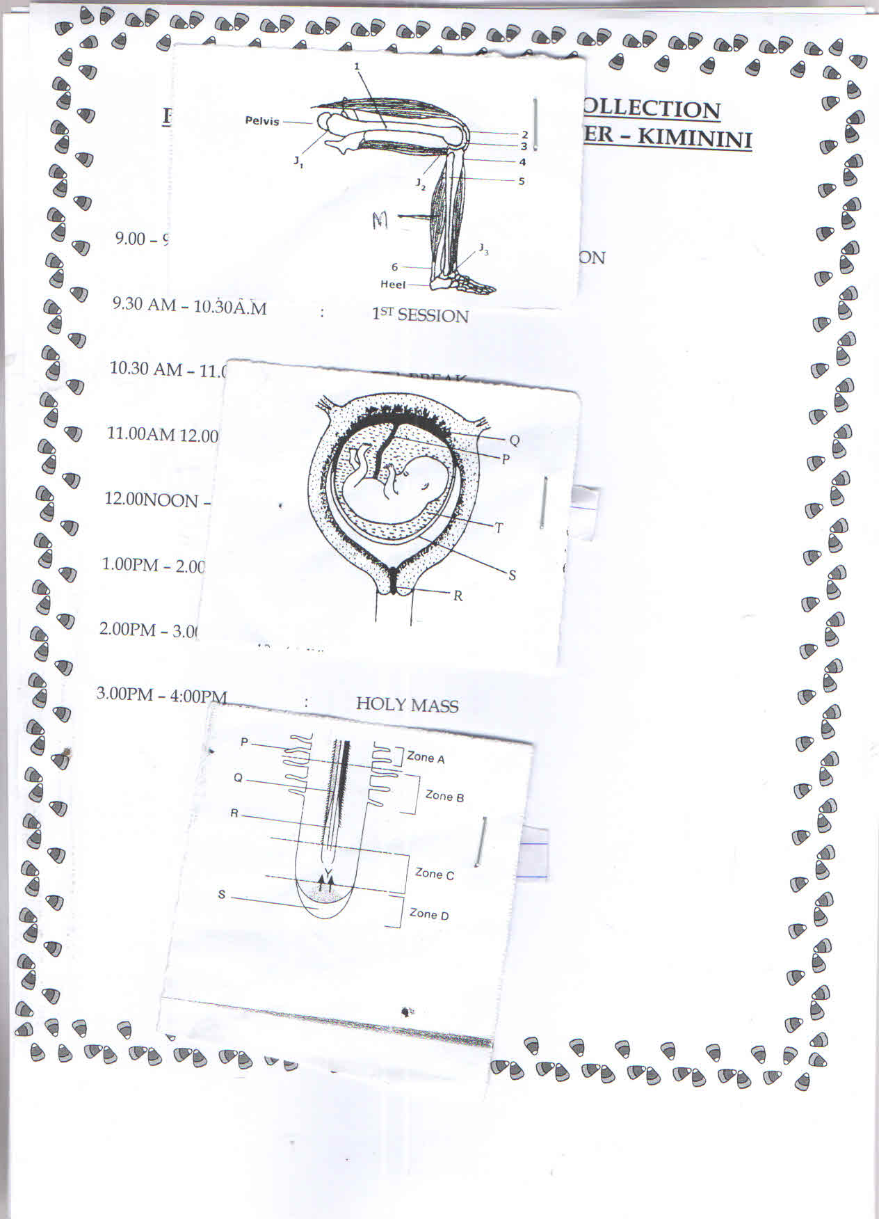
- Identify
- The substance found in the part marked 3 (1 mk)
........................................................................................................................................................................................................................................................................................................................
- The type of joint found at the distal end of the bone marked 1 (1 mk)
........................................................................................................................................................................................................................................................................................................................
- Explain the function of the substance identified in a(i) above (2 mks)
................................................................................................................................................................................................................................................................................................................................................…................................................................................................................................
- Give two structural differences between muscles labelled M and muscles of the gut (2 mks)
....................................................................................................................................................................................................................................................................................................................................................................................................................................................................................
- Name the structure at the elbow that perform the same function as the part marked 2.
- Name ……………………………………………………………………..(1 mk)
- Function :…………………………………………………………………(1 mk)

- a) Name two parts of the body that have thicker cornified layer. (2 mks)
............................................................................................................................................................ ........................................................................................................................................................................................................................................................................................................................
b) Explain two protective roles of the skin. (2 mks)
........................................................................................................................................................................................................................................................................................................................................................................................................................................................................................................................................................................................................................................................................…................................................................................................................................
c) Explain how the human skin brings about cooling of the body on hot day using the following structure.
i. Hair: (1 mk)
........................................................................................................................................................................................................................................................................................................................ ........................…................................................................................................................................
ii. Blood vessels (1 mk)
....................................................................................................................................................................................................................................................................................................................... ........................…...............................................................................................................................
d) Explain how each of the following part of the skin are adapted to their function.
i. Sebaceous gland (1 mk)
....................................................................................................................................................................................................................................................................................................................................................................................................................................................................................
ii. Sweat glands (1 mk)
....................................................................................................................................................................................................................................................................................................................................................................................................................................................................................

- The diagram below shows the longitudinal section of a dicot root.
- i) Name the hormone produced at zone D (1 mk)
........................…............................................................................................................................................................................................................................................................................................
ii) What is the effect of the hormone named in a(i) above on root development (1 mk)
........................................................................................................................................................................................................................................................................................................................
- Explain the function of the part labelled R. (2 mks)
............................................................................................................................................................ ................................................................................................................................................................................................................................................................................................................................................................................................................................................................................................................................................................................................................................................
- State two adaptations of the part labelled P. (2 mks)
................................................................................................................................................................................................................................................................................................................................................…................................................................................................................................
- i) Identify the part labelled S. (1 mk)
........................................................................................................................................................................................................................................................................................................................
ii) State the role of the part identified in d(i) above (1 mk)
........................................................................................................................................................................................................................................................................................................................
- The diagram below represents a mammalian Embryo and associated maternal structures
- i) Name the part labelled R (1mk)
........................................................................................................................................................................................................................................................................................................................
ii) State one adaptations of the part named in a(i) above to its function (1 mk)
........................................................................................................................................................................................................................................................................................................................
- Name two blood vessels found in the structure P and state the function in each
Vessel: …………………………………………………………………………………….
Function: …………………………………………………………………………………..
Vessel: …………………………………………………………………………………….
Function: …………………………………………………………………………………..

- a) What is meant by the term sex-linked genes (1 mk)
.......................................................................................................................................................................................................................................................................................................................
- Coat colour in cats is determined by a sex-linked gene with two alleles, black and orange. When black cats are mated with orange cats, the female offspring are always tortoise shell, their coats show black and orange patches of various sizes, while male offspring have same coat colour as their mothers. Using the symbol X^{B} for black and X^{O} for orange, use a punnet square to show a cross between Black female and Orange male (4 mks)

- List the genotype and phenotype of the offspring that may result from mating a tortoise shell female and a black male (3 mks)
........................…....................................................................................................................................................................................................................................................................................................................................................................................................................................................................................................................................................................................................................

SECTION B(40 MARKS
Answer question 6 (compulsory) and either question 7 or 8
- During germination and growth of a cereals, the dry weight of the endosperm, the embryo and total dry weight were determined at two day intervals. The results are shown in the table below.
Time after planting (days) | Dr weight of endosperm | Dry weight of embryo (mg) | Total dry weight (mg)
0 | 43 | 2 | 45
2 | 40 | 2 | 42
4 | 33 | 7 | 40
6 | 20 | 17 | 37
8 | 10 | 25 | 35
10 | 6 | 33 | 39
- On the same axis draw graphs of dry weight of endosperm, embryo ant total dry weight against time (8 mks)
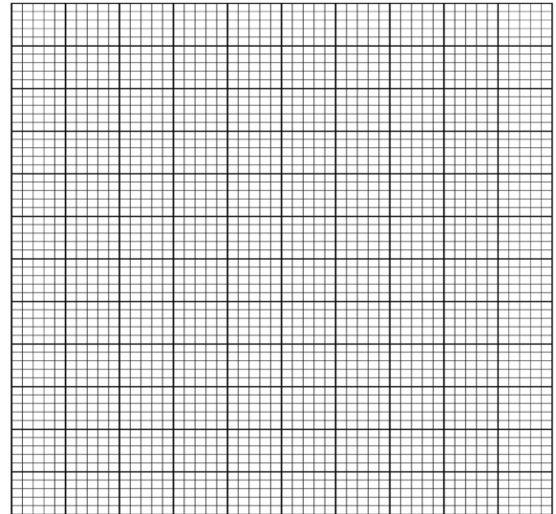

- What was the total dry weight on day 5 (1 mk)
............................................................................................................................................................ ............................................................................................................................................................
- Account for
- Decrease in dry weight of endosperm from day 0 to day 10. (2 mks)
................................................................................................................................................................................................................................................................................................................................................................................................................................................................................................................................................................................................................................................
ii) Increase in dry weight of embryo from day 0 to day 10. (2 mks)
....................................................................................................................................................................................…........................................................................................................................................................................................................................................................................................................................................................................................................................................................
iii) Decrease in total dry weight from day weight from day 0 to day 8 (1 mk)
........................................................................................................................................................................................................................................................................................................................
............................................................................................................................................................
vi) Increase in dry weight after day 8 (1 mk)
....................................................................................................................................................................................................................................................................................................................................................................................................................................................................................
- State two factors within the seed and two outside the seed that cause dormancy.
- Factors within the seed. (2 mks)
..........................................................................................................................................................................................................................................................................................................................
- Factors outside the seed. (2 mks)
..........................................................................................................................................................................................................................................................................................................................
- Give one characteristic of meristematic cells. (1 mk)
............................................................................................................................................................ ............................................................................................................................................................
- Describe how the mammalian Body protects itself against infection. (20 mks)

8. a) How are xerophytes adapted to their habitat (10 mks)
b) Discuss various ways in which Anaerobic respiration is utilized in industries and Homes (10 mks)
........................................................................................................................................................................................................................................................................................................................................................................................................................................................................................................................................................................................................................................................................…................................................................................................................................................................................................................................................................................................................................................................................................................................................................................................................................................................................................................................................................................................................................................................................
................................................................................................................................................................................................................................................................................................................................................................................................................................................................................................................................................................................................................................................................................................................................................................................................................................................................................................................................................................................................…................................................................................................................................................................................................................................................................................................................................................................................................................................................................................................................................................................................................................................................................................................................................................................................ ................................................................................................................................................................................................................................................................................................................................................................................................................................................................................................................................................................................................................................................................................................................................................................................................................................................................................................................................................................................................…................................................................................................................................................................................................................................................................................................................................................................................................................................................................................................................................................................................................................................................................................................................................................................................ ........................................................................................................................................................................................................................................................................................................................................................................................................................................................................................................................................................................................................................................................................…................................................................................................................................................................................................................................................................................................................................................................................................................................................................................................................................................................................................................................................................................................................................................................................
................................................................................................................................................................................................................................................................................................................................................................................................................................................................................................................................................................................................................................................................................................................................................................................................................................................................................................................................................................................................…................................................................................................................................................................................................................................................................................................................................................................................................................................................................................................................................................................................................................................................................................................................................................................................ ................................................................................................................................................................................................................................................................................................................................................................................................................................................................................................................................................................................................................................................................................................................................................................................................................................................................................................................................................................................................…................................................................................................................................................................................................................................................................................................................................................................................................................................................................................................................................................................................................................................................................................................................................................................................ ........................................................................................................................................................................................................................................................................................................................................................................................................................................................................................................................................................................................................................................................................…................................................................................................................................................................................................................................................................................................................................................................................................................................................................................................................................................................................................................................................................................................................................................................................
................................................................................................................................................................................................................................................................................................................................................................................................................................................................................................................................................................................................................................................................................................................................................................................................................................................................................................................................................................................................…................................................................................................................................................................................................................................................................................................................................................................................................................................................................................................................................................................................................................................................................................................................................................................................
………………………………………………………………………………………………………

