BRISINGA EXAMINATION
BIOLOGY PAPER 1(231/1) JULY 2024
MARKING SCHEME
1. Name the branch of Biology that deals with the study of fish. (1mk)
Ichthyology
2. State one advantages of metamorphosis in the life of insects (1mk)

- Reduce competition between the stages as they feed/ require on different food;
- Avoid predation of the young ones as they are different ;
- The pupa stage can withstand harsh environment by being inactive;
(mark first one)
3. Name the phylum whose members possess notochord. (1mk)
Chordata; (first letter must be capital)
4. The diagram below represents a bread mould.

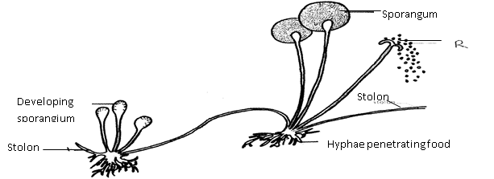
- (i) Name the Kingdom to which bread mould belongs. (1mk)
Fungi;

(ii) Give two distinguishing characteristics of the Kingdom named in (a)(i) above. (2mks) Non— green/ lacks chlorophyll;
- Body made up of hyphae/ mycelia; Acc Mycellium
(b) State the function of the part labelled R. (1mk)
Asexual reproduction; OW TTE/Germinates into anew hyphae/organism
Acc reproduction
Rej sexual

5. Explain why the following processes are important during the preparation of temporary
slides :-
(a) Staining (1mk) Make cells more visible/distinct/more clear;
To obtain thin sections.

- Use of a sharp cutting blade (1mk) Prevent distortion of cells;

6. In a laboratory exercise a student observing a drop of pond water under a microscope saw and drew a spirogyra. If the magnification of the eye-piece was x5 and that of the objective
lens was x100, what was the magnification of the spirogyra? (2mks)
- Magnification = Objective lens magnification x Eyepiece lens magnification

= 100 x 5
= x500;
7. Identify the structures of the cells that perform the following functions:- (a) Synthesize ribosomes. (1mk)
nucleolus; (b)Regulate exchange of substances in and out of the nucleus (1mk)
nuclear membrane/pore;

8. What are the functions of the following parts of a light microscope?
(a) Condenser (1mk)Concentrates light onto the object on the stage. b)Diaphragm (1mk).Regulates amount of light illuminating the object on the stage;

9. Potato cylinders were weighed and kept in distilled water overnight. They were then
reweighed.

2.5 g 2.4g 2.7g 3.0 g 3.1 g 3.2g
At the beginning of the Experiment. At the end of the experiment
- Calculate the average mass of potato cylinders after reweighing. Show your working. (2mks)
a) 3.0 + 3.1 + 3.2 = 9.3 g;
Average = $\frac{9.3}{3}$;
Average = 3.1g;
Penalize without units.

- Explain why mass of the cylinders hand increased. (2mks)

The cell sap had a higher concentration of solutes than distilled water;
water therefore moves from the environment to the cell by osmosis;
Distilled water was hypotonic/dilute to the hypertonic cell sap:
: water moves by osmosis.

10. The diagram below represents a cell at a certain stage in meiotic cell division
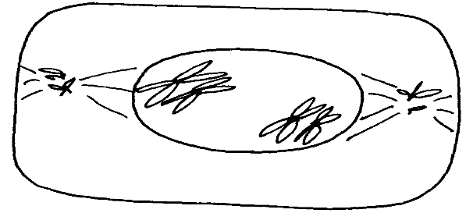

a) Name the stage at which the cell drawn above represents (1mk)

Prophase I ;Reject prophase alone;

b)Give a distinguishing reason for your answer in 10(a) above .(1mk)

Homologous Chromosomes lie side by side or Bivalency

11. The chemical equation below represents a physiological process that takes place in living
R
organisms:
C₆H₁₂O₆ + C₆H₁₂O₆ C₁₂H₂₂O₁₁ + Q
- Name the process R (1mk) Condensation;

- Name the substance Q (1mk) water; Rej H₂O

12. The diagram below shows cells in plants:-

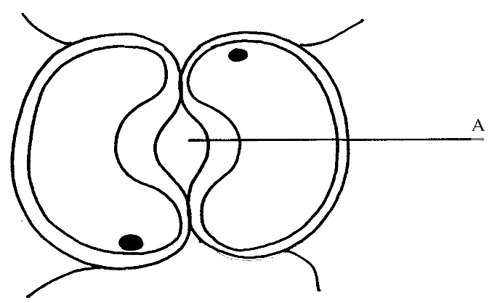

- Identify the cells shown above (1mk) Guard cells;

- Explain how the cells are adapted to their function (2mks)
Cells walls have thicker inelastic inner side and thin elastic outer wall; which enables them to pull inwards when the cells are turgid; /to control opening and closing of the stoma.
contains chloroplasts that are able to phosynthesize and produce sugars which enable them to absorb water; (any two points)
- Bean shaped/face one another to form a pore; to allow for G.E;

(c) Explain how accumulation of carbon (IV) Oxide in the cells above would lead to the closure of structure A. (2mks)

Accumulation of carbon (IV) oxide in the leaf forms a weak carbonic acid// lowering the pH
which favours conversion of sugar to starch//causing the guard wells to lose turgidity; and
close;

13. Below is a process that takes place along the mammalian digestive system:
Lipids
Fatty acids + glycerol
B
A

- Name the processes represented by A and B. (2mks)
A.Hydrolysis

B.; Condensation;
(b) Name part of the alimentary canal where the process A takes place (1mk)

b)Duodenum; (any correct Rj .wrong spelling)
-ileum;

14. In an experiment to investigate an aspect of digestion, two tubes A and B were set up as shown in the diagram below.

Starch + saliva
Starch + boiled saliva
Water bath at 37ºC
A
B

The test tubes were left in the water bath for 30 minutes. The content of each tube was then tested for starch using iodine solution.
- What was the aim of the experiment? (1mk)
To investigate the effect of heat/Temperature on salivary amylase/ptyalin;
- Explain the expected results in the tube. (2mks)
A – The brown colour of iodine was retained because the starch was digested by enzyme amylase in the saliva;
B – The colour changed to blue black/black; because amylase in the saliva was denatureby heat;
15. Name the blood vessel that nourishes the heart (1mk).
Coronary Artery;

16. a) In which form is oxygen transported in the blood. (1mk) Oxyhaemoglobin;
- Why do plants not take in oxygen during the day although they need it for respiration. (2mks)
During the day plant carry out photosynthesis, they release oxygen as one of their by-products
Oxygen released from photosynthesis process is used in respiration;
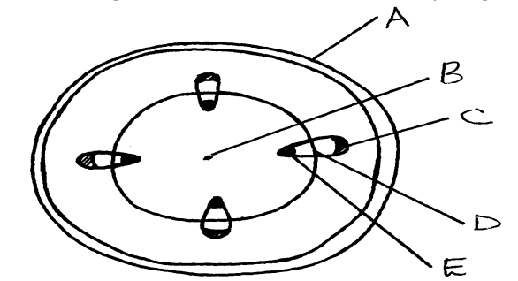
17.. The diagram below represents a transverse section of a young stem.

- State the functions of the parts labeled C and E . (2mks)
C secondary phloem;
D cambium//vascular//interfascular cambium//cambium ring
18. Give a reason for each of the following on mammalian Red blood cells (2mks)
(a) Absence of the nucleus
. Create more room/space for packaging of more haemoglobin;
- Biconcave shape
To provide a large surface area for diffusion of a lot of respiratory gases;
19. Name the nitrogenous wastes excreted by the following organisms:- (3mks)
Animal Nitrogenous Waste
(i) Desert mole urea;
(ii) Marine fish Triethylamine;//trimethylamine oxide//urea
(iii) Tilapia Ammonia;
20. Study the homeostatic scheme below:
Excess
Less hormone A
released
Normal concentration of sodium ions in the blood
Release of hormone A
Normal concentration of sodium ions in the blood
Further deficiency
D
Deficiency
C
C

(a) Identify the hormone labeled A.(1mk) Aldosterone;

(b) Name the site of action of hormone A (1mk)
Ascending Loop of Henle;
Distal convoluted tubule;
Collecting duct;

(c) Identify the feedback labeled D (1mk) Positive feed back;

21. A student wanted to estimate the number of grasshoppers in 5km² grass field near the school compound.Using a sweep net he captured 36 grasshoppers. He used a red felt pen to mark the thorax of each insect before releasing it back into the field. Three days later he made another catch of grasshoppers. He collected 45 grasshoppers of which only 4 had been marked with red mark.
a) Name the above method used in the population estimation (1mk)
Capture –recapture method;
b) Calculate the population of grasshoppers using the above data (3mks) .
First Marked x Second Capture = 36 x 45 ; = 405;
Marked Recapture = 4
22. The figure represents a feeding relationship in an ecosystem
Grasshopper
Grass
Guinea fowls fowfowls
Termites
Gazelles
Leopards
Vulture

Lion

- Write down the food chain in which the Guinea Fowls are secondary consumers. (2mks)
Grass Grasshopper Guinea Fowl;
Grass Termites Guinea Fowl;
- What would be the short term effects on the ecosystem if lions invaded the area. (2mks)- Leopards will decrease// migrate//starve; - Gazelles will also decrease;
(c) Name the organism through which energy from the sun enters the food web. (1mk) Grass;

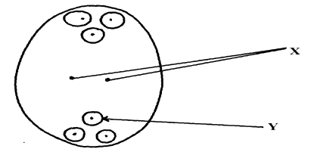
23. The diagram below represents a mature embryo sac. Study it carefully and answer the questionsthat follow:

- Identify structures X and Y (2mks)
X – Polar nuclei; reject polar nucleus Y – Egg cell// functional egg
- Why is cross pollination more advantageous to a plant species than self-pollination? (2mks)
Results to variation; that makes the plant to be adapted for survival// hybrid vigor
24. Explain why menstrual periods stop immediately after conception? (2mks)
Production of the hormones progesterone and oestrogene continues; that maintains the pregnancy; thickened endometrium
These hormones inhibit the production of follicle Stimulating hormone (FSH) and lutenising hormone (LH); This inhibits the maturation of more follicles,
25. The diagrams below represent two gynoecia A and B obtained from two different plants.
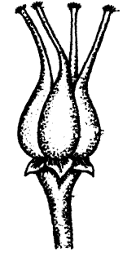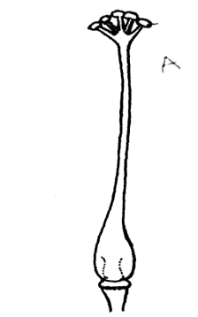
A
B

(a) What name is given to; Gynoecium A?Syncarpous:….(2mks)

Gynoecium B? …. Apocarpous;

. Rj: Wrong spellings
State the observable difference between the gynoecia A and B (1mk)
A fused ovaries
B — separate ovaries

- State the role played by Heterostyly in plants. (1mk)

Hinder self pollination? fertilization:

26. State the difference between the sperm cell and the ovum. (3mk)

Sperm | Ovum
- Spear shaped.  - Posses a tail.  - Has acrosome .  No vitelline membrane. | - Spherical shaped  - No tail  - No acrosome  - Has vitelline membrane.

27. State two sources of variation (2mkS)

Genetic recombination’s of alleles reading to variations;
Independent assortment of chromosomes;
Random fusion of gametes; mutations;
28. The table below is a representation of a chromatidewith genes along its length. It
undergoes mutation to appear as shown below:
Before mutation | L | M | N | O | P | Q
After mutation | L | O | N | M | P | Q
- Name the type of chromosomal mutation represented (1mk).
Inversion ;
b) Name one mutagenic agent (1mk)
- mustard gas/colchicine
Exposure to
- ionizing radiation;
- gamma rays;
- X- rays
29. a) Distinguish between homologous and analogous structures in evolution. (2mks)
Homologous structures have a common embryonic origin but are modified to Perform different functions; while analogous structures have different embryonic origin but are modified to perform similar functions;
- Name one vestigial structure in mammals. (1mk)
Nictitating membrane; Nictating memberane; facial hair; coccyx in humans
30. (a) What is meant by the term natural selection (1mk)
Nature or the environment selects those individuals that are sufficiently adapted; and rejects
those that are not adapted

31. A response exhibited by a certain plant tendril is illustrated below:

(i) Name the type of response. (1mk) Thigmotropism / haptotropism rej: trophism
(ii) Explain how the response named in (i) above occurs (2mks)
ii) High concentration of auxin on side away from contact surface; promotes faster growth of this
side; causing tendril to curl/twine around the object.

