**KCSE FORM I - BIOLOGY**

[**1.0.0 Introduction to Biology  (5 Lessons)**](http://www.elimu.net/Secondary/Kenya/KCSE_Student/Biology/Form1/Introduction/KCSE%20Biology%20Curriculum%20Form%20I-Introduction%20to%20Biology.htm)

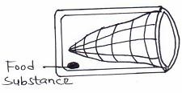

Study the diagram below and answer the questions

that follow:

1.

1. Identify the above apparatus. (1mk)
2. State the function of the above apparatus. (2mks)
3. Name an apparatus that can be used for catching insects on barks of trees or rock surfaces. (1mk)
4. Name the branch of Biology that deals with the study of birds. (1mk)
5. Some form one students wanted to collect the following animals for study in the laboratory. State the suitable apparatus they should use.
   1. Flying insects. (1mk)
   2. Crawling stinging insects. (1mk)
   3. Small animals from tree barks. (1mk)
6. A scientific space craft brought some material to earth from the outer space. Explain how one would establish if the material is living or non-living. 2mks
7. State the field of biology described below:
   1. Study of interrelationship of living things in their surroundings. (1mark)
   2. Study of fossils. (1mark)

5. Study the diagram below and answer the questions that follow.

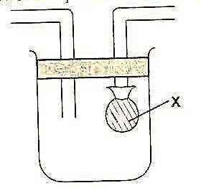

1. Identify the apparatus. (1mark)
2. State the functions of the part labeled x. (1mark)

6. Name the branch of Biology that involves the study of: 2mks

a) Organisms for the sake of classifying them

b) Microscopic organisms

1. Differentiate between movement and locomotion as used in characterizing living things. (1mk)
2. State one function of each of the following apparatus in the study of living organisms.
   1. Sweep net (1 mark)
   2. Pooter (1 mark)
   3. Magnifying lens (1 mark)

|  |  |
| --- | --- |
| 9. State the functions of the following apparatus;  Pitfall trap | (1mk) |

10. Plants do not have ability to move from one place to another. How do they compensate for this in order to carry out the following processes.

* 1. Reproduction (2 marks)
  2. Nutrition (2 marks)

1. a) Name the most suitable biological equipment for collecting the following organisms;
   1. moths from a coffee farm ............................................................................... (1 mark)
   2. ants from a tree trunk ...................................................................................... (1 mark)

b) State the term that refers to the scientific system of assigning two names to an organism.

1. mark)
2. Name two major branches of biology. (2 marks)
3. What name is given to a scientist who studies the following:
   1. Insects (1mark)
   2. Plants (1mark)
   3. Identification and classification of living organisms. (1mark)
4. Give the name of the study of (4 marks)
   1. The cell ..................................................................................................................................................
   2. Microorganism ..................................................................................................................................................
   3. Insects .................................................................................................................................................
   4. Fungi .................................................................................................................................................