  - Cell Physiology (20 Lessons)

- State three roles of osmosis in plants (3marks)

- Potato cylinders were weighed and kept in distilled water overnight. They were then reweighed.
At the beginning At the end


2.5
g

2.
4
g

2.7
g

3.0
g

3.1
g

3.2
g

- Calculate the average mass of the potato cylinders at the end of the experiments.
(Show your working). (2mks)
- Explain why the mass of the cylinders had increased. (3mks)

3. The following set up was used to investigate a physiological process in life.

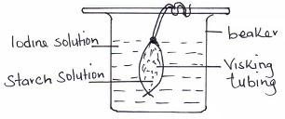

(a) (i) Name the physiological process that was being investigated. |  |  | (1mk)
(ii) What is the representative of the visking tubing in life? |  |  | (1mk)
(b) (i) State the observation that would be made in the visking tubing after few minutes. |  |  | (1mk)
(ii) Explain why similar results were not obtained inside the beaker. |  |  | (2mks)
(c) State the roles of the process being investigated in mammals. |  |  | (3mks)

4. Two potato cylinders were carefully dried on a blotting paper and weighed. Each piece weighed 2 grams. One was placed in each test tube as shown in the diagram below.

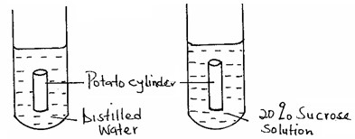

  - After 48hrs, which potato cylinder will be heavier. Explain. (2 marks)
  - Name the substance whose movement was responsible for the weight changes in the potato cylinder you identified in (a)
above. (1 mark)
  - Name the process which was responsible for the movement of the substance you identified in (b) above. (1 mark)
- An experiment was set up as shown below
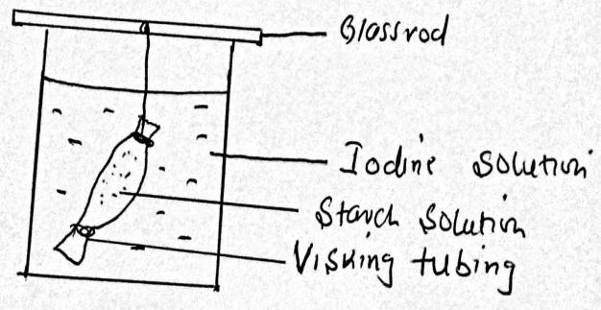

  - What are the observations made after 30 minutes in the experiment above (2marks)

- State three differences between osmosis and active transport. (3mk

7. What is meant by the following biological terms?
i) Crenation (1mk) ii) Haemolysis (1mk) iii) Plasmolysis (1mk)
8. Examine the diagram below carefully and use it to answer the questions that follow.

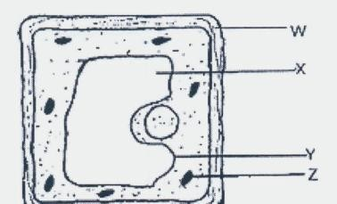
  - Name the parts X, Y and Z. (3 marks)
  - State the main substance which make-up the part labeled W. (1 mark)
  - Name the process through which mineral salts move into the structure labeled X. (1 mark)
  - Explain what happens to a red blood cell when placed in distilled water. (3 marks)

9. Define the following terms in relation to a cell. (3mks)
    - Isotonic solution:
    - Hypotonic solution:
    - Hypertonic solution:

- (a) Define active transport. (2mks)
(b) State two roles of active transport in animals. (2mks)

11. In an experiment, a visking tubing was half filled with concentrated sugar solution containing methylene blue dye. Both ends were tied well to prevent leakage. It was then rinsed with distilled water and immersed in a beaker containing distilled water. The set-up is shown below. After 6 hours the water in the beaker turned blue, and the visking tubing was swollen with more solution.
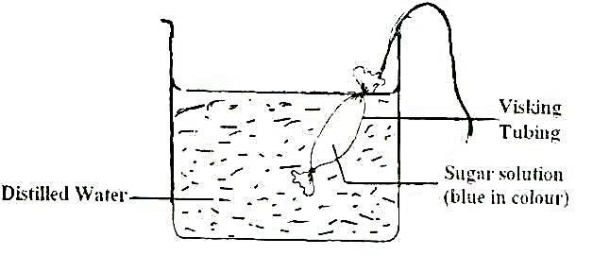

- Explain why the visking tubing was swollen with the solution at the end of the experiment (3 marks)
- Name the process through which the water in the beaker turned blue. (1 mark)
- Distinguish between diffusion and active transport in a human body (2 marks)
- State two roles of active transport in the human body. (2 marks)

12. A group of students set up an experiment as shown below. The experimental set up were left for
20 minutes.

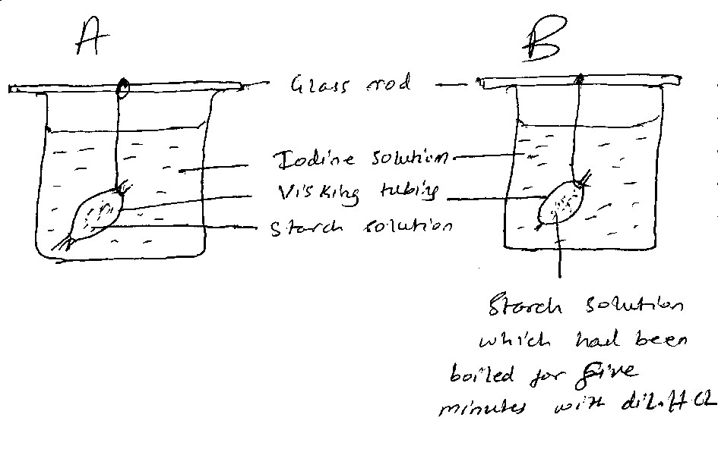
The observation after 20 minutes were as shown in thetable below.
Set up |  | Observations
Set up | Inside tubing |  | Outside tubing
A | Blue black colour |  | Colour of liodine.
B | Colour of iodine |  | Colour of iodine

  - State the process being demonstrated in this experiment. 1mks
  - Explain the results in set up A. 3mks

13. An investigation was set up as shown below.
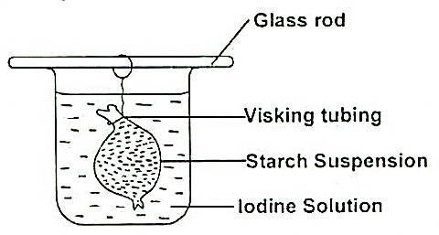
After 30 minutes, starch suspension had turned blue-black while iodine solution retained its colour.
  - Name the physiological process that was being investigated in the experiment. (1mark)
  - Account for the results observed after 30 minutes. (3marks)

14. A group of form 1 West students set up an experiment to demonstrate a certain physiological process. The set up was left to stand for 20minutes.

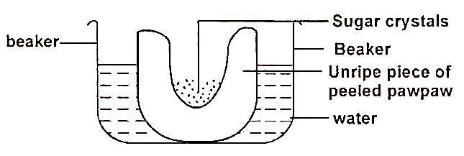
- Name the physiological process demonstrated in the experiment (1mark)
- What observations were made after 20minutes? (2marks)
- Explain the observations you have made in (b) above. (3marks)
- State two roles of the process you have made in (b) above. (3marks)

- four cylinders of potato were carefully dried on blotting paper and weighed. Each piece weighed 3g. One was placed in each as shown in the drawing below.
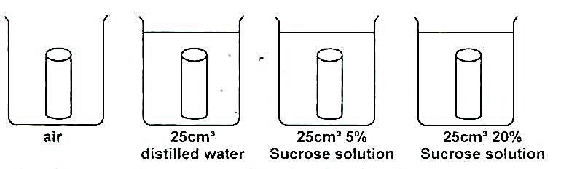
  - After 48hours, which potato would be the heaviest 2mks
  - Name the substance whose movement was responsible for the weight changes in potato cylinders. 1mk
c) Name the process which was responsible for this movement in tubes B, C and D. 1mk

16. Explain the term Osmotic potential in plant physiology. 1mk

17. Differentiate between osmosis and diffusion. (4 marks)

18. List three factors that affect the process of active transport. (3 marks)

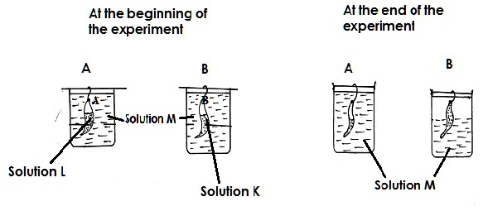
19. In an experiment two equal volumes of solution L and M were placed into visking tubing. The visking tubing was suspended into beakers containing equal volumes of solutions K. The set –up is as shown in the diagram A and B. The set-up was allowed to stand for 45minutes and results are as shown in the diagrams.

- Name the process that was being demonstrated. (1mark)
- Explain the results that were obtained at the end of the experiment in
- Set-up A. (2marks)
- Set up B. (2marks)
- What is the biological importance of the process demonstrated in this experiment to plants? (2marks)

20. How do the following factors affect the rate of diffusion?
a) Diffusion gradient (1 mark)
b)Surface area to volume ratio (1 mark)

