AGORO OYOMBE SECONDARY SCHOOL
Name………………………………… ADM Number………………… Class…………..

Candidate’s Signature…………………… Date………………………………….

BIOLOGY FORM 2
TIME: 1 Hours 45mins
FORM ONE END TERM EXAMS 2024

Answer All Questions (7omks)

- The set up was used to investigate a certain physiological process. Study it and answer the questions that follow.

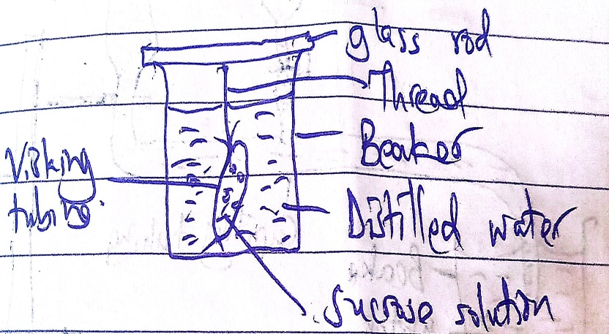

- Which physiological process was being investigated? (1mk)

- State the expected observation after the set up was left for two hours.( 1mk)

- Explain your answer in (b) above

- State and explain the expected observation if the experiment is repeated with distilled water in both the visking tubing and beaker. (2mks)

- Give two roles in the above process in living organism. (2mks)

- Highlight two functions of the root in plants. (2mks)

- What do you understand by the following terms? (2mks)
- Assimilation

- Emulsification

- Study the diagram and answer the questions that follow.

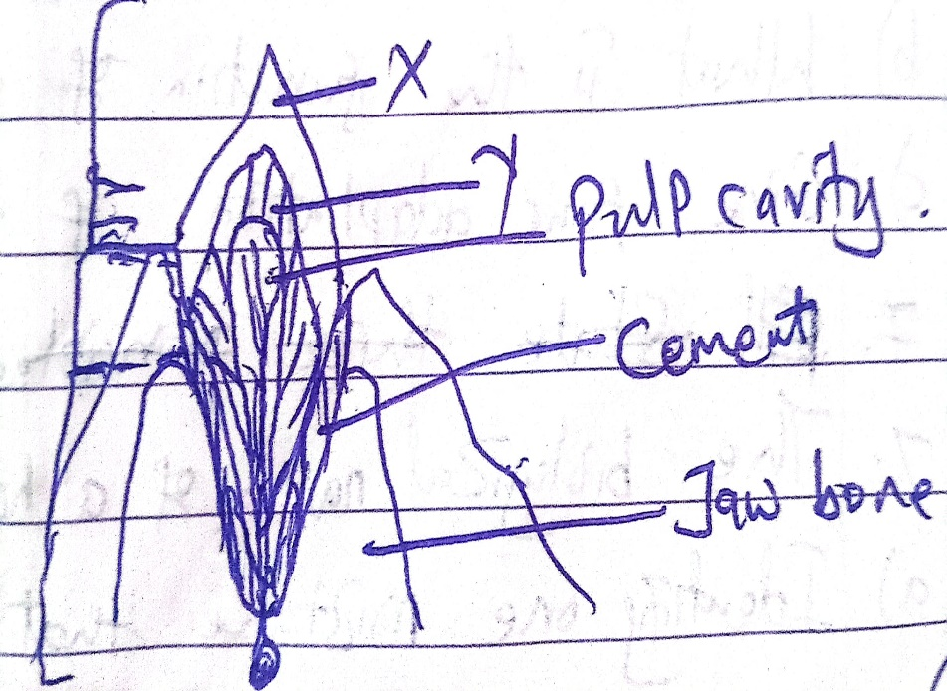

- Identify the parts lebelled.
- X
- Y
- What is the significance of the part labelled X

- Highlight two dental diseases that affect teeth. (2mks)

- The set up below was used to investigate a certain process in plants. Study it and answer the questions that follows

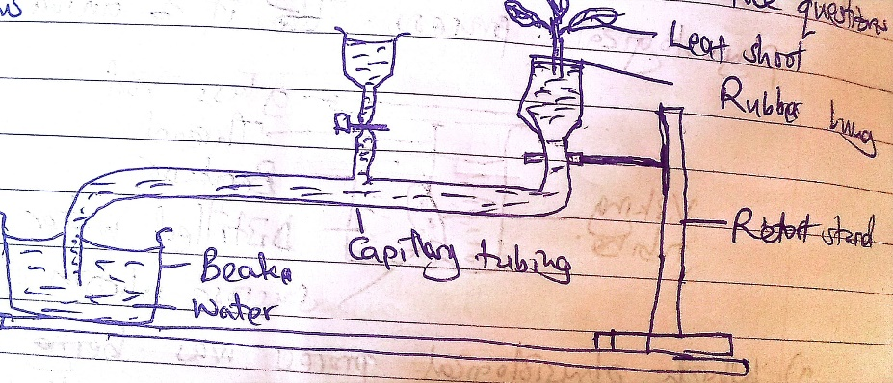

- What process was being investigated? (1mk)

- State the precautions that should be taken when setting up the experiment. (2mks)

- What is the significance of the above process in plants? (2mks)

- Study the diagram below. Use it to answer the questions that follows:

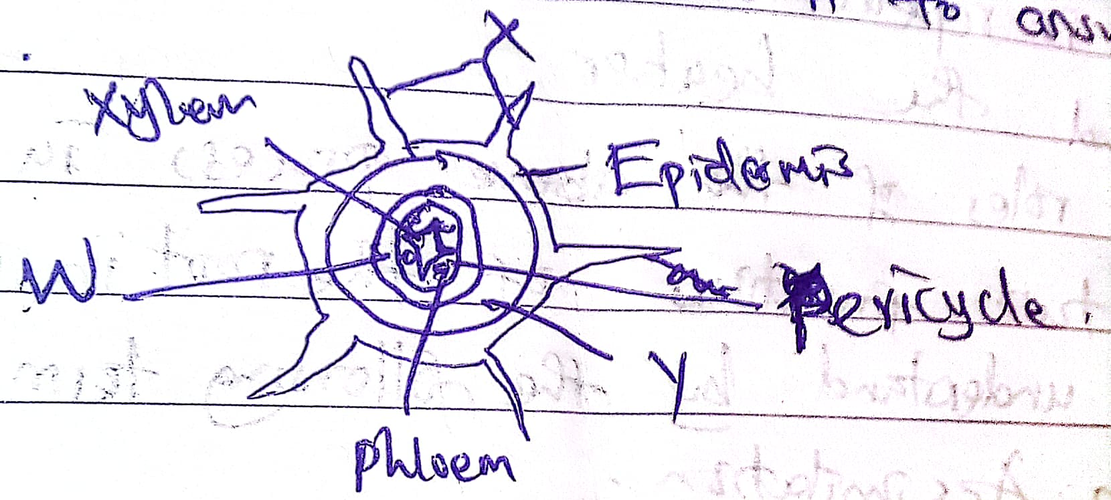

- Identify the part labelled.
- W
- Y
- What is the function of the part labelled Y. (1mk)

- Give four adaptations of the parts labelled X to its function. (4mks)

- The biological name of housefly is MUSLA DOMESTICA.
- Identify one mistake that was made while writing the scientific name. (1mk)

- Write the name in the correct manner following all rules of Binomial Nomenclature. (1mk)

- State three principles that govern Binomial Nomenclature. (3mks)

- Give two differences between osmosis and Active transport. (2mks)

- Differentiate the following
- Hemolysis and plasmolysis. (2mks)

- The following apparatus are used in collecting specimen. Study them and answer the questions below.

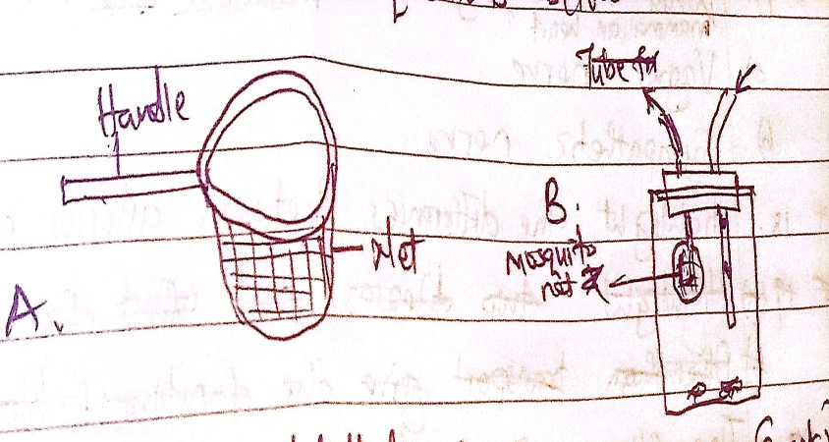

- Identify the apparatus labelled. (2mks)
- A
- B
- What is the function of apparatus label A and B. (2mks)

- What are precautions to be taken during the collection of specimen? (3mks)

- Highlight two factors that determine energy requirement in human beings. (2mks)

- Explain why a variegated leaf produces less food as compared to non – variegated leaf. (2mks)

- What do you understand by the term photosynthesis.(2mks)

- Highlight two factors affecting photosynthesis. (2mks)

- Study the diagram below. Use it to answer the questions that follows:

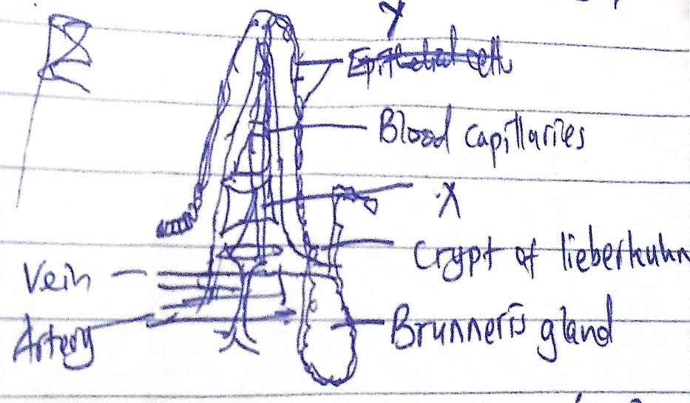

- Identify the above diagram (1mk)

- Name the part labelled X and Y (2mks)

- Give the adaptations of ileum to its functions. (4mks)

- Differentiate the following:
- Pulmonary circulation and systematic circulation.(2mks)

- What is the significance of the following nerves in beating of Mammalia heart?
- Vagus nerve

- Sympathetic nerve
- Highlight the differences between arteries and veins. (2mks)

- The following is the dental formula of a mammal

I 0/4, c 0/0, pm 3/3, m 2/3

- What is the total no of teeth? (1mk)

- What is the mode of feeding for the above mammal? (1mk)

- Give one reason for your answer above. (1mk)

- What is the dental formula? (1mk)

