**NAME ………………………………………………………………INDEX NO…….………………………………**

**SCHOOL……………………………………SIGN ……….CLASS…………..……....DATE……………………..**



**231/2**

**BIOLOGY THEORY**

**JULY/AUGUST, 2024**

**TIME: 2 HOURS**

**KABOURA JOINT EXAMINATION**

***Kenya Certificate of Secondary Education (K.C.S.E)***

**INSTRUCTIONS TO CANDIDATES**

* Write your name and Index Number in the spaces provided above.
* This paper consists of **two** sections. Section **A** and section **B.**
* Answer **ALL** questions in section **A** in the spaces provided. In section **B** answer question **6** (compulsory) and either question **7** or **8** in the spaces provided after question 8
* This paper consists of 8 Printed pages. Candidates should check the question paper to ensure that all the papers are printed as indicated and no questions are missing.

**For Examiners use only.**

|  |  |  |  |
| --- | --- | --- | --- |
| **Section** | **Question** | **Maximum score** | **Candidates score** |
| **A** | **1** | **8** |  |
| **2** | **8** |  |
| **3** | **8** |  |
| **4** | **8** |  |
| **5** | **8** |  |
| **B** | **6** | **20** |  |
| **7** | **20** |  |
| **8** | **20** |  |
|  | **Total score** | **80** |  |

**SECTION A (40MKS)**

***Answer all the questions in this section in the spaces provided***

1. (a) During a microscopy class a student was unable to see the field view. State two possible adjustments the student needed to make for the field of view to become visible (2mk

* Adjust the mirror;
* Ensure diaphragm is fully open;
* Ensure the objective lens is clicked into position with the eye piece lens;

(b) The figure below represents a certain cell organelle.

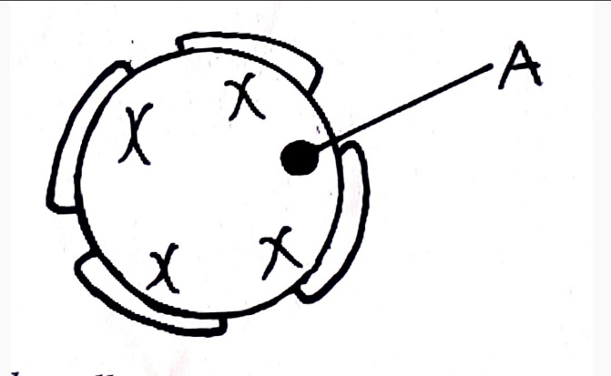

1. Identify the cell organelle (1mk)
2. What is the function of the part labelled A. (1mk)

(c) Name the organelles that perform the following functions (2mks)

(i) Osmoregulation in amoeba

1. Transport of packaged glycoproteins.

(d)Give two adaptations of the spermatozoa to its functions (2mks)

1. The photograph below shows a mammalian vertebra

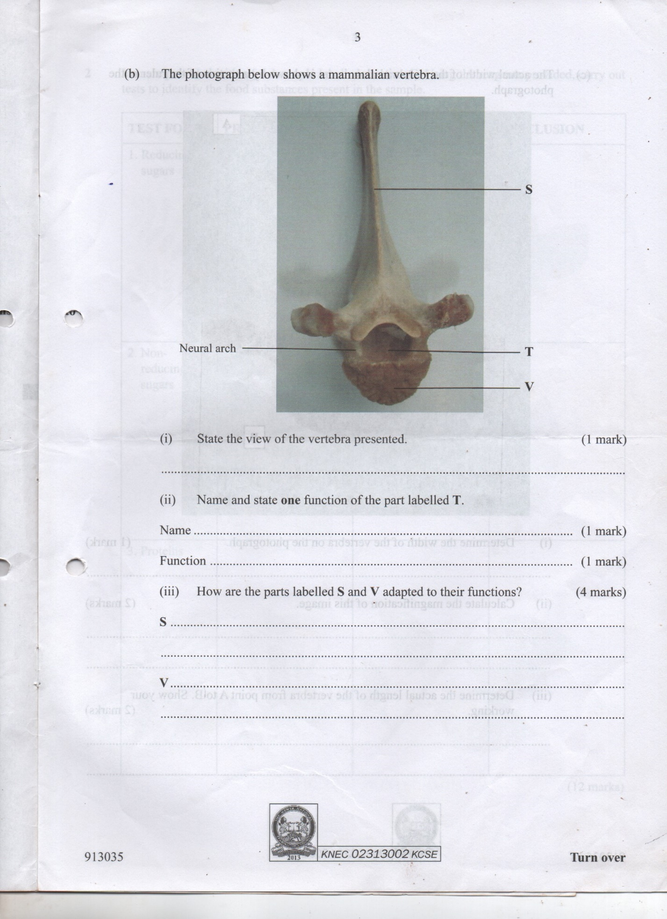

1. Identify the vertebra presented (1mk)
2. State the view of the vertebra presented (1mk)
3. Name and state one function of the part labelled T

Name………………………………………………………………… (1mk)

Function ……………………………………………………………..(1mk)

1. How are the parts labeled S and V adapted to their functions (4mks)
2. S
3. V
4. The diagram below shows an organism in a certain Kingdom.

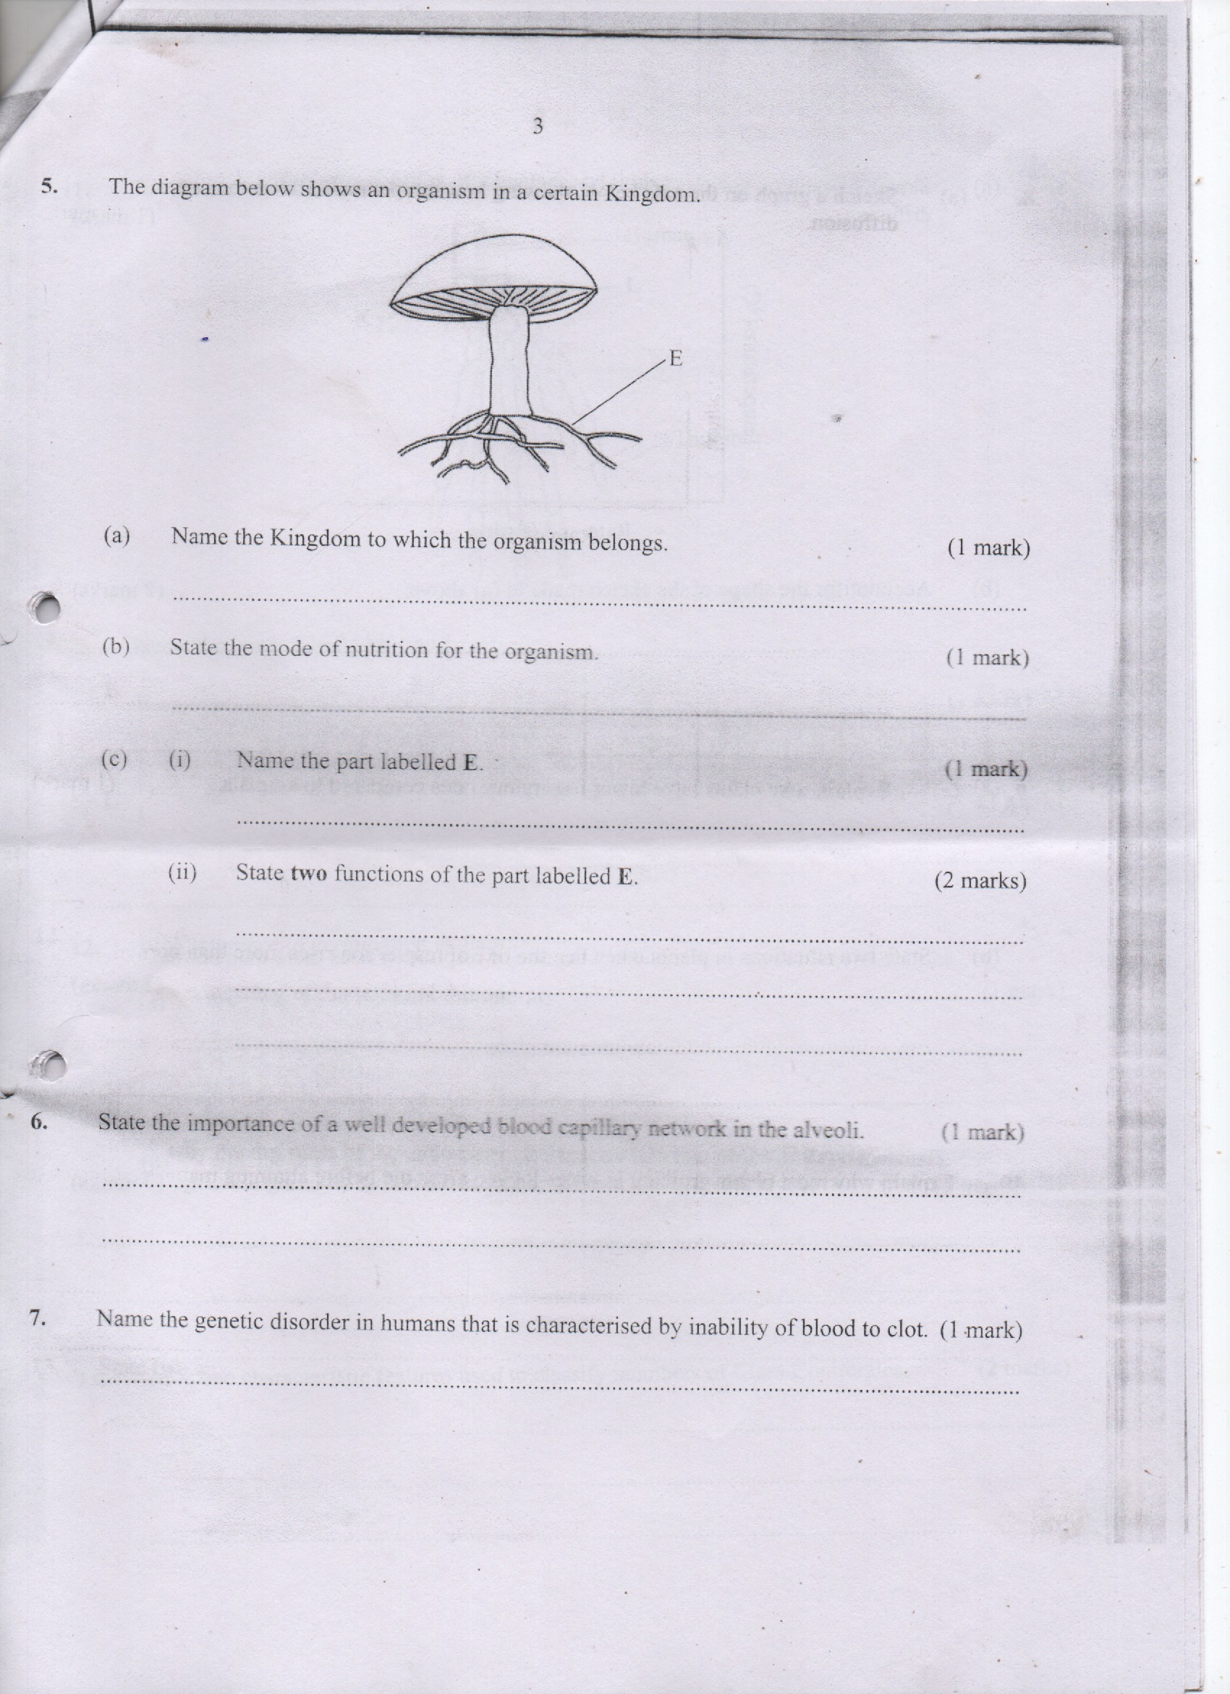

1. (i) Name the kingdom to which the organism belongs (1mk)

(ii) State two characteristics of the organism that have enabled you to put it in the above kingdom (2mks)

1. Name the part labelled E and state its two functions

Name ……………………………………………………………….. (1mk)

Function (i) ………………………………………………………… (2mks)

(ii)…………………………………………………………

1. Outline two economic importance of the organism (2mks)
2. In human beings colour blindness is caused by a recessive gene and is sex-linked. A man whose mother was colour blind married a normal woman whose father was also colour blind. Let n represent recessive gene.
3. Define dominant gene (1mk)
4. (i) Work out the genotypes of the first filial generation of their marriage. Show your working. (4mks)

(ii) What is the probability of a daughter being colour blind (1mk)

1. State two areas where genetic engineering has been applied in farming (2mks)
2. The diagrams below shows the simplified structure of kidneys from two different animals

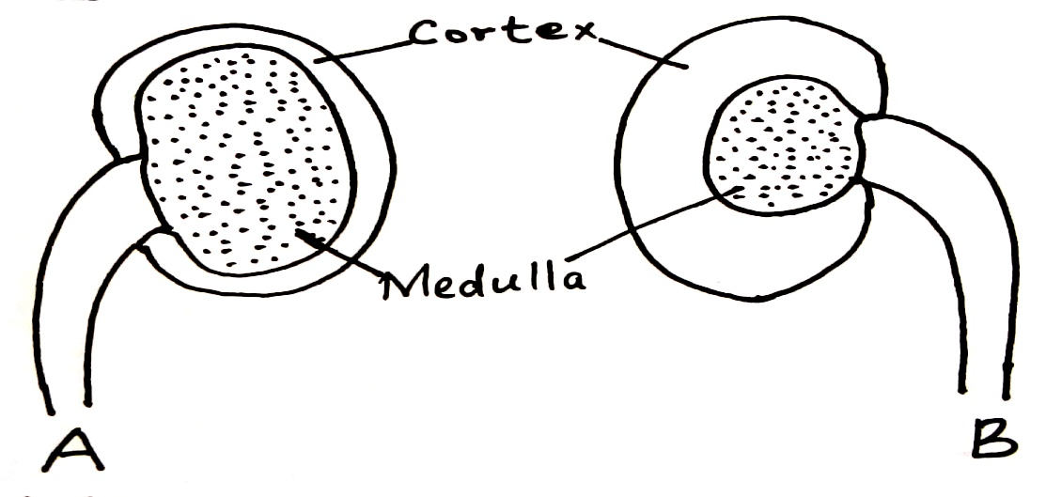

1. State one main observable difference between these two kidneys (1mk)
2. With a reason, state the possible structural difference between the nephrons of these of two kidneys.

Difference (1mk)

Reasons (2mks)

1. Suggest the likely habitat of the animals whose kidneys are shown in the diagrams giving a reasons for your answer (4mks)

|  |  |  |
| --- | --- | --- |
|  | Habitat | Reason |
| Animal with Kidney A |  |  |
| Animal with kidney B |  |  |

**SECTION B (40MKS)**

**Answer question 6 (compulsory) and either question 7 or 8 in the spaces provided after question 8.**

1. In an experiment to investigate the effect of temperature on seed germination, soaked maize seeds were subjected to varying temperatures as tabulated below.

|  |  |  |  |  |  |  |  |  |
| --- | --- | --- | --- | --- | --- | --- | --- | --- |
| Temperature (oC) | 0 | 6 | 12 | 17 | 28 | 33 | 41.5 | 51 |
| Percentage germination (%) | 0 | 0 | 2.5 | 5 | 13 | 44 | 26 | 3 |

1. Plot the graph of percentage germination against temperature on the graph paper provided. (6mks)



1. Why were the maize seeds soaked before the experiment (3mks)
2. Account for the percentage germination at:
3. 6 oC (2mks)
4. 33 oC (3mks)
5. 51 oC (2mks)
6. State two internal factors that affect seed germination (2mks)
7. Name two hormones that control growth in insects (2mks)
8. (a) Explain the roles of the mammalian blood plasma

(b) Describe the mechanism of blood clotting in human beings (10mks)

1. (a) Describe the adaptive features of an insect pollinated flower (10mks)

(b) Explain how the distribution of auxins brings about the following plant responses

i) Phototropism (5mks)

ii) Haptotropism (5mks)