Name………………………………… ADM Number………………… Class…………..

Candidate’s Signature…………………… Date………………………………….

BIOLOGY FORM 1
TIME: 1 Hours 45mins
FORM ONE END TERM EXAMS 2024

Answer All Questions (7omks)

- Define the following terms. (3mks)
- Cell
- Tissue
- Organ
- State two functions of a microscope. (2mks)

- Highlight two differences between plant cell and animal cell. (2mks)

- Fill in the blank space in the table below. (7mks)

Branch | Field of study
Zoology
 | Study of insect
Botany
Genetics
Taxonomy
 | Study of parasites
 | Study of micro-organism

- The following set up was used to investigate a physiological process in life.

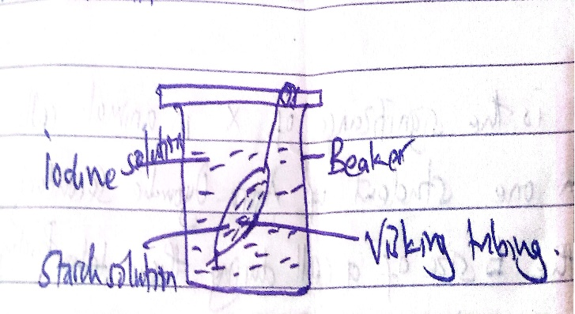

- Name the physiological process that was being investigated. (1mk)

- What is the representative of the visking tubing life? (1mk)

- State the observation that would be made on the visking tubing after few minutes. (1mk)

- Explain why similar results were not obtained inside the beaker.(2mks)

- Explain the roles of the process being investigated above in mammals. (3mks)

- Give three adaptions of a cell membrane to its functions. (3mks)

- What do you understand by the term photosynthesis? (1mk)

- Highlight 2 stages of photosynthesis. (2mks)

- Give five adaption of the leaf to its photosynthetic functions. (5mks)

- Study the diagram below and answer that questions that follow.

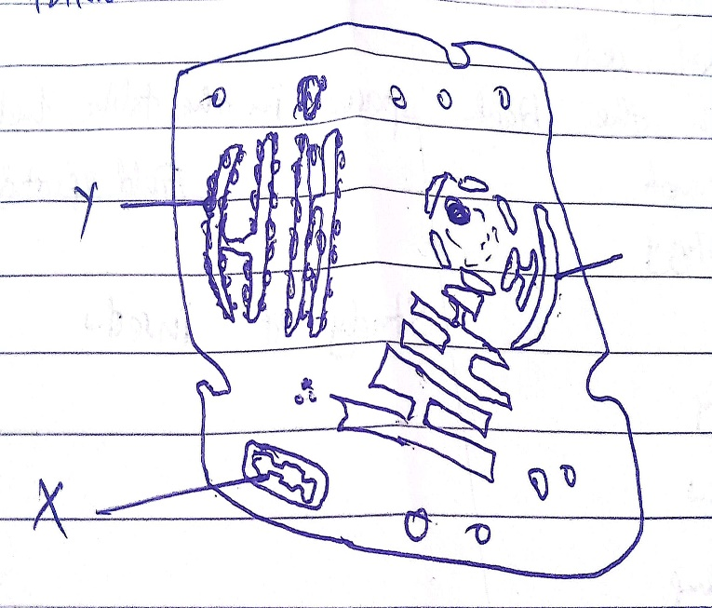

- Based on the diagram, identify which type of cell it is. (1mk)

- Give reason in your answer in (a) above. (2mks)

- Identify the following. (2mks)
- X
- y
- What is the significance of X in animal cells? (1mk)

- A form one student of Agoro Oyombe Secondary wanted to know the size of a cell during their biological practiced in the laboratory. Using alight microscope, he counted 8 cells through the field of view of diameter 2.2mm. Determine the length of each cell. (3mks

- Study the diagram below and answer the questions that follow.
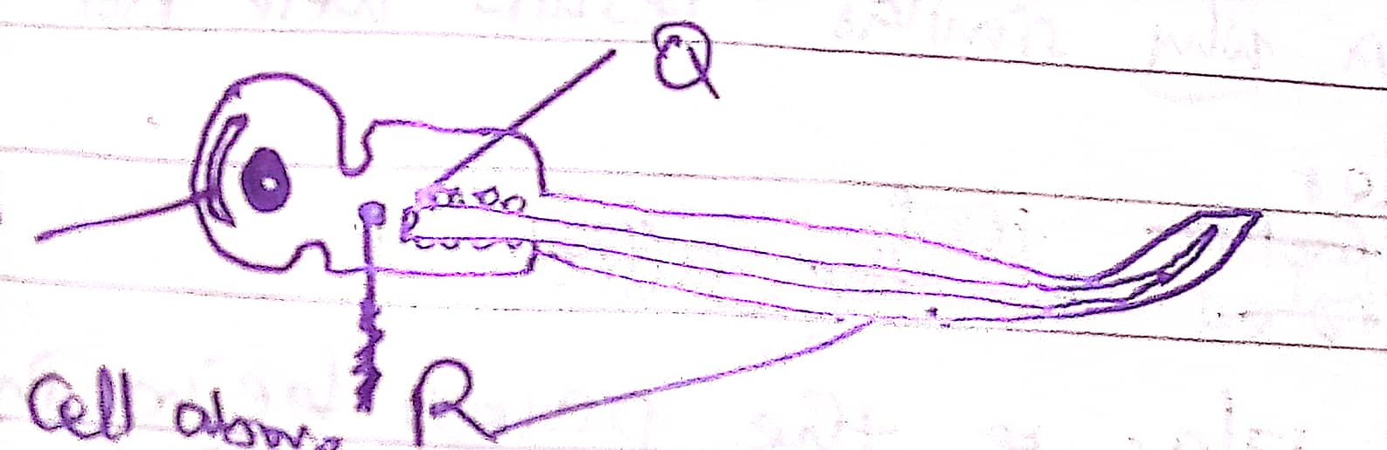

- Identify the cell above
- Identify parts labelled
- P
- Q
- What is the function of the parts labelled? (2mks)
- P
- R
- The set up below was used to study a certain physiological process.

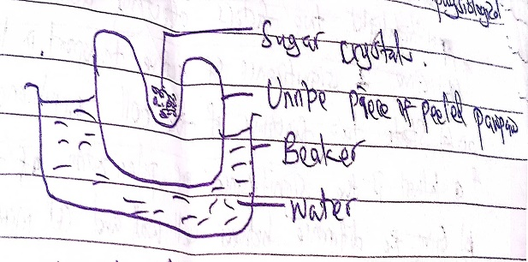

- Name the physiological process demonstrated above. (1mk)

- What observation were made if the set up was left for 20 minutes.(2mks)

- Explain your observation made in (b) above

- State three roles of process identified above. (2mks)

- Distinguish the following.
- Haemolysis and plasmolysis. (2mks)

- Osmotic pressure and turgor pressure. (2mks)
- Highlight two differences between osmosis and active transport. (2mks)

- Study the diagram below and answer the questions that follow.

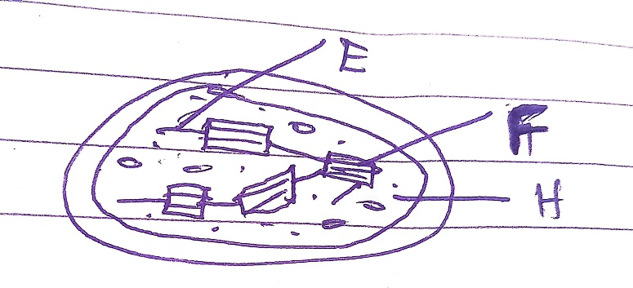

- Identify the above cell organelle. (1mk)
- Identify the parts labelled. (3mks)
E
F
G
- From the information you have given above cell organelle, where does the following stages of photosynthesis occur
- Light stage (1mk)
- Dark stage (1mk)
- Highlight 3 significance of active transport in living organisms. (3mks)

