**NAME: ……………………………………………………… ADM NO: …………………..**

**DATE: ……………………………………………………… CLASS: ……………**

**END - TERM 2 EXAM-2024**

**FORM 1**

**MATHEMATICS**

**END OF TERM II EXAM 2024**

**TIME: 2HOURS**

**INSTRUCTIONS TO CANDIDATES**

*1.Write your name and index number in the spaces provided at the top of this page.*

*2.This paper consists of two sections:* ***Section l and Section II***

*3.Answer all questions in* ***section l*** *and 3 questions in* ***Section II.***

*4. Show all the steps in your calculations in the spaces provided, giving your answers at each stage in the spaces below each question.*

*5.Marks may be given for correct working even if the answer is wrong.*

*6.Non- programmable silent electronic calculators* ***and KNEC*** *Mathematical tables may be used.*

**SECTION A: Answer all questions in this section (50MKS)**

1. Evaluate $\frac{-4 of \left(-4+ -15÷5\right)+ -3-4÷2}{84÷-7+3--5}$ (3marks)

1. If $x = -2, y = -6 and z=4$, find the value of: (2marks)
$$\frac{3yz}{x}$$

2. Express the following numbers in terms of their prime factors. (2mks)
4. Use tables to find the:
5. Square of 36.21 (2mks)
6. Square root of 0.0293 (2 marks)
7. Three tanks are capable of holding 36, 84 and 90 litres of milk. Determine the capacity of the greatest vessel which can be used to fill each one of them an exact number of times. (2 marks)
8. The cost of 5 skirts and 3 blouses is sh. 1750. Mueni bought three of the skirts and one of the blouses for sh.850. Find the cost of each item. (3 marks)
9. Forty-five men can construct a road 210m long in 60 days. What length would be constructed by 72 men in 50 days assuming that all work at the same rate? (3mks)
10. The figure below shows a circle centre O. Chord AB subtends 300 at the centre. If the area of the shaded section is 5.25cm2, find the radius of the circle  (3mks)

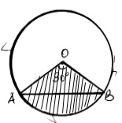

1. Juma, Ali and Hassan share the profit of their business in the ratios 3:7: 9 respectively. If Juma receives Ksh 60000. How much profit did the business yield? (2mks)
2. The exterior angle of a regular polygon is an eighth of the interior angle. How many sides does the regular polygon have? (3 marks)
3. Express each of the following as a fraction; (2 mks)

3. $\dot{7}\dot{2 }$

1. Find the ratio of x: z if x: y=9:10 and y:z=5:3. (3mks)
2. In the figure below, lines AB and LM are parallel.

1300

A

B

L

M

y

z

x

830

1. Find the values of the angles marked x, and z. (2 mks)
2. Solve for y in the following equation; (3mks)

$$\frac{y+3}{3}+\frac{y-3}{4}=\frac{1}{12}$$

Find the surface area of the prism. 4mks

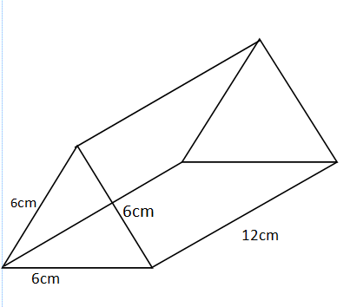

1. A mother divides a certain number of mangoes among her five daughters so that each got six mangoes. If she was left with three mangoes, how many mangoes did she have initially? (2 mark)
2. The sum of interior angles of a regular polygon is 720O. Find the number of sides of the polygon and give its name. (3mks)
3. Simplify
4. 3p + 6n - 2(p-10p) (2marks)

b. 6x2m – (4x2m + mx2) + x (3 marks)

**SECTION II *(Answer ONLY three questions in this section)***

1. The table below shows a time table for a public surface vehicle operating between two towns A and D via town B and C.

|  |  |  |
| --- | --- | --- |
| town | Arrival time | Departure time |
| A |  | 8:20am |
| B | 10:40pm | 11:00am |
| C | 2:30 pm | 2:50pm |
| D | 4:00pm |  |

1. At what time in 24hour clock system:
2. The vehicle leaves town A. 2mks
3. The vehicle arrives in town D. 2mks
4. How long does it take to travel from town A to D. 4mks
5. If the distance between the two towns A and D is 900km, find the average speed of the vehicle. 2mks
6. Use a ruler and a pair of compasses only in this question.
7. Construct triangle ABC in which AB = 7 cm, BC = 8 cm and ∠ABC = 600. (4mks)
8. Measure (i) side AC. (1mk)

(ii) ∠ ACB. (1mk)

(c) On the same diagram, drop a perpendicular from C to meet AB at D. Measure CD hence calculate the area of the triangle (4mks)

1. Maureen spent sh. 207 to buy 7 exercise books and 4 pens while Sharon spent sh. 165 to buy 5 exercise books and 5 pens of same type. Find the cost of each item. (3mks)
2. (a) Solve the following pair of simultaneous equations using elimination method. (4mks)

2x – y = 3

X + 2y = 14

Use the graph below to solve the simultaneous equations graphically (6 marks)

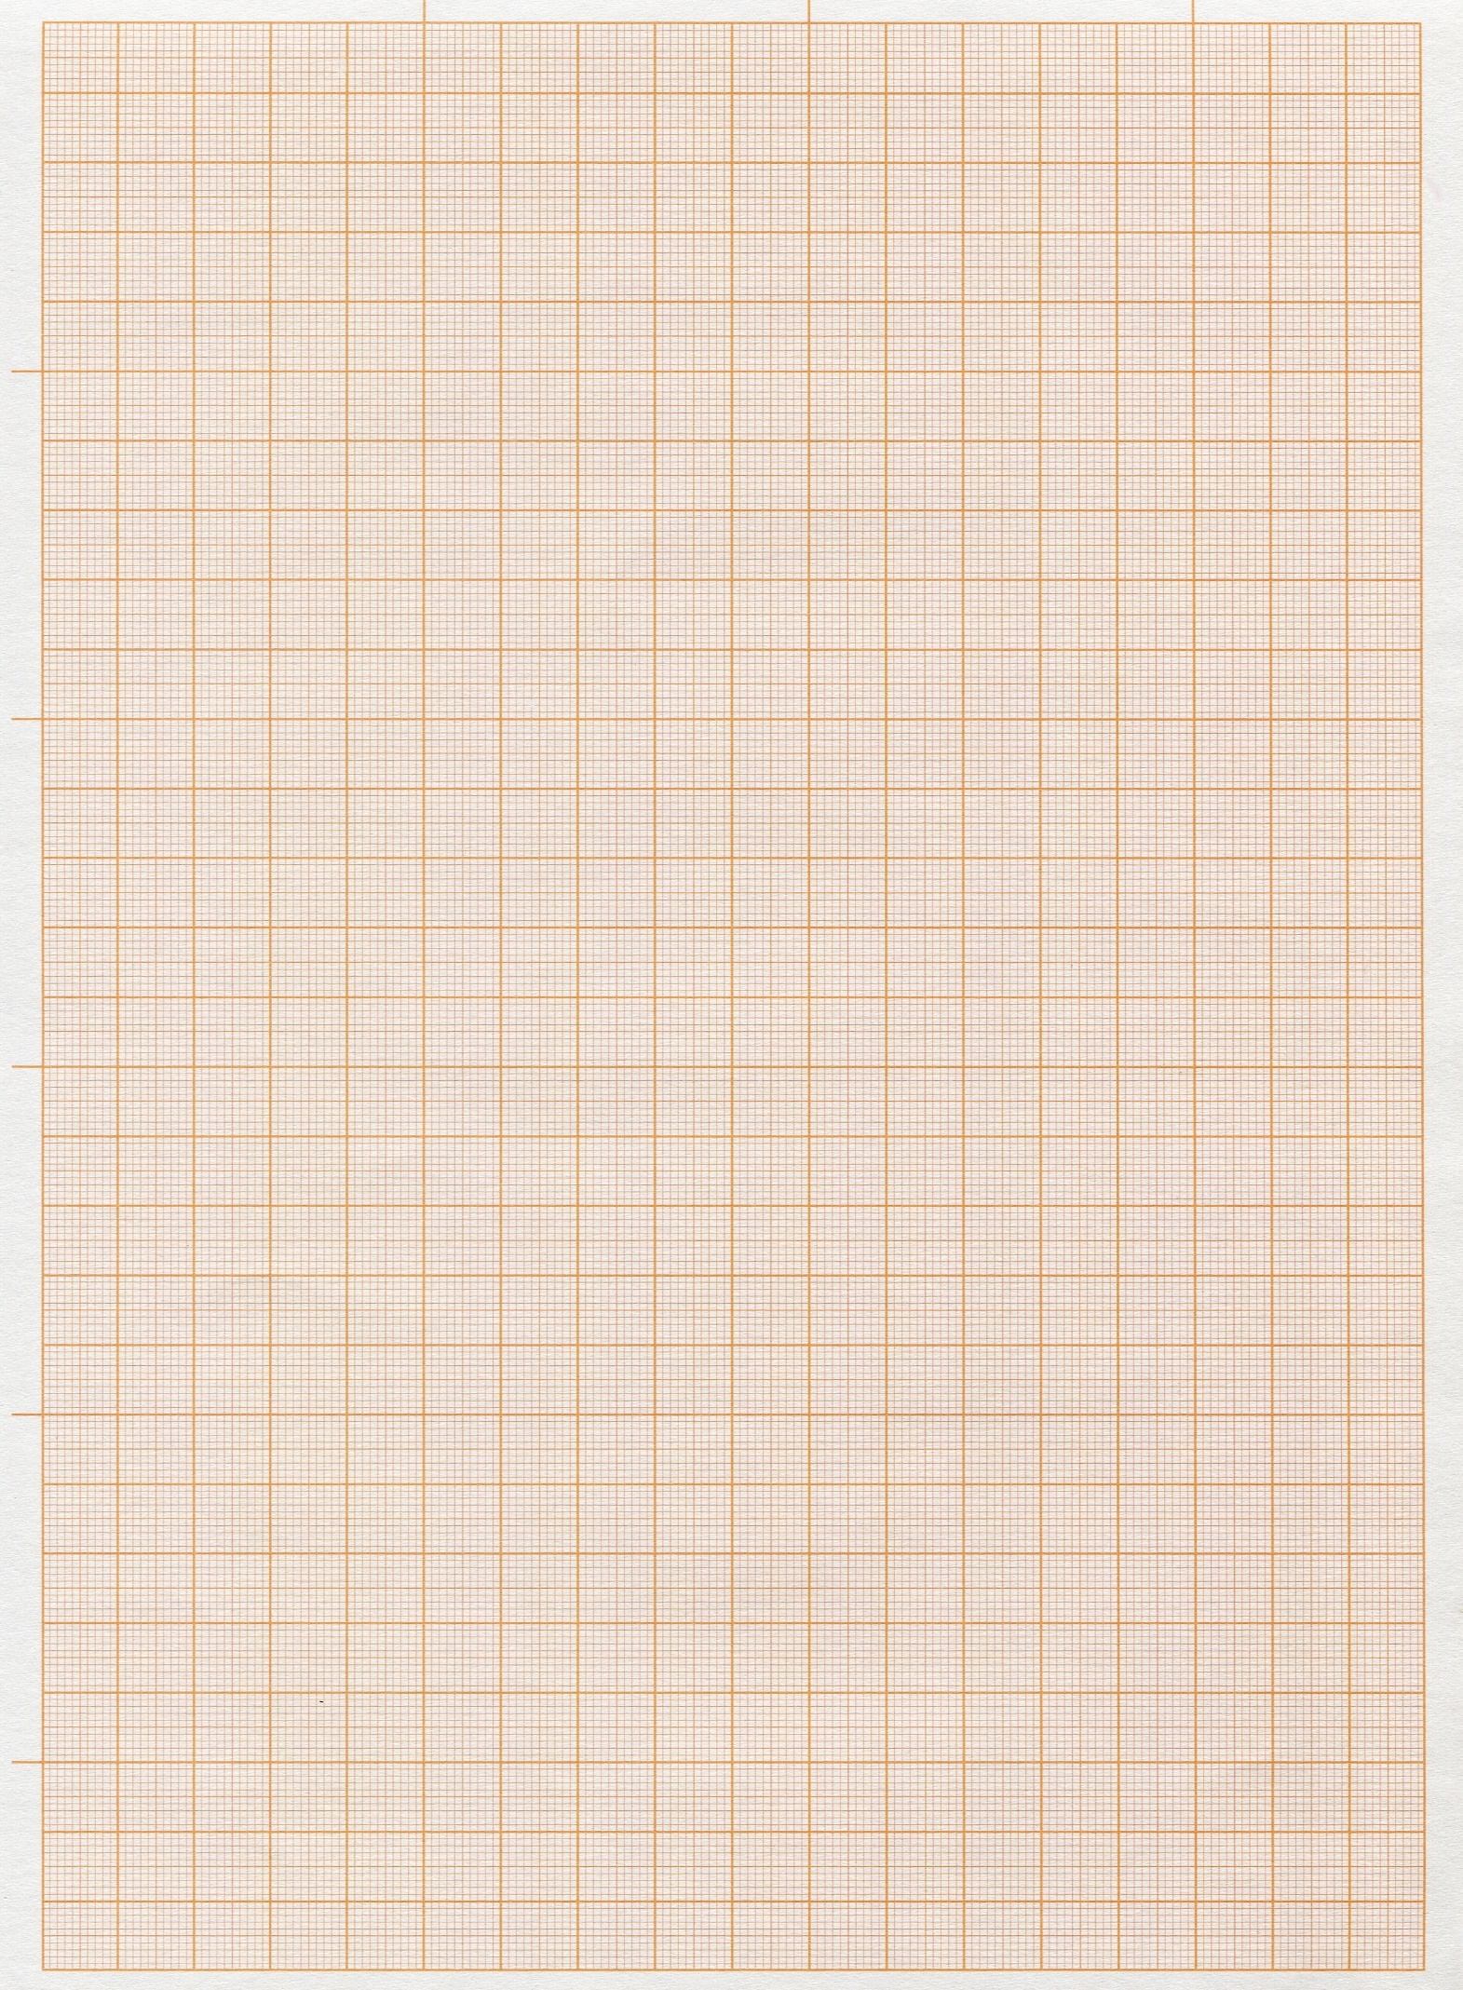

1. A rectangle whose length is 7cm longer than its width has a perimeter of 120cm.
2. Find the width of the rectangle. (3mks)
3. Find the area of the rectangle (2mks)
4. If the cost of the material used to make the rectangle is shs.30 per centimetre square (cm2). What will be the cost of the material used to make up the entire rectangle (2mks)
5. Two similar triangles are obtained from the rectangle. What is the area of each triangle? (2mks)
6. What is the hypotenuse of the triangles? (2mks)
7. Daniela spent ¼ of her net January salary on school fees. She spent ¼ of the remainder on electricity and water bills. She then spent 1/9 of what was left on transport. If she finally had sh. 3400.
8. What fraction of her January salary was spent on electricity and water bill? (2mks)
9. What fraction remained after she spent on fees, electricity and water bills? (2mks)
10. What fraction was spent on transport? (2mks)
11. Calculate her net January salary. (4mks)