NAME……………………………………INDEX NO…………………SCHOOL…………………………….

451/1
COMPUTER STUDIES PAPER 1
TIME: 2½ HOURS
Ng’iya Maseno joint

Kenya Certificate of Secondary Education

COMPUTER STUDIES
PAPER 1
(THEORY)
TIME: 2½ HOURS

INSTRUCTIONS TO CANDIDATES
- This paper consists of TWO Sections A and B
- Answer all questions in Section A
- Answer question 16 (compulsory) and any other THREE question in section B
- All answers should be written in the space provided in the question paper

FOR OFFICIAL USE ONLY:
Section | Question | Candidates  Score
A | 1-15
B | 16
B | 17
B | 18
B | 19
B | 20
Total Score

This paper consists of 7 printed pages.
Candidates should check the question paper to ascertain that
all pages are printed and no questions are missing

SECTION A: (40 MARKS)

Answer ALL the questions in this section in the space provided.

1. (a) A computer laboratory should be constantly kept dust and smoke free. Specify two effects that dust would have on the operation of computers. (2 marks)

- Why should you first switch on the UPS before switching on the system unit and the monitor?
(1 mark)
2. Explain the meaning of backup. (2 marks)

3. State the following types of transcription errors. (2 marks)

- 3455 instead of 3456
- Smith instead of simth

4.(a)State three ways used to represent a negative number. (3 marks)

(b)Perform the following binary arithmetic giving the answer in decimal notation.
1110.0111 + 1101001.011 (2 marks)

5. Distinguish between data privacy and data integrity as used in computing. (2 marks)

6. Differentiate between a primary key and a foreign key while designing a database. (2 marks)

7. Distinguish between ‘count’ and ‘countif’ functions as used in spreadsheets. (2 marks)

8.Match the following statements with repeater, router or a bridge. (2 marks)

 | STATEMENT | DEVICE
(a) | Operates at data link layer | bridge
(b) | Determine the best path for data to follow | router
(c) | Regenerates signals | repeater
(d) | Forwards everything which it doesn’t recognize | router

9. Explain the impact of Information Technology on organization in each of the following areas. (2 marks)
- Competition.

- Pace of growth.

10. List two roles performed by system analyst. (2 marks)

11. Explain the following internet related terms. (4 marks)

(a) Sign IN

(b) Search engine

- Surf

(d) Sign up

12. In Kenya Tea Packers Company, several people are employed as record clerks, typists and messenger. The company intends to introduce a computerized system in all the departments. Suggest three reasons that would make workers unhappy with the new system. (3 marks)

13. State two magnetic Storage devices. (2 marks)

14. State three functions of Central Processing Unit. (3 marks)

15. For each of the following file organization methods, state an appropriate storage medium:
(2 marks)
(a) Serial

- Random

Answer question 16 (compulsory) and any other THREE questions from this section.

16.(a) a) Explain three errors which may occur in computer programs (3 mks)

b) Draw a flowchart which can be used to design a program to work out the cost of covering the windows of
a house with curtains given that; (10 mks)
-Number of windows are six
-The area of the window is in square meters (SOW)
-The cost of material per square meter is (COM) is 400
-the length of a window is (L) and the breadth (B)in meters.
The Program should;
i) Calculate the Area in square meters (SOW) required for each window and the cost per window.
ii) Calculate the total cost for the six windows.
iii) Print the total cost of the material required.

c) . Give two features/characteristics of high-level programming languages. (2 mks)

17 Study the spreadsheet below and use it to answer the questions that follow.
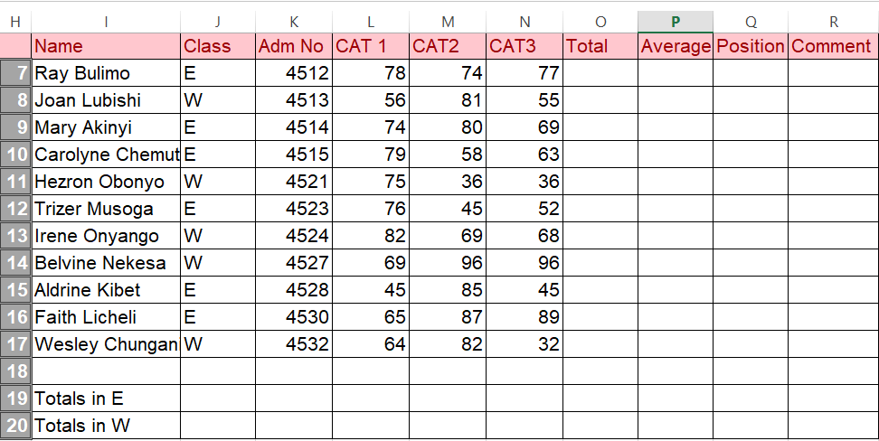
- Write a function that would be entered in cell L19 to calculate the total marks for CAT 1 for students in Class E. (3 marks)

- Write a function that would be entered in cell R7 to insert comments basing on the following criteria: A student whose average is above or equals to 70 is given “Excellent”, an average of 65 or above but less than 70 award “Average” and an average less than 65 award “Below average” (3 marks)

- Write down a function that can be typed in cell Q7 and copied down the column to find positions basing on the average. (3 marks)

e. Differentiate between cropping and resizing an object as used in desktop publishing. (2 marks)

f) Give a reason why a user would apply a master page in his/her publication. (1 mark)

g) Explain the following features as used in DTP. (2 marks)
- Pasteboard
- Printable area
h) State one advantage of using DTP software to make publications as opposed to word processors. (1 mark)

18.(a) Explain two coding schemes used in data representation techniques. (4 marks)

- Using two’s complement work out 9₁₀-14₁₀. (4 marks)

(c)Work out the hexadecimal equivalent of 101111100011₂ (2 marks)

(d)Identify the following types of ports. (5 marks)
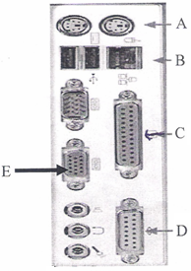

A………………………………………………………………………………………….

B………………………………………………………………………………………….

C………………………………………………………………………………………….

D………………………………………………………………………………………….

F…………………………………………………………………………………………..

19.(a) Explain two functions of an operating system. (4 marks)

- Explain the following terms as used in disk management using operating system:
(i)Disk defragmentation. (2 marks)

(ii)Disk clean up. (2 marks)

- What will happen if you attempt to delete a folder while a file contained in it is Open? (1mark)

(d)State two properties that an operating system displays about a file. (2 marks)

(e)Give four advantages of storing files in folders. (4 marks)

20. (a) The diagram below shows four common network topologies A, B, C and D.

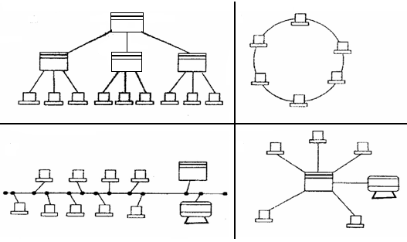

B
D
A
C
Server
Terminal
Printer
X

(i)Name the network topologies labeled A, B, C and D. (4 marks)

(ii)Explain what happens if server X in topology A fails. (1 mark)

(iii)List two problems associated with network topology B. (2 marks)

(iv)List two disadvantages associated with network topology labeled D. (2 marks)

(b)Differentiate between Internet and World Wide Web. (2 marks)

(c)Describe the following network services and identify their applications. (4 marks)
(i) Voice mail.

- Video conferencing.

