NAME……………………….…………………………………………..…CLASS………….ADM:.................
SCHOOL……………………………………………………………INDEX NO……………………………..
312/2
GEOGRAPHY PAPER 2
JULY/AUGUST 2023
Time: 2¾ hours

GEOGRAPHY PAPER 2
LANJET CLUSTER JOINT EVALUATION
FORM FOUR GEOGRAPHY PAPER 2 (312/2)
Time: 2 hrs 45 minutes
INSTRUCTIONS TO CANDIDATES
- This paper has two sections: A and B
- Answer ALL the questions in section A.
- In section B, answer questions 6 and any other TWO questions.
- All the answers must be written on the foolscaps provided after page 4.
- Candidates must answer the questions in English.

FOR EXAMINER’S USE ONLY

Section | Questions | Maximum  Score | Candidate’s  Score
A | 1 - 5 | 25
B | 6 | 25
B |  | 25
B |  | 25
Total Score

This paper consists of 4 printed pages. Candidates should check the question paper to ascertain that all pages are printed as indicated and that no questions/pages are missing.

SECTION A
1. (a) List the two types of environment. (2 marks)
(b) Explain how Geography is related to economics. (2 marks)
2. (a) Name two main indigenous breeds of beef cattle reared in Kenya. (2 marks)
(b) State three ways in which government policy influences agriculture in Kenya.(3 marks)
3. The diagram below some national parks in East Africa. Name the parks marked A, B, C and D. (4 marks)
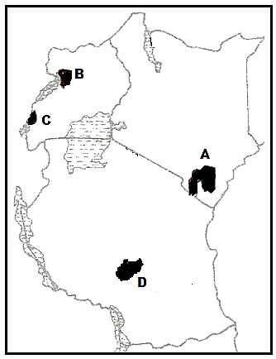
4. (a) Give two main projects through which land was reclaimed in the Netherlands. (2 marks)
(b) State four benefits that resulted in the reclamation of the Yala swamp in Kenya. (4 marks)
5. (a) State three physical factors favouring coffee farming in Brazil. (3 marks)
(b) Give three similarities between coffee farming in Kenya and in Brazil. (3 marks)

SECTION B
6. Study the photograph below and use it to answer the following questions.
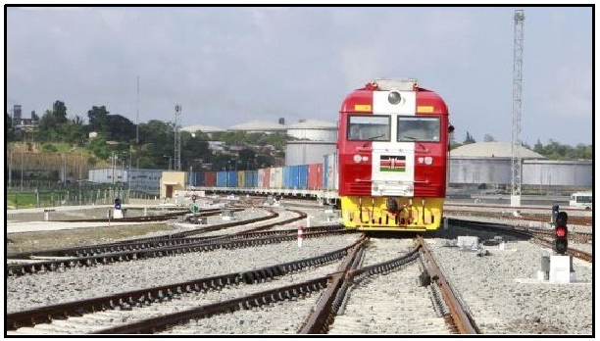
(a) (i) Identify the type of photograph provided. (1 mark)
(ii) Give two reasons for your answer in (a)(i) above. (2 marks)
(iii) Identify the main activity shown on the photograph. (1 mark)
(b) (i) Draw a rectangle 15 cm by 10 cm to represent the area covered by the photograph. (1 mark)
(ii) On the rectangle, sketch and label five human made features. (5 marks)
(c) (i) State five reasons why river transport is poorly developed in Africa. (5 marks)
(ii) Explain five measures taken to solve transport and communication problems in Africa. (10 marks)

7. (a) (i) Define the term mining. (1 mark)
(ii) Give four factors that the occurrence of minerals. (4 marks)
(b) Explain three ways in which mining activities cause pollution. (6 marks)
(c) Describe the stages involved in gold processing in South Africa (6 marks)
(d) Explain four problems facing the gold mining industry in South Africa (8 marks)

8. (a) What is unfavourable balance of payments? (2 marks)
(b) Name three major imports to Kenya from the Far East Asia. (3 marks)
(c) Explain four benefits of international trade to Kenya. (8 marks)
(d) (i) State four objectives of ECOWAS. (4 marks)
(ii) Explain four problems facing regional trading blocs in Africa. (8 marks)

9. (a) (i) What is a Census? (2 marks)
(ii) State four reasons why a census is important to Kenya (4 marks)
(b) Explain four positive effects of high population growth to a country. (8 marks)
(c) Explain three causes of a reduced fertility rate in Kenya (6 marks)
(d) State five differences between Kenya’s population and that of Sweden. (5 marks)

10. (a) (i) Define the term urbanization. (2 marks)
(ii) List the three functional zones of an ideal urban centre. (3 marks)
(b) Explain four physical factors that influence settlement. (8 marks)
(c) Explain four factors that have led to the growth of Rotterdam as a large port. (8 marks)
(d) State four similarities in the functions of Nairobi and New York cities. (4 marks)

