NAME:…………………………………………………………SCHOOL:……………………………………
ADM NO………….CLASS:.…DATE: …………….CANDIDATE’S SIGNATURE:……………………
121/1
MATHEMATICS LANJET CLUSTER JOINT EVALUATION – 2023

PAPER 1 Kenya Certificate to Secondary Education
JUL/AUG 2023 MATHEMATICS PAPER 1- ALT A
TIME: 2 ½ HOURS TIME: 2 ½ HOURS

Instructions to candidates
- Write your name and admission number in the spaces provided above.
- Sign and write the date of examination in the spaces provided.
- This paper consists of two sections: Section I and Section II.
- Answer all questions in section I and only five questions from section II.
- Show all the steps in your calculations, giving the answers at each stage in the spaces provided below each question.
- Marks may be given for correct working even if the answer is wrong.
- Non-programmable silent electronic calculators and KNEC mathematical tables may be used, except where stated otherwise.
- This paper consists of 15 printed pages.
- Candidates should check the question paper to ascertain that all the pages are printed as indicated and that no questions are missing.
- Candidates should answer the questions in English.
For Examiner’s Use Only
1 | 2 | 3 | 4 | 5 | 6 | 7 | 8 | 9 | 10 | 11 | 12 | 13 | 14 | 15 | 16 | Total
SECTION I

SECTION II Grand Total

17 | 18 | 19 | 20 | 21 | 22 | 23 | 24 | Total

SECTION I (50 MARKS)
( Answer all questions in this section in the spaces provided below each question)

- Simplify $\frac{12x^{2}+ax-6a^{2}}{ 9x^{2} -4a^{2}}$ (3 marks)

- Paul bought a refrigerator on hire purchase by paying monthly instalments of Ksh. 2000 per month for 40 months and a deposit of Ksh. 12,000. If this amounted to an increase of 25% of the original cost of the refrigerator, what was the cash price of the refrigerator? (3 marks)

- Without using calculator, evaluate
${\left(\frac{7}{3}\left[\frac{2}{5}of1\frac{2}{3}-\frac{1}{2}{\left(\frac{1\frac{2}{3}-2\frac{1}{2}}{\frac{1}{3}-\frac{19}{27}}\right)}^{\frac{1}{2}}+\frac{2}{3}\right]\right)}^{\frac{1}{2}}$leaving the answer as a mixed fraction.(4 marks)

- During a certain month, the exchange rates in a bank were as follows;
 | Buying (Ksh.) | Selling (Ksh.)
1 US $ | 91.65 | 91.80
1 Euro | 103.75 | 103.93

A tourist left Kenya to the United States with Ksh.1 000,000.On the air port he exchanged all the money to dollars and spent 190 dollars on air ticket. While in US he spent 4500 dollars for upkeep and proceeded to Europe. While in Europe he spent a total of 2000 Euros. How many Euros did he remain with? (3marks)

- A regular n-sided polygon has its interior angle equal to 4 times its exterior. Find n. (3 marks)

- The ratio of the lengths of the corresponding sides of two similar rectangular petrol tanks is 3:5.The volume of the smaller tank is 8:1m³.Calculate the volume of the larger tank.(3 marks)

- A man walks directly from point A towards the foot of a tall building 240m away. After covering 180m, he observes that the angle of elevation of the top of the building is 45⁰.Determine the angle of elevation of the top of the building from A. (3 marks)

- The G.C.D. and L.C.M. of three numbers are 3 and 1008 respectively. If two of the numbers are 48 and 72, find the least possible value of the third number. (3 marks)

- Solve for x in the equation below without introducing logarithms
$5^{2x-1}= {60}^{2x-1}$ (3 marks)

- The table below shows masses of fifty students in a form one class.

Mass (kg) | Frequency
25-30 | 6
30-35 | 10
35-40 | 24
40-45 | 7
45-50 | 4

- State the modal class. (1mark)

- Calculate to 3 d.p the median mass. (2 marks)

- Given that the position vectors of points P and Q are $p=\left(\begin{matrix}-4 \\ -2\end{matrix}\right)$ and $q=\left(\begin{matrix}5 \\ 4\end{matrix}\right)$. M is a point on PQ such that PM:MQ = 2:1. Find the coordinates of M. (3 marks)

- Calculate the area of the shaded region. (3 marks)
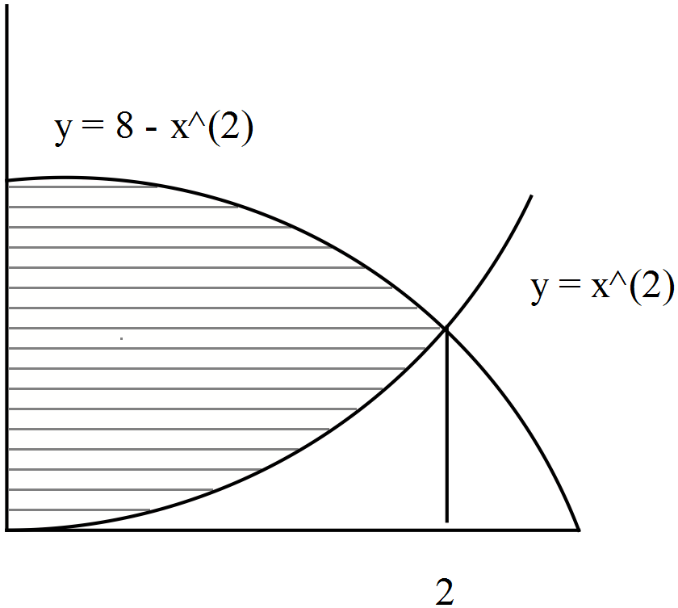

- Solve the simultaneous equations. (4 marks)

$\frac{p}{q+1}= \frac{1}{4}$ , $\frac{p-3}{p+q}=\frac{2}{3}$

- The ratio of boys to girls in a school is 4:5. One day $\frac{1}{3}$ of the boys and $\frac{1}{5}$of the girls were absent. If 8 less pupils had been absent, $\frac{3}{4}$ of the school would have been present. Calculate the number of pupils in the school on that day. (3 marks)

- Tap A can fill a tank in 10 minutes; tap B can fill the same tank in 20 minutes. Tap C can empty the tank in 30 minutes. The three taps are left open for 5 minutes, after which tap A is closed. How long does it take to fill the remaining part of the tank? (3 marks)

- A solid in a shape of a right pyramid on a square base of side 8cm and height 15cm is cut at 6cm height from the base. Find the volume of the frustrum formed. (3 marks)

SECTION II (50 MARKS)
(Answer ANY FIVE questions in the spaces provided)

17. The points $A^{I}B^{I}C^{I}$ are the images of $A\left(4, 1\right), B\left(0, 2\right)and C(-2, 4)$ respectively under a transformation represented by the matrix $M= \left(\begin{matrix}1 & 1 \\ 1 & 3\end{matrix}\right)$.
- Write down the coordinates of $A^{I}B^{I}C^{I}$ (3 marks)

- $A^{II}B^{II}C^{II}$ are the images of $A^{I}B^{I}C^{I}$ under another transformation whose matrix is $N= \left(\begin{matrix}2 & -1 \\ 1 & 2\end{matrix}\right)$. Write down the co – ordinates of $A^{II}B^{II}C^{II}$ (3 marks)

- Transformation M followed by N can be replaced by a single transformation P. determine the matrix for P. (2 marks)

- Hence determine the inverse of matrix P. (2 marks)

- The figure below shows a triangle OAB with O as the origin. OA=a OB = b, OM 2/5a and ON = 2/3b.
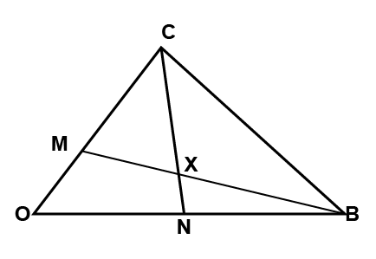

- Express in terms of a and b the vectors
- BM (1 mark)

- AN (1 mark)

- Vector OX can be expressed in two ways: OB + KBM or OA + hAN, where K and h are constants.
Express OX in terms of:
- a, b and k. (2 marks)

- a, b and h. (2 marks)

- Find the values of k and h. (4 marks)

- In the figure below, O is the center of the circle. PQ is a tangent to the circle at N. Angle NCD is 10∘ and angle ANP is 30∘

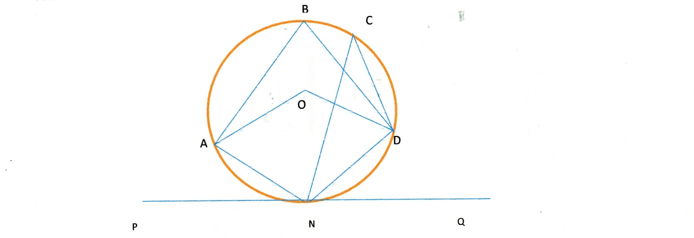
Giving reasons find;
- Angle DON (2marks)

- Angle DNQ (2marks)

- Angle DBA (2marks)

- Angle ONA (2marks)

- Angle ODN. (2marks)

- The displacement h metres of a particle moving along a straight line after t seconds is given by h=-2t³+$\frac{3}{2}$ t² + 3t.
- Find its initial acceleration (3 marks)

- Calculate;
i) The time when the object was momentarily at rest (3 marks)

ii) Its displacement by the time it comes to rest (2 marks)

- Calculate the maximum speed attained (2 marks)

21. A metal R is an alloy of two metals X and Y. Metal X has a mass of 70g and a density of 16g/cm³. Metal Y has a mass of 19g and a density of 4g/cm³.
(a) Calculate the density of the metal R. (4 marks)

(b) If metal R is divided into two equal parts and each half reinforced by adding metal X to get to initial volume. Find the density of the new alloy. (4 marks)

(c)The two metals are mixed in a ratio of 4:1 respectively. What is the density of the alloy? (2 marks)

22. A trailer moving at a speed of 80km/h is being overtaken by a car moving at 100km/h in a clear section of a road. Given that the bus is 21m long and the car is 4m long.
- How much time (in seconds) will elapse before the car can completely overtake the bus? (3 marks)

- How much distance (in metres) will the car travel before it can completely overtake the bus? (2 marks)

- Given that as soon as the car completed overtaking the trailer, a bus heading towards the trailer and the car and moving at a speed of 90km/h became visible to the car driver. It took exactly 18 seconds for the car and the bus to completely by pass each other from the moment they first saw each other.
i. How far was the tail of the bus from the tail of the car at the instance they first saw each other given that the bus is 12 metres long? (3 marks)

ii. How far a part was the trailer and the bus just immediately after the car and the bus had passed each other? (2 marks)

23. Every Sunday Alex drives a distance of 80km on a bearing of 074⁰ to pick up his brother John to go to church. The church is 75km from John’s house on a bearing of S50⁰E. After church they drive a distance of 100km on a bearing of 260⁰ to check on their father before Alex drives to John’s home to drop him off then proceeds to his house.
(a) Using a scale of 1cm to represent 10km, show the relative positions of these places. (4 marks)

(b) Use your diagram to determine:
(i) the true bearing of Alex’s home from their father’s house. (1 mark)

(ii) the compass bearing of the father’s home from John’s home. (1 mark)

(iii) the distance between John’s home and the father’s home. (2 marks)

(iv) the total distance Alex travels every Sunday. (2 marks)

24. P and Q are two points on a geographical globe of diameter 50 cm. They both lie on a parallel latitude 50º North. P has longitude 90º West and Q has longitude 90º East. A string AB has one end at point P and another at point Q when it is stretched over the North pole. Taking $= 3.142$;
- Calculate the length of the string. (3 marks)

- If instead the string is laid along the parallel of latitude 50ºN with A at point P, calculate the longitude of point B. (3 marks)

- State the position of B if the string is stretched along a great circle of P towards the South pole if point A is static at P. (4 marks)

